Parental Code of Conduct:
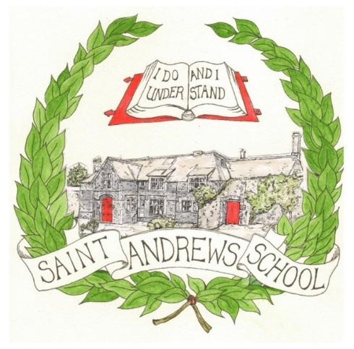
At St Andrew’s School we are committed to creating a safe, supportive and inclusive environment for all students, staff and families. We understand the importance of a good working relationship so we can maintain our vision of ‘Encouraging every student through learning, creativity and adventure to become a kind, respectful and independent young adult prepared for the future.’ As an important part of our school community, we ask that parents and carers adhere to the following expectations in their interactions with staff and others.
Respect for All
We expect all parents and carers to treat staff, students and other members of the school community with kindness, courtesy and respect. Mutual respect is fundamental in ensuring we maintain a positive and collaborative environment. In order to adhere to this, we ask that all communication, whether in person, by phone or in writing, is respectful and constructive.
Professional Boundaries
While we value open communication, it is important to maintain professional boundaries between staff and parents; as such, we do ask that you respect the personal time and space of school staff, particularly outside of school hours. We encourage you to address the concerns through appropriate channels such as using the home-school communication book, Class Dojo, emailing the class teacher or calling the school office.
Zero Tolerance for Violent and Abusive Behaviour
Any forms of violent, threatening or abusive behaviour – whether physical or verbal – will not be tolerated. This includes aggressive actions, threatening language, insults, intimidation, or harassment directed towards staff, students or other parents and carers. Such behaviours put the safety and well-being of our community at risk and will result in immediate actions, which may include removal from the premises and/or contacting the appropriate authorities.

Behaviours that will not be tolerated
- Disrupting, or threatening to disrupt, school operations (including events on the school grounds and off-site activities)
- Swearing, or using offensive language
- Displaying a temper, or shouting at members of staff, students or other parents
- Threatening another member of the school community
- Sending abusive messages to another member of the school community, including via text, email or social media
- Posting defamatory, offensive or derogatory comments about the school, its staff or any member of its community, on social media platforms
Finding a Resolution
We understand that disagreements may arise. When they do, we encourage respectful and calm communication to resolve issues constructively. If you have concerns about your child’s education or experience at school, please reach out to the appropriate members of staff so we can address them in a professional and collaborative manner.
Breaching the code of conduct
If the school suspects or becomes aware that a parent or carer has breached the code of conduct, the school will gather information from those involved and speak to the parent or carer regarding the incident.
Depending on the nature of the incident, the school may then:
- Invite the parent or carer into school to meet with the headteacher or another senior member of staff
- Send a warning letter to the parent or carer
- Contact the appropriate authorities (in cases of criminal behaviour)
- Seek advice from legal teams regarding further action, if required
- Ban the parent or carer from the school site
The school will always respond to an incident in a proportional way. The final decision for how to respond to breaches of acceptable behaviour rests with the headteacher. The headteacher will consult the chair of trustees before banning a parent or carer from the school site.
We appreciate your understanding and cooperation in maintaining a safe and respectful atmosphere at St Andrew’s School. Together, we can provide the best possible learning environment for all our students.
Thank you for your continued support.

