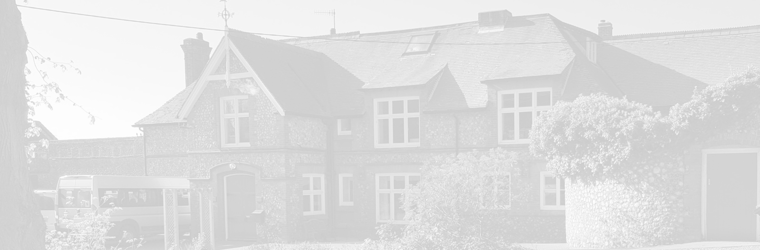
St Andrew’s School
A school with Quaker values

Aylmerton Hall Holt Road
Aylmerton Norfolk NR11 8QA
Telephone: 01263 837927

Executive Head: Julie Jackson
Head of School: Jim Collin

The St Andrew’s School Trust is a Registered Charity No. 1129232

Remote Learning
Policy

Last reviewed date: January 2023
Adopted by Trustees date: January 2024
Next review date: January 2026

Contents
1. Aims 2
2. Roles and responsibilities 2
3. Who to contact 4
4. Data protection 4
5. Safeguarding 5
6. Monitoring arrangements 5
7. Links with other policies 5

1. Aims
This remote learning policy aims to
- Ensure consistency in the approach to remote learning for students who are not in school
- Set out expectations for all members of the school community with regards to remote learning
- Provide appropriate guidelines for data protection

2. Roles and responsibilities
- Executive headteacher to oversee remote learning throughout the school
- Head of School to manage department input
- Subject teachers to monitor student response
- Pastoral Lead to monitor well-being of students
2.1 Teachers
When providing remote learning, teachers must be available between 9am – 3.45pm.
If they are unable to work for any reason during this time, for example due to sickness or caring for a dependent, they should report this using the normal absence procedure. When providing remote learning, Teachers are responsible for:
  - Setting work for their classes
  - Ensuring approximately 30 minutes’ worth of work per lesson
  - Set by 3pm the previous day
  - Emailed to students with Key Stage Leader and Teaching Assistant carbon copied (cc’d) in
  - Teachers to ensure students understand that they need to email finished work back to Teachers.
  - Know how they should handle any complaints or concerns shared by parents and students – for any safeguarding concerns, teachers should refer to the section below.
  - Knowing how to handle any behavioural issues.
  - Monitoring student’s failure to complete work
  - Give ne to one written or verbal feedback on work to be given weekly.

- Attending virtual meetings with staff, parents, and students:
  - Ensure they are dressed appropriately for any virtual meetings
  - Ensure locations are appropriate
  - Use the record option for all virtual meetings with students
These guidelines apply to any remote learning set up in school and from school
2.2 Teaching Assistants
When assisting with remote learning, Teaching Assistants must be available between 9am - 4pm
If they’re unable to work for any reason during this time, for example due to sickness or caring for a dependent, they should report this using the normal absence procedure.
When assisting with remote learning, Teaching Assistants are responsible for:
- Supporting students who are not in school with learning remotely:
  - In their class only
  - Sending supportive emails at the beginning and the end of the day
- Attending virtual meetings with teachers, parents and students:
  - Ensure they are dressed appropriately for any virtual meetings
  - Ensure locations are appropriate
These guidelines apply to any remote learning set up in school and from school
2.3 Subject leads
Alongside their teaching responsibilities, Subject Leads are responsible for:
Considering whether any aspects of the subject curriculum needs to change to accommodate remote learning
- Working with Teachers who are teaching their subject remotely to make sure all work set is appropriate and coherent
- Working with other Subject Leads and Senior Leaders to make sure work set remotely across all subjects is appropriate and consistent, and deadlines are being set an appropriate distance away from each other
- Monitoring the remote work set by Teachers in their subject – explain how they’ll do this, such as through regular meetings with Teachers or by reviewing work set
- Alerting Teachers to resources they can use to teach their subject remotely
2.4 Senior Leaders
Alongside any teaching responsibilities, Senior Leaders are responsible for:
- Co-ordinating the remote learning approach across the school
- Monitoring the effectiveness of remote learning – explain how they will do this, such as through regular meetings with Teachers and Subject Leaders, reviewing work set or reaching out for feedback from students and parents
- Monitoring the security of remote learning systems, including data protection and safeguarding considerations
2.5 Designated Safeguarding Lead (DSL)
The DSL is responsible for:
Ensuring that all school safeguarding procedures are followed in the same way
2.6 Students and Parents
Staff can expect students learning remotely to:
- Be contactable during the school day – although they should consider they may not always be in front of a device the entire time
- Complete work to the deadline set by Teachers
- Seek help if they need it, from Teachers or Teaching Assistants
- Alert Teachers if they are not able to complete work
Staff can expect parents with children learning remotely to:
- Make the school aware if their child is sick or otherwise cannot complete work
- Seek help from the school if they need it
- Be respectful when making any complaints or concerns known to staff
2.7 Trustees
The Trustees are responsible for:
- Monitoring the school’s approach to providing remote learning to ensure education remains as high quality as possible
- Ensuring that staff are certain that remote learning systems are appropriately secure, for both data protection and safeguarding reasons

3. Who to contact
If staff have any questions or concerns about remote learning, they should contact the following individuals:
- Issues in setting work – Subject Leader
- Issues with behaviour – Key Stage Leader
- Issues with IT – IT staff
- Issues with their own workload or wellbeing – line manager
- Concerns about data protection – Julie Jackson
- Concerns about safeguarding – Johanna Lewis

4. Data protection
4.1 Accessing Personal Data
When accessing personal data for remote learning purposes, all staff members will:
Explain:
- How they can access the data, such as on a secure cloud service or a server in your IT network
- Which devices they should use to access the data
4.2 Processing Personal Data
Staff members may need to collect and/or share personal data such as email addresses as part of the remote learning system. As long as this processing is necessary for the school’s official functions, individuals will not need to give permission for this to happen.
However, staff are reminded to collect and/or share as little personal data as possible online.

4.3 Keeping Devices Secure
All staff members will take appropriate steps to ensure their devices remain secure. This includes, but is not limited to:
- Keeping the device password-protected – strong passwords are at least 8 characters, with a combination of upper and lower-case letters, numbers and special characters (e.g. asterisk or currency symbol)
- Making sure the device locks if left inactive for a period of time
- Not sharing the device among family or friends
- Installing antivirus and anti-spyware software
- Keeping operating systems up to date – always install the latest updates

5. Safeguarding
School's safeguarding policy and ‘Keeping Children Safe in Education’ should be revisited frequently and followed.

6. Monitoring arrangements
This policy will be reviewed yearly. At every review, it will be approved by the Trustees.

7. Links with other policies
This policy is linked to our:
- Behaviour Policy
- Safeguarding Policy and coronavirus addendum to our Safeguarding Policy
- Data Protection Policy and Privacy Notices
- Home-School Agreement
- ICT and Internet Acceptable Use Policy
- Online Safety Policy

