

St Andrew’s School
A school with Quaker values

Aylmerton Hall Holt Road
Aylmerton Norfolk NR11 8QA
Telephone: 01263 837927
Email: office@standrewsschool.co.uk

Headteacher: Adrian Crossland
The St Andrew’s School Trust is a Registered Charity No. 1129232

Restrictive Intervention
Policy

Summary of changes

Page Ref | Section | Amendment | Date of change

Adopted by Trustees date: 28th September 2026
Next review date: Autumn Term 2027

The Department for Education defines reasonable force as covering “a range of actions involving physical contact with students.” (Department for Education guidance Restrictive interventions, including the use of reasonable force in schools (2025, effective from 1 April 2026)).

https://www.gov.uk/government/publications/use-of-reasonable-force-in-schools
This policy recognises that restrictive interventions can have a significant impact on students, particularly those who have experienced trauma, loss, adversity, sensory needs, communication difficulties or other vulnerabilities. Physical intervention must therefore only ever be used as a last resort, where it is necessary, proportionate and lawful to prevent immediate risk of harm. It must never be used as a punishment or routine behaviour management strategy.
Aims of the Policy
- To protect every person in the school community from harm
- To protect all students against any form of physical intervention which is unnecessary, inappropriate, excessive or harmful.
- To provide adequate information and training for staff so they are clear as to what constitutes appropriate behaviour and to deal effectively with violent or potentially violent situations.
- To ensure that staff are trained and there are designated staff who can use the safe and lawful restrictive interventions.
- To take into account the Department for Education guidance Restrictive Interventions, including the use of reasonable force in schools (2026) and Reducing the Need for Restraint and Restrictive Intervention (2019)
Definitions
For the purposes of this policy, the following definitions apply:

Restrictive intervention

This is an action that stops a child from moving freely. This could be a physical hold or using an object or barrier to stop them from moving their whole body or just a part of it (like their arms). This may be used to prevent a child from hurting themselves, others, or causing significant damage to property.

Reasonable force

This is when staff use physical touch to stop someone from getting hurt, breaking things, or causing a serious disturbance. Staff must only use the smallest amount of force needed and only for the shortest time possible.

Significant incident

This is where the use of force goes beyond appropriate physical contact between a student and a member of staff. This includes when physical force is used to implement a non-physical restrictive intervention. This must be formally recorded and written down in a formal report.

Seclusion

This is when a student is kept in a room or space on their own for safety and is not allowed to leave. This is not a “timeout” or a punishment; it is a safety measure.
The school does not use seclusion as a disciplinary sanction or routine behaviour management strategy. Seclusion will only be considered in exceptional circumstances where it is necessary and proportionate to protect others from immediate harm when a student is experiencing significant emotional or behavioural dysregulation.
Where seclusion is used, the school will ensure that:
- The student is continuously supervised by a member of staff
- The environment is safe and does not feel threatening or intimidating to the student
- The intervention lasts for the shortest possible time
- The student is allowed to leave as soon as the immediate risk of harm has reduced
- A senior leader is informed as soon as practicable
- The incident is recorded and reported in accordance with this policy and statutory guidance

Restraint

This is a way of stopping a child from moving. It might involve holding them, or it might be done without touching them at all. It is used for safety, never as punishment.
The school will never use force as a punishment. Staff must not use restraint in a way that restricts a student’s airway, breathing or circulation, including covering the mouth or nose, applying pressure to the neck, chest or abdomen, or holding a student on the ground other than unintentionally and for the shortest possible time required to move to a safer position.
The school does not operate a ‘no contact’ policy. Appropriate physical contact is sometimes necessary, lawful and beneficial in supporting students’ safety, wellbeing, emotional regulation and participation in school life. Staff are expected to use professional judgement when engaging in physical contact with students, taking account of safeguarding responsibilities and the individual needs of the child.
There are occasions where appropriate physical contact with students is entirely proper and does not constitute restrictive intervention. Examples include providing first aid, comforting a distressed student, guiding or escorting students safely around the school, or demonstrating techniques in PE or music lessons. Staff should always exercise professional judgement, taking account of the student’s age, needs, vulnerabilities and the context of the interaction.

Legal framework
This policy reflects current legislation and statutory guidance relating to the use of reasonable force and restrictive interventions in schools. The legal framework includes:
- The Education and Inspections Act 2006 (Sections 93 and 93A)
- The Schools (Recording and Reporting of Seclusion and Restraint) (No. 2) (England) Regulations 2025
- The Independent School Standards Regulations 2014 (as amended April 2026), including paragraphs 16A and 32A.

It also takes account of:
- The Equality Act 2010
- The Children Act 1989 and 2004
- The Children and Families Act 2014
- The Human Rights Act 1998
- The Health and Safety at Work Act 1974 and associated regulations
- Keeping Children Safe in Education (latest version).

From 1 April 2026, schools are required to record and report each significant use of force and each incident involving seclusion, restraint or immobilisation. For independent schools, these duties are reflected in paragraphs 16A and 32A of the Independent School Standards Regulations, which require schools to maintain clear procedures for recording such incidents and for informing parents in writing or, where there is a safeguarding risk, the local authority.

This policy also takes account of the Department for Education guidance Restrictive interventions, including the use of reasonable force in schools (2026), and Reducing the Need for Restraint and Restrictive Intervention (2019).

Recording and reporting procedures

For the purposes of this policy, a ‘significant incident’ includes any use of restraint, seclusion, immobilisation, or any use of force beyond minimal physical contact (such as guiding), particularly where there is a risk of injury, distress, or where the intervention is prolonged or repeated.

The school will ensure that every significant incident involving the use of reasonable force, and every use of seclusion, restraint or immobilisation, is recorded as soon as reasonably practicable and, in any event, on the same day. All incidents must be recorded using Restrictive Physical Intervention Record (Appendix A).

Records will include:

- The name(s) of the student(s) involved
- The date, time and location of the incident
- The names of staff involved and any witnesses
- A factual description of the incident, including what led up to it
- The type of intervention used and its duration
- Any injury to students or staff and any medical attention required
- The outcome of the incident and any follow-up actions

All records will be reviewed by the Head or a delegated senior leader and a Norfolk Steps Practitioner to ensure that the intervention was justified, proportionate and in line with this policy. Parents will be informed in writing as soon as reasonably practicable after any significant incident involving the use of force or any use of seclusion, unless doing so would be likely to result in serious harm to the student. In circumstances where informing a parent would be likely to result in serious harm to the student, the incident will be reported to any parent who can be informed safely or, where this is not possible, to the relevant local authority, in accordance with statutory guidance and safeguarding procedures.

Any citizen has the common law power to intervene in an emergency to use reasonable force in self-defence, to prevent another person from being injured or committing a criminal offence. All staff who have control or charge of students also have statutory power, in addition to common law power. Section 93 of the Education and Inspections Act (2006) enables school staff to use such force as is reasonable and proportionate to prevent a student from doing or continuing to do any of the following:

- Committing an offence (or, for a student under the age of criminal responsibility, what would be an offence for an older student)
- Causing personal injury to any person (including the student themself)
- Causing damage to the property of any person (including the student themself)
- Prejudicing the maintenance of good order and discipline at the School or among any students receiving education at the School, whether during a teaching session or otherwise

Government guidance, Reducing the need for restraint and restrictive intervention (June 2019), also requires schools to take steps to reduce the use of physical intervention for vulnerable children. https://assets.publishing.service.gov.uk/government/uploads/system/uploads/attachment_data/file /812435/reducing-the-need-for-restraint-and-restrictive-intervention.pdf
Training
The school uses Norfolk Steps to provide training for designated staff in the safe and lawful use of restrictive interventions.

Designated staff receive training, which is refreshed in line with provider guidance
(typically every 12–24 months). All staff receive annual updates on the use of reasonable force, including de-escalation strategies and safeguarding considerations. New staff receive this guidance as part of their induction.

The Head ensures that an appropriate number of staff are trained and that training reflects current statutory guidance and the needs of the students. Approved restrictive intervention techniques are taught through accredited Team Teach training and may only be used by staff who have received appropriate training and completed all required refresher training in line with school procedures.

Why use restrictive interventions (including restraint)?
Restrictive interventions (including restraint) should avert danger by preventing or deflecting a student’s action or perhaps by removing a physical object, which could be used to harm themselves or others. It is only likely to be needed if a student appears to be unable to exercise self-control of emotions and behaviour. Such situations are often related to overwhelming stress or trauma responses, and the priority must always be to reduce harm with empathy and respect for the child’s dignity. Staff understand the neuroscience of stress and its effect on behaviour.

It is not possible to define every circumstance in which restrictive interventions would be necessary or appropriate and staff will have to exercise their own judgement in situations which arise within the above categories. Staff should always act within the school’s Code of Conduct and in accordance with the school’s safeguarding procedures.

Staff should be aware that when they are in charge of students during the school day, or during other supervised activities, they are acting in loco parentis and should, therefore, take reasonable action to ensure students’ safety and well-being. Alternative strategies to prevent and de-escalate behaviours that precipitate the use of physical intervention should always be used in the first instance.

There are some situations in which the need for a restrictive intervention is immediate and where there are no equally effective alternatives, e.g., if a student is about to run across a road. In many circumstances, there are alternatives, e.g., the use of assertiveness skills such as:

- The 'broken record' in which an instruction is repeated until the student complies
- Use of a distracter, such as a loud whistle, to interrupt the behaviour (such as a fight), long enough for other methods of verbal control to be effective
- Withdrawal of attention (audience), e.g., if an action such as damage to property is threatened
- Other techniques designed to defuse the situation, such as the avoidance of confrontation, or the use of humour (in these cases, the incident can be dealt with later when emotions are no longer running high)
- The employment of other sanctions consistent with the School’s Behaviour Policy
- Use of space, e.g., changes to the environment, moving around
- Use a non-confrontational stance and posture, including facial expressions and intonation
- Giving simple positive messages reinforcing any positive behaviour
- Use co-regulation strategies such as a calm tone of voice, breathing with the student or modelling self-regulation
- Reduce demands and offer choices where appropriate
- Recognise and name emotions, helping students to label their feelings in the moment

Use of physical restraint
Restrictive interventions (including restraint) should be applied as an act of care and control with the intention of re-establishing verbal control as soon as possible and, at the same time, allowing the student to regain self-control. It should never take a form which could be seen as a punishment. All teachers and support staff are authorised to use reasonable force where it is necessary and proportionate to prevent a student from causing injury to themselves or others. Staff who are likely to need to use reasonable force and/or other restrictive interventions should be adequately trained in their safe and lawful use, as well as in preventative strategies. School leaders should ensure that the chosen training reflects the principles set out in the latest government guidance. Any use of seclusion, restraint or immobilisation must be treated as a restrictive intervention and must meet the same principles of necessity, proportionality, dignity, safety, minimum duration and post-incident review. Restrictive interventions must never intentionally obstruct a student’s airway, breathing or circulation and must avoid positions that may increase the risk of respiratory distress.

Staff are only authorised to use reasonable force when applying restrictive interventions, including restraint, although there is no absolute definition of this, as what constitutes reasonable force depends upon the particular situation and the student to whom it is being applied.

Wherever possible, another member of staff should be present as a witness during any use of restrictive intervention, unless there is an immediate risk of harm that requires urgent action.

Department for Education guidance Restrictive interventions, including the use of reasonable force in schools (2025, effective from 1 April 2026) states the following:

What is reasonable force?
- The term ‘reasonable force’ covers the broad range of actions used by most teachers at some point in their career that involve a degree of physical contact with students
- Force is usually used either to control or restrain. This can range from guiding a student to safety by the arm through to more extreme circumstances, such as breaking up a fight or where a student needs to be restrained to prevent violence or injury
- ‘Reasonable in the circumstances’ means using no more force than is needed
- As mentioned above, schools generally use force to control students and to restrain them. Control means either passive physical contact, such as standing between students or blocking a student's path, or active physical contact, such as leading a student by the arm out of a classroom
- Restraint means to hold back physically or to bring a student under control. It is typically used in more extreme circumstances, for example, when two students are fighting and refuse to separate without physical intervention
- School staff should always try to avoid acting in a way that might cause injury, but in extreme cases, it may not always be possible to avoid injuring the student
When can reasonable force be used?
- Reasonable force can be used to prevent students from hurting themselves or others, from damaging property, or from causing disorder
- In schools, force is used for two main purposes: to control students or to restrain them
- The decision on whether or not to physically intervene is down to the professional judgement of the staff member concerned and should always depend on the individual circumstances
Schools can use reasonable force to:
- Remove disruptive children from the classroom where they have refused to follow an instruction to do so
- Prevent a student from behaving in a way that disrupts a school event, a school trip or visit
- Prevent a student from leaving the classroom, where allowing the student to leave would risk their safety or lead to behaviour that disrupts the behaviour of others
- Prevent a student from attacking a member of staff or another student, or to stop a fight in the playground
- Restrain a student at risk of harming themselves through physical outbursts
Schools cannot:
- Use seclusion, restraint or immobilisation as a disciplinary penalty. These interventions must only be used as safety measures where necessary and proportionate to prevent harm
- Use force as a punishment - it is always unlawful to use force as a punishment
As a general rule, only the force necessary to stop or prevent the behaviour should be used, in accordance with the guidelines above. Staff should use the minimum force for the shortest amount of time possible.
There are some forms of physical intervention, which may involve minimal physical contact, such as blocking a student’s path or the staff member physically interposing him or herself between the student and another student or object. However, in some circumstances, direct physical contact may be necessary.
In all circumstances, other methods should be used if appropriate or effective physical restraint should be a last resort. They should prevent injury, pain and distress.

When restrictive intervention becomes necessary
Use of force should always be a last resort. Staff must consider the risks of restrictive intervention compared to other non-restrictive strategies and whether the intervention is proportionate, necessary, and in the best interests of the student.

Staff must continually assess whether the intervention remains necessary and proportionate throughout the incident and should reduce, adapt or stop the intervention immediately if it is no longer required or if it risks escalating the situation further.

DO
- Check for known trauma triggers or sensory needs before initiating contact
- Use a calm, slow pace and give the child time to process instructions
- Identify hazards and people likely to come into contact with them
- Tell the student what you are doing and why
- Prompt positive responses
- Control the environment, issue clear guidance, provide training and change working practices to reduce exposure
- Use the minimum force necessary
- Involve another member of staff if possible
- Tell the student what they must do for you to remove the restrictive intervention (this may need frequent repetition)
- Use simple and clear language
- Hold limbs above a major joint if possible, e.g. above the elbow
- Use holds demonstrated in accordance with Norfolk Steps staff training
- Relax your restraint in response to the student’s compliance
- Offer emotional support and validation during and after the incident
- Maintain the student’s dignity and privacy as far as possible, including consideration of the location and presence of peers during any intervention

DON’T
- Act in temper (involve another staff member if you fear loss of control)
- Involve yourself in a prolonged verbal exchange with the student
- Use pain-inducing, punitive or degrading interventions

Post-incident support and review
Following any incident involving restrictive intervention:
- The student will be supported to recover emotionally and physically, including opportunities to reflect and rebuild relationships
- Where appropriate, students and staff involved will be checked to ensure there have been no injuries. If there have, these will need to be recorded
- Staff involved will have access to a debrief to reflect on practice and receive support where needed
- Any students who witnessed the incident and became distressed will also be offered appropriate emotional support where necessary
- A senior leader, alongside a Norfolk Steps Practitioner where appropriate, will review the incident record to ensure that the intervention was necessary, proportionate and in line with this policy
- Any learning will be used to inform future planning, including updates to behaviour support plans and risk assessments

Student Vulnerability
Some students may exhibit challenging behaviour in response to overstimulating environments, stressful situations or an inability to communicate distress in any other way. This can make them more vulnerable to experiencing restrictive interventions, including restraint and it is likely the experience will be traumatising. Staff are trained to recognise the impact of developmental trauma and adverse childhood experiences (ACEs).

Schools should be mindful of students who may be vulnerable, such as (but not limited to):
- Students who have learning and other disabilities
- Students who are experiencing mental health difficulties
- Students who have experienced trauma in their lives, for example, looked after children, refugee children, children living with domestic abuse and students with child protection plans
Under the Equality Act 2010, it is essential that schools can demonstrate that reasonable adjustments have been made to ensure any policy on physical intervention and restraint does not disadvantage these students.

Schools must demonstrate that the specific needs of these students have been considered and that the school will tailor their approach accordingly to avoid discrimination against these students.

School policies on behaviour management should uphold the rights of vulnerable students, ensure their safety and dignity, and work in partnership with parents to reduce the need for restrictive interventions.

- All students whose behaviour is likely to increase the risk of physical intervention and restraint should have a behaviour support plan in place from the outset and students and parents should be fully involved in agreeing this plan (See Appendix F)
- The plan should set out the strategies for managing challenging behaviour and should include a hierarchical response ranging from prevention, de-escalation and detailing how incidents will be dealt with.

- The plan should be based on an assessment of the student’s particular needs and how these contribute to challenging behaviour, including any triggers for challenging behaviour and what steps can be taken to avoid these triggers and maintain a positive learning environment for the student.
- The school should seek to understand the underlying triggers of challenging behaviour to develop proactive strategies aimed at reducing the likelihood of using reasonable force and/or other restrictive interventions. This includes working with the student, parents, and other professionals to develop prevention and de-escalation strategies.
- The plan should include any techniques for de-escalating situations and how best to manage challenging behaviour in order to avoid the use of restrictive interventions
- Behaviour support plans should be reviewed following any significant restrictive intervention incident to evaluate effectiveness, identify learning and consider any additional reasonable adjustments or preventative strategies required
- Forms of restraint or intervention to be used should be identified and agreed in advance and the circumstances for its use set out clearly so that students and parents understand the circumstances in which it will be used.
- The plan should include which staff members will be responsible for its implementation and what specific training they will receive to support them in this role.
- Behaviour support plans should also cover any transitions that a student may experience between services or locations, as movement to unfamiliar places may be a trigger for challenging behaviour.
- Schools using any form of seclusion, withdrawal, restraint or immobilisation that may restrict a student’s liberty must have clear written rules about when and how this may be used. Parents and, where age appropriate, students should be involved in advance planning; however, prior agreement within a behaviour support plan does not remove the statutory duty to record and report each incident.

Post-incident reflection and student voice
Following any incident involving restrictive intervention, staff must engage in a reflective debrief to consider what happened, why it occurred and how best to support the student going forward. The child should also be given a developmentally appropriate and emotionally safe opportunity to share their perspective. This process supports emotional repair, strengthens relationships, promotes learning for all involved and informs any necessary changes to practice or planning. The student’s account, any communication needs, and any agreed adjustments to reduce future risk must be reflected in the written record (Appendix B – Post Incident Debrief for Staff and Students).

Actions after an incident
Restrictive interventions often occur in response to highly charged emotional situations and there is a clear need for debriefing after the incident, both for the staff involved and the student. A member of the Senior Leadership Team should be informed of any incident as soon as possible and will take responsibility for making arrangements for debriefing once the situation has stabilised. An appropriate member of the teaching staff should always be involved in debriefing the student involved and any victims of the incident should be offered support, and their parents informed.

If the behaviour is part of an ongoing pattern, it may be necessary to address the situation through the development of an appropriate intervention, which may include the involvement of outside agencies or other strategies agreed by the relevant SEN Co-ordinator.

It is also helpful to consider the circumstances precipitating the incident to explore ways in which future incidents can be avoided.

From 1 April 2026, the school will record and report all incidents involving the use of reasonable force, seclusion, restraint or immobilisation in accordance with the procedures set out in the “Recording and Reporting Procedures” section above.

All records must be completed as soon as reasonably practicable and, in any event, no later than the same day, using the school’s Record of Restrictive Interventions Form (appendix A) and uploaded to CPOMS. Please ensure they are tagged under behaviour log as a restrictive or non-restrictive incident.

Parents will be informed by telephone as this will be followed up in writing as soon as reasonably practicable following any reportable incident, unless doing so would place the student at risk of harm, in which case safeguarding procedures will be followed. These must be signed by a Norfolk Steps Practitioner and the headteacher who will send to parents (appendix C – Parent notification).

Risk assessments
If we become aware that a student is likely to behave in a disruptive way that may require the use of reasonable force, we will plan how to respond if the situation arises in a carefully considered intervention. The Risk Assessment Calculator may be used to support (see Appendix E) Such planning will address:
- Management of the student (e.g., reactive strategies to de-escalate a conflict, the holds to be used if necessary)
- Actions and/or reasonable adjustments for vulnerable students
- Involvement of parents to ensure that they are clear about the specific action the school might need to take and contribute from their experience. This must include making clear that all reportable incidents will still be recorded and reported, even where a restrictive intervention is anticipated in an agreed plan.
- Briefing of staff to ensure they know exactly what action they should be taking (this may identify a need for training or guidance)
- Completing an audit of need form (see appendix D)
- Identification of additional support that can be accessed if appropriate

Complaints
A clear restraint policy, adhered to by all staff and shared with parents, should help to avoid complaints from parents. It is unlikely to prevent all complaints, however, and a dispute about the use of force by a member of staff might lead to an investigation, either under disciplinary procedures or by the police and/or local authority children’s social care under child protection procedures.

Any allegation or concern about the inappropriate use of force will be managed in accordance with the School’s Safeguarding and Child Protection Policy and statutory guidance, including Keeping Children Safe in Education, and may be considered under the school’s procedures for managing allegations and low-level concerns about staff.

This Policy will be monitored and reviewed annually by the Senior Leadership Team, or sooner in response to changes in statutory guidance or following any significant incident.

Linked policies
- Anti-bullying Policy for Students
- Behaviour Policy
- Code of Conduct
- Complaints Procedure
- Health and Safety Policy
- Risk Assessment Policy
- Safeguarding and Child Protection Policy
- SEND Policy

Appendix A – Restrictive Physical Intervention Record

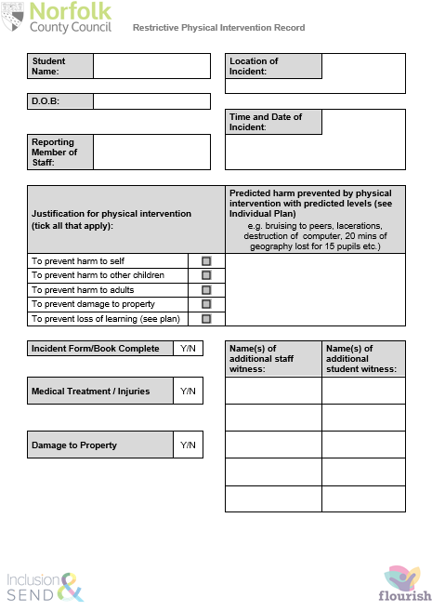
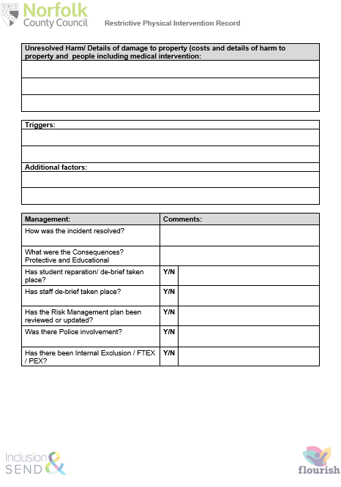

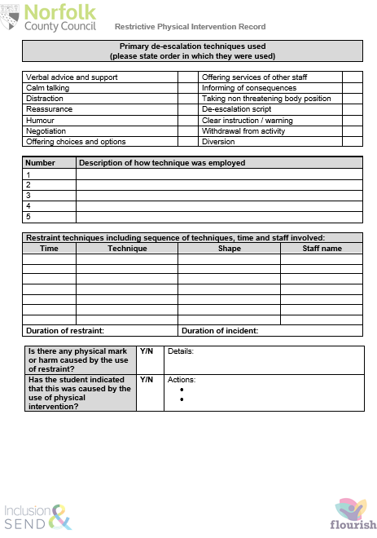

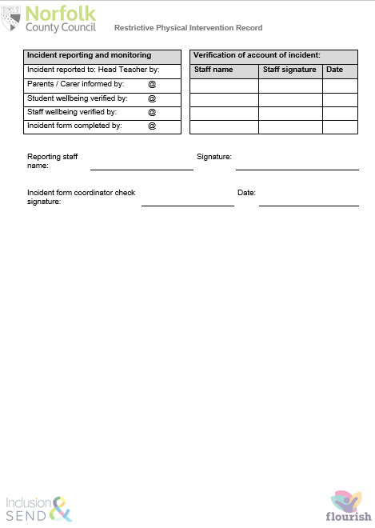

Appendix B – Post Incident Debrief (staff and students)
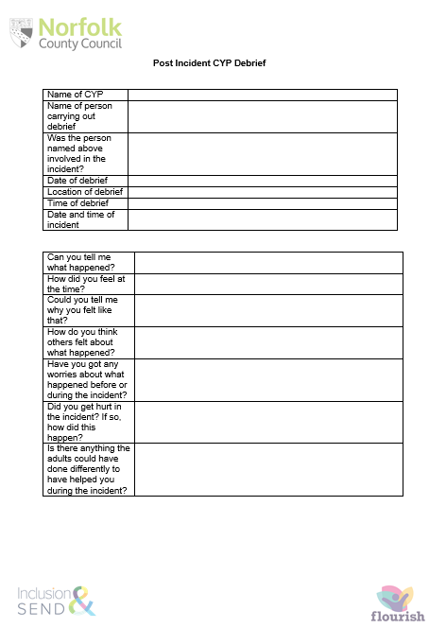
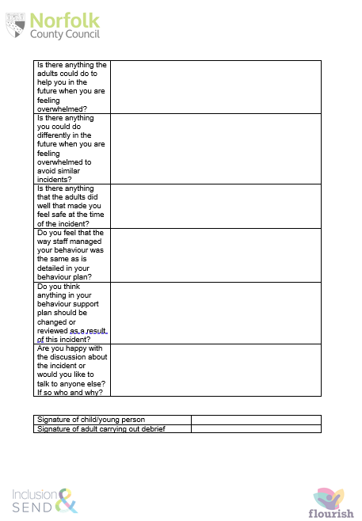

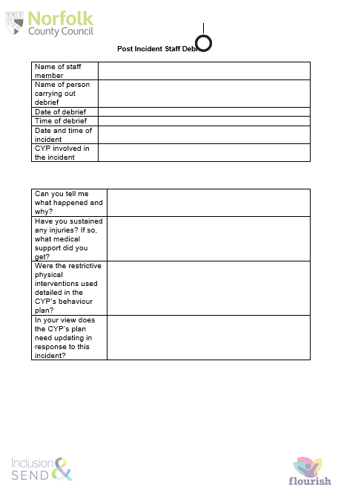

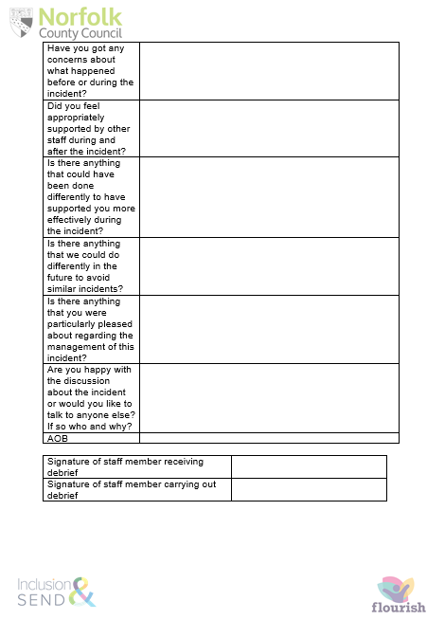

Appendix C – Parent Notification Form

Record of Restrictive Intervention

Following our phone call discussion regarding the incident where restrictive intervention was used, here is a record of restrictive intervention.

Time:
Date:
Location:
Duration:

Why was the intervention necessary? | To prevent harm to self,
Why was the intervention necessary? | To prevent harm to other students.
Why was the intervention necessary? | To prevent harm to adults.
Why was the intervention necessary? | To prevent damage to property.
Why was the intervention necessary? | Other…
What force was applied? | Hand holding, alternative to hand hold and shoulder hug
What force was applied? | Arm guide and arm hug
What force was applied? | 2 person paired arm hug
What force was applied? | Elbow Tuck and Lone Worker (Step Up Trained)
What force was applied? | 2 person figure of 4 (Step Up Trained)
What force was applied? | 2 person braced elbow (Step Up Trained)
What force was applied? | Shielded Escort (Step Up Trained)
Any physical injuries sustained (if applicable)
Did the child spend any time in seclusion?

Member(s) of staff who carried out the intervention:
Signed: Signed:

Norfolk Step Lead Professional:
Signed:

Member of SLT:
Signed:

Appendix D – Audit of Need

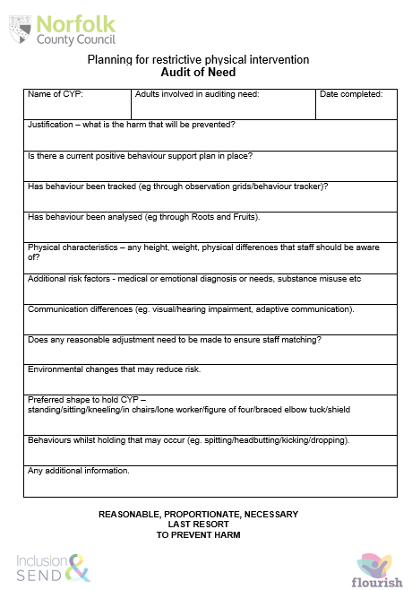

Appendix E– Risk Assessment Calculator

Name
DOB
Date of Assessment

Harm/Behaviour | Opinion  Evidenced  O/E | Conscious  Sub-conscious  C/S | Seriousness  Of Harm  A  1/2/3/4 | Probability  Of Harm  B  1/2/3/4 | Severity Risk  Score  A x B
Harm to self

Harm to peers

Harm to staff

Damage to property

Harm from disruption

Criminal offence

Harm from absconding
Other harm

Seriousness

1 | Foreseeable outcome is upset or disruption
2 | Foreseeable outcome is harm requiring first aid, distress or minor damage
3 | Foreseeable outcome is hospitalisation, significant distress, extensive damage
4 | Foreseeable outcome is loss of life or permanent disability, emotional trauma requiring counselling or critical property damage
Probability

1 | There is evidence of historical risk, but the behaviour has been dormant for over 12 months and no identified triggers remain
2 | The risk of harm has occurred within the last 12 months, the context has changed to make a reoccurrence unlikely
3 | The risk of harm is more likely than not to occur again
4 | The risk of harm is persistent and constant

Risks which score 6 or more (probability x seriousness) should have strategies listed on next page
Appendix F– Positive Behaviour Support Plan Guide
