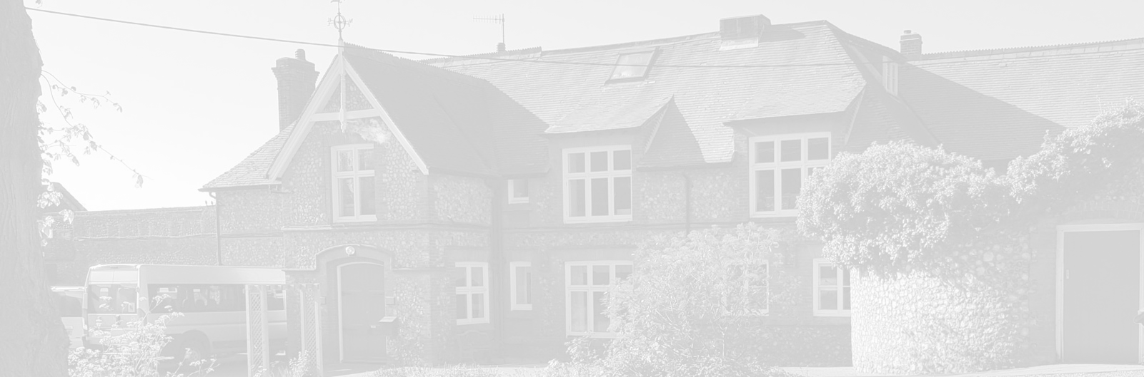
St Andrew’s School
A school with Quaker values

Aylmerton Hall Holt Road
Aylmerton Norfolk NR11 8QA
Telephone: 01263 837927
Email: office@standrewsschool.co.uk

Headteacher: Adrian Crossland
The St Andrew’s School Trust is a Registered Charity No. 1129232

SAFEGUARDING POLICY
INCORPORATING CHILD PROTECTION

Summary of changes

Page Ref | Section | Amendment | Date of change
6 | 3 | Removal of Deputy DSL due to member of staff leaving the school. | 06.01.2026

Adopted by Trustees date: 1st September 2025
Next review date: Autumn 2026

Policy Consultation & Review

This policy is available on our school website and is available on request from the school office. We also inform parents and carers about this policy when their children join our school and through our school newsletter.

We recognise the expertise our staff build by undertaking safeguarding training and managing safeguarding concerns on a daily basis and we therefore invite staff to contribute to and shape this policy and associated safeguarding arrangements.

The policy is provided to all staff at induction alongside our Staff Code of Conduct, Behaviour Policy and the safeguarding response to those pupils who are absent from education. In addition, all staff are provided with Part One of the statutory guidance ‘Keeping Children Safe in Education’, DfE (2025).

This policy will be reviewed in full by the Trustee Board on an annual basis. This policy was last reviewed and agreed by the Trustee Board in September 2025. It is due for review in September 2026

Signature: 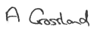 Headteacher Date: 1st September 2025

Signature : Michael Goodwin Chair of Trustees Date:1st September 2025

CONTENTS

 | - Purpose & Aims
 | - School Ethos
 | - Roles & Responsibilities
 | - Training & Induction
- Procedures for Managing Concerns

- Specific Safeguarding Issues
- Recording & Information Sharing

- Working with Parents & Carers
 | - Child Protection Conferences
 | - Safer Recruitment
 | - Safer Working Practice
12.Managing Allegations and Concerns
13. Other relevant policies
14. Statutory Framework

Appendices
1 | Recording form for reporting concerns
2 | Induction checklist for staff & volunteers
3 | Local Safeguarding Procedures
4 | Advice for schools, colleges and alternative education providers where there are concerns about an adult who works within the setting

1. PURPOSE & AIMS

1.1 The purpose of St Andrew’s School’s safeguarding policy is to ensure every child who is a registered pupil at our school is safe and protected from harm. This means we will always work to:
- Provide help and support to meet the needs of children and young people as soon as problems emerge.
- Protect children from maltreatment, whether that is within or outside the home, including online.
- Prevent impairment of our children’s and young people’s mental and physical health or development.
- Ensure that children and young people at our school grow up in circumstances consistent with the provision of safe and effective care.
- Undertake that role to enable children and young people at our school to have the best outcomes.

1.2 This policy will give clear direction to all staff including supply staff, volunteers, visitors and parents about expected behaviour and our legal responsibility to safeguard and promote the welfare of all children at our school.

1.3 Our school fully recognises the contribution it can make to protect children from harm and supporting and promoting the welfare of all children who are registered pupils at our school. The elements of our policy are prevention, protection and support.

1.4 We recognise that our safeguarding responsibilities are clearly linked to our responsibilities for ensuring that appropriate safeguarding responses are in place for children who are absent from school or who go missing from education, particularly for prolonged periods and/or on repeat occasions. The Attendance Lead will regularly liaise with the Designated Safeguarding Lead, to discuss all persistently absent pupils and those who go missing to identify the risk of abuse and neglect including sexual abuse or exploitation and to ensure that appropriate safeguarding responses have been put in place to reduce the risk of future harm.

1.5 This policy applies to all pupils, staff, parents, trustees, volunteers and visitors.

2. OUR ETHOS

2.1 The child’s welfare is of paramount importance. Our school will establish and maintain an ethos where pupils feel secure, are encouraged to talk, are listened to and are safe. Children at our school will be able to talk freely to any member of staff at our school if they are worried or concerned about something. All staff will reassure victims that they are being taken seriously and that they will be supported and kept safe. Victims will never be given the impression that they are creating a problem by reporting abuse, sexual violence or sexual harassment.

2.2 Everyone who comes into contact with children and their families has a role to play in safeguarding children. We recognise that staff at our school play a particularly important role as they are in a position to identify concerns early and provide help for children to prevent concerns from escalating. All staff are advised to maintain an attitude of ‘it could happen here’ where safeguarding is concerned. When concerned about the welfare of a child, staff members must always act in the best interests of the child.

2.3 At St Andrew’s School we ensure that safeguarding and child protection is at the forefront and underpin all relevant aspects of process and policy development. We operate with the best interests of the child at their heart.
2.4 Where there is a safeguarding concern, the child’s wishes and feelings are taken into account when determining what action to take and what services to provide. The systems we have in place are well promoted, easily understood and easily accessible for children to confidently report abuse, knowing their concerns will be treated seriously, and knowing they can safely express their views and give feedback.

2.5 All staff and regular visitors will, through training and induction, know how to recognise indicators of concern, how to respond to a disclosure from a child and how to record and report this information. We will not make promises to any child, and we will not keep secrets. Every child will know what the adult will have to do with any information they have chosen to disclose. All staff will be trained to recognise that children may not feel ready or know how to tell someone that they are being abused, exploited, or neglected, and/or they may not recognise their experiences as harmful.

2.6 Throughout our broad and balanced curriculum, we will provide activities and opportunities for children to develop the knowledge, values and skills they need to identify risks, including knowing when and how to ask for help for themselves and others to stay safe (this includes online). The Relationships Education, Relationships and Sex Education and Health Education (delivered in regularly timetabled lessons and reinforced throughout the whole curriculum) will cover relevant topics in an age and stage appropriate way, enabling pupils to learn about their rights and responsibilities to behave and stay safe in a variety of contexts on and offline. This will provide further reinforcement to help children identify risks, know when to seek support and develop the skills to ask for help from trustworthy, reliable sources. We achieve this by:

Ensuring that students are fully involved in risk assessments which are discussed before any offsite trip, helping them to understand the risks and importance of listening and adhering to instruction when away from the school. We invite the local Police to attend the school on occasions to discuss online safety, anti-bullying, Child Exploitation and Online protection issues (CEOP) and the role of Police in society. The different aspects of Safeguarding are embedded throughout the curriculum, regularly reinforcing the message of safety and protection.

Further information can be found in the DfE guidance ‘Teaching online safety in school’ and ‘Relationships Education, Relationships and Sex Education and Health Education’ This education is underpinned by the school’s behaviour policy and pastoral support system.

2.7 At all times we will work in partnership and endeavour to establish effective working relationships with parents, carers and colleagues from other agencies in line with Working Together to Safeguard Children (2023) and the Norfolk Multi Agency Safeguarding Partnership arrangements.

2.8 As part of our responsibilities for safeguarding and promoting the welfare of children, we will provide a co-ordinated offer of early help when additional needs of children are identified. These may include if a child:
- is disabled or has certain health conditions and has specific additional needs
- has special educational needs (whether or not they have a statutory education, health and care plan)
- has a mental health need
- is a young carer
- is showing signs of being drawn in to anti-social or criminal behaviour, including gang involvement and association with organised crime groups or county lines
- is frequently missing/goes missing from education, care or from home
- has experienced multiple suspensions, is at risk of being permanently excluded from schools, colleges and in Alternative Provision or a Pupil Referral Unit
- is at risk of modern slavery, trafficking or sexual and/or criminal exploitation
- is at risk of being radicalised or exploited
- has a parent or carer in custody, or is affected by parental offending
- is in a family circumstance presenting challenges for the child, such as drug and alcohol misuse, adult mental health issues and domestic abuse
- is misusing drugs or alcohol themselves
- is at risk of ‘honour’-based abuse such as Female Genital Mutilation or Forced Marriage
- is a privately fostered child

2.9 At St Andrew’s School we understand the importance of working in a way that adheres to the following legislation:
- The Human Rights Act 1998
- Equality Act 2010
- Public Sector Equality Duty
- Data Protection Act 2018 and UK GDPR
This means we do not unlawfully discriminate against pupils because of their sex, race, disability, religion or belief, gender reassignment, pregnancy and maternity, or sexual orientation (protected characteristics).

3. ROLES AND RESPONSIBILITIES

Role | Name | Contact details
Designated Safeguarding Lead (DSL) | Carol McKean | 01263 837927
Mental Health Lead | Carol McKean | 01263 837927
Deputy DSL | Adrian Crossland  Jim Collin | 01263 837927
Headteacher | Adrian Crossland | 01263 837927
Named Safeguarding Trustee | Sue Brisbane | 01263 837927
Co- Chairs of Trustees | Michael Goodwin & Jenny Meara | 01263 837927

3.1 It is the responsibility of every member of staff, volunteer and regular visitor to our school to ensure that they carry out the requirements of this policy and, at all times, work in a way that will safeguard and promote the welfare of all of the pupils at this school. This includes the responsibility to provide a safe environment in which children can learn.

The Trustee Board

3.2 The Trustee Board of St Andrew’s School is accountable for ensuring the effectiveness of this policy and our compliance with it. Although our Trustee Board takes collective responsibility to safeguard and promote the welfare of our pupils, we also have a named trustee who champions safeguarding within the school.

3.3 The Trustee Board will ensure that:

- The safeguarding policy is in place, is reviewed annually, is available publicly via our school website and has been written in line with Local Authority guidance and the requirements of the Norfolk Safeguarding Children Partnership policies and procedures.

- The school contributes to inter-agency working in line with Working Together to Safeguard Children (2023).

- A named Safeguarding Trustee is appointed.

- A senior member of staff from leadership team is designated to take the lead responsibility for safeguarding and child protection and that there is at least one deputy DSL(s) who is appropriately trained member to deal with any issues in the absence of the Designated Safeguarding Lead (DSL). There will always be cover for this role. The role will be evidenced explicitly in the role holder’s job description.

- All staff receive a safeguarding induction and are provided with a copy of this policy, the staff code of conduct, the behaviour policy and the school’s safeguarding response for those pupils who are absent from education as detailed in section 6 of this policy.

- All staff undertake appropriate child protection training that is updated annually and online safety training.

- In terms of filtering and monitoring there is consideration to the number of and age range of children, those who are potentially at greater risk of harm and how often they access the IT system along with the proportionality of costs versus safeguarding risks.

- Procedures are in place for dealing with allegations against members of staff and volunteers in line with statutory guidance.

- Safer recruitment practices are followed in accordance with the requirements of ’Keeping Children Safe in Education’ DfE (2025);

- They remedy without delay any weakness in regard to our safeguarding arrangements that are brought to their attention.

3.4 The Trustee Board will receive a safeguarding report at each meeting that will record the training that has taken place, the number of staff attending and any outstanding training requirements for the school. It will also record all safeguarding activity that has taken place, for example, meetings attended, reports written, training or induction given. It will not identify individual pupils.

The Headteacher

3.5 At St Andrew’s School the Headteacher is responsible for:

- Identifying a senior member of staff from leadership team to be the Designated Safeguarding Lead (DSL).
- Identifying alternate members of staff to act as the Designated Safeguarding Lead (DSL) in her absence to ensure there is always cover for the role.
- Ensuring that the policies and procedures adopted by the Trustee Board, particularly concerning referrals of cases of suspected abuse, neglect or exploitation, are followed by all staff.
- Ensuring that all staff and volunteers feel able to raise concerns about poor or unsafe practice and such concerns are addressed sensitively in accordance with agreed whistle-blowing procedures.
- Liaise with the LADO in the event of an allegation of abuse being made against a member of staff or volunteer.

The Designated Safeguarding Lead (DSL)

  - The Designated Safeguarding Lead is a senior member of staff, from the
leadership team who takes lead responsibility for safeguarding and child protection within our school. The DSL will carry out their role in accordance with the responsibilities outlined in Annex C of ‘Keeping Children Safe in Education’.

  - The DSL will provide advice and support to other staff on child welfare and
child protection matters. Any concern for a child’s safety or welfare will be recorded in writing and given to the DSL.

  - During term time the Designated Safeguarding Lead and or a deputy will
always be available (during school or college hours) for staff in the school or college to discuss any safeguarding concerns. If in exceptional circumstances, a DSL is not available on the school site in person, we will ensure that they are available via telephone and/or any other relevant media.

3.9 The DSL at St Andrew’s School will represent our school at child protection conferences and core group meetings. Through appropriate training, knowledge and experience our DSL will liaise with Children’s Services and other agencies where necessary, and make referrals of suspected abuse to Children’s Services, take part in strategy discussions and other interagency meetings and contribute to the assessment of children.

3.10 The DSL will maintain records and child protection files ensuring that they are kept confidential and stored securely (see section 7 for more information.)

3.11 The DSL is responsible for ensuring that all staff members and volunteers are aware of our policy and the procedure they need to follow. They will ensure that all staff, volunteers and regular visitors have received appropriate child protection information during induction and have been trained within the school to the agreed school’s safeguarding training package provided by Children’s Services.

3.12 The DSL will obtain details of the Local Authority Personal Advisor appointed to guide and support a child who is a care leaver.

3.13 The DSL(s) will work with the headteacher and senior leaders, taking lead responsibility for promoting educational outcomes by knowing the welfare, safeguarding and child protection issues that children in need are experiencing, or have experienced, and identifying the impact that these issues might be having on children’s attendance, engagement and achievement.

3.14 This will include understanding their academic progress and attainment and maintaining a culture of high aspirations for this cohort and supporting teaching staff to provide additional academic support or reasonable adjustments to help children who have or have had a social worker reach their potential.

3.15 We recognise that a child’s experiences of adversity and trauma can leave them vulnerable to further harm, as well as educationally disadvantaged in facing barriers to attendance, learning, behaviour, and mental health. The DSL will use the information that they hold about children with a social worker to make decisions in the best interests of the child’s safety, welfare and help promote educational outcomes. The DSL will ensure that staff, know who these children are, understand their academic progress and attainment and maintain a culture of high aspirations for this cohort; supporting teaching staff to identify the challenges that children in this group might face and the additional academic support and adjustments that they could make to best support these children.

3.16 The DSL will take the lead responsibility for understanding the filtering and monitoring systems and processes in place at the school.

4. TRAINING & INDUCTION

4.1 When new staff join our school they will be informed of the safeguarding arrangements in place. They will be given a copy of our school’s safeguarding policy along with the staff code of conduct, Part one and/or Annex A of ‘Keeping Children Safe in Education’ and told who our Designated Safeguarding Lead (DSL) and Deputy DSLs are. They will also receive a copy of the behaviour policy and the school’s response to children who are absent from education – this information is included in section 6 of this policy. All staff are expected to read these key documents. They will also be provided with information about how to record and report safeguarding concerns on the electronic CPOMs system used within the school and who to pass these concerns on to.

4.2 Every new member of staff or volunteer will receive safeguarding training during their induction period within the first week of joining the school. This programme will include information relating to signs and symptoms of abuse, how to manage a disclosure from a child (including reassuring victims that they are being taken seriously and that they will be supported and kept safe), how to record, the processes for referral to Children’s Services and the statutory assessments under Section 17 and Section 47 as well as the remit of the role of the Designated Safeguarding Lead (DSL). The training will also include information about whistleblowing in respect of concerns about another adult’s behaviour and suitability to work with children. Staff will also receive online safety training, including understanding the expectations, applicable roles, and responsibilities in relation to filtering and monitoring as this is part of the overarching safeguarding approach of our school.

4.3 In addition to the safeguarding induction, we will ensure that mechanisms are in place to assist staff to understand and discharge their role and responsibilities as set out in Part one of ‘Keeping Children Safe in Education’. In order to achieve this, we will ensure that:
- all members of staff will undertake appropriate safeguarding training on an annual basis, and we will evaluate the impact of this training.
- all staff members receive regular safeguarding and child protection updates (for example, via email, e-bulletins, staff meetings), as required, but at least annually, to provide them with relevant skills and knowledge to safeguard children effectively.
- all staff will receive some form of safeguarding training at least termly; this may be undertaken during in–service training (INSET) days or during twilight sessions. The content of the training may be determined by current safeguarding issues that students may be facing and / or guided by results from the Core training evaluation forms.

4.4 All regular visitors, temporary staff and volunteers to our school will be given a set of our safeguarding procedures; they will be informed of whom our DSL and alternate DSL members are and what the recording and reporting system is. (See Appendix 2). They will be given a visitors’ badge, which has the DSL details on the back, and on their first visit to the school they will receive a leaflet documenting the safeguarding procedures in place at the school and what to do if they have any concerns. They will also be informed and reminded by posters and leaflets about the use of mobile devices whilst on the school premises.

4.5 The DSL, the alternate designated member(s) of staff and any other senior member of staff who may be in a position of making referrals or attending child protection conferences or core groups will attend one of the multi-agency training courses organised by Norfolk Safeguarding Children’s Partnership at least once every three years. The DSL and alternate(s) will attend Designated Safeguarding Lead (DSL) training provided by the Local Authority every two years. In addition to formal training, DSLs will ensure that they update their knowledge and skills at regular intervals, but at least annually, to keep up with any developments relevant to their role. This will be achieved by means of Management Information Sheets from the Local Authority, attendance at DSL’s forum meetings / training sessions and webinars, Conferences, Mental Health and Domestic Abuse update training and other continued professional development opportunities.

4.6 Our Trustee Board will also undertake appropriate training to equip them with the knowledge to provide strategic challenge to test and assure themselves that the safeguarding policies and procedures in place are effective and support the delivery of a robust whole school approach to safeguarding. This training takes place at induction and is updated regularly.
Training for trustees to support them in their safeguarding role is available from Norfolk Governor Services.

4.7 We actively encourage all our staff to keep up to date with the most recent local and national safeguarding advice and guidance, Annex B of ‘Keeping Children Safe in Education’ (2025) provides links to guidance on specific safeguarding issues such as Child Exploitation and Female Genital Mutilation. In addition, local guidance can be accessed via Norfolk Safeguarding Children Partnership and within the Safeguarding Toolkit on the Norfolk Schools and Learning Providers website.

5. PROCEDURES FOR MANAGING CONCERNS

5.1 St Andrew’s School adheres to child protection procedures that have been agreed locally through the Norfolk Safeguarding Children Partnership. Where we identify children and families in need of support, we will carry out our responsibilities in accordance with Norfolk Local Assessment Protocol and the Norfolk Continuum of Need Guidance.

5.2 Every member of staff including volunteers working with children at our school are advised to maintain an attitude of ‘it could happen here’ where safeguarding is concerned. When concerned about the welfare of a child, staff members should always act in the interests of the child and have a responsibility to take action as outlined in this policy.

5.3 All staff are encouraged to report any concerns that they have and not see these as insignificant. On occasions, a referral is justified by a single incident such as an injury or disclosure of abuse. More often however, concerns accumulate over a period of time and are evidenced by building up a picture of harm over time; this is particularly true in cases of emotional abuse and neglect. In these circumstances, it is crucial that staff record and pass on concerns in accordance with this policy immediately to allow the DSL to build up a picture and access support for the child at the earliest opportunity. A reliance on memory without accurate and contemporaneous records of concern could lead to a failure to protect.

5.4 It is not the responsibility of school staff to investigate welfare concerns or determine the truth of any disclosure or allegation. All staff, however, have a duty to recognise concerns and pass the information on in accordance with the procedures outlined in this policy.

5.5 The Designated Safeguarding Lead (DSL) should be used as a first point of contact for concerns and queries regarding any safeguarding concern in our school. Any member of staff or visitor to the school who receives a disclosure of abuse or suspects that a child is at risk of harm must report it immediately to the DSL or, if unavailable, to the alternate designated person. In the absence of either of the above, the matter should be brought to the attention of the most senior member of staff.

5.6 All concerns about a child or young person should be reported without delay and recorded in writing using the agreed system in the setting (see Appendix 1 for suggested template). Records should include:
• a clear and comprehensive summary of the concern
• details of how the concern was followed up and resolved
• a note of any action taken, decisions reached and the outcome

5.7 Following receipt of any information raising concern, the DSL will consider what action to take and seek advice from the Norfolk Children’s Advice & Duty Service (CADS) as required. All information and actions taken, including the reasons for any decisions made, will be fully documented.

5.8 All referrals will be made in line with Norfolk Children’s Services procedures as outlined in Appendix 3.

5.9 If, at any point, there is a risk of immediate serious harm to a child a referral should be made to Norfolk CADS immediately. Anybody can make a referral in these circumstances. If the child’s situation does not appear to be improving the staff member with concerns should press for re-consideration by raising concerns again with the DSL and/or the Headteacher. Concerns should always lead to help for the child at some point.

5.10 Staff should always follow the reporting procedures outlined in this policy in the first instance. However, they may also share information directly with Norfolk CADS, or the police if:

- the situation is an emergency and the designated senior person, their alternate and the Headteacher are all unavailable.
- they are convinced that a direct report is the only way to ensure the pupil’s safety.

5.11 Any member of staff who does not feel that concerns about a child have been responded to appropriately and in accordance with the procedures outlined in this policy should raise their concerns with the Headteacher or the Chair of Trustees. If any member of staff does not feel the situation has been addressed appropriately at this point should contact Norfolk CADS directly with their concerns.

6. SPECIFIC SAFEGUARDING ISSUES

Contextual safeguarding
6.1 At St Andrew’s School we recognise that safeguarding incidents and/or behaviours can be associated with factors outside of the school environment and/or can occur between children outside of the school. This is known as contextual safeguarding. It is key that all school staff understand the definition of contextual safeguarding and consider whether children are at risk of abuse or exploitation in situations outside their families. Through training we will ensure that staff and volunteers are aware that extra-familial harms take a variety of different forms and children can be vulnerable to multiple harms including (but not limited to) sexual exploitation, criminal exploitation, and serious youth violence. When reporting concerns, staff should include as much information and background detail as possible so the DSL can make a referral with a holistic view of the child. This will allow any assessment to consider all the available evidence and the full context of any abuse.

6.2 We recognise that children with special educational needs and/or disabilities (SEND) can face additional safeguarding challenges, and these are discussed in staff training. These additional barriers can include:
- assumptions that indicators of possible abuse such as behaviour, mood and injury relate to the child’s disability without further exploration.
- children with SEN and disabilities can be disproportionally impacted by things like bullying - without outwardly showing any signs; and
- communication barriers and difficulties in overcoming these barriers.

6.3 At St Andrew’s School we recognise that a previously looked after child potentially remains vulnerable and all staff should have the skills, knowledge and understanding to keep previously looked after children safe. When dealing with looked after children and previously looked after children, it is important that all agencies work together, and prompt action is taken when necessary to safeguard these children, who are a particularly vulnerable group.

Child Sexual Exploitation (CSE), Child Criminal Exploitation (CCE): County Lines and serious violence

6.4 At St Andrew’s School we train staff to recognise that both CSE and CCE are forms of abuse and both occur where an individual or group takes advantage of an imbalance in power to coerce, manipulate or deceive a child into sexual or criminal activity. Whilst age may be the most obvious, this power imbalance can also be due to a range of other factors including gender, sexual identity, cognitive ability, physical strength, status, and access to economic or other resources. Victims can be exploited even when activity appears consensual, and it should be noted exploitation as well as being physical can be facilitated and/or take place online.

6.5 At St Andrew’s School we recognise that Child Sexual Exploitation is a form of child sexual abuse, and this imbalance of power coerces, manipulates or deceives a child or young person into sexual activity (a) in exchange for something the victim needs or wants, and/or (b) for the financial advantage or increased status of the perpetrator. Child sexual exploitation does not always include physical contact; it can also occur through the use of technology. We understand that some children may not realise they are being exploited e.g. they may believe they are in a genuine romantic relationship.

6.6 At St Andrew’s School we understand that criminal exploitation of children is a geographically widespread form of harm that is a typical feature of county lines criminal activity. Drug networks or gangs groom and exploit children and young people to carry drugs and money from urban areas to suburban and rural areas, market and seaside towns. Key to identifying potential involvement in county lines are missing episodes, when the victim may have been trafficked for the purpose of transporting drugs.

6.7 We understand that children can become trapped by this type of exploitation as perpetrators can threaten victims (and their families) with violence or entrap and coerce them into debt. They may be coerced into carrying weapons such as knives or begin to carry a knife for a sense of protection from harm from others. We will treat these children as victims understanding that they have been criminally exploited even if the activity appears to be something they have agreed or consented to. We recognise the experience of girls who are criminally exploited can be very different to that of boys and that both boys and girls being criminally exploited may be at higher risk of sexual exploitation.

6.8 At St Andrew’s School staff are aware of the indicators and risk factors which may signal a child is vulnerable to or involved with serious violent crime. We make reference to the Home Office’s Preventing youth violence and gang involvement, and Criminal exploitation of children and vulnerable adults: county lines and the Children’s Society Preventing Child Sexual Exploitation guidance for more information.

6.9 If a child is suspected to be at risk exploitation or involvement in county lines, a referral to the Children’s Advice and Duty Service (CADS) will be made alongside consideration of availability of local services/third sector providers who offer support to victims of county lines exploitation.

So-called ‘honour-based abuse (including Female Genital Mutilation and Forced Marriage)
6.10 At St Andrew’s School we recognise that our staff are well placed to identify concerns and take action to prevent children from becoming victims of Female Genital Mutilation (FGM) and other forms of so-called ‘honour-based’ abuse (HBA) and provide guidance on these issues through our safeguarding training. If staff have a concern regarding a child that might be at risk of HBA, they should inform the DSL who will activate local safeguarding procedures, using existing national and local protocols for multiagency liaison with police and children’s social care.

6.11 Where FGM has taken place, since 31 October 2015 there has been a mandatory reporting duty placed on teachers. Section 5B of the Female Genital Mutilation Act 2003 (as inserted by section 74 of the Serious Crime Act 2015) places a statutory duty upon teachers in England and Wales, to report to the police where they discover (either through disclosure by the victim or visual evidence) that FGM appears to have been carried out on a girl under 18. Those failing to report such cases will face disciplinary sanctions. We will provide guidance and support to our teachers on this requirement and further information on when and how to make a report can be found in the following Home Office guidance: Mandatory Reporting of Female Genital Mutilation- procedural information Home Office (January 2020).

6.12 At St Andrew’s School we recognise that forcing a person into a marriage is a crime in England and Wales. A forced marriage is one entered into without the full and free consent of one or both parties where violence, threats or any other form of coercion is used to cause a person to enter into a marriage. Threats can be physical or emotional and psychological. Since February 2023 it has also been a crime to carry out any conduct whose purpose is to cause a child to marry before their eighteenth birthday, even if violence, threats or another form of coercion are not used. The Forced Marriage Unit has statutory guidance and Multi-agency guidelines and can be contacted for advice or more information: Contact 020 7008 0151 or email fmu@fco.gov.uk

Preventing radicalisation and extremism

6.13 We recognise that safeguarding against radicalisation and extremism is no different to safeguarding against any other vulnerability in today’s society. At St Andrew’s School, we will ensure that:
- Through training, staff, volunteers and trustees have an understanding of what radicalisation and extremism is, why we need to be vigilant in school and how to respond when concerns arise.
- There are systems in place for keeping pupils safe from extremist material when accessing the internet in our school by using effective filtering and monitoring policies.
- The DSL has received Prevent training and will act as the point of contact within our school for any concerns relating to radicalisation and extremism.
- The DSL will make referrals in accordance with Norfolk Channel Procedures and will represent our school at Channel meetings as required.
- Through our curriculum, we will promote the spiritual, moral, social and cultural development of pupils.

Child on child sexual violence and sexual harassment

6.14 At St Andrew’s School all staff are trained so that they are aware that safeguarding issues can manifest themselves via child-on-child abuse. This is most likely to include, but may not be limited to:
- bullying (including cyberbullying).
- physical abuse such as hitting, kicking, shaking, biting, hair pulling, or otherwise causing physical harm.
- sexual violence and sexual harassment.
- upskirting.
- sexting (also known as youth produced sexual imagery); and
- initiation/hazing type violence and rituals.

6.15 We recognise that children are vulnerable to physical, sexual and emotional abuse by other children or siblings. Abuse perpetrated by children can be just as harmful as that perpetrated by an adult, so it is important that all staff and volunteers remember the impact on both the victim of the abuse as well as to focus on the support for the child or young person exhibiting the harmful behaviour. We understand that abuse can occur in intimate personal relationships between children; and that consensual and non-consensual sharing of nudes and semi-nude images and or videos (also known as sexting or youth produced sexual imagery) is a form of child-on-child abuse.

6.16 We understand, that even if there are no reports in our setting it does not mean it is not happening, it may be the case that it is just not being reported. We recognise that pupils may not find it easy to tell staff about their abuse and can show signs or act in ways that they hope adults will notice and react to. In some cases, the victim may not make a direct report, and this may come from a friend or a conversation that is overheard. Such abuse will always be taken as seriously as abuse perpetrated by an adult and the same safeguarding children procedures will apply in respect of any child who is suffering or likely to suffer significant harm. Staff must never tolerate or dismiss concerns relating to child-on-child abuse and they will always challenge this. It must never be tolerated or passed off as ‘banter’, ‘just having a laugh’ or ‘part of growing up’. Doing this can lead to a culture of unacceptable behaviours, an unsafe environment for children and in worst case scenarios a culture that normalises abuse leading to children accepting it as normal and not coming forward to report it.

6.17At St Andrew’s School we regularly review decisions and actions, and relevant policies are updated to reflect any lessons learnt. We look out for potential patterns of concerning, problematic or inappropriate behaviour. Where a pattern is identified, we decide upon an appropriate course of action.

6.18 At St Andrew’s School all staff will reassure victims that they are being taken seriously and that they will be supported and kept safe. Victims will never be given the impression that they are creating a problem by reporting abuse, sexual violence or sexual harassment. Nor will a victim ever be made to feel ashamed for making a report. We will also offer appropriate support to the perpetrator and any other children involved.

6.19 All staff will understand that they should follow our safeguarding procedures for reporting a concern if they are worried about child-on-child abuse. The DSL will respond to any concerns related to child-on-child abuse in line with guidance outlined in Part five of ‘Keeping Children Safe in Education.’ We will ensure that all concerns, discussions and decisions reached are clearly recorded and any identified actions are followed up.

6.20 We will work with other agencies including the police and Children’s Social Care, as required to respond to concerns about sexual violence and harassment. We will seek consultations where there are concerns or worries about developmentally inappropriate or harmful sexual behaviour from the Harmful Sexual Behaviour (HSB) Team as required so that we ensure we are offering the right support to the child(ren).

6.21 Support will depend on the circumstances of each case and the needs of the child, it may include completion of risk assessments to support children to remain in school whilst safeguarding other children and the victim, delivery of early intervention in respect of HSB and/or referral to The Harbour Centre Sexual Assault Referral Centre (SARC) where a pupil discloses a rape, an attempted rape or a serious sexual assault whether this has happened recently or in the past. The assault does not have to have taken place in Norfolk but the victim must live in Norfolk to access support. The SARC also has a 24/7 helpline 01603 276381 if pupils or staff need to speak to a Crisis Worker for help & advice. Referral forms can be found on The Harbour Centre website. The DSL will always contact the police in cases of rape and serious sexual assault as per the guidance When to call the Police: a guide for schools and colleges, National Police Chiefs Council.

Modern Slavery

6.22 At St Andrew’s School we understand that modern slavery encompasses human trafficking and slavery, servitude and forced or compulsory labour. Exploitation can take many forms, including sexual exploitation, forced labour, slavery, servitude, forced criminality and the removal of organs. We refer to the DfE guidance Modern slavery: how to identify and support victims for concerns of this nature. for concerns of this nature.

Safeguarding responses to children who are absent from education

6.23 At St Andrew’s School we adhere to the ‘Working Together to Improve School Attendance’ (2024) guidance. All staff should be aware of their safeguarding responsibilities for children who are absent from education, particularly on repeat occasions, or for prolonged periods, to help identify the risk of abuse and neglect, including sexual abuse or exploitation, and to help prevent the risks of them going missing in future.

6.24 At St Andrew’s School we adhere to the following procedures and processes to ensure there is an appropriate safeguarding response to children who are absent from education:
- An attendance register is taken at the start of the first session of each school day and once during the second session.
- We make every effort to contact parents and carers and follow up with the emergency contacts held.
- We hold at least two emergency contact numbers for each of the pupils on our roll wherever possible.
- Staff will alert DSLs to any concerns raised regarding children who are absent from school.
- The DSLs will meet regularly with the Attendance Lead, SENCo and other members of the pastoral team to ensure that each response is thorough and takes into account all the relevant information about individual children.
- We will follow the procedures outlined in our attendance policy including undertaking first day calling and monitoring data to ensure we intervene early in cases of poor attendance and/or unexplained absences.
- We understand that we remain responsible for the safeguarding of all pupils who are placed in an alternative provision.
- When removing a child from roll at the standard and non-standard transition points, we will inform the Local Authority in accordance with statutory requirements and pass on all safeguarding files.

We will arrange to have weekly welfare checks, either in person or via online technology, to actually see and maintain contact with any student unable to attend school for a prolonged period of time, as per our Safeguarding responsibility for each student on our school roll. Unannounced home welfare checks may also take place.

Mental Health
6.25 At St Andrew’s School all staff are made aware, through training, that mental health problems can, in some cases, be an indicator that a child has suffered or is at risk of suffering abuse, neglect or exploitation. Our staff are well placed to observe children day-to-day and identify those whose behaviour suggests that they may be experiencing a mental health problem or be at risk of developing one.

6.26 We understand that where children have suffered abuse, neglect or exploitation, or other potentially traumatic adverse childhood experiences, this can have a lasting impact throughout childhood, adolescence and into adulthood. Therefore, through training, staff are aware of how children’s experiences can impact on their mental health, behaviour and education. All staff are aware that if they have a mental health concern about a child that is also a safeguarding concern, they should take immediate action by passing the information on to a Designated Safeguarding Lead.

6.27 At St Andrew’s School we have a named Mental Health Lead. There are clear systems and processes in place for identifying possible mental health problems and work with other agencies as required to respond to these concerns. Designated Safeguarding Leads make reference to the ‘Mental Health and Behaviour in Schools’ DfE guidance for further support.

Online Safety
6.28 At St Andrew’s School all staff are aware that technology is a significant component in many safeguarding and wellbeing issues. Children are at risk of abuse online as well as face to face. We understand that in many cases abuse will take place concurrently via online channels and in daily life. We know that children can also abuse other children online, this can take the form of abusive, harassing, and misogynistic messages, the non-consensual sharing of indecent images, especially around chat groups, and the sharing of abusive images and pornography.

6.29 As part of the requirement for staff to undergo regular updated safeguarding training, online safety training is also delivered. We will ensure online safety is a running and interrelated theme throughout the curriculum and is reflected in relevant policies, teacher training, the role and responsibilities of the Designated Safeguarding Lead and any parental engagement.

6.30 At St Andrew’s School we adhere to the DFE guidance on filtering and monitoring of technology use within the school and work closely with our IT partner (Anglia Computer Solutions) to ensure that appropriate blocks and filters are in place to protect our students. More details can be found in our policies on Online Safety and Mobile and Smart Technology which consider the 4Cs, content, contact, conduct and commerce and reflect the fact that many children have unlimited and unrestricted access to the internet via mobile phone networks (i.e. 3G, 4G and 5G).

6.31 At St Andrew’s School we recognise that technology, and risks and harms related to the internet evolve and change rapidly. Therefore, we carry out an annual review of our approach to online safety, supported by a risk assessment (on at least an annual basis) that considers and reflects the risks that children face in our setting. We also communicate with parents and carers to reinforce the importance of children being safe online.

Cybercrime
6.32 We understand that cybercrime is criminal activity committed using computers and/or the internet. It is broadly categorised as either ‘cyber-enabled’ (crimes that can happen off-line but are enabled at scale and at speed on-line) or ‘cyber dependent’ (crimes that can be committed only by using a computer). We are aware of the Cyber security standards for schools and colleges.GOV.UK and the guidance from the National Education Network.

6.33 If there are concerns about a child in this area, the Designated Safeguarding Lead will consider a referral to the Cyber Choices programme which aims to intervene where young people are at risk of committing, or being drawn into, low level cyber-dependent offences and divert them to a more positive use of their skills and interests. It aims to intervene where young people are at risk of committing, or being drawn into, low level cyber-dependent offences and divert them to a more positive use of their skills and interests.

Domestic Abuse

6.34 At St Andrew’s School all staff are aware that domestic abuse can encompass a wide range of behaviours and may be a single incident or a pattern of incidents. That abuse can be, but is not limited to, psychological, physical, sexual, financial or emotional. We understand that children can be victims of domestic abuse. Where they see, hear or experience the effects this can have a detrimental and long-term impact on their health, well-being, development, and ability to learn. We are aware of the Norfolk Integrated Domestic Abuse Service (NIDAS) and signpost victims to the service. Norfolk and Suffolk Victim Care are available to offer support where threshold for NIDAS support has not been met.

Children with special educational needs and disabilities or physical health issues

6.35 At St Andrew’s School we recognise that children with special educational needs or disabilities (SEND) or certain health conditions can face additional safeguarding challenges such as
  - assumptions that indicators of possible abuse such as behaviour, mood and injury relate to the child’s condition without further exploration.
  - these children being more prone to peer group isolation or bullying (including prejudice-based bullying) than other children.
  - the potential for children with SEND or certain medical conditions being disproportionally impacted by behaviours such as bullying, without outwardly showing any signs; and
  - communication barriers and difficulties in managing or reporting these challenges.

6.36 We work to address these additional challenges and consider extra pastoral support and attention for these children, along with ensuring any appropriate support for communication is in place.

6.37 At St Andrew’s School we also recognise that pupils who attend Alternative Provision will often have complex needs and due to this we are aware of the additional risk of harm these children may be vulnerable to.

Children who are lesbian, gay, bisexual or questioning their gender

6.38 The fact that a child or a young person may be lesbian, gay, bisexual or questioning their gender is not in itself an inherent risk factor for harm. However, in line with ‘Keeping Children Safe in Education’, we recognise that these children and in some cases children who are perceived by other children to be lesbian, gay or bisexual can be just as vulnerable as children who are. Therefore, we work to reduce any additional barriers faced and provide a safe space for these children to speak out or share their concerns with members of staff. Through our curriculum, we counter homophobic, biphobic and transphobic bullying and abuse.

7. RECORDS AND INFORMATION SHARING

7.1 If staff are concerned about the welfare or safety of any child at our school, they will record their concern either on the agreed reporting form (Appendix 1) or through the setting’s electronic system known as CPOMs. Any concerns should be passed to the DSL without delay.

7.2 Any information recorded will be kept in a separate named file, in a secure cabinet if a paper system is used and not with the child’s academic file. These files will be the responsibility of the DSL. Child protection information will only be shared within school on the basis of ‘need to know in the child’s interests’ and on the understanding that it remains strictly confidential.

7.3 Child protection information will be kept up to date. Each concern logged will include:
  - a clear and comprehensive summary of the concern.
  - details of how the concern was followed up and resolved.
  - a note of any action taken, decisions reached and the outcome.
At St Andrew’s School we will keep detailed, accurate, secure written records of all concerns, discussions and decisions made including the rationale for those decisions. This includes instances where referrals were or were not made to another agency such as the Children’s Advice and Duty Service or the Prevent programme. Invitations to child protection conferences, core groups and all other multi-agency meetings and minutes taken at these will be stored on the child’s file whether an electronic or paper system is used. All our safeguarding records will include a chronology, contents front cover and will record significant events in the child’s life.

7.4 When a child leaves our school, (including in year transfers) the DSL will contact the DSL at the new school and will ensure that the child protection file is forwarded to the receiving school. This will be within 5 days for an in-year transfer or within the first 5 days of the start of a new term. We recognise that not providing information as per the timescales can impact on the child’s safety, welfare and educational outcomes.

7.5 We will retain evidence to demonstrate how the file has been transferred; this may be in the form of a written confirmation of receipt from the receiving school and/or evidence of recorded delivery.

7.6 Prior to a child leaving we will consider if it would be appropriate to share any additional information with the new school or college in advance to help them put in place the right support to safeguard this child.

7.7 Where a parent elects to remove their child from the school roll to home educate, the school will make arrangements to pass any safeguarding concerns to the Services to Home Educators Team within Norfolk County Council.

8. WORKING WITH PARENTS & CARERS
8.1 St Andrew’s School is committed to working in partnership with parents/carers to safeguard and promote the welfare of children and to support them to understand our statutory responsibilities in this area.

8.2 When new pupils join our school, parents and carers will be informed that we have a safeguarding policy. A copy will be provided to parents on request and is available on the school website. Parents and carers will be informed of our legal duty to assist our colleagues in other agencies with child protection enquiries and what happens should we have cause to contact Norfolk Children’s Advice & Duty Service.

8.3 We are committed to working with parents positively, openly and honestly. We ensure that all parents are treated with respect, dignity and courtesy. We respect parents’ rights to privacy and confidentiality and will not share sensitive information unless we have permission, or it is necessary to do so in order to safeguard a child from harm.

8.4 We will seek to share with parents any concerns we may have about their child unless to do so may place a child at increased risk of harm. A lack of parental engagement or agreement regarding the concerns the school has about a child will not prevent the DSL making a referral to Norfolk CADS in those circumstances where it is appropriate to do so.

8.5 In order to keep children safe and provide appropriate care for them, the school requires parents to provide accurate and up to date information regarding:
- Full names and contact details of all adults with whom the child normally lives.
- Full names and contact details of all persons with parental responsibility (if different from above).
- Emergency contact details (if different from above).
- Full details of any other adult authorised by the parent to collect the child from school (if different from the above).

The school will retain this information on the pupil file. The school will only share information about pupils with adults who have parental responsibility for a pupil or where a parent has given permission, and the school has been supplied with the adult’s full details in writing.

8.6 At St Andrew’s School we are working in partnership with Norfolk Constabulary and Norfolk Children’s Services to identify and provide appropriate support to pupils who have experienced domestic abuse in their household or a missing from home or care episode; this scheme is called Operation Encompass. In order to achieve this, Norfolk Children’s Services staff will share police information of all domestic incidents where one of our pupils has been present or experienced a missing episode with the Designated Safeguarding Lead(s). On receipt of any information, the Designated Safeguarding Lead will decide on the appropriate support the child requires, this could be silent or overt. All information sharing and resulting actions will be undertaken in accordance with the ‘Norfolk Operation Encompass Protocol’. We will record this information and store this information in accordance with the record keeping procedures outlined in this policy.

9. CHILD PROTECTION CONFERENCES

9.1 Children’s Services will convene a Child Protection conference once a child protection enquiry under Section 47 of the Children Act 1989 has been undertaken and the child is judged to be at continuing risk of significant harm. A review conference will take place once a child has been made the subject of a Child Protection Plan in order to monitor the safety of the child and the required reduction in risk.

9.2 Staff members may be asked to attend a child protection conference or core group meetings on behalf of the school in respect of individual children. Usually, the person representing the school at these meetings will be the DSL or Headteacher. In any event, the person attending will need to have as much relevant up to date information about the child as possible; any member of staff may be required to contribute to this process.

9.3 All reports for child protection conferences will be prepared in advance using the guidance and template report provided by the Norfolk Safeguarding Children Partnership. The information contained in the report will be shared with parents before the conference as appropriate and will include information relating to the child’s physical, emotional, and intellectual development, the child’s presentation at school and information about school attendance. To complete such reports, all relevant information will be sought from staff working with the child in school.

9.4 Clearly child protection conferences can be upsetting for parents. We recognise that we are likely to have more contact with parents than other professionals involved. We will work in an open and honest way with any parent whose child has been referred to Children’s Services or whose child is subject to a child protection plan. Our responsibility is to promote the protection and welfare of all children, and our aim is to achieve this in partnership with our parents.

10. SAFER RECRUITMENT

10.1 We will ensure that the Headteacher and at least one member of the Trustee Board have completed appropriate safer recruitment training. At all times the Headteacher and Trustee Board will ensure that safer recruitment practices are followed in accordance with the requirements of ‘Keeping Children Safe in Education’, DfE (2025). At least one person involved in conducting an interview will have received safer recruitment training.

10.2 At St Andrew’s School we will use the recruitment and selection process to deter and prevent people who are unsuitable to work with children from applying for or securing employment, or volunteering opportunities.

10.3 We require details of a candidate’s present (or last) employment and reason for leaving; full employment history, (since leaving school, including education, employment and voluntary work) including reasons for any gaps in employment and evidence of original academic certificates. We do not accept testimonials and insist on taking up references prior to appointment. We will question the contents of application forms if we are unclear about them, and shortlisted candidates will be asked to complete a self-declaration of their criminal record or information that would make them unsuitable to work with children.
10.4 At St Andrew’s School we use a range of selection techniques to identify the most suitable person for the post. Structured questions are agreed by the interview panel and any potential areas of concern are explored to determine the applicant’s suitability to work with children.

10.5 We will undertake Disclosure and Barring Service checks, and other pre-employment checks as outlined in ‘Keeping Children Safe in Education’ to ensure we are recruiting and selecting the most suitable people to work with our children.

10.6 We will maintain a Single Central Record (SCR) of all safer recruitment checks carried out in line with statutory requirements. A senior member of staff will check the SCR regularly to ensure that it meets statutory requirements.

10.7 At St Andrew’s School we recognise that safer recruitment is not just about carrying out the right DBS checks and is not limited to recruitment procedures. Therefore, we understand the importance of continuous vigilance, maintaining an environment that deters and prevents abuse and challenges inappropriate behaviour. Further information about all of these processes can be found in our Recruitment and Selection policy.

11. SAFER WORKING PRACTICE

11.1 All adults who come into contact with our children have a duty of care to safeguard and promote their welfare. There is a legal duty placed upon us to ensure that all adults who work with or on behalf of our children are competent, confident and safe to do so.

11.2 All staff will be provided with a copy of our school’s code of conduct at induction. They will be expected to know our school’s Code of Conduct and carry out their duties in accordance with this advice. There will be occasion when some form of physical contact is inevitable, for example if a child has an accident or is hurt or is in a situation of danger to themselves or others around them. However, at all times the agreed policies for safeguarding students must be adhered to. A list of staff that have accessed Norfolk Steps training will be kept by the Headteacher.

Staff at St Andrew’s School do not undertake any personal intimate care of students and will encourage and support the student to undertake these tasks independently should the need arise.

11.3 If staff, visitors, volunteers or parent helpers are working with children alone they will, wherever possible, be visible to other members of staff. They will be expected to inform another member of staff of their whereabouts in school, who they are with and for how long. Doors to classrooms and other rooms used for working with students in St Andrew’s School do have a clear glass panel in them for external viewing, which will not be obscured in any way.

11.4 Guidance about acceptable conduct and safe practice will be given to all staff and volunteers during induction. These are sensible steps that every adult should take in their daily professional conduct with children. This advice can be found in ‘Guidance for Safer Working Practices for Adults who work with Children and Young People in Education Settings’ (February 2022). All staff and volunteers are expected to carry out their work in accordance with this guidance and will be made aware that failure to do so could lead to disciplinary action.

12. MANAGING ALLEGATIONS AGAINST STAFF & VOLUNTEERS

Allegations that may meet the harms threshold

12.1 Our aim is to provide a safe and supportive environment which secures the wellbeing and very best outcomes for the children at our school. We do recognise that sometimes the behaviour of adults may lead to an allegation of abuse being made.

12.2 Allegations sometimes arise from a differing understanding of the same event, but when they occur, they are distressing and difficult for all concerned. We also recognise that many allegations are genuine and there are some adults who deliberately seek to harm or abuse children. We work to the thresholds for harm as set out in ‘Working Together to Safeguard Children’ (2023) and ‘Keeping Children Safe in Education’, DfE (2025) below. An allegation may relate to a person who works / volunteers with children who has:
  - behaved in a way that has harmed a child or may have harmed a child and/or.
  - possibly committed a criminal offence against or related to a child and/or.
  - behaved towards a child or children in a way that indicates he or she may pose a risk of harm to children; and/or
  - behaved or may have behaved in a way that indicates they may not be suitable to work with children.
The 4th bullet point above recognises circumstances where a member of staff (including supply teachers) or a volunteer is involved in an incident outside of school/college which did not involve children but could have an impact on their suitability to work with children; this is known as transferrable risk.

12.3 At St Andrew’s School we recognise our responsibility to report / refer allegations or behaviours of concern and / or harm to children by adults in positions of trust who are not employed by the School to the LADO service directly at lado@norfolk.gov.uk These are adults such as those in the voluntary sector, taxi drivers, escorts, and fosters carers.

12.4 We will take all possible steps to safeguard our children and to ensure that the adults in our school are safe to work with children. When concerns arise, we will always ensure that the procedures outlined in the local protocol Allegations Against Persons who Work with Children and Part 4 of ‘Keeping Children Safe in Education’, DfE (2025) are adhered to and will seek appropriate advice. The first point of contact for schools regarding concerns and/ or allegation issues (including for supply teachers) is via the Local Authority Education Duty Desk on 01603 307797. A Duty Advisor (not a LADO) will give advice and guidance on next steps. If the advice is to make a referral to the LADO service then the LADO referral form should be completed. The completed LADO referral form is then sent via e-mail to: LADO@norfolk.gov.uk. See Appendix 4 for further details.

12.5 If an allegation is made or information is received about any adult who works/ volunteer in our setting which indicates that they may be unsuitable to work / volunteer with children, the member of staff receiving the information should inform the Headteacher immediately. This includes concerns relating to agency and supply staff and volunteers. Should an allegation be made against the Headteacher, this will be reported to the Chair of Trustees. In the event that neither the Headteacher nor Chair of Trustees is not contactable on that day, the information must be passed to and dealt with by either the member of staff acting as Headteacher.

12.6 The Headteacher or Chair of Trustees will seek advice from the LADO within one working day. No member of staff or the Trustee Board will undertake further investigations before receiving advice from the LADO.

12.7 When using a supply agency, we inform the agency of our process for managing allegations against staff and keep them up to date with any policy developments. Where concerns are raised about an individual and the school is not their employer, we recognise that we still have responsibility to ensure allegations are dealt with properly. In order to achieve this, we will liaise with relevant parties including the LADO to determine a suitable outcome. Whilst the supply agency should be fully involved and co-operate with any enquiries from the LADO, police and/or children’s services, we recognise that the school will usually take the lead in conducting an investigation as we have direct access to any affected children and other school staff to collect the facts.

12.8 Any member of staff or volunteer who does not feel confident to raise their concerns with the Headteacher or Chair of Trustees should contact the LADO directly via email to lado@norfolk.gov.uk.

12.9 Further information and guidance documents in relation to the LADO process, forms, leaflets and the Allegations against Persons who Work/Volunteer with Children Procedures are found on the Norfolk Safeguarding Children Partnership website. Further national guidance can be found at: Advice on whistleblowing. The NSPCC whistleblowing helpline is also available for staff who do not feel able to raise concerns regarding child protection failures internally. Staff can call: 0800 028 0285 – the line is available from 8:00am to 8:00pm, Monday to Friday or via e-mail: help@nspcc.org.uk.

12.10 The School has a legal duty to refer to the Disclosure and Barring Service anyone who has harmed, or poses a risk of harm, to a child, or if there is reason to believe the member of staff has committed one of a number of listed offences, and who has been removed from working (paid or unpaid) in regulated activity or would have been removed had they not left. The DBS will consider whether to bar the person. If these circumstances arise in relation to a member of staff at our school, a referral will be made as soon as possible after the resignation or removal of the individual in accordance with advice from the LADO and/or HR. The school must also consider whether to refer the case to the Secretary of State (via the Teaching Regulation Agency) if a teacher is dismissed or the setting ceases to use the services of a teacher because of serious misconduct or might have dismissed them or ceased to use their services had they not left first.

Concerns that do not meet the harm threshold

12.11 The term ‘low-level’ concern does not mean that it is insignificant, it means that the behaviour towards a child does not meet the thresholds as stated above. In Norfolk the ‘low level’ concern process is to consult with the Local Authority Education Duty Desk on 01603 307797. At St Andrew’s School we recognise a low-level concern to be something which is
- inconsistent with the staff code of conduct, including inappropriate conduct outside of work; and
- does not meet the allegations threshold or is otherwise not considered serious enough to consider a referral to the LADO.

12.12 At St Andrew’s School we promote an open and transparent culture in which all concerns about all adults working in or on behalf of the school or college (including supply teachers, volunteers and contractors) are dealt with promptly and appropriately. Through training, staff are made aware of what low level concerns are and understand the importance of reporting and these types of concerns in writing.

12.13 At St Andrew’s School staff report all low-level concerns to the Headteacher. If reported to the DSL, then the DSL will inform the Headteacher of the concern in a timely fashion. The Headteacher will always be the ultimate decision maker in respect of all low-level concerns.

12.14 Through training and induction, we ensure that all staff understand the importance of self-referring, where, for example, they have found themselves in a situation which could be misinterpreted, might appear compromising to others, and/or on reflection they believe they have behaved in such a way that they consider falls below the expected professional standards.

12.15 At St Andrew’s School we understand the importance of recording low-level concerns and the actions taken in light of these being reported. The records are kept confidential and stored securely. We also use the electronic Staff Safe system. We will review the records we hold to identify potential patterns and take action. This could be through a disciplinary process but also by referring to the Local Authority Education Duty Desk on 01603 307797. Please note, where a child, parent/carer or staff member makes an allegation of harm, this will not be considered as a ‘low level’ concern without consultation with the Local Authority Education Duty Desk or the LADO service directly.

12.16 We recognise that low level concerns should not be included in references unless they relate to issues which would normally be included in a reference, for example, misconduct or poor performance. However, where a low-level concern (or group of concerns) has met the threshold for referral to the LADO and found to be substantiated, it should be referred to in a reference.

13. RELEVANT POLICIES

13.1 To underpin the values and ethos of our school and our intent to ensure that pupils at our school are appropriately safeguarded the following policies are also included under our safeguarding umbrella:
- Staff Code of Conduct
- Anti-Bullying
- Behaviour which includes measures to prevent bullying (including cyberbullying, prejudice-based and discriminatory bullying)
- Recruitment & Selection which adheres to Part 3 of Keeping Children Safe in Education’.
- Whistleblowing
- Attendance
- Online Safety
- Health and Safety including site security
- Harassment and discrimination including racial abuse
- Meeting the needs of pupils with medical conditions
- First aid
- Educational visits including overnight stays
- RSHE

14. STATUTORY FRAMEWORK

This policy has been devised in accordance with the following legislation and guidance:
- Working Together to Safeguard Children DfE (December 2023)
- Keeping Children Safe in Education DfE (2025)
- Working Together to Improve School Attendance, DfE (2024)
- Norfolk Safeguarding Children Partnership procedures
- Norfolk Safeguarding Children Partnership Protocol: Allegations Against Persons Who Work with Children
- Guidance for Safer Working Practices for Adults who work with Children and Young People in Education Settings (Feb 2022)
- What to do if you're worried a child is being abused DfE (March 2015)
- Information sharing: advice for practitioners providing safeguarding services DfE (May 2024)
- The Prevent duty: Departmental advice for schools and childcare providers DfE (September 2023)
- The Prevent duty: safeguarding learners vulnerable to radicalisation (September 2023)
- Mandatory Reporting of Female Genital Mutilation- procedural information Home Office (January 2020)
- Multi-agency practice principles for responding to child exploitation and extra-familial harm
- Child sexual exploitation: guide for practitioners DFE (February 2017)
- Teaching online safety in school DfE (January 2023)
- Mental Health and Behaviour in Schools DfE (November 2018)
- Data protection: toolkit for schools DfE (June 2025)
- Promoting the education of children with a social worker (March 2024)
- Preventing youth violence and gang involvement
- Criminal exploitation of children and vulnerable adults: county lines
- Relationships Education, Relationships and Sex Education (RSE) and Health Education
- Domestic Abuse Act 2021 Statutory Guidance (Home Office April 2023)

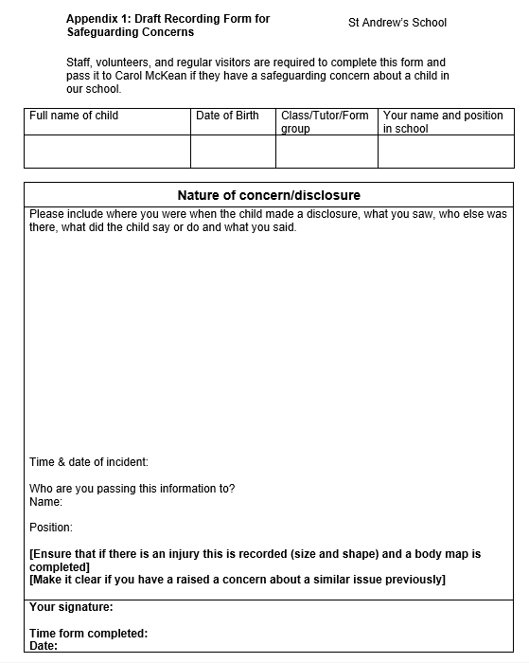

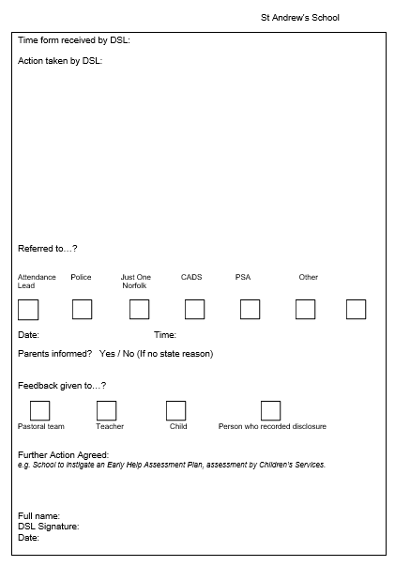

Body Map

Indicate clearly where the injury was seen and attach this to the Recording Form
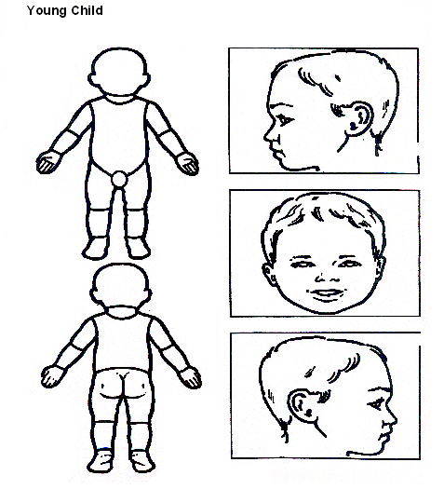

Indicate clearly where the injury was seen and attach this to the Recording Form

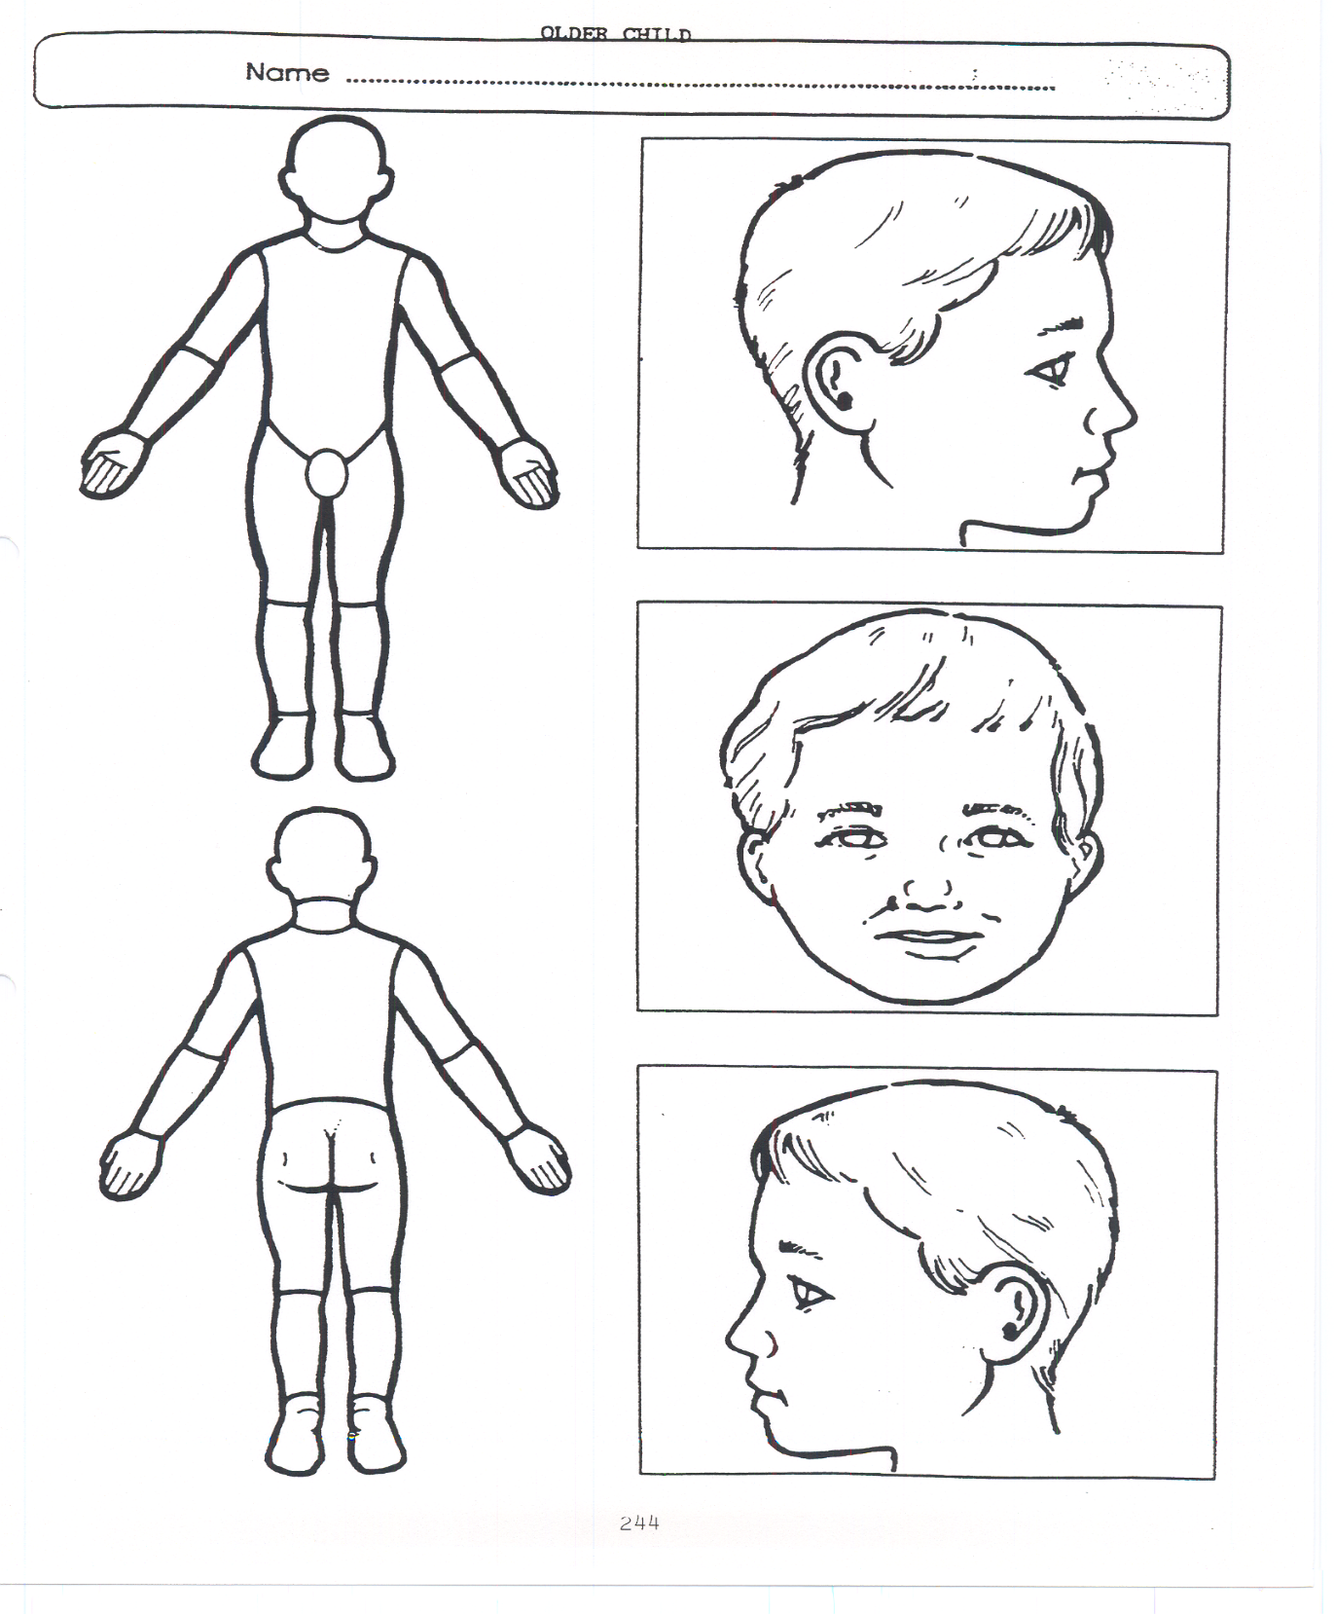
Older Child

Appendix 2: Safeguarding Induction Sheet for new or supply staff and regular visitors or volunteers.

We all have a statutory duty to safeguard and promote the welfare of children, and at our school we take this responsibility seriously.

If you have any concerns about a child or young person in our school, you must share this information immediately with our Designated Safeguarding Lead (DSL) or one of the alternate post holders.

Do not think that your worry is insignificant if it is about hygiene, appearance or behaviour – we would rather you told us as we would rather know about something that appears small than miss a worrying situation.

If you think the matter is very serious and may be related to child protection, for example, physical, emotional, sexual abuse or neglect, you must find one of the designated professionals detailed below and provide them with a written record of your concern. A copy of the form to complete is attached to this and others can be obtained from Carol McKean – Lead DSL. Please ensure you complete all sections as described.

If you are unable to locate them ask a member of the school office staff to find them and to ask them to speak with you immediately about a confidential and urgent matter.

Any allegation or low-level concern about a member of staff, a child’s foster carer or a volunteer should be reported immediately to the Headteacher. If an allegation is made about the Headteacher you should pass this information to the Chair of the Trustee Board. Alternatively, you can contact the Local Authority Duty Desk on 01603 307797. NSPCC whistleblowing helpline is also available for staff who do not feel able to raise concerns regarding child protection failures internally. Staff can call: 0800 028 0285 – the line is available from 8:00am to 8:00pm, Monday to Friday or via e-mail: help@nspcc.org.uk.

The people you should talk to in school are:
Designated Safeguarding Lead (DSL): Carol McKean
Location of office: Upstairs in Main Building
Contact Number: 01263 837927

Deputy Designated Leads: Adrian Crossland and Jim Collin
Location of office: Main Building
Contact Number: 01263 837927

Chair of Trustee Board: Michael Goodwin and Jenny Meara
Contact Number: 01263 837927

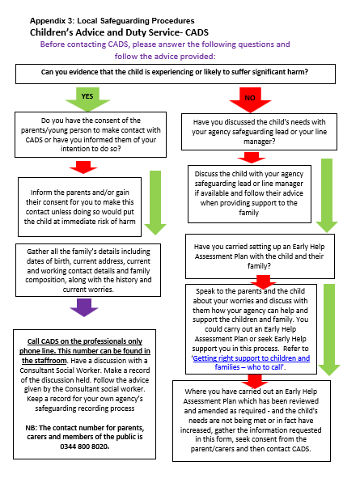

UKCIS guidance: Sharing nudes and semi-nudes advice for education settings

