Head’s Note
Dear Parents and Carers,
Another half-term has flown by and this latest newsletter shares some of the fabulous opportunities our students have experienced in the last few weeks. There are already a number of exciting activities and events planned for after the break and we look forward to welcoming you to the school for both the afternoon tea and the Christmas Fayre.
Thank you to everyone who has already attended one of our Parents' Evenings. It is still possible to sign up to one of the remaining dates. Please contact the school office if you would like support with booking appointments.
I hope everyone has a wonderful break.
Best wishes
Adrian Crossland

Key Dates
Monday 10th November – Students return
Week commencing 10th November - Year 11 Mock Maths Exams
Tuesday 11th November – Dental presentation
Wednesday 12th November – Parents’ Evening
Week commencing 17th November – Year 11 Mock English Exams
Wednesday 19th November – Parents’ Evening
Friday 21st November – Parent Café @ 14:00
Week commencing 24th November – Year 11 Mock Science Exams
Monday 1st December – Football League Event, Aylsham Youngs Park
Thursday 4th December – KS4 Basketball Event at the UEA
Friday 5th December – Winter Festival – (13:15-15:00)
Tuesday 9th December – KS2, Year 7 and Year 8 Christmas meal
Wednesday 10th December – Year 9, Year 10 and Year 11 Christmas meal
Week commencing Monday 15th December – Cinema trip and panto trip (Dates to be confirmed)
Thursday 18th December – Christmas Fayre
Friday 19th December – Talent Show and Christmas Parties (09:00 – 13:30)
Friday 19th December – Last day of term
Monday 5th January 2026 – Students return
Harvest Festival Donation
We would like to thank everyone for all the kind Harvest Festival donations. We are proud of everyone’s efforts to support our chosen charity for this half term. We received a lovely range of items, and all the donated goods have been given to the North Norfolk Food Bank who were very grateful.
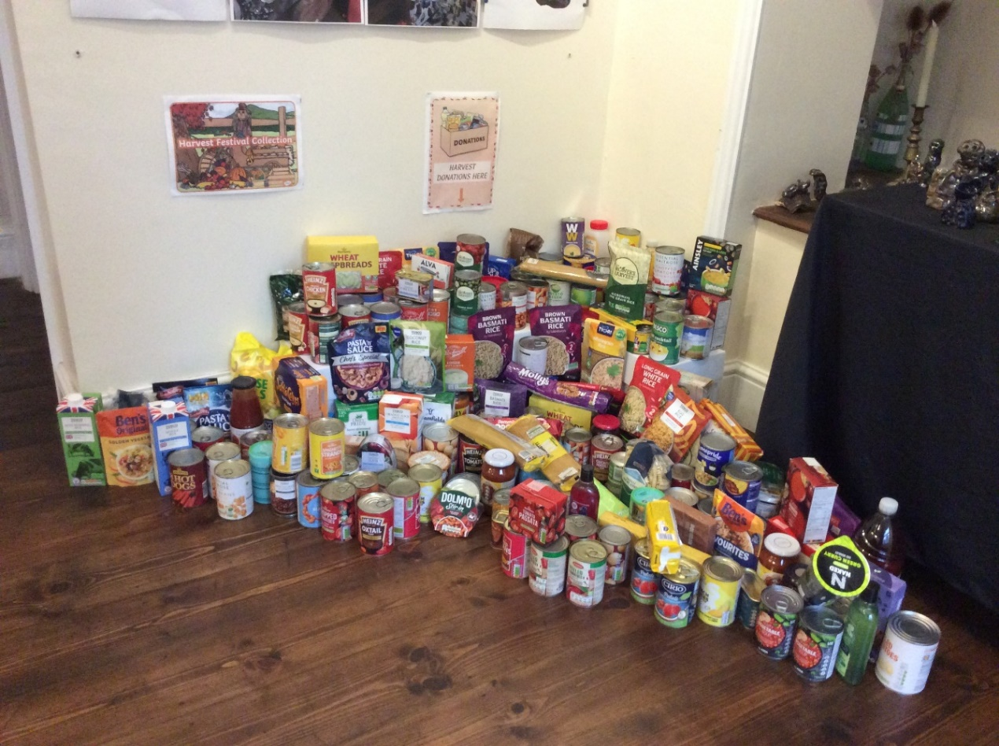
Thank you, Lauren Burdett.

Forest School
The students have been enjoying their new forest school area with Sophie and Cat. This new sector includes a mud kitchen, hammock, crafts, firepit and a cooking area to prepare yummy treats.
Students have been learning how to light a fire using cotton wool and how to chop wood safely. They have also been busy making conker soap and conker bracelets. During these sessions the students have enjoyed deciding their job role and have either helped to light the fire, chop the wood or make and serve the food and drink.

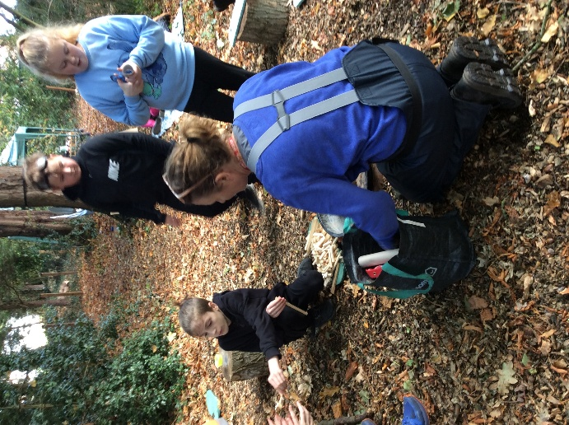
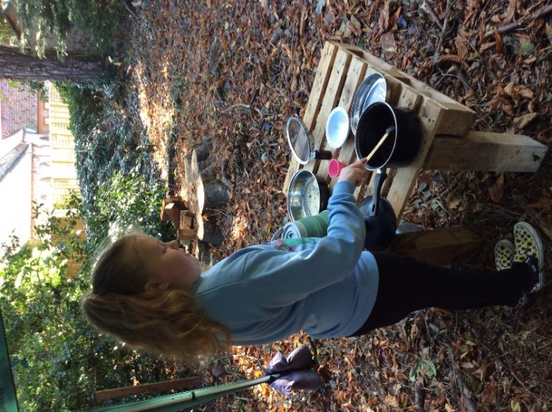

Music

We have successfully kept our Music Mark status for another year. This year the bar was raised and we had to demonstrate our dedication and improvement in multiple areas, which we successfully did.

We are now looking at training staff to use our new DJ equipment donated by DJ Small so that we can offer a DJ club and perhaps offer DJ music-making as another of the musical activities we provide.
Our staff band is also starting to take shape on a Thursday after school. We have bass guitar, double bass, lead guitar, cello, keyboard, vocals and drums and hope eventually to have student apprentices for each role. The first aim, however, is to be able to perform at the Christmas talent show without too many wrong notes. Watch this space!
Judith Crass – Music Teacher
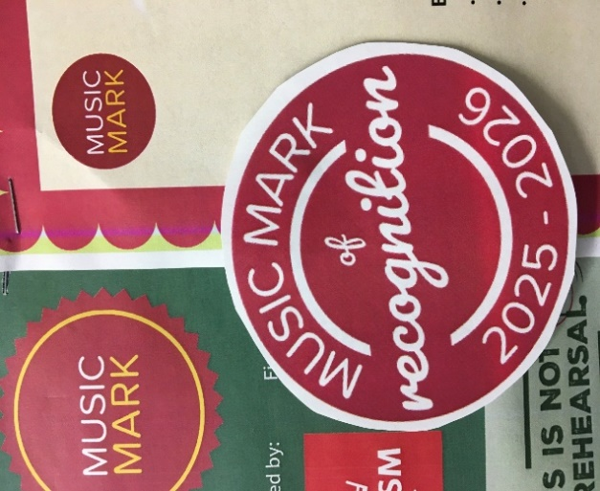


8A Autumn Adventures
All of our classes have the opportunity to participate in a weekly social visit, but in this newsletter, we are going to share 8A’s Autumn Adventures!
It’s been a busy and exciting start to the term for Class 8A, with several wonderful trips exploring nature and the local area.
Our first outing took us to East Runton Beach, where students enjoyed rock pooling and discovering a variety of fascinating coastal creatures hiding among the rocks and seaweed. There was plenty of excitement as we spotted crabs, fish and other seaside treasures!
Next, we visited Hillside Animal Sanctuary, where everyone loved meeting and petting the friendly animals. It was a lovely opportunity to learn about how the sanctuary cares for rescued animals and the importance of kindness to all living things.
After that, we visited Suffield Play Park, where students had great fun enjoying the play equipment and taking part in some field games together. Laughter and teamwork filled the afternoon!
We also enjoyed a visit to a local community orchard, where students had the chance to pick apples and pears straight from the trees. They learned about how fruit grows, the importance of local produce, and, of course, enjoyed tasting some delicious, freshly picked fruit!
Our last trip was to Felbrigg, where we went on a nature walk through the beautiful grounds. Students identified different trees, collected leaves and natural materials, and brought them back to school to help decorate our classroom and celebrate the changing seasons.
It’s been a wonderful term of outdoor learning and adventure.
Paula, Kelly and Megan

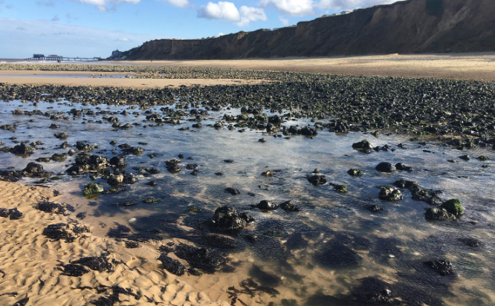

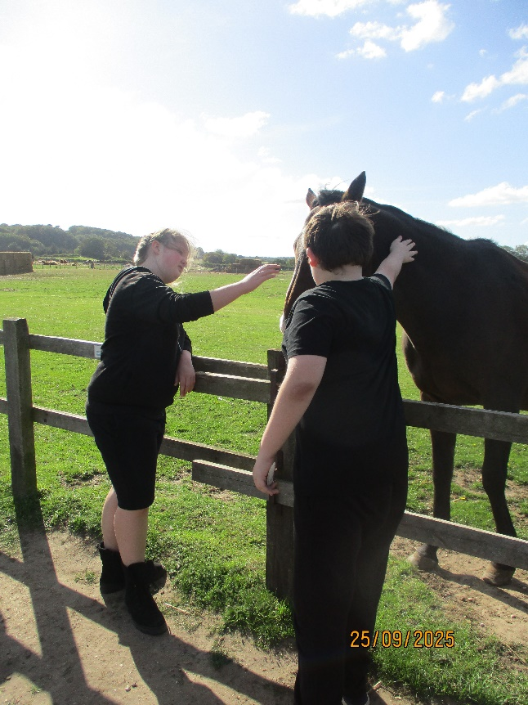

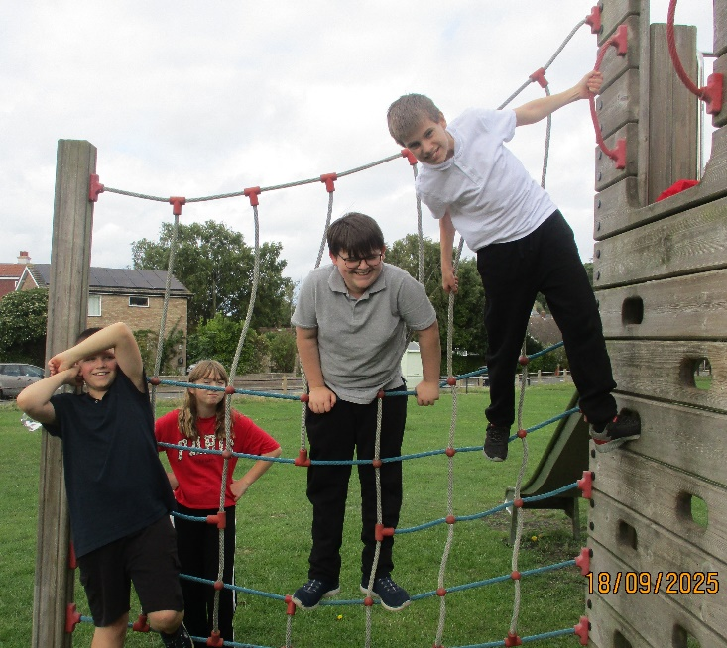
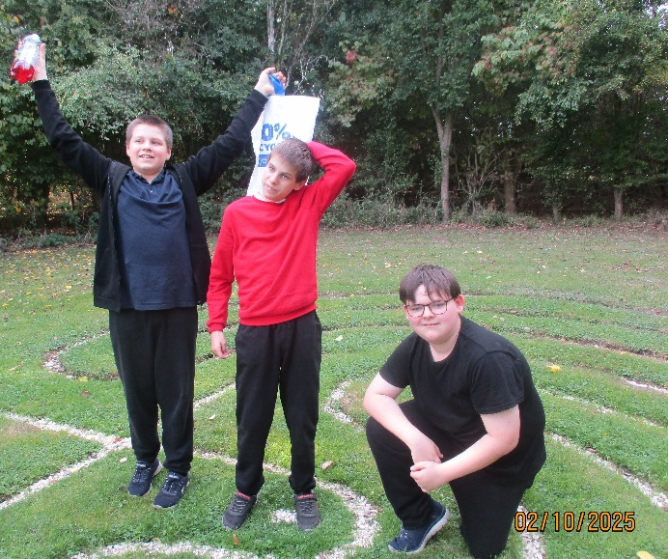

PE
During this half term students, have enjoyed going off-site for one lesson a week to participate in adventurous PE. KS2 and Year 7 have explored local woodlands and thoroughly enjoyed den-building. Whilst Year 8 to Year 11 students have experienced running in varying terrain, building stamina and how this links to sports and the benefits.
We are so lucky to have lots of lovely places to visit, with Pretty Corner Woods, Roman Camp Woodland and Felbrigg and Sheringham Park National Trusts only minutes away from the school. We have also been covering football skills and continuing with my Group Games syllabus which is all about playing non-competitive games in small groups to build social skills and interest in PE through play.
Vassy Stamatov – PE Teacher
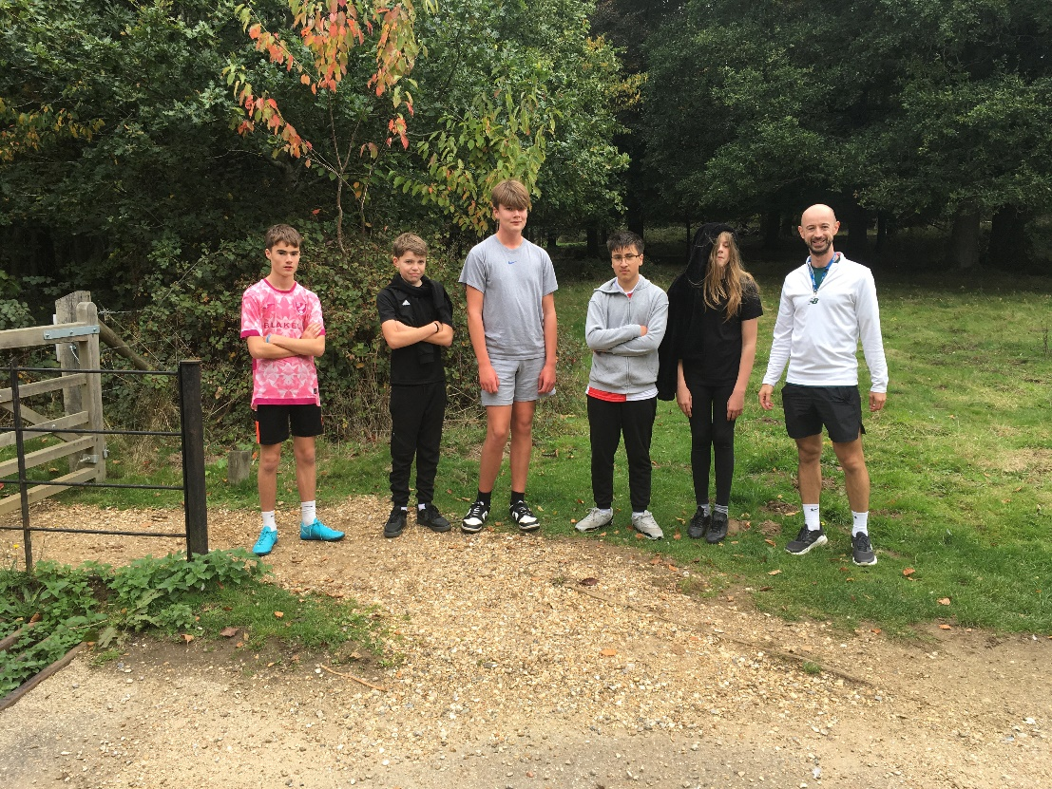

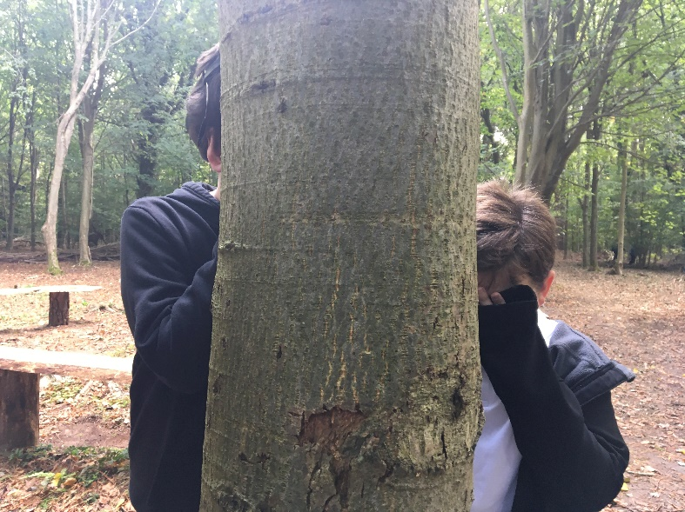

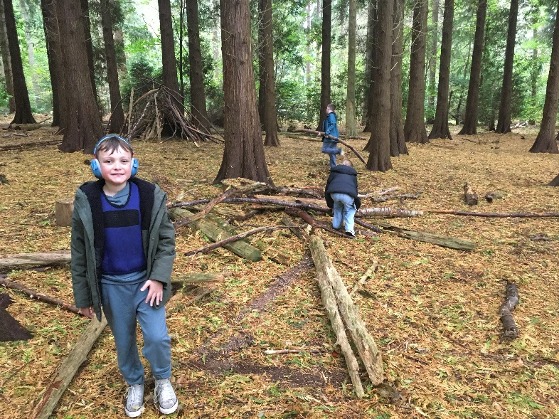
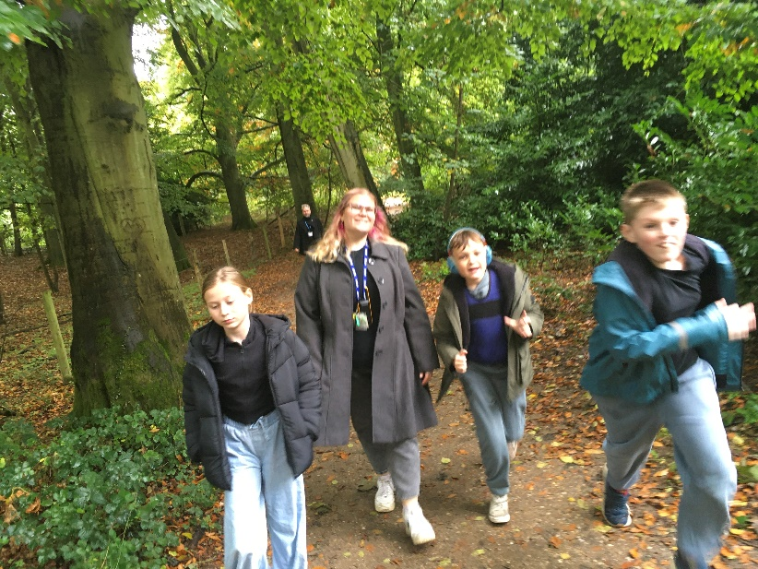

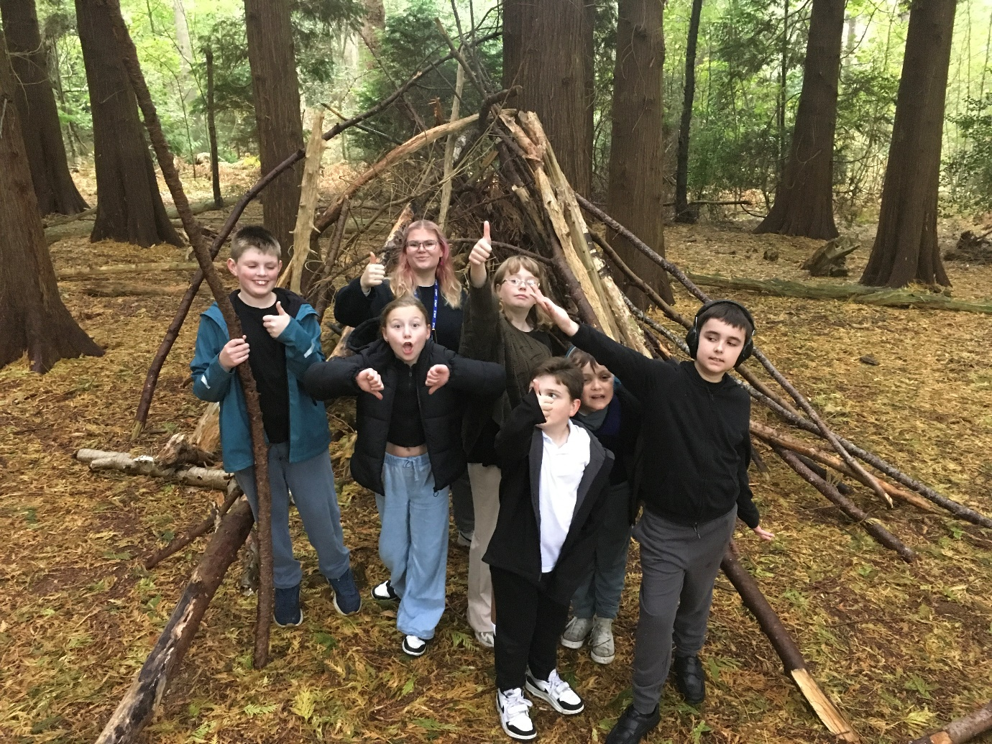

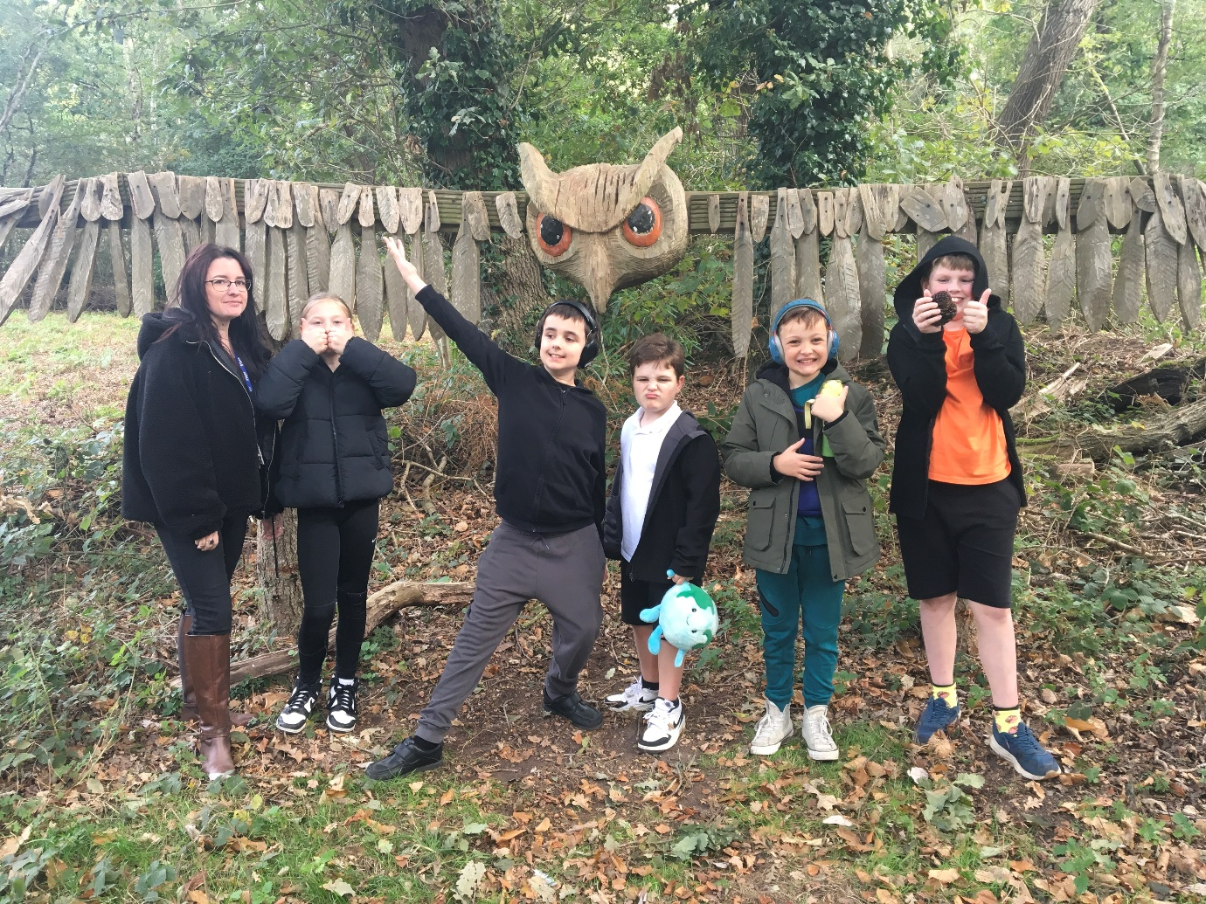

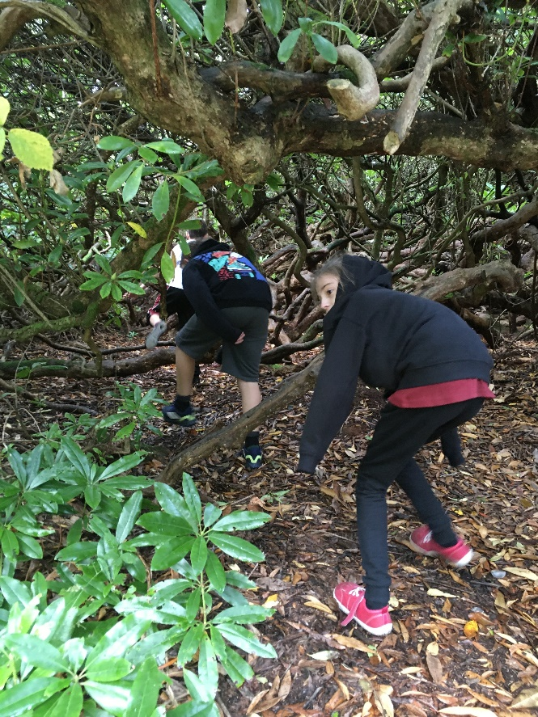
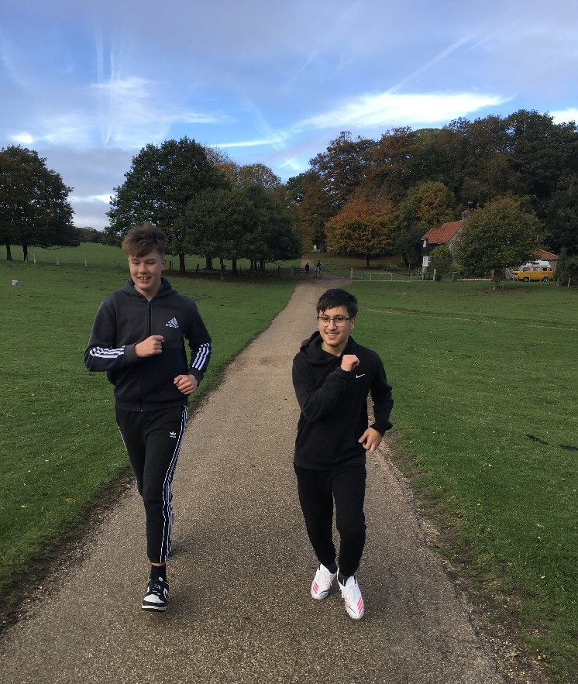

Year 11
Year 11 opted for a visit to Sainsbury's in Cromer for their half termly paid social trip to view and buy their preferred 'meal deal'. Students were presented with an independent task in working out what is included in the meal deal, selecting a main, snack and a drink. Once selected, they independently used a self-checkout till and paid in cash to complete the transaction.
I think it is fair to say it went down well!

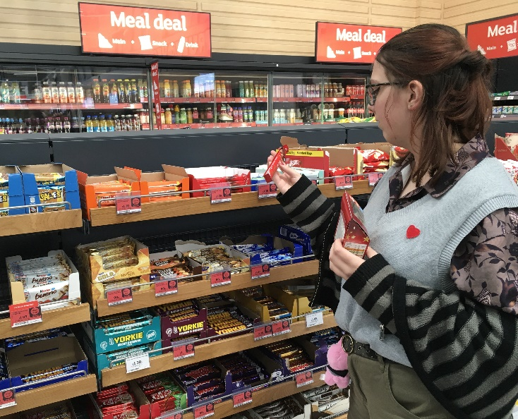
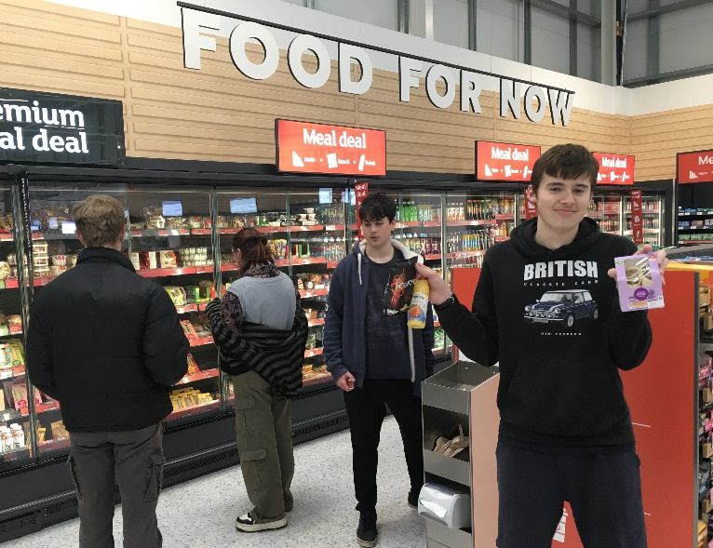

Year 11 Staff - Vassy, Sam & Barney

SMSC Day
Students took part in a special Black History SMSC Day, celebrating the spiritual, moral, social, and cultural contributions of Black history through a range of creative activities.
Highlights included exploring Gospel and Grime music in Music, discovering Black authors in English, studying British Black artists in Art, researching key facts in IT, tasting cultural dishes in Food Technology, and playing traditional Caribbean games in PE.
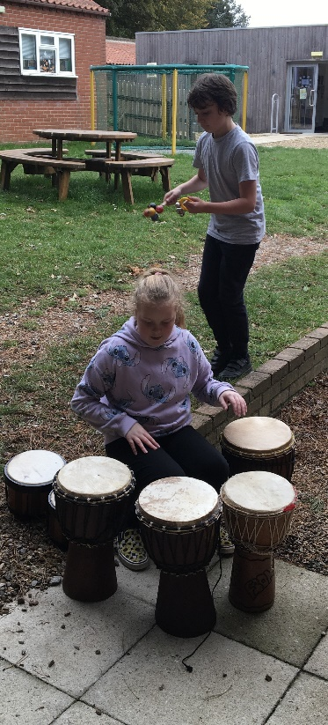
The day was a fantastic opportunity for students to learn, create, and reflect on the rich influence of Black history in our world today.
Emma Lawer – Food Technology Teacher
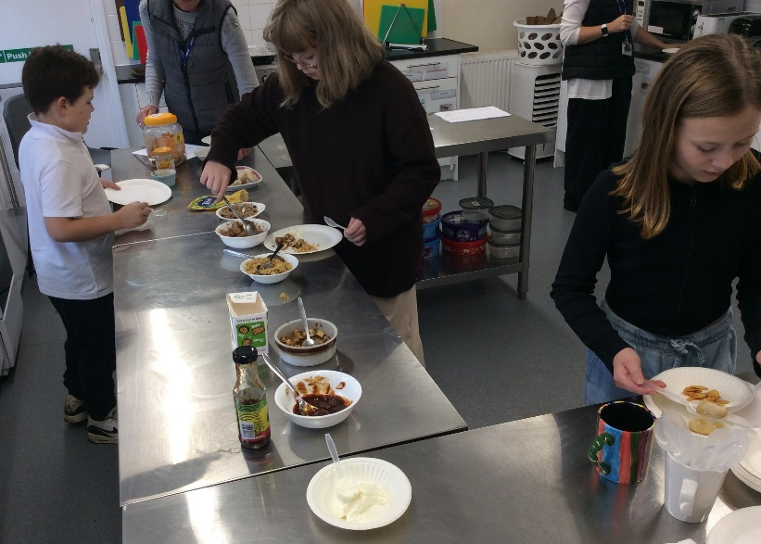
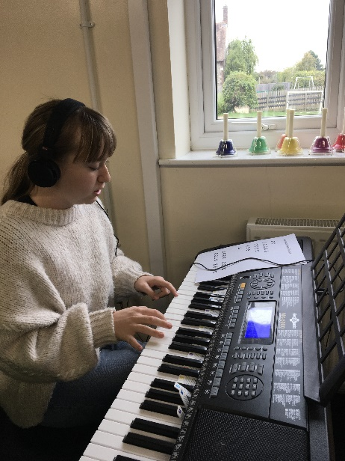

Food Technology

Music
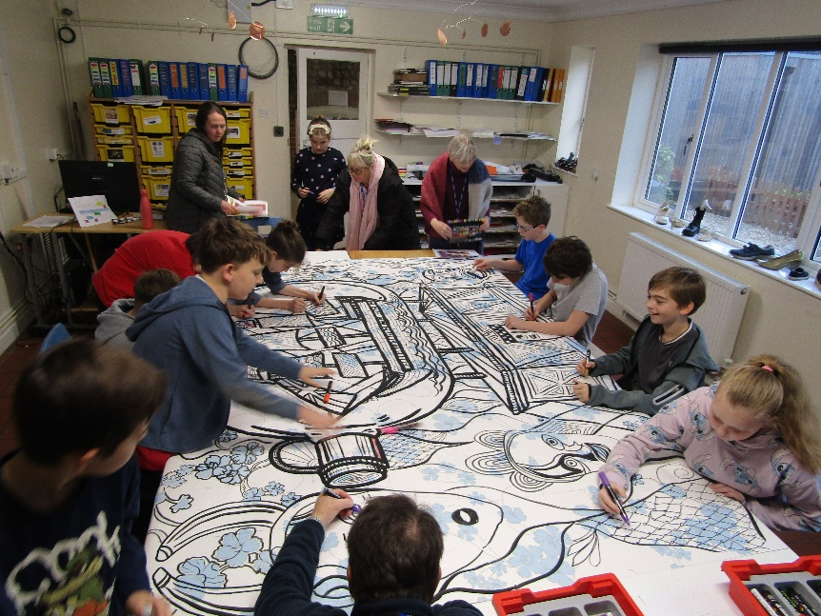


Art

