Spellings to be assessed on  Friday, 28th February | Spellings to be assessed on  Friday, 7th March | Spellings to be assessed on  Friday, 14th March | Spellings to be assessed on  Friday, 21st March
Recap - High Frequency Words  two  once | Recap -Tricky/High Frequency Words  great  clothes | Tricky/High Frequency Words  Your child will be told a sentence – they will write the correct homophone  were  where  wear  we’re | Recap - Tricky/High Frequency Words  Your child must have a capital letter for the personal pronoun I.  it's  I'm  I'll  I've
Alternative C  rocks  clue  crawl  cry  Christmas | C as s  race  cell  nice  spicy  sentence | St as s and se  rustling  whistling  pause  tease | J and edge  dodge  edge  fudge  badge
Spellings to be assessed on  Friday, 28th March | Spellings to be assessed on  Friday, 4th April |  Top tip!  Learn a couple of spellings each night. | 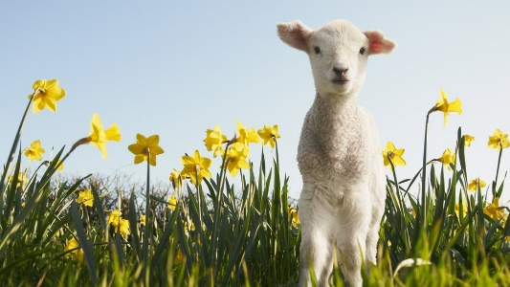
Recap - Tricky/High Frequency Words  don’t  can’t  didn’t | Tricky/High Frequency Words  Your child will be told a sentence – they will write the correct homophone  their  there  they’re
l as le  table  bottle  middle  title | m as mb  crumbs  thumb  comb
Year 1 - Spellings for Spring 2 2024-2025

