Spellings to be assessed on  Friday, 25th April | Spellings to be assessed on  Friday, 2nd May |  | Spellings to be assessed on  Friday, 9th May |  | Spellings to be assessed on  Friday, 16th May
Recap - High Frequency Words  don’t  can’t  didn’t | Recap -Tricky/High Frequency Words  because  off  of |  | Tricky/High Frequency Words  come  some |  | Recap - Tricky/High Frequency Words  first  second  third
n as kn and gn as r  r as wr  knock  gnome  wrap  write | Ch as tch and sh alternatives  stretch  match  special  mission |  | e as ea and z as s  deaf  instead  treasure  leisure |  | o as w(a) and u as o  wallet  swamp  skeleton  pentagon
Spellings to be assessed on  Friday, 23rd May |  Top tip!  Learn a couple of spellings each night. | 
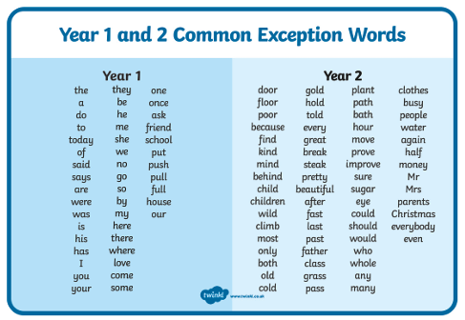
Recap - Tricky/High Frequency Words
Year 1 - Spellings for Summer 1 2024-2025

