**Y1 Recommended Reading List**

**‘The more that you read, the more things you will know. The more that you learn, the more places you’ll go.’**

***Dr. Seuss***

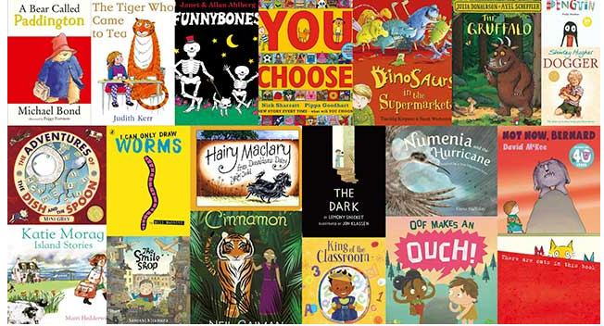

|  |  |  |
| --- | --- | --- |
| Fiction | Non-fiction | Poetry/ Rhymes |
| Aliens Love Underpants by Claire Freedman | Neil Armstrong by Little People/ Big Dreams | The Owl and the Pussy Cat by Edward Lear |
| Funny Bones by Allan Ahlberg | What a Waste by Jess French | Revolting Rhymes by Roald Dahl |
| How to Catch a Star by Oliver Jeffers | Do you Love Oceans? By Matt Robertson | Old MacDonald had a Farm |
| Superworm by Julia Donaldson | Queen Elizabeth by Little People/ Big Dreams | Hickory Dickory Dock |
| Horrid Henry’s Birthday Party by Francesca Simon | The Royal Family by Helen Cox Cannons | The Wind by Christina Rossetti |
| The Jolly Postman by Janet and Allan Ahlberg | First Animal Encyclopaedia | Over the Deep Blue Sea |
| Hansel and Gretel | Wild Life by Sir David Attenborough | The Seaside by Jo Peters |
| Percy the Park Keeper by Nick Butterworth | Plants by Peter Riley | Humpty Dumpty |
| Paddington by Michael Bond | The Big Book of the Blue by Yuval Zommer | Five Little Ducks |
| Peace at Last by Jill Murphy | Children of the World by Nicola Edwards | Chicken on the Roof by Matt Goodfellow |
| My Two Grannies by Floela Benjamin | Can we Really Help the Bees? By Katie Daynes |  |
| Giraffes Can't Dance by Giles Andreae | Who Ate All the Bugs? By Matt Long |  |
| Toys in Space by Mini Grey | Meet the Weather by Caryl Hart |  |
| Careful Santa by Julie Sykes | Animal Atlas by Ingela Arrhenius |  |