
Member of staff responsible: Emily Clarke
Date policy updated: September 2024
Date to be reviewed: September 2025

ST ANTHONY’S CATHOLIC PRIMARY SCHOOL
HANDWRITING POLICY

At St Anthony’s Catholic Primary School we are very proud of our pupil’s handwriting and take particular care in our cursive handwriting style. We use Letter-join’s on-line handwriting resource and Lesson Planners as the basis of our handwriting policy as it covers all the requirements of the National Curriculum.

Objective:
Handwriting is a basic skill that influences the quality of work throughout the curriculum. By the end of Key Stage 2 all pupils should have the ability to produce fluent, legible and, eventually, speedy joined-up handwriting, and to understand the different forms of handwriting used for different purposes.

Aims:
At St. Anthony's, we believe that neat, well-formed handwriting is an important element in encouraging children to have self-respect and to take pride in their work. Children must be able to write with ease, speed and legibility to maximise the fluency, quality and quantity of their work. Cursive handwriting teaches pupils to join letters and words as a series of flowing movements and patterns. We believe that using this style raises standards across the whole school, developing confidence, accuracy, fluency and improved presentation.

At St Anthony’s Catholic Primary School, we aim:
- To provide equal opportunities for all pupils to achieve success in handwriting.
- To develop a neat, legible, speedy handwriting style using continuous cursive letters, this leads to producing letters and words automatically in independent writing.
- To develop accuracy and fluency.
- To help children recognise that handwriting is a form of communication and as such should be considered important in order for it to be effective.
- To establish and maintain high expectations for the presentation of written work.
- For pupils to understand, by the end of Year 6, the importance of neat presentation and the need for different letterforms (cursive, printed or capital letters) to help communicate meaning clearly.
- To promote confidence and self-esteem.
- To encourage children to take pride in their work.
- To build in cross-curricular links to broaden experience.
- To help children recognise that handwriting is a life-long skill and will be a fundamental element of all forms of written communication throughout their lives.
- To display neatly presented work around the school as a model of excellence for others to aspire to.
Pupils should experience coherence and continuity in the learning and teaching of handwriting across all school years and be encouraged to take pride in the presentation of their work.
Our objective is to help pupils enjoy learning and developing their handwriting with a sense of achievement and pride.

In order to achieve these aims, the following principles are followed:
- Handwriting is taught regularly and systematically in classes, groups or individually as appropriate using the Letter-Join handwriting scheme.
- Consistency throughout the school.
- Patterns are used initially, by writing with a variety of tools and using multisensory methods, to help free flowing hand motions and to develop muscle strength.
- Correct pencil hold and letter formation are taught from the beginning.
- When marking or writing comments, members of staff use cursive handwriting as appropriate.
- All teaching staff are encouraged to model the cursive style in all their handwriting, whether on whiteboards, displays or in pupils’ books.
- Writing that is displayed throughout the school includes cursive writing.
- Handwriting frequency.
- Handwriting is a cross-curricular task and will be taken into consideration during all lessons. Formal teaching of handwriting will be carried out regularly and systematically to ensure Key Stage targets are met.

Pens, pencils and resources
Teachers use the Letter-join Handwriting scheme from Foundation Stage to Y6. Initially, large equipment is used by Foundation Stage and Key Stage One children; smaller equipment is introduced when fine motor skills are of a good standard. In Foundation Stage, resources range from sand trays, construction sets, chalks, paintbrushes and playdough to large pencils, crayons and whiteboard pens. In Key Stage One, children are given experience of a variety of writing tools including pens, pencils, crayons and whiteboard markers. Whiteboard pens are used in daily handwriting and phonics sessions. Guidelines may be used with plain paper. Resources for those who have difficulties with fine motor skills (letter shapes, magnet boards, sand trays) are available for pupils across the school. When fine motor skills have been established a handwriting pen can be used. More competent pupils may have the opportunity to use a ballpoint pen.

Inclusion
For children who experience handwriting difficulties due to fine motor development, including those who are left-handed and those with special educational needs, the appropriate additional support will be put into place. Letter-join’s Lesson Planners all include differentiation activities for extra practice/challenge. Teachers of children, whose handwriting is limited, by problems with fine motor skills, should liaise with the SENCO to develop a programme designed for the individual child. Additional support such as one-to-one sessions with a Teaching Assistant may be necessary.

The Tripod Pencil Grip
Both right and left handed children should be encouraged to use the tripod grip which allows the pen/pencil to be held securely whilst allowing controlled movements of the pen/pencil nib. We use the Tripod Grip Rhyme:
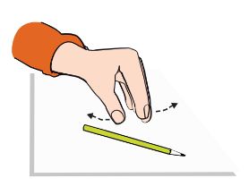
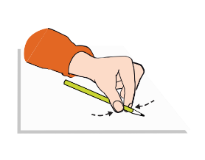
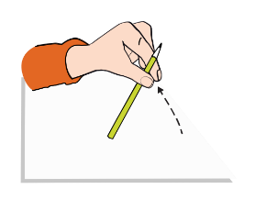
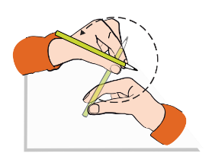
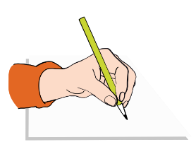
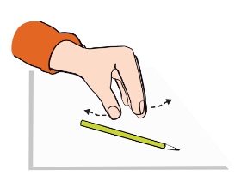
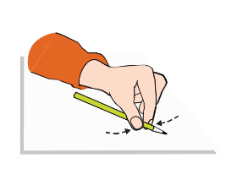
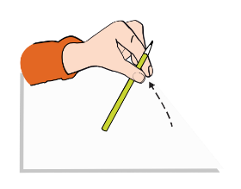
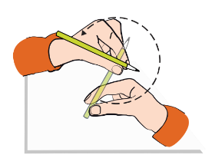
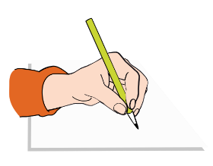
Point away the pencil, Pinch it near the tip, Lift if off the table, Spin it round... and grip.
Point away the pencil, Pinch it near the tip, Lift if off the table, Spin it round... and grip.
Right-handed pencil grip
Left-handed pencil grip

Correct posture and pencil grip for handwriting
Pupils should be taught to sit correctly at a table, holding a pencil comfortably and correctly.
Sitting position
Sit with a straight back, not leaning over the page
Pull the chair close in to the table
Keep feet flat on the floor
Sit right back in the seat
The table reaches to below elbow height

Paper position for right-handed children.

Provision for left handed children
At least 10% of the population are left-handed, the majority of whom are boys. All teachers are aware of the specific needs of left-handed pupils and make appropriate provision:
- Paper should be positioned to the left for right handed pupils and to the right for left handed pupils and slanted to suit the individual in either case;
- A writing tool which moves smoothly across the paper is used;
- The writing tool is held sufficiently far from its point to ensure that the child can see what he/she is writing;
- Pupils should be positioned so that they can place their paper to their left side;
- Left-handed pupils should sit to the left of a right-handed child so that they are not competing for space;
- Extra practice with left-to-right exercises may well be necessary before pupils write left-to-right automatically.
Children should be encouraged to have the correct sitting posture for good handwriting, for example: the bottom of the back to go into the back of the chair.

Teachers are aware of the fact that it is very difficult for left-handed pupils to follow handwriting movements when a right-handed teacher models them. Teachers demonstrate to left-handers on an individual or group basis, even if the resulting writing is not neat.

Paper position for left-handed children.

Handwriting at Home
Pupils are encouraged to practise their handwriting at home by using the Pupil log-in for Letter-join. Teachers will set specific tasks such as:
- Magic Patterns
- Magic Words
- PhonicsMatch
- Word Search
- Word Bank
- Write it Right!
Children can also watch the word and letter animations and practice and explore other handwriting resources on Letter-join. Please ask your child’s teacher for their username and password. Please see additional attachments to this policy.

Standards of handwriting across the curriculum
It is important that children understand that writing is a communication and recording skill. Therefore, neat, legible handwriting is a requirement in order to communicate in other curriculum areas. Teachers will seek to take advantage of opportunities to make cross-curricular links and will ensure that the highest standards of handwriting are maintained across all curriculum areas where handwriting forms part of the learning.

Assessment and monitoring of standards
Handwriting is assessed throughout the year by class teachers. The consistent use and teaching of cursive script will be monitored through work scrutiny by the Handwriting Subject Leader and Senior Leadership team.

Use of ICT
All teachers use the interactive whiteboards in classrooms. Resources to support the direct teaching of handwriting may be used. The following are suggested uses of ICT to enhance the teaching and learning of a consistent handwriting style:
- Use of the lined writing templates
- Video demonstration of the correct letter formation
- Video demonstration of the joins to link letters together in words

Handwriting and Reading links
In school, children are exposed to both cursive and print styles, as well as to commercial print. They develop the ability to read both print and cursive writing as they learn using prompts around classrooms and school, for example: display lettering, labels around the classroom, teaching aids and through teachers’ modelling of writing. It is important that handwritten writing around school is consistent with the school’s approach to handwriting.

Role of subject leader:
The Subject Leader should be responsible for improving the standards of writing through:
Monitoring and evaluating:-
- Standards of handwriting across the curriculum
- Pupil progress against age-related expectations of handwriting
- The quality of the Learning Environment, displays and modelled writing;
- Taking the lead in policy development
- Auditing and supporting colleagues in their CPD
- Purchasing and organising resources
- Delivery of training to Teachers and Teaching Assistants

Parental involvement
Parents will be informed of the agreed handwriting style and information will be shared with parents at parents’ evenings in EYFS and Key Stage One. ‘St Anthony’s Letter-join Home Access’ will be shared with parents.

The Governing Body
Regular reports will be made to the governors on the progress of handwriting and writing standards.
This policy will be reviewed every three years or in the light of changes to legal requirements.

Key Stage Teaching Expectations

In the Foundation Stage (Reception), children regularly take part in activities to develop gross and fine motor skills through both continuous provision and adult-led activities. For our youngest pupils we also teach short handwriting lessons on a daily basis, which will include the following:
- Enhancing gross motor skills such as air-writing, pattern-making and physical activities
- Exercises to develop fine motor skills such as mark-making on paper, whiteboards, sensory trays, iPads, tablets, etc.
- Becoming familiar with letter shapes, their sounds, formation and vocabulary
- Correct sitting position and pencil grip for handwriting

When the child is ready, individual letter formation of lower case letters is taught, modelled and practiced in working towards the objectives listed below at Key Stage 1. Reception children will experience a pre-cursive transition during the summer term of Reception to prepare them further for Key Stage 1 expectations.

Lesson Planner Early Years – Printed letters is a lesson planner for our school’s choice to start teaching handwriting with printed letters.
Supporting resources using a printed font include:
- All lower case letters and words
- All of the Phonics activities
- Easy letters and words
- Harder letters and words
- All games and activities
- All KS1 worksheets
At the end of this module, children should be able to recognise and form all the printed, lowercase letters of the alphabet.

At Key Stage One (Years 1 and 2), children are taught how to form both lower and upper case letters and how to join them, whilst continuing to develop fine and gross motor skills using a range of multi-sensory activities. Handwriting is taught daily and is linked to the daily phonics sessions. The children continue to use large 'chunky' pencils for writing until the teacher feels that the child is ready to use smaller equipment.
The children are taught to:
- Write from left to right and from top to bottom of the page.
- Sit their writing on the line.
- Start and finish letters correctly in line with the Letter-join handwriting scheme (Start and finish letters correctly using lead ins and lead outs in Year 1 and when appropriate for the child correctly joining letters both vertically and horizontally).
- Be consistent with the size and shape of letters and the spacing of letters and words.
- Experiment with numerals, capitals and printed letters; knowing where and when to use, through learning and practice.
- Have the correct pencil grip.
- Have the correct posture and position.

Lesson Planner Module 2 for Year 1 contains lessons for teaching how to write capital letters, printed letters, numbers and symbols, whilst reinforcing cursive handwriting using Letter-join’s on-line and printed resources. It is divided into three sections covering:
- Capital letters
- Printed letters
- Numbers and symbols
On finishing this module, children should be confident in writing all the capital and printed letters, numbers and symbols and start to become familiar with their use.

Lesson Planner Module 3 for Year 2 includes lessons to improve letter formation and orientation of letters through regular practice and to support spelling, grammar and punctuation in readiness for KS1 SATs. The sections in this module cover:
- Letter families
- High frequency words
- Joining techniques
- Sequencing sentences
- Dictation exercises
- Times table facts
- SPaG practice for KS1 SATs
With the regular handwriting practice throughout this module, children should now be developing the fluency and speed of their writing.

Capital letters stand alone and are not joined to the next letter. Children must practice starting sentences and writing names using a capital letter and not joining the subsequent letter. This should be modelled by the teacher during discrete handwriting sessions as well as English and all other subjects when writing is involved.

At Key Stage Two (Years 3-6), children continue to have direct teaching and regular practice of handwriting. We aim for them to develop a clear and fluent style and, by the end of Key Stage 2, be able to adapt their handwriting for the following different purposes:
- A neat legible hand for finished, presented work.
- A faster script for notes.

Lower Key Stage 2: Years 3 and 4
Handwriting lessons will continue twice a week in Lower Key Stage 2.

Lesson Planner Module 4 for Year 3 is targeted at children in lower KS2 where pupils should be using a cursive style throughout their independent writing in all subjects, helping to refine their handwriting in line with the requirements of each lesson. This module covers topics such as dictation, double letters, number vocabulary, palindromes, tongue twisters, MFL (French and Spanish), onomatopoeia, simile and statutory spellings.
Completion of Module 4 should ensure improvement in the legibility, consistency and quality of the children’s handwriting through a variety of resources which link handwriting to other areas of the curriculum.

Lesson Planner Module 5 for Year 4 focuses on using handwriting practice to support other subjects in the curriculum and, at the same time, builds on fluency and consistency. This module aims to promote meaningful links with other subjects such as English, Maths, Science, Geography, French and Spanish. Making such links enables children to apply the skills they are learning in context and also provides depth to the curriculum.
Learners will continue to build on producing fluent, consistent and legible handwriting through the regular practice offered in this module’s lessons.

On concluding this module, children will have practised applying size-appropriate handwriting to all areas of the curriculum whilst maintaining fluency and legibility.

Capital letters stand alone and are not joined to the next letter. Children must practice starting sentences and writing names using a capital letter and not joining the subsequent letter. This should be modelled by the teacher during discrete handwriting sessions as well as English and all other subjects when writing is involved.

Upper Key Stage 2: Years 5 and 6
More advanced handwriting techniques will be taught during two weekly lessons:
- Reinforcing cursive handwriting across the curriculum
- Form-filling/labelling using printed and capital letters
- Dictation exercises promoting quick note-taking and speedy handwriting writing skills
- KS2 SATs SPaG practice

Lesson Planner Module 6 for Year 5 continues to build on combining fluent handwriting with other subjects across the curriculum.
In this module, learners will have plenty of opportunity to develop the stamina and skills to write at length, with accurate spelling and punctuation. With Letter-join’s wide range of resources they will be able to work towards producing consistently neat and well-presented handwriting in all curriculum subjects.
On completing this module, children should be producing cursive writing automatically, enabling them to focus on the content of their work rather than the process of writing.

Lesson Planner Module 7 Year 6 presents learners with a range of tasks where they have to decide on an appropriate style of handwriting. Promoting speedy, fluent writing continues to be a strong feature. Challenging dictation exercises will refine pupils’ revising and checking skills as well as boosting their handwriting speed, stamina and fluency. A range of curriculum-based worksheets will give pupils the opportunity to practise writing at length.

Module 7 also contains a series of worksheets to aid KS2 SATs SPaG revision. They are designed to support year 6 pupils in meeting expected standards for spelling, punctuation and grammar, with lots of SPaG preparation and plenty of handwriting practice.
By the end of this module, children should be able to adapt their handwriting for a range of tasks and purposes and to create different effects. They should be clear about what standard of handwriting is appropriate for a particular task, for example, quick notes, a final handwritten version, an un-joined style or capital letters. All of these writing styles are covered in this module.

Capital letters stand alone and are not joined to the next letter. Children must practice starting sentences and writing names using a capital letter and not joining the subsequent letter. This should be modelled by the teacher during discrete handwriting sessions as well as English and all other subjects when writing is involved.

Conclusion

All children should be taught a consistent letter formation from EYFS and throughout the school. This should be displayed in every classroom and consulted regularly by staff and children – particularly for those letters with a variety of formations.

This policy also needs to be in line with other school polices and therefore should be read in conjunction with the following school policies:
- Teaching and Learning Policy
- Marking and Feedback Policy
- Special Educational Needs Policy
- ICT Policy
- Equal Opportunities Policy



at home!

Dear Parents,  Our school is now part of the Letter-join handwriting scheme and our pupils can log in to the Letter-join website on iPads and tablets as well as desktop and laptop computers at home.  There you will find the same, easy-to-use handwriting resources that we use at school. | 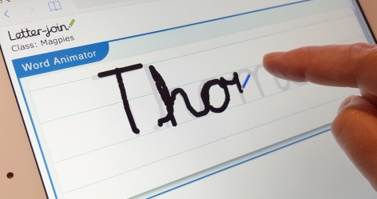

PC DESKTOP AND LAPTOP LOG-IN  Log in at www.letterjoin.co.uk and use the  Desktop log-in option with these details:  User name: wk9133  Password: home | PC Browsers:  Letter-join will work on the following browsers on PCs/Macs:  • Google Chrome  • Firefox  • Safari  Do not use Internet Explorer.

IPAD AND TABLET LOG-IN    Go to www.letter-join.co.uk and use the Tablet log-in option with these details:  User name: wk9133  Swipe code (starting at top left): | Tablet/iPad Browsers:  Letter-join will run on the following tablets:  • iPads running iOS7 and above through the Safari browser.  • Windows 8 tablets (8 inch and bigger) using the built-in browser.  • Android tablets (8 inch and bigger) using Google Chrome, Firefox or Opera.

CHOOSING A CLASSROOM  Once logged-in, choose your child’s classroom and you can use Letter-join’s resources and fun activities to reinforce the handwriting we teach at school. You can trace over the letters and words and play the games on your tablet.  We are limited to the number of users who can log in to this account, so please do not share these log-in details. |  |  |  | 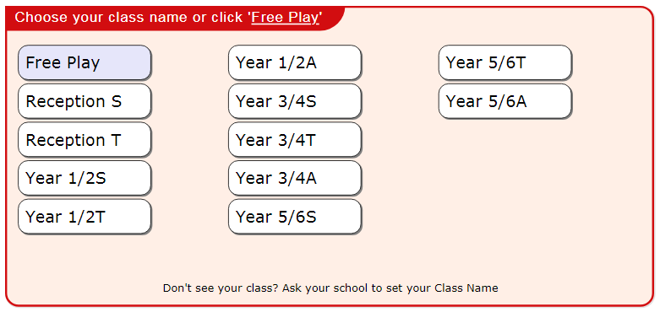
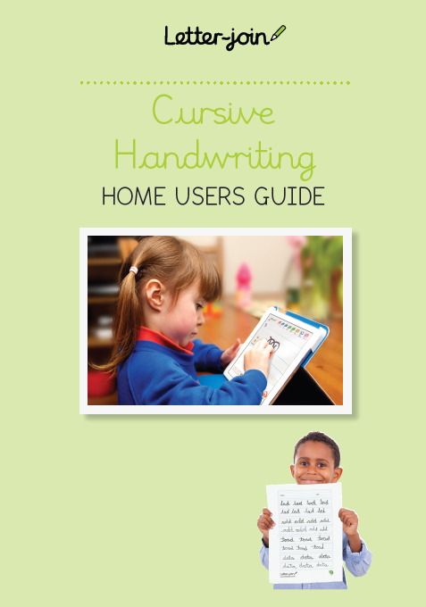 |  |  | 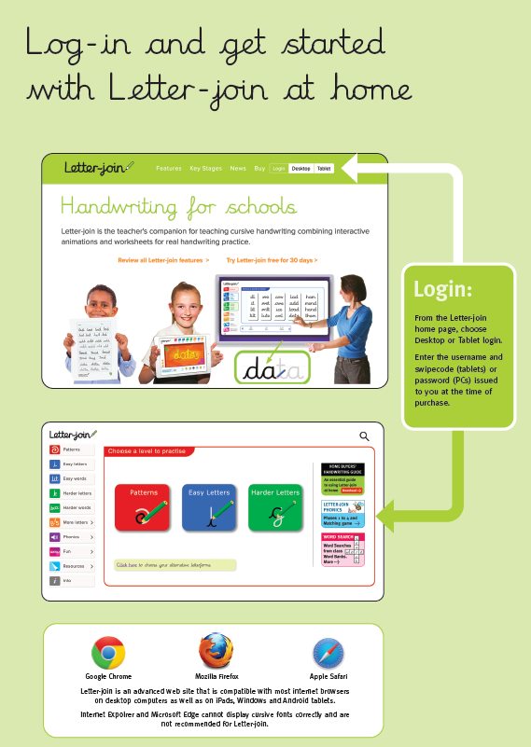
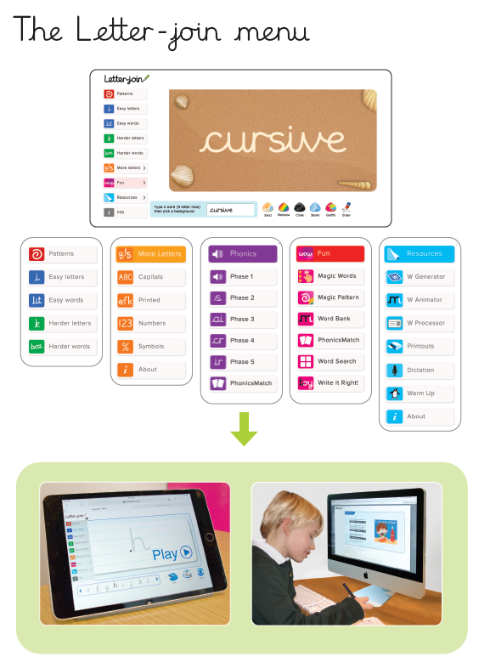 |  | 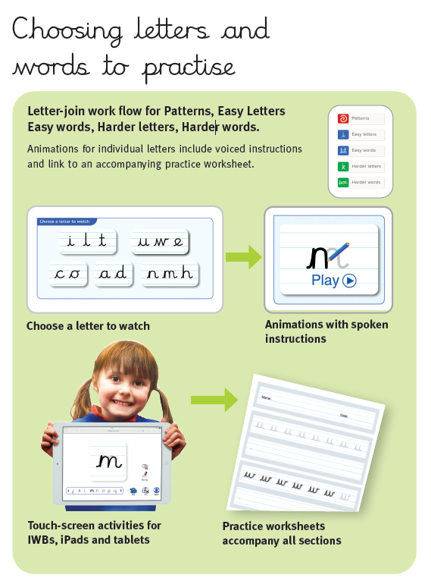
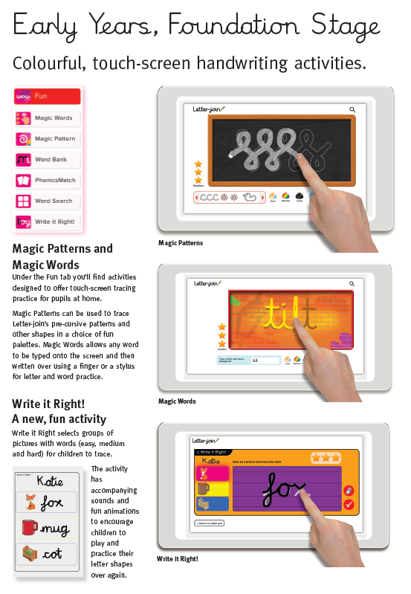 |  | 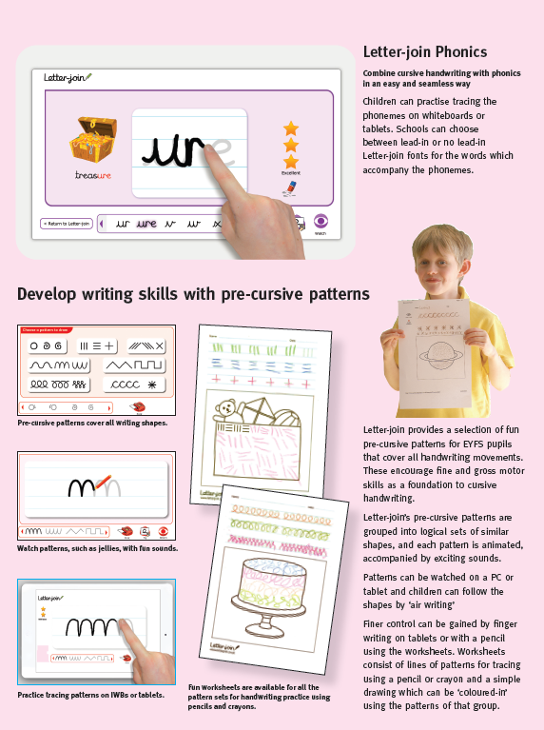
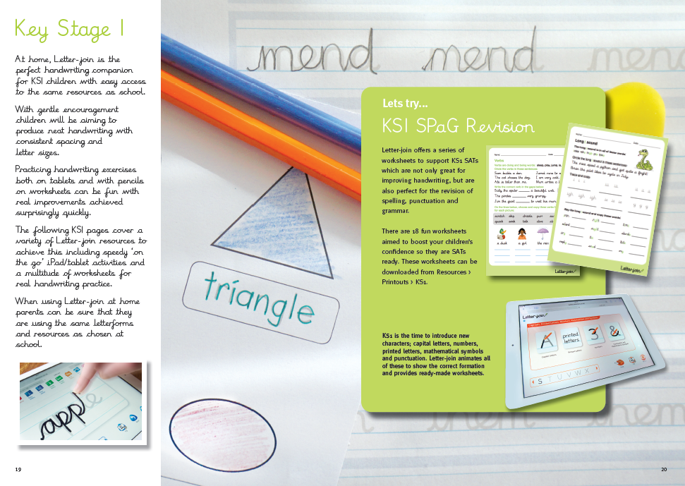
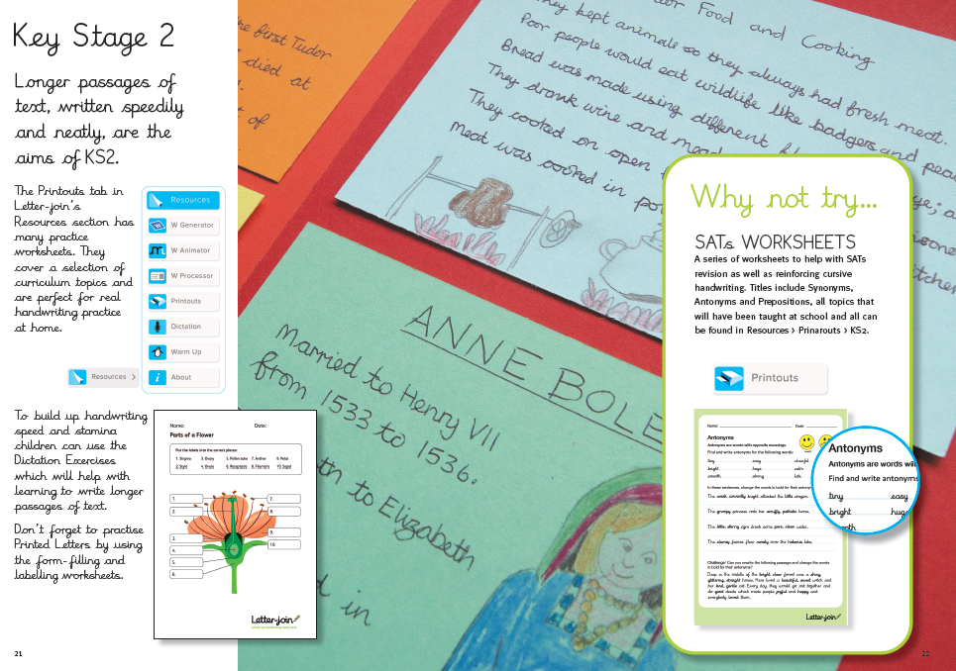
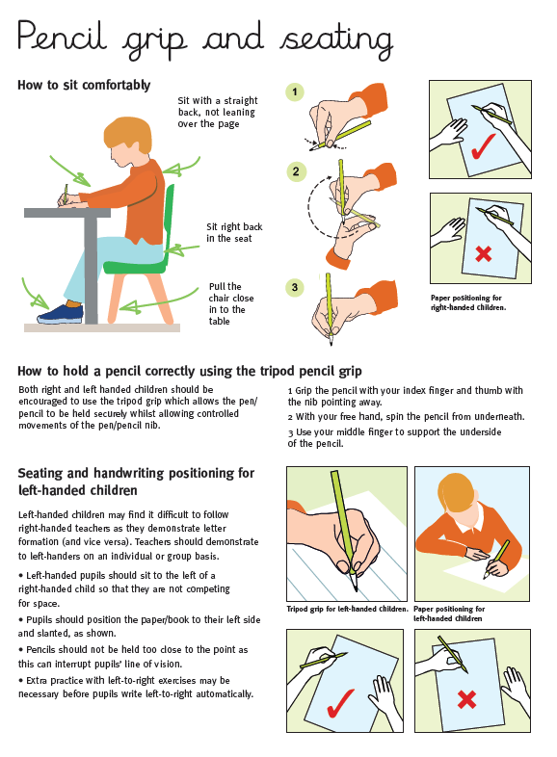 | 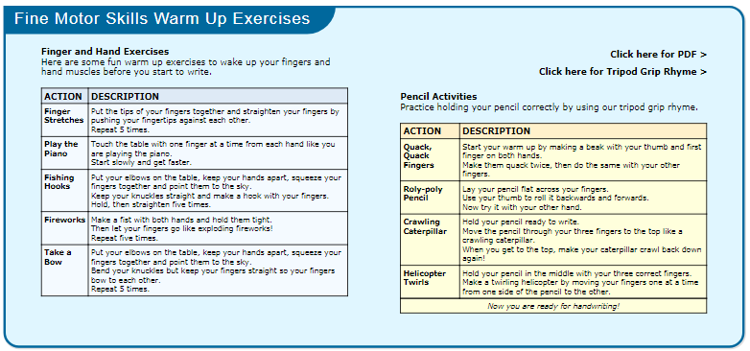
 | 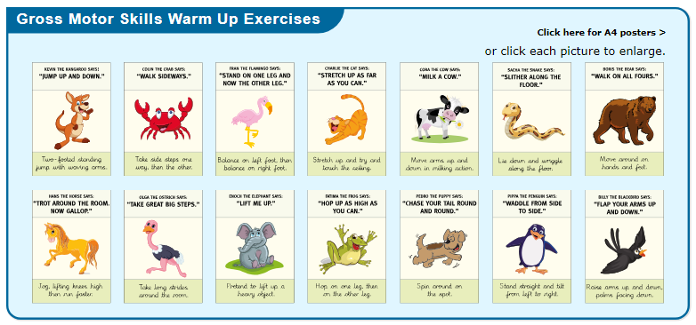
Thank you for your continued support at home.
For additional guidance please watch the following video. How to log in at home - https://www.letterjoin.co.uk/videos/homelogin.mp4
