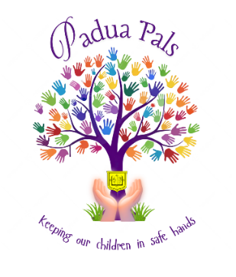
Padua Pals Registration Form
2026-2027
Sessions Required (Please highlight/tick session required)
Breakfast Club | Monday | Tuesday | Wednesday | Thursday | Friday
After School Club | Monday | Tuesday | Wednesday | Thursday | Friday

Childs Full Name: Preferred Name:

Date of Birth: | Year:  from Sept 2026 | Password:  To be used on collection of your child

Parent/Carers Details
Name: | Name:
Home Address: | Home Address:
Work Address: | Work Address:
Mobile Number: | Mobile Number:
Email: | Email:

I give permission for my child to be photographed at the Club and for the photos to be used in Club promotions.
I give permission for my child to take part in food preparation activities.

Please give details of any other adults (over 16 years old) who may collect your child from the Club. We will also use them as an emergency contact should we not be able to contact you.
Name | Relationship to child | Phone number

Please state any information about your child you feel that we need to know (A medical needs form is also included)

Please circle any dietary requirements

Vegetarian / Dairy Free/ Gluten Free / Egg Allergy / Nut Allergy / Seafood

Please detail anything additional …………………………………..

Please note we do not offer Halal so you would need to circle Vegetarian

I give consent for a member of staff to administer first aid as required. I also consent to staff seeking emergency medical advice or treatment during the running of the Club. I authorise Padua Pals Club staff to sign any written consent required by hospital authorities if the delay in getting my signature is considered by doctors to endanger my child’s health.

Signature__________________________________________________________________ Date_______________
If you are planning on paying for your fees by Childcare Vouchers please detail the name of the provider and the reference number for your child below:

Name of Provider:

Reference Number:

