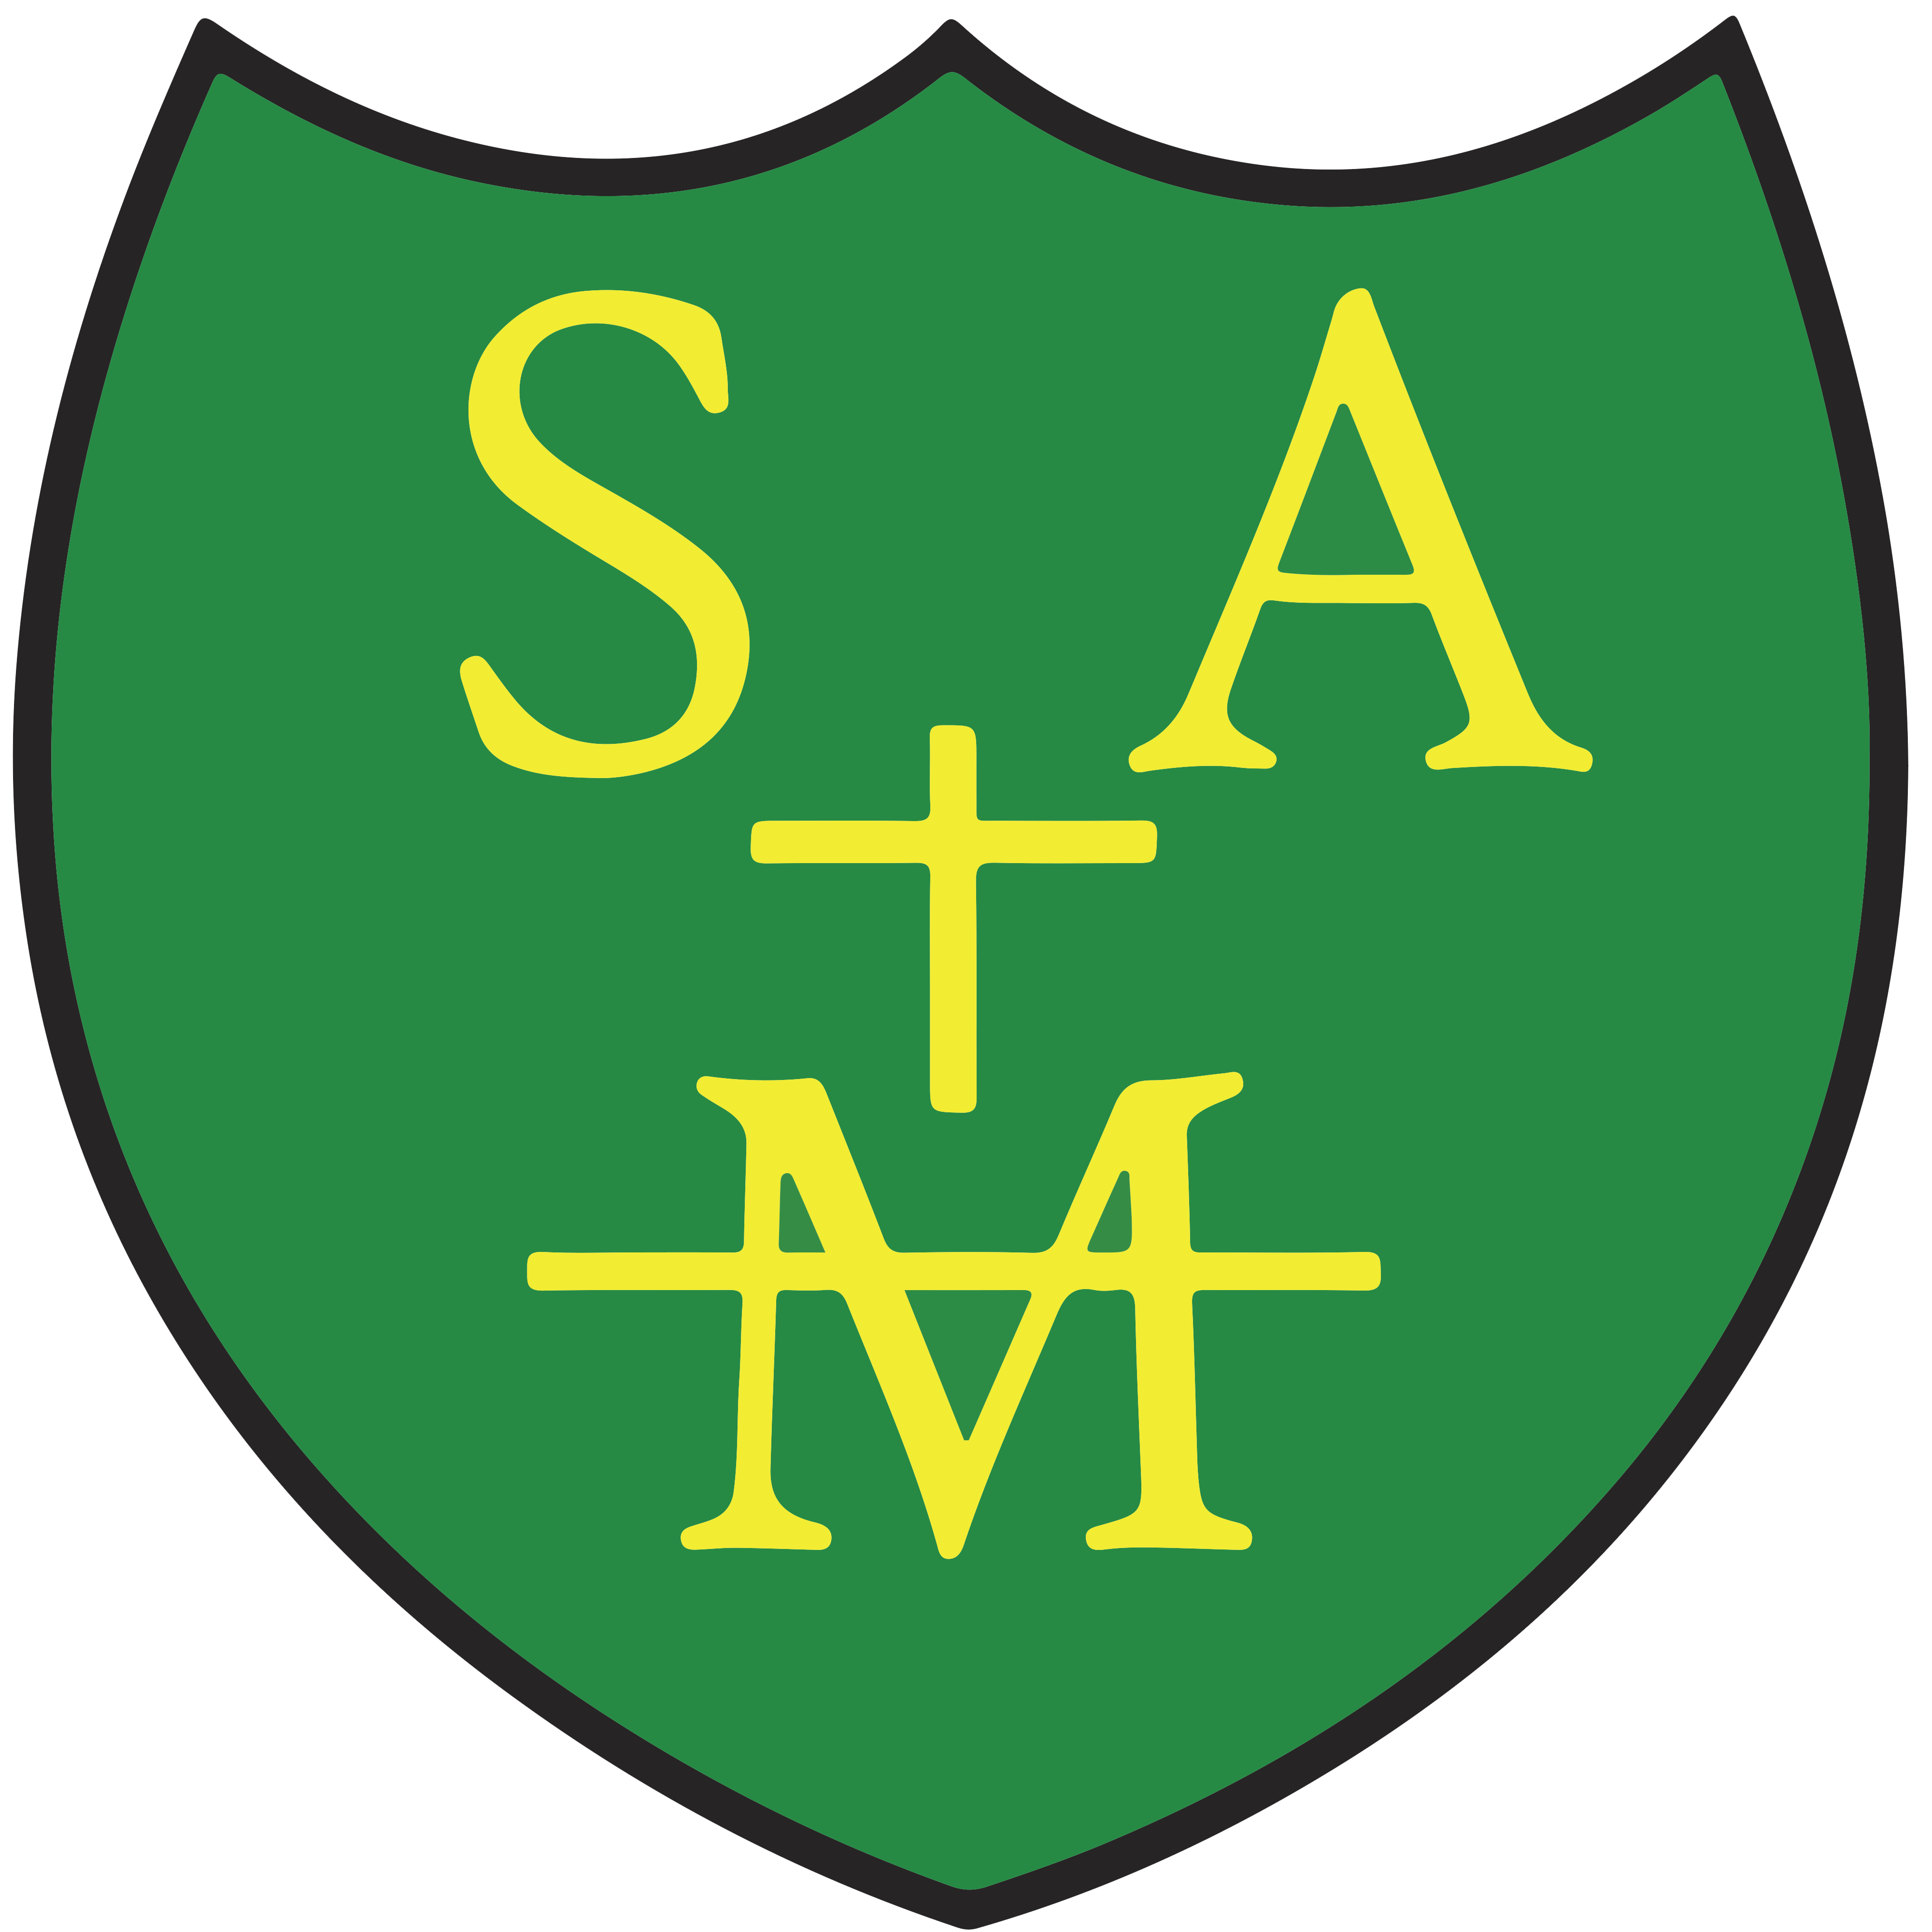
St Augustine's Primary School
EYFS Communication & Language Progression

Intent: At St Augustine’s, children develop as writers through high-quality texts, Drawing Club, systematic phonics, communication and language opportunities, and explicit teaching of handwriting and letter formation. Writing develops from mark making and storytelling through to independent sentence writing by the end of Reception.
Nursery Autumn Term
Area | Progression Expectations
Foundational Skills | Develop gross motor control through climbing, balancing, pushing and pulling. Strengthen fine motor skills through threading, dough, pegs and sensory play. Begin using mark-making tools with increasing control and build shoulder, arm and wrist strength for future handwriting.
Comprehension | Engage in story time, listen with interest, join repeated refrains and begin responding to stories and rhymes. Develop vocabulary through quality texts, talk and Drawing Club discussions.
Phonics & Reading | Notice environmental sounds and rhythm in rhymes. Recognise familiar logos and print. Recognise own name with picture support and begin understanding that print carries meaning.
Drawing Club & Writing | Enjoy mark making using a range of materials. Give meaning to marks and drawings. Represent people, ideas and experiences through drawing. Begin making marks to represent own name and participate in Drawing Club story discussions.

Nursery Spring Term
Area | Progression Expectations
Foundational Skills | Develop one-handed tool control, anti-clockwise movements and pre-writing patterns through large and small scale activities.
Comprehension | Retell key events from familiar stories, sequence three events, identify beginning, middle and end and use vocabulary learned through books and discussion.
Phonics & Reading | Develop Phase 1 phonological awareness. Recognise rhyming words, initial sounds and begin sequencing letters in own name. Recognise own name amongst similar names.
Drawing Club & Writing | Use marks to represent words, labels and messages. Clap syllables, experiment with letter-like shapes and communicate story ideas through Drawing Club.

Nursery Summer Term
Area | Progression Expectations
Foundational Skills | Develop tripod grip, control and precision. Accurately copy circles, squares and horizontal and vertical lines.
Comprehension | Answer who, what and where questions and begin making predictions about stories.
Phonics & Reading | Begin oral blending and segmenting of simple words, recognise letters from own name and understand key concepts about print.
Drawing Club & Writing | Write own name using some correctly formed letters. Begin representing sounds in writing and create story representations through Drawing Club.

Reception Autumn Term
Area | Progression Expectations
Handwriting & Letter Formation | Develop secure pencil grip and correct posture. Form some taught lower-case letters correctly following school handwriting expectations and linked to Sounds-Write.
Comprehension & Vocabulary | Answer retrieval questions, predict events and learn ambitious vocabulary from stories and Drawing Club texts.
Reading & Phonics | Begin Initial code Sounds-Write phonics. Blend some CVC words, recognise own name and understand print concepts.
Composition & Writing | Use Drawing Club to orally rehearse ideas and stories. Write letters, names and CVC words. Apply taught phonemes in labels and captions.

Reception Spring Term
Area | Progression Expectations
Handwriting & Letter Formation | Form most lower-case letters correctly, begin capitals and form numerals accurately.
Comprehension & Vocabulary | Discuss characters, settings and events. Identify beginning, problem and ending and use vocabulary from shared texts.
Reading & Phonics | Continue initial code phonics. Read captions, simple sentences and common exception words.
Composition & Writing | Use Drawing Club and a variety of text types as a stimulus for independent writing. Orally rehearse sentences, write labels, captions and dictated sentences, use phonics to spell and begin using finger spaces.

Reception Summer Term
Area | Progression Expectations
Handwriting & Letter Formation | Form letters consistently and fluently, maintain correct orientation and spacing and develop writing stamina.
Comprehension & Vocabulary | Retell stories, explain characters and events and use recently taught vocabulary accurately.
Reading & Phonics | Apply taught phonics confidently, read words by blending and read books matched to phonics knowledge including common exception words.
Composition & Writing | Use Drawing Club and a variety of text types as a stimulus for independent writing. Compose and write simple sentences, re-read writing and apply finger spaces and phonics independently.

End of Reception- Early Learning Goals
Children demonstrate secure foundations in transcription, composition and communication. They form recognisable letters, apply phonics to spell words, write simple phrases and sentences, and use vocabulary developed through phonics, Drawing Club and high-quality texts.

