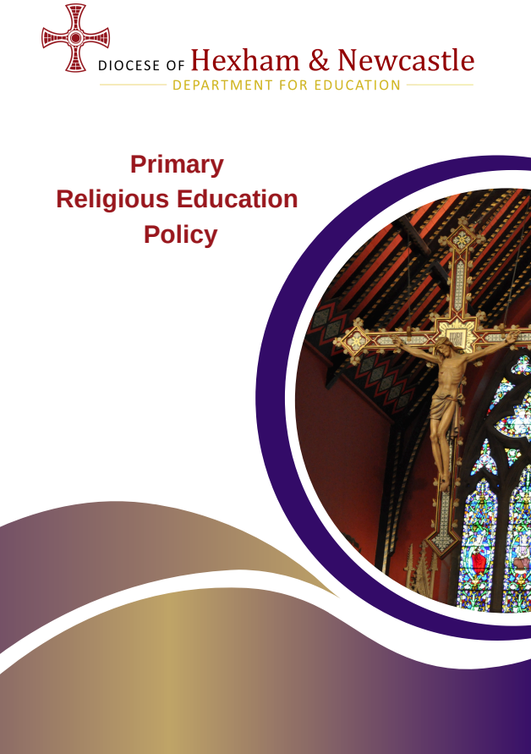

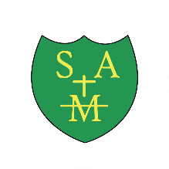

School mission statement:
“ I have come so that they may have life and life to the full.” John 10:10

- Context of this religious education policy

In the nineteenth century, St John Henry Newman passionately defended the principle that

Catholic universities become places where dialogue between academic disciplines was encouraged and celebrated as essential in the pursuit of truth. To dialogue means to reach out to others by actively listening to them.

In our times and circumstances, we strive to extend this principle to our schools, and the religious education curriculum needs to lead the way, offering everyone the opportunity to speak openly and with true freedom so that minds can meet in the pursuit of truth.

Newman said, ‘I wish the intellect to range with the utmost freedom, and religion to enjoy an equal freedom; but what I am stipulating for is, that they should be found in one and the same place and exemplified in the same persons.’

Our task is to make that place the Catholic school, with religious education at its heart.
- The importance of religious education

Religious education is the core of the core curriculum in a Catholic school. Placing religious education at the core of the curriculum helps the school to fulfill its mission to educate the whole person in discerning the meaning of their existence

A Catholic education is “focused on integral formation of its students and at the same time prepares them for full participation in civic life. It forms the Catholic student as ‘both human and a person of faith, the protagonist of culture and the subject of religion’. It teaches subjects with methods proper to them and at the same time imbues the whole curriculum with a Christian outlook. It is established for Catholic students and at the same time draws others to its doors. In short, the Catholic school reflects the apparent paradox of the incarnation that is resolved in Christ: it is both fully Catholic and really a school. Religious education in a Catholic school also bears witness to the same mystery: it is both fully religious and genuinely educational.”

Aims for religious education
Religious education is at the heart of our school life. We aim to ensure that all pupils will have the opportunity:
- To engage in a systematic study of the mystery of God, of the life and teaching of Jesus Christ, the teachings of the Church, the central beliefs that Catholics hold, the basis for them and the relationship between faith and life.
- To enable pupils continually to deepen their religious and theological understanding and be able to communicate this effectively.
- To present an authentic vision of the Church’s moral and social teaching to provide pupils with sure guide for living and the tools to critically engage with contemporary culture and society.
- To give pupils an understanding of the religions and worldviews present in the world today and the skills to engage in respectful and fruitful dialogue with those whose worldviews differ from their own.
- To develop the critical faculties of pupils so to bring clarity to the relationship between faith and life, and between faith and culture.
- To stimulate pupils’ imagination and provoke a desire for personal meaning as revealed in the truth of the Catholic faith.
- To enable pupils to relate the knowledge gained through religious education to their understanding of other subjects in the curriculum.

- The Curriculum
At St Augustine’s Catholic Primary School, religious education is based on the Religious Education Directory (RED) “To Know You More Clearly”. In line with the Bishop’s mandate, the RE curriculum is taught through the Diocesan resource, ‘The Way’.
In recognition of the importance of religious education in our school, we devote 10% of the teaching week to religious education lessons; not including Collective Worship. In Early Years, the timetable and learning style is more flexible, but teaching of Religious Education is prioritised to give children the opportunity to engage fully with the curriculum.
Through The Way, pupils are given opportunities to deepen their knowledge and understanding of key theological concepts and teachings of the Catholic Church. They are encouraged to make links between faith and daily life, apply their learning across the wider curriculum and reflect on how Gospel values influence their choices and actions. Religious Education supports pupils in developing respect for others, critical thinking skills and a growing understanding of their place within God's world.

The Religious Education Curriculum Directory has a clear framework for learning:
- Knowledge lenses
Hear, believe, live and celebrate indicate what should be known by the end of each age phase.
- Ways of knowing
Understand, discern and respond are the skills through which children progress and develop their thinking during the curriculum journey.
- Expected Outcomes
Sets out what pupils should be able to know, remember and do in each year group
- Curriculum branches
Divide the model curriculum into 6-week units of study which repeat annually, giving a spiral curriculum which allows children to build progressively on the prior knowledge and develop their understanding year by year.
The curriculum branches are:
Branch 1 | Creation and Covenant
Branch 2 | Prophecy and Promise
Branch 3 | Galilee to Jerusalem
Branch 4 | Desert to Garden
Branch 5 | To the Ends of the Earth
Branch 6 | Dialogue and Encounter
The curriculum is firmly founded on building children’s knowledge and understanding of Scripture, while providing opportunities to make connections to other faiths and cultures, as well as to their daily lives.
- Religious education in the classroom and beyond
At St Augustine’s Catholic Primary School, the teaching of religious education is designed to be as varied and creative as possible, to help children to engage fully with the ideas explored, to ask questions and to lead their own learning in discerning their response.
Learning within the classroom may include:
- Whole class teaching and discussion
- Partner and group work
- Drama and role play
- Artwork, music and creative responses
- Scriptural enquiry and theological discussion
- Use of religious artefacts and sources
- Visits and visitors where appropriate

Learning in religious education cannot always be recorded and does not begin or end in the classroom. Learning from religious education will flow into other curriculum areas as pupils make links between their learning. We aim to give children the opportunity to connect their formal learning with their wider understanding through regular opportunities to reflect and respond.
Learning beyond the classroom may include:
- Mini Vinnies projects and charitable outreach
- CAFOD fundraising and awareness campaigns
- Parish links and sacramental preparation
- Celebration of the Word
- Gospel value and virtues activities
- Opportunities for leadership through chaplaincy and liturgy
- Acts of service within school and the wider community.
We work closely with parents and with the parish(es) to support children’s progress in understanding and developing on their curriculum and faith journey.
- The importance of the role of parents in religious education

Our school community recognises the central role parents have in the religious education of their children. The Bishops’ Conference of England and Wales reiterated that: “The first educators in the faith are parents.”

In recognition of this, we strive to maintain a faithful partnership with parents, communicating clearly both the curriculum and the wider spiritual opportunities offered to families and warmly inviting parents to share their knowledge and experiences with the school community.

Our school works closely in partnership with families and with St Augustine's Parish. Through this partnership, children are supported in developing both their religious knowledge and their faith journey. Parents are encouraged to participate in liturgies, celebrations and sacramental preparation programmes, recognising their role as the first educators of their children in faith. The General Directory for Catechesis confirms, “This partnership between home and parish is enhanced by the role of the Catholic school in which the educational mission of the Church finds a particular and important expression.” Religious education in a Catholic school encompasses the whole educational mission of the Church and is not confined to timetabled Religious Education lessons.
- Other world views
Catholic education seeks to form pupils who are well prepared to play a positive role in society and to follow Jesus' teaching to "love your neighbour". We therefore embrace learning about other world views with "a willingness… to try to understand better the religion of one's neighbours, and to experience something of their religious life and culture."
The Religious Education Directory includes the branch Dialogue and Encounter, which focuses on exploring other world views and recognising connections with the Catholic faith. Through The Way curriculum, pupils develop respect for those of different faiths and beliefs whilst deepening their understanding of their own faith tradition.
At St Augustine's Catholic Primary School, opportunities for dialogue and encounter are built into the curriculum and wider life of the school. We seek to broaden pupils' knowledge, understanding and appreciation of different faiths and world views through meaningful learning experiences, which may include:
- Study of Judaism and other world faiths as outlined within The Way curriculum and Religious Education Directory.
- Visits to places of worship, including local churches and other faith communities where appropriate.
- Encounters with visitors from different faith backgrounds who can share their beliefs, traditions and experiences.
- Exploration of religious artefacts, texts, symbols and practices from other faith traditions.
- Participation in discussions which encourage pupils to reflect on similarities and differences between faith traditions and their own lived experiences.
- Independent research and enquiry activities which promote curiosity, respect and understanding.
- Links with Catholic Social Teaching, helping pupils recognise the dignity of every person and their responsibility to contribute positively to a diverse society.
Through these experiences, pupils are encouraged to develop mutual respect, understanding and empathy, preparing them to live and work alongside people of all faiths and none within modern Britain.
External speakers are always checked in line with the Catholic Education Service guidance for external speakers to ensure safe, balanced and constructive opportunities for dialogue and encounter.
Meeting God in Friend and Stranger, Catholic Bishops' Conference of England and Wales (2009)
- Feedback, assessment, recording and reporting
Feedback is given in religious education to support children’s progress and to challenge their thinking. Feedback follows the school's Teaching, Learning and Feedback Policy and may be verbal, written or through live feedback during lessons.
Assessment follows diocesan and national guidelines, assessing against the expected outcomes for each branch in the Religious Education Directory. Pupil attainment in Religious Education is assessed against the expected outcomes identified within The Way and the Religious Education Directory. Assessment information is recorded termly and monitored by the RE Subject Leader, Headteacher and Senior Leadership Team to ensure pupils make appropriate progress.
Assessment information is used to identify strengths, areas for development and any additional support required. Moderation activities are undertaken both within school and alongside other Catholic schools to ensure consistency and accuracy of judgements.
The RE subject leader will moderate outcomes in religious education both internally and with other Catholic schools, to ensure consistency of expectations with other schools in the diocese.
Outcomes for religious education are shared in line with other core curriculum subjects, both during parent consultation meetings and in end-of-year reports.
- Monitoring and evaluating
The RE subject leader and Senior Leadership Team monitor every aspect of religious education in line with other core curriculum subjects. Monitoring takes place termly and includes lesson visits, learning walks, pupil discussions, planning scrutiny, work scrutiny and assessment reviews. Outcomes are used to identify strengths, inform future staff training and support the continued development of Religious Education throughout the school.
The RE Subject Leader is given opportunities to work alongside colleagues during RE lessons to provide coaching, support and professional dialogue to ensure high-quality implementation of The Way across all year groups.

Self-evaluation of religious education is the responsibility of the Headteacher, the RE subject leader, Governors and the Senior Leadership Team, with further input from all teachers of religious education, from families and from pupils. This process ensures a culture of continuous improvement, so that teaching and learning in religious education remains the best it can be.
- Staff formation
All staff support the Catholic ethos of St Augustine's Catholic Primary School and are committed to nurturing pupils' faith development, spiritual growth and Religious Education. Staff are provided with regular opportunities for prayer, reflection and professional dialogue, recognising that formation is an essential part of working within a Catholic school community.
The RE Subject Leader attends diocesan subject leader meetings, training events and moderation opportunities throughout the year to ensure Religious Education remains up to date and reflects current diocesan guidance. Good practice is shared with staff through meetings, coaching conversations and professional development opportunities.
As The Way curriculum is being implemented across the school, staff receive regular training to develop their confidence and subject knowledge. This includes diocesan training, trust-wide professional development, staff meeting updates and access to diocesan online training materials. Ongoing support is provided to ensure consistency and high-quality delivery of the curriculum across all year groups.
All new staff receive induction and mentoring in Religious Education, Catholic Life and Mission, and Prayer and Liturgy. The RE Subject Leader provides bespoke support, guidance and training to ensure staff are confident in planning and delivering The Way curriculum and leading prayer opportunities.
Staff are encouraged to engage in continuing professional development through diocesan training, Catholic Certificate in Religious Studies (CCRS), Bishop Hogarth Catholic Education Trust professional development opportunities, trust-wide networks, moderation activities and school-based training. Opportunities are also provided for staff to work alongside colleagues, observe good practice and receive support within the classroom.
The school is committed to ensuring that all staff continue to deepen their understanding of Catholic education and are equipped to deliver high-quality Religious Education, Prayer and Liturgy and Catholic Life and Mission experiences for all pupils.

- Catholic Life and Mission
Religious Education forms part of the wider Catholic Life and Mission of St Augustine's Catholic Primary School. Through Prayer and Liturgy, Gospel values, Catholic Social Teaching, charitable outreach and parish partnerships, pupils are encouraged to live out their faith in practical ways. Opportunities such as Mini Vinnies, CAFOD fundraising, community service activities and leadership of worship support pupils in becoming active disciples who serve others and contribute positively to society.

- Review
The policy will be reviewed as part of the regular cycle of policy review conducted by the governors.
This religious education policy has been approved and adopted by the Local Governing Committee on [enter date] and will be reviewed on [enter date].

Signed by the Chair of Local Governing Committee: _________________________________

Signed by the Headteacher: _______________________________________________________

Person responsible for implementation of policy: ____________________________________

Review date: ________________

To know You more clearly, Religious Education Directory for Catholic Schools, Academies and Colleges in England and Wales, June 2023, p4-5
Address to Bishops’ of Great Britain during ad limina visit to the Vatican, Pope St John Paul II, 1992
To know You more clearly, Religious Education Directory for Catholic Schools, Academies and Colleges in England and Wales, June 2023, p9
To know You more clearly, Religious Education Directory for Catholic Schools, Academies and Colleges in England and Wales, June 2023, p6
Religious Education in Catholic Schools from the Catholic Bishops' Conference of England and Wales, 2000
Religious Education in Catholic Schools from the Catholic Bishops' Conference of England and Wales, 2000

