SEND Information Report 2027
St Augustine’s Catholic Primary School


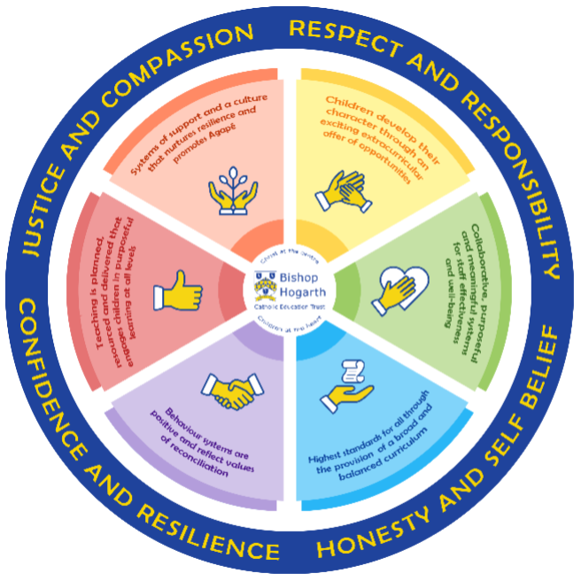

As part of the family of Bishop Hogarth Catholic Education Trust, our school has at its core, the virtues, and values of:
Respect for others and themselves, recognising that we are all created in the image of God and therefore must be compassionate towards others, especially the vulnerable. ​
Confidence in their own abilities, knowing that their talents are gifts from God and resilience to persevere when things become difficult. ​
Honesty in regard to the world around them and themselves and the ability to take responsibility for the times we may fall short of the mark. ​
Gratitude for all the amazing gifts from God and willingness to share their gifts both personal and material. ​

As an inclusive school, all teachers are teachers of pupils with Special Educational Needs & Disabilities. We deliver a curriculum and create an environment that meets the needs of every pupil within our school. We ensure that every pupil with Special Educational Needs and / or disabilities makes the best progress possible. We foster and promote effective working partnerships with parents / carers, pupils, and outside agencies. We consider the ‘whole’ child and strive to ensure that all our SEND pupils are prepared for adulthood.​

Our school’s approach to supporting pupils with SEND

At St Augustine’s Catholic Primary School, we strive to be an inclusive school. Inclusion is central in the Catholic ethos and values of our school – a philosophy, which covers every child’s right and entitlement to the very best experiences education can offer. Our school aims to encourage all children to see Christ in themselves and others in a caring environment which allows them the opportunities to develop to their full potential and “live life to the full”.
Our St. Augustine’s approach to supporting our pupils with SEND is simple. We believe that every teacher is a teacher of SEND.
Our approach follows the 5 recommendations from The EEF guidance report for Special Educational Needs in Mainstream School.
We ensure that we:
- Create a positive and supportive environment for all pupils without exception.
At St Augustine’s we strive to remove barriers to learning and participation to ensure we provide an education that is appropriate to all pupils’ needs. In doing so, we ensured to promote high standards so as to enable all children to fulfil their potential. To do so, we ensure that relationships are key by adopting a child centred approach to creating positive relationships with all pupils, including those with SEND. We promote positive relationships, active engagement and the wellbeing for our pupils. We ensure that all pupils are provided with and access the best possible teaching.

- Build an ongoing, holistic understanding of our pupils and their needs.
We make it a priority to understand the individual learning needs of all of our children by using the graduated approach of ‘assess, plan, do, review’. We make sure that assessment is purposeful and regular, ensuring to involve and seek input from the child, families and specialist professionals where appropriate. As a leadership team, we empower and trust the teachers to use the information they collect to inform their decisions regarding the next steps for teaching.

- Ensure all pupils have access to high quality teaching.
We are firm believers that good teaching for all, is good teaching for pupils with SEND. As class teachers, we are proactive in using a range of strategies to support all learners including: explicit instructions, scaffolding, modelling, flexible grouping and cognitive and metacognitive strategies. Class teachers adopt the process of adaptive teaching so that all pupils can access and learn.

- Complement high quality teaching with carefully selected small-group and one-to-one interventions.
We ensure that all interventions, whether they are small-group or one-to-one, are used carefully and to complement high quality teaching. For most children, we believe that high quality teaching will reduce the need for extra support. For those children who require additional support, St. Augustine’s adopts a strategy that offers tiers of increasingly intense support to pupils as required. We ensure that our interventions are high quality, structured, targeted interventions to support the child in making progress. We carefully target these interventions through identification and assessment of need through our graduated approach.

- Work effectively with teaching assistants
We take great care to ensure effective deployment of teaching assistants across St Augustine’s to ensure they have a positive impact on pupils with SEND. We firmly believe that TAs should supplement and not replace teaching from the class teacher.

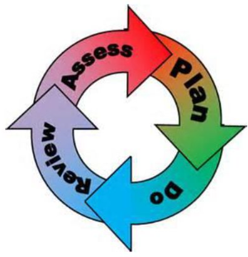
How will the school staff support my child?
The graduated response-Identifying, planning for and supporting pupils with SEND
Where a pupil is identified as having a special educational need, School will follow a graduated approach which takes the form of cycles of ‘Assess, Plan, Do, Review’. ​
• Assess a child’s special educational need. ​
• Plan the provision to meet your child’s aspirations and agreed outcomes. ​
• Do put the provision in place to meet those outcomes. ​
• Review the support and progress.

How does the school know if children need extra help and what do I do if I think my child has special educational needs?

- Assess
Our teachers work carefully to carry out observations and hold discussions with key individuals including the SENDCo, parents/carers and the child so as to accurately identify, understand and assess the child’s individual needs so that we can provide the right support. We believe it is crucial to ensure that families, and where appropriate the child, are actively involved in this process. When required, with parental consent, we may seek further advice from external professionals including Education Psychologists, Speech and Language Therapists, Occupational Therapists, CAMHS and outreach teams.

- Plan
Following the assessment, our teachers will invite families into school for a meeting to discuss the plan for what support will be put into place for each child. In partnership with school and home, we agree the SMART outcomes to be focussed on during that half term. We make sure these are specific, measurable, achievable, relevant and timely. The plan ensures to involve the child and the family at the centre. During this time, it will be discussed what support will be required and any provisions and interventions identified. The plan will be agreed and shared with families at the end of the meeting.

- Do
Our teachers are skilled at adapting teaching and learning to meet the needs of all children in each class. ​
Daily planning considers individual children’s needs and requirements and is adapted according to need. Explicit reference is made in the teacher’s planning to the needs of those children identified with SEND. ​
Adaptive teaching is approached in a range of ways to support access to the curriculum and ensure that all children can experience success and challenge in their learning. Grouping arrangements consider the different skills and abilities of each child. This ensures that learning is maximised. ​Additional adults support groups and individual children with the long-term goal of developing independent learning skills. The class teacher monitors this support to avoid students becoming over reliant on this. ​ We fully encourage parental support and offer opportunities for individual meetings with parents/carers to provide clarity and recommendations on how they can support their child at home.

- Review
Termly, families are invited into school to review the child’s progress. Half- termly, progress is reviewed by teachers and families together via Dojo or a Phone call. This is documented on Edukey. Following discussions and setting of targets, learning plans will then be sent home in a sealed envelope within the second week of each half term upon a return to school. It is important that families, and the child (where applicable), are involved in this review. This will involve a discussion with all involved about how effective the support has been and the impact noticed. The previous SMART outcomes will be discussed and reviewed. The next steps will then be carefully planned and new outcomes set. If a child has not met the outcomes set, it will be important to discuss and decide what can be done next. It might be that involvement of external professionals may be requested to provide a greater understanding into a child’s needs and to support the next steps. For some children, the next step may be, in partnership with families, to ask Darlington Local Authority for an EHC needs assessment. If families also think it is needed, they can do a parental request.

How will the curriculum at our school be matched to my child’s needs?
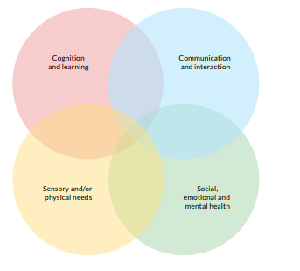

SEN needs are classified under four broad areas of need (which often interlink as shown). Below are the strategies, in class support and interventions that St Augustine’s may put in place to support your child.
Communication and Interaction
Strategies to support children with these needs include:
- QFT approaches to support the development of social communication and interaction skills.
- Flexibility to support the child to follow instructions and record work.
- Flexible pupil groupings to encourage positive peer speech and language models
- Visual systems including visual timetables.
- Preparation for change and the need for clear routines,
- Reduction of complex language especially when giving instructions and asking questions.
- Targeted support for parts of the day including unstructured parts of the day e.g. start and end of the school day, breaks and lunch times.
- Support for areas of sensory needs for example a ‘time out’ space
- Environment adaptions so as to reduce stress and anxiety.
- Opportunity for planned small group activity focussing on language and communication.
- Zones of Regulation
- Lego Therapy
- Sensory Circuits
- ELKLAN
- Social Stories

Cognition and Learning
Strategies to support children with these needs include:
- Simplify level / pace / amount of teacher talk
- Opportunities for skill reinforcement, revision, transfer and generalisation
- Opportunities for small group work based on identified need
- Emphasis on identifying and teaching gaps assessment
- Formal teaching of vocabulary concepts including pre-teach
- Multi-sensory learning opportunities
- Alternative ways of recording
- Technology including ICT as appropriate e.g. text to speech and Clicker
- Visual cues to support auditory information
- Scaffolding
- Pre and post teaching
- Over learning
- Nessy
- Colourful Semantics
- Sounds Write
- Touch Typing- Read and Spell

Sensory/Physical
Strategies to support children with these needs include:
- Sensory Circuits
- Speed Up!
- Technology to support including access to appropriate ICT provision
- Adapted writing materials and equipment
- Attention to position within the classroom

Social, Emotional and Mental Health
Strategies to support children with these needs include:
- Clear routines and visual timetable
- Consistent rules and expectations across all staff
- Group work to be planned and tailored to meet identified need
- Emotional literacy delivered by our ELSA
- Preparation for changes to routines/changes/staffing
- Comic strip conversations
- Social stories
- Zones of Regulation
- The Incredible 5 Point Scale
- Sensory Circuits
- Mental Health Support Team

Our Tiered Offer to support all:

St Augustine’s Catholic Primary School
Tiers of Support
At our school, we want every child to feel confident, successful and supported. Sometimes children need a little extra help with their learning, and we use a tiered system to make sure they get the right help at the right time. There are three tiers, starting with what every child gets, and adding more support if needed.
Tier 1: Quality First Teaching for Every Child
This is the teaching your child receives every day in the classroom. This includes well planned and engaging lessons, adapting work to meet different needs, clear explanations and good routines help children learn and teachers regularly checking learning and addressing gaps.
Most children make good progress with tier 1 alone.
Cognition and Learning | Communication & Interaction | Social, Emotional and Mental Health | Sensory and Physical
- Minimal distractions in the classroom/setting  - Consideration of a range of learning styles in one classroom- practical tasks, written tasks, visual tasks  - Sounds-Write | - A safe space for pupils to share their views  -Consistent expectations from all adults | - Safe and Stimulating Environment, rooted in mutual respect  - Morning Greeting  - Predictable Structured routines  - Visual Timetable  - A whole class ‘fresh start’, ‘mistakes are okay’ | - The seating position of each child  - Environmental Layout
- Explicit Instructions: Teacher-led approaches with a focus on clear explanations, modelling and frequent checks for understanding. This is then followed by guided practice, before independent practice
- Cognitive and metacognitive strategies: Provide opportunities for students to plan, monitor and evaluate their own learning
- Scaffolding: Supportive tools or resources such as a writing frame or a partially completed example, gradually withdrawing/minimising as needed.
- Flexible Groupings
- Use of technology
- Scaffolding
- RIP/PIP
- Routines
- Range of Learning styles: visual, practical, written
- Questioning
- Pace
- Zones of regulation

Tier 2: Targeted Support
Some children may need a short period of extra help, working with a n additional adult to catch up or strengthen skills. This may involve: small-group session, support in reading, writing, maths or other curriculum areas, a planned programme lasting a few weeks, close monitoring to check progress or support linked to an Education, Health and Care Plan (EHCP). All interventions in tier 1 can be accessed in tier 2. These small steps can make a big difference in confidence and learning.
Cognition and Learning | Communication & Interaction | Social, Emotional and Mental Health | Sensory and Physical
- Educational Psychologist Recommendations  - Colourful Semantics  - Nessy  - Touch Typing  - SNIP  - Pre/Post teaching | - Speech and Language Support  - Lego Therapy  - ELKLAN  - Social Stories | - ELSA  - Time to talk  - Talkabout  - Lunch time group  - Mental Health Support Team | - Occupational Therapist  - Speed Up!  - Dough Disco  - Sensory Circuits  - Fine/Gross Motor
- Zones of Regulation
- Small Group and One-to-One Support
- Diagnostic Assessments

Tier 3: Specialist Support
A few children may need more individual or long-term support, because their needs are more significant or ongoing. This could include: 1:1 teaching or highly personalised programmes, specialist advice (e.g., Speech and Language Therapy, Occupational Therapy), adapted resources, routines or curriculum, support linked to an Education, Health and Care Plan (EHCP) if the child has one. This support is carefully planned and reviewed more frequently.
All interventions in tier 1 and tier 2 can be accessed in tier 3.
Cognition and Learning | Communication & Interaction | Social, Emotional and Mental Health | Sensory and Physical
- Delivery of personalised programs
- Highly individualised support plans
- Multi-agency collaboration
- Individual Visual Timetable
- Range of areas to access
- Individual workstation
- School layout adaptations

What training is provided for staff supporting children with SEND?
Whole Staff
What is SEND? Areas of Need. Darlington Ranges. Current context of school. Graduated response. NASEN – support for SEND across the curriculum. Universal Offer. SMART Target training. Initial and ongoing Edukey training. Adaptive teaching. Every Teacher is a Teacher of SEND. Zones of Regulation. Dyslexia Awareness through Nessy. EP support and drop in consultations. PDA. Autism and Neurodiversity training, End of Year consultation with the Educational Psychologist linked to transition, Sensory Smart classrooms, Mental Health Support Team

Bespoke Training
Delivery of provisions including: precision teaching, colourful semantics, sensory circuits. ELSA training and supervision sessions. Beacon House developmental trauma. Autism and Practical support. Managing behaviour that challenges. ELKLAN EEF Communication Friendly Settings Programme. De-escalation Training.

How do we support transition in our school?

Transition within classes/key stages: ​
- Transition mornings or afternoons where children meet their new class teacher
- Extended transition offers for those children who require this
- SEND hand over at the end of the academic year where outcomes are reviewed and new set with the family, current class teacher and next years class teacher present.
- Thorough written hand over documents to the next class teacher
- Teachers have the opportunity to consult the Educational Psychologist about new cohort as part of transition

Transition to Secondary settings: ​
- SENDCo and Y6 teachers in regular discussion with secondary schools including formal meetings.
- Pupil profiles for all children with SEND written
- SEND plans and documentation shared
- Enhanced transition offers for those children who require this additional to the 2 days
- Visits arranged prior to the transition days for those children who require this.
- Meetings with the secondary SENDCo’s organised where required.

Where can I get further information about services for my child?

The Local Offer
The Local Offer is Darlington Borough Council's publication of all the provision the local authority expects to be available across Education, Health, and Social Care for children and young people (0-25) in our area, who have special educational needs and/or are disabled, including those who do not have Education Health and Care (EHC) plans.

The main purpose of the Local Offer is to provide clear, comprehensive, accessible and up-to-date information about the available provision and how to access it; and to make provision more responsive to local needs and aspirations by directly involving children and young people with special educational needs and/or disabilities, their parents, and service providers in its development and review.

Independent, impartial advice on all matters SEND is freely available to children, young people and their parents and carers from SENDIASS and also from the Darlington Parent Carer Forum. The staff in these organisations have had relevant training regarding the SEND Code of Practice and the Equalities Act, as well as appropriate personal checks carried out on their suitability to carry out their roles. Both organisations comply with data protection legislation to keep you and your information safe and secure and both are covered by public liability insurance. When seeking advice and support on SEND matters please ensure you are doing so safely – the easiest way to do this is through the appropriate and recognised channels.

For more information please see: https://livingwell.darlington.gov.uk/Categories/528

What key school documents refer to support and provision for pupils with SEND?

- SEND Policy​
- Admissions Policy​
- Supporting Pupils with Medical Needs Policy​
- Accessibility Plan​

What to do if you have a complaint, a compliment, or a query.

The school details and relevant contacts
You can telephone on: 01325 380819

You can email at: sta-sen@staugustines.bhcet.org.uk

Key Contacts:
Mrs K Whitehead - Headteacher
Miss E Barnard - SENDCo

Name of school SEND governor.
Mr S Rhatigan

