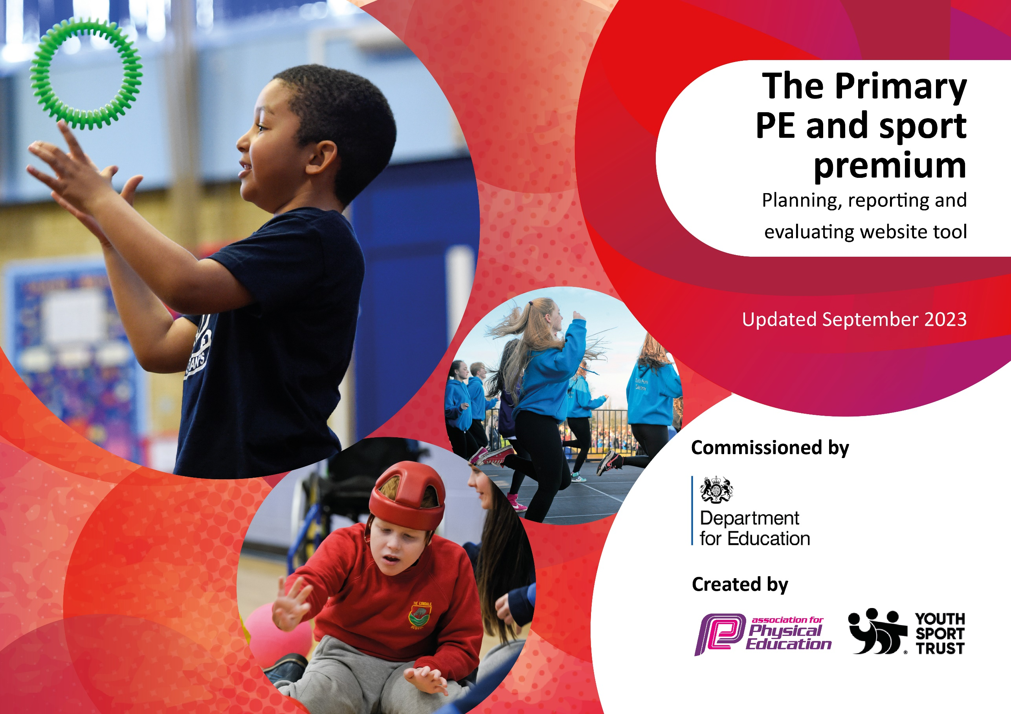

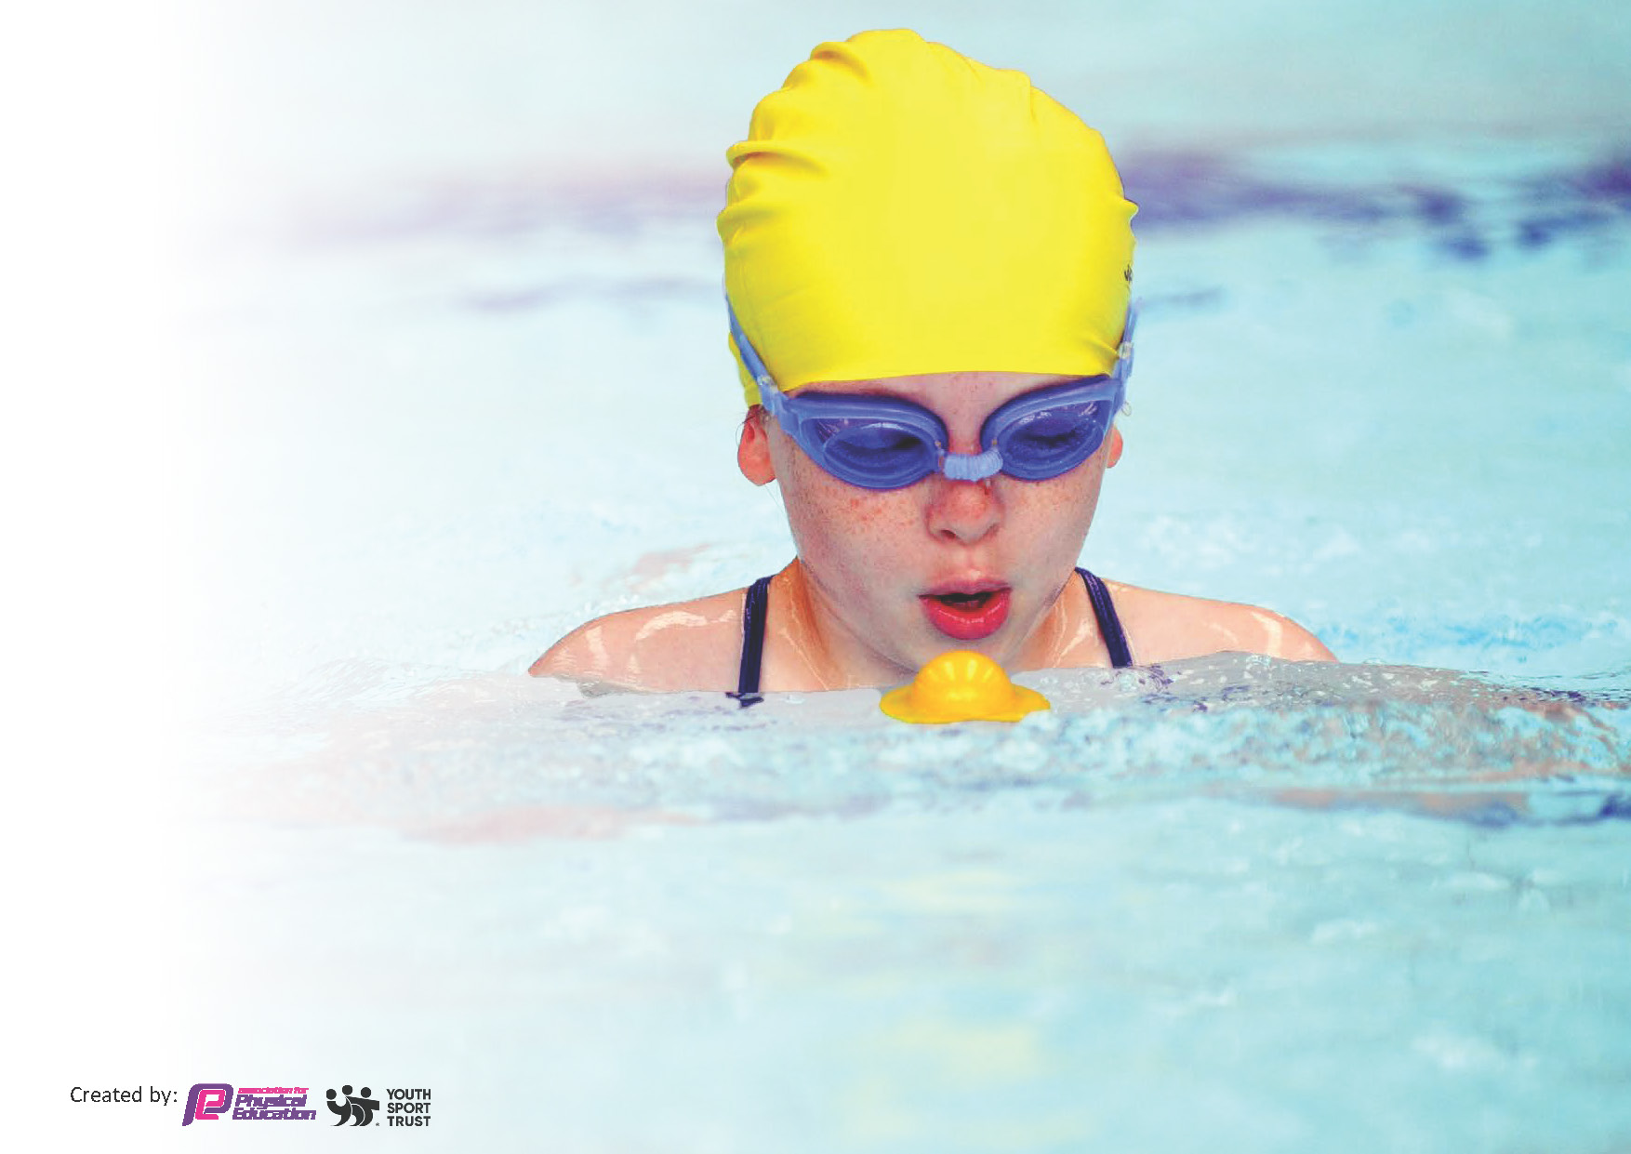
This template can be used for multiple purposes:
by:
- It enables schools to effectively plan their use of the Primary PE and sport premium
- It helps schools to meet the requirements (as set out in guidance) to publish information on their Primary PE and sport premium
- It will be an effective document to support Ofsted inspections enabling schools to evidence progress in Physical Education (PE) and evidence swimming attainment, which forms part of the PE National Curriculum. We would recommend schools consider
the Intent, Implementation and Impact of any spend, as examined within the Education Inspection Framework.

It is important that your grant is used effectively and based on school need.

Schools must use the funding to make additional and sustainable
improvements to the quality of the PE, School Sport and Physical Activity (PESSPA)
they offer. This means that you should use the Primary PE and sport premium to:

- Build capacity and capability within the school to ensure that improvements made now will benefit pupils joining the school in future years
- Develop or add to the PESSPA activities that your school already offers.

The Primary PE and sport premium should not be used to fund capital spend projects; the school’s core budget should fund these. Further detail on capital expenditure can be found in the updated Primary PE and sport premium guidance.

The Primary PE and sport premium guidance, outlines 5 key priorities that funding should be used towards. It is not

necessary that spending has to meet all the key priorities, you should select the priorities that you aim to use any funding towards.

Although completing this template is not a requirement for schools, schools are required to publish details of how they spend this funding. Schools must also outline what the impact this funding has had on pupils’ PE and sport participation and attainment and how any spending will be sustainable in the future. All funding must be spent by 31st July 2024.

The Department for Education has worked closely with the Association for Physical Education (afPE) and the Youth Sport Trust (YST) to develop this template and encourages schools to use it. This template is an effective way of meeting the reporting requirements of the Primary PE and sport premium.
Review of last year’s spend and key achievements (2022/2023)

We recommend you start by reflecting on the impact of current provision and reviewing your previous spend.

Activity/Action | Impact | Comments
KI 1: Children to take part in a regular run and improve fitness and stamina. Least active children are targeted.  KI 2: Acknowledge sports participation and achievement both in and out of school  Pupils share ownership of promotion of sports and exercise.  KI 3: Increased subject leader knowledge. Increased confidence in the teaching of PE. Renewal of Get Set 4 PE.  KI 4: Experience a range of sports and allow pupils to access specialist coaching/teaching  KI 5: Children will be able to attend a wide variety of competitions throughout the school year. | All staff will continue to regularly take their classes out for a run. A timetable will be created if necessary. Children set personal goals for improvement. The children have access to a range of activities and find something that they enjoy and may wish to pursue beyond school  Change for life Champions can share their knowledge of healthy lifestyles with peers.  Change for Life pupils have opportunities to represent the school in ‘festival’ style sports events. Children improve their coordination and gross motor skills.  Pupils are inspired by their peers to become involved in sports and sports clubs.  Parents/carers are informed about sports events and opportunities and encouraged to enrol their child in sports and other physical activities being offered in school and beyond  PE lead to share ideas from conference at staff meeting so that these ideas can be incorporated into school practise. Teacher’s will be present in these lessons and take notes on new ideas. There will be a time table to ensure that different year groups benefit and that the TAs subject knowledge/expertise is used effectively. Continue to use scheme  Review use of scheme once Trust PE Curriculum is produced.  Pupils and their families  consider healthy and sustainable travel options.  Continue to offer a range of sporting clubs. Provide more opportunities for KS1 pupils.  School will continue to participate in competitive sports  School participated well in sporting events with a positive uptake within PE for targetted groups. School achieved Bronze overall with School Games Mark. | Targets implemented by previous PE lead.

Key priorities and Planning
This planning template will allow schools to accurately plan their spending.

Action – what are you planning to do | Who does this action impact? | Key indicator to meet | Impacts and how sustainability will be achieved? | Cost linked to the action
Upgrading/re-spraying schoolyard to incorporate playground activities, which children can participate.  Aim to engage children who are less active. | Pupils, as this will enable them to take pride in their playtime and PE lessons and enable them to carry out further physical activity to increase participation throughout. Staff will be able to lead more efficient PE lessons. | Key indicator 1: The engagement of all pupils in regular physical activity – Chief Medical Officers guidelines recommend that primary school pupils undertake at least 30 minutes of physical activity a day in school | Children have the opportunity to participate in activities on the yard.  Staff to utilise markings within PE sessions.  Sports leaders to lead active sessions with new markings. | £7000 allocated for purchasing of markings.
Purchasing of sporting equipment, kits and items (such as drone), to assist in raising the profile of physical education within the school. Continuing to acknowledge sporting achievements with the use of social media and publications. Implementing the use of sports leads/playground leads to assist with the delivery of PE at playtimes.  Use of athletes/inspirational speakers to promote other sports and inspire children. | Pupils, this will enable pupils to take a sense of pride within their PE lessons and sporting activities as they will be provided with new equipment which will generate further enthusiasm. The use of playground and sports leads will enable children to be targeted for sport sessions during break and lunch times. By raising and promoting sporting achievements with the use of publications and photographs, we will be able to raise the awareness of sporting successes within school and raise children’s enthusiasm for sport.  Pupils will be introduced to different sports. | Key indicator 2: The profile of PESSPA being raised across the school as a tool for whole school improvement | Pupils to become inspired by their peers to become involved in sports and sports clubs.  Parents/carers are informed about sports events and opportunities and encouraged to enrol their child in sports and other physical activities offered in school and beyond.  Sports leaders and assistants continue to promote sporting activity throughout the school in relation to achieving the Active 60 programme.  Children inspired to compete during Sport’s Day events.  Children to be exposed to a variety of sports and inspired to participate in other sporting events. | £3000 allocated for new equipment and items such as drone, sports kits and trophies.  £1400 for athletes
Renewal of Get Set 4 PE scheme  Use of external providers to assist in the delivery of sporting areas in which staff may not feel as comfortable in delivering. | Staff will gain understanding of different aspects of PE.  Pupils will participate in high quality PE lessons.  Staff will experience coaching from rugby coaches provided by Newcastle Thunder Rugby Foundation (inclusion of girl’s rugby league participation) and Sporting Futures to aid in the delivery of subject specific lessons (CPD). Pupils will be subject to high quality lessons. | Key indicator 3: Increased confidence, knowledge and skills of all staff in teaching PE and sport | Staff to gain confidence in the delivery of the PE curriculum, increasing their knowledge and understanding.  Children to access high quality PE lessons.  Children to access high quality PE sessions led by a Sports Specialist. Staff to gain further understanding of certain aspects of PE. | £600 towards subscription  £3700 to external providers
Children to experience a range of sports, to allow pupils to access specialist coaching/teaching and the opportunities to experience activities they may not previously had access to.  SLA with Wheel Education (Bike ability and Learn to Ride)  SLA with Skip2b Fit  Enrich educations Quidditch Day  Darlington Foundation (promotion of girl’s football)  Sports clubs ran at lunchtimes and after school by staff, TAs and external providers.  Purchase into outdoor play with investment into Outdoor Play and Learning (OPAL) scheme. | Pupils will experience a number of different activities via the use of external providers.  Children to access enriching activities at break and lunch times, allowing children to participate in active play.  Review and further develop outdoor area and equipment. All staff trained to support and guide children. | Key indicator 4: Broader experience of a range of sports and activities offered to all pupils  Key indicator 4: Broader experience of a range of sports and activities offered to all pupils | Pupils and their families  consider healthy and sustainable travel options.  Offer sporting opportunities to those children who may not have experienced certain sports. To promote girl’s tag rugby and increase participation.  Sporting activity day for the children, to provide enrichment.  Continue to offer a range of sporting events for children across school.  Children to access enriching activities at break and lunch times, allowing children to participate in active play. | £4600 towards SLA’s with external providers.  £5500 towards establishment of OPAL programme.
Children will be able to attend a wide variety of competitions throughout the school year with membership to Darlington SSP.  Funding to pay transportation to attend sporting events.  The school can host competitive football matches | Children can access sporting events which are provided by Darlington SSP. This will allow children to gain experiences of participating in sporting events . | Key indicator 5: Increased participation in competitive sport | Profile of sports at St. Augustine’s to be raised.  Children to engage in sporting activities and experience participation in competitions.  School will continue to participate in competitive sports  The profile of sporting events within St. Augustine’s to be raised. | £3900 towards membership of DSSP, transportation and football affiliation fees

Key achievements 2023-2024
This template will be completed at the end of the academic year and will showcase the key achievements schools have made with their Primary PE and sport premium spending.

Activity/Action | Impact | Comments
Key Indicator 1: Upgrading of school yard markings to increase participation and quality of lessons.  Key Indicator 2: Purchasing of new sports equipment and items.  Key Indicator 3: Renewal of PE scheme and use of external providers to assist with the delivery of sporting areas to increase staff understanding (CPD)  Key Indicator 4: Experience a range of sports, to allow pupils to access specialist coaching/teaching and the opportunities to experience activities they may not previously had access to.  Investment to Outdoor Play and learning (OPAL)  Key Indicator 5: Children will be able to attend a wide variety of competitions throughout the school year with membership to Darlington SSP. | Marking have allowed playground to be utilised more efficiently. Higher uptake of children participating in physical activity (Active 30/60) especially in KS1. Sports Leaders from KS2 have carried out breaktime sports activities with KS1 children.  Children have taken pride in their PE and sporting activities. This has transpired to their PE lessons and allowed high quality sessions to be delivered. Children have been able to participate in sporting events (no matter ability level) in attire which represents the school and exhumes pride in doing so. Sporting events have been celebrated throughout the school community, from a very successful Sports Day and a number of sporting achievements across all events the school has participated within this year.  Staff understanding of curriculum, along with a LTP which covers areas of curriculum established. Staff have been able to carry out lessons covered successfully. Newcastle Thunder Rugby Foundation, helped with staff CPD, along with delivering PE sessions and targeted participation of girls within rugby. Sporting Future’s delivered sessions on a Tuesday afternoon, along with afterschool clubs to enhance staff CPD.  Numerous external providers used throughout the year. Wheel Education allowed children to learn to ride in EYFS and enhanced abilities within KS2, with the eventual bike ride day trip in Year 6. The Quidditch experience day was well met by staff, pupils and parent alike, with numerous positive feedback. We have targeted girl’s participation in football, with coaching sessions from the Darlington Foundation and have participated in very successful Skip2bFit and Box2bFit sessions across the school. All children have been able to participate in a variety of activities throughout the year.  OPAL in the early stages within school. Staff CPD and policies have started to be drawn up, along with the establishment of the OPAL team within school. Aim to begin carrying out scheme effectively next academic year.  The school has had a very successful year in terms of sporting successes, especially in relation to athletics and football. Our girl’s football team have represented Darlington in the National League U11’s cup, taking part in the North Finals. We have also had children represent Darlington in the Tees Valley Athletics event, gaining medals for their achievements. Children across the school, from all backgrounds and abilities, have participated in numerous events this year, performing admirably throughout. | Due to the impact of Sport’s Funding this year, St. Augustine’s School has achieved their first ever Gold School Games award. There has been the implementation of an enriching curriculum, a wide variety of experience days, the establishment of playground/sports leads and numerous sporting achievements, which have been made possible. All of these have raised the profile of sport within St. Augustine’s further and have contributed hugely to the game smark received.

Swimming Data
Meeting National Curriculum requirements for swimming and water safety.
Priority should always be given to ensuring that pupils can perform safe self-rescue even if they do not fully meet the first two requirements of the National Curriculum programme of study

Question | Stats: | Further context  Relative to local challenges
What percentage of your current Year 6 cohort can swim competently, confidently and proficiently over a distance of at least 25 metres? | 89.655% | Local pool has underwent key repairs over the last 2 years, with the main pool only reopening at the beginning of 2024. This has limited children to the use of the smaller training pool only for a significant period of time.
What percentage of your current Year 6 cohort can use a range of strokes effectively [for example, front crawl, backstroke, and breaststroke]? | 82.759% | Local pool has underwent key repairs over the last 2 years, with the main pool only reopening at the beginning of 2024. This has limited children to the use of the smaller training pool only for a significant period of time.

What percentage of your current Year 6 cohort are able to perform safe self-rescue in different water-based situations? | 82.759% | Some children were absent from school on the day of the deep water assessment.
If your schools swimming data is below national expectation, you can choose to use the Primary PE and sport premium to provide additional top-up sessions for those pupils that did not meet National Curriculum  requirements after the completion of core lessons. Have you done this? | Yes/No
Have you provided CPD to improve the knowledge and confidence of staff to be able to teach swimming and water safety? | Yes/No

Signed off by:

Head Teacher: | (Name)
Subject Leader or the individual responsible for the Primary PE and sport premium: | Mr. B. Cummins
Governor: | (Name and Role)
Date:

