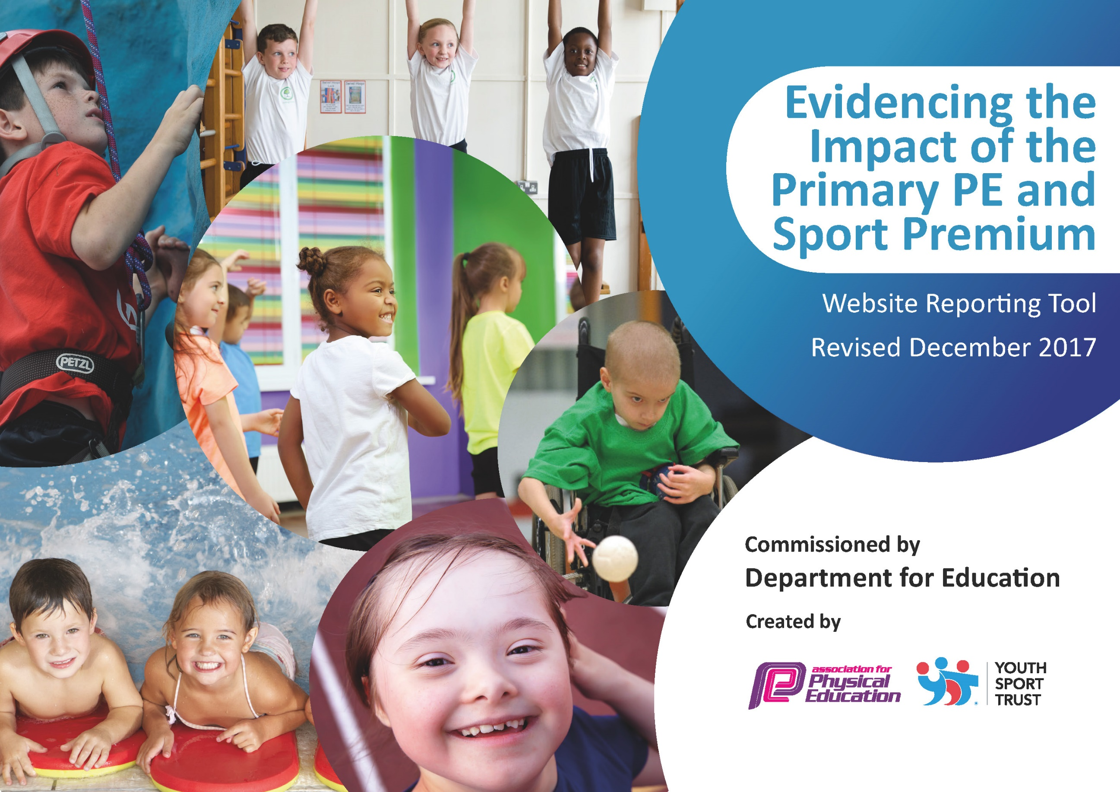

Schools must use the funding to make additional and sustainable improvements to the quality of PE and sport they offer. This means that you should use the Primary PE and Sport Premium to:

- develop or add to the PE and sport activities that your school already offers
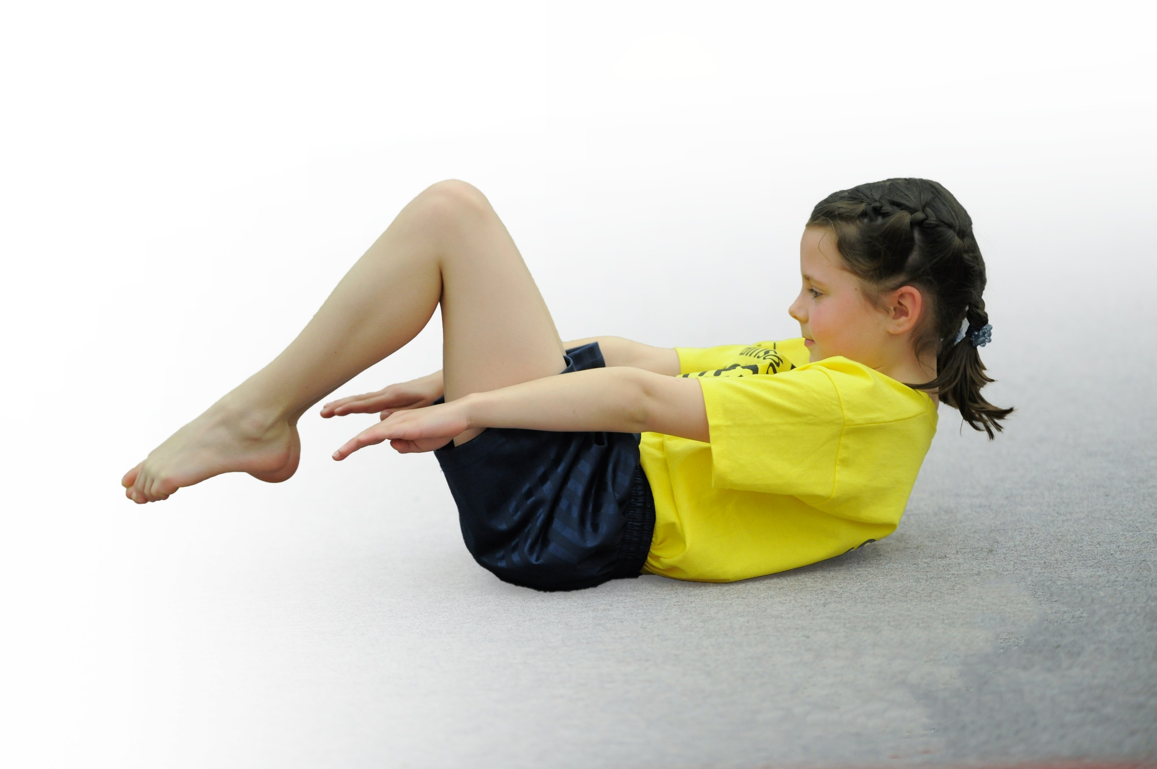
- build capacity and capability within the school to ensure that improvements made now will benefit pupils joining the school in future years

Please visit gov.uk for the revised DfE guidance including the 5 key indicators across which schools should demonstrate an improvement. This document will help you to review your provision and to report your spend. DfE encourages schools to use this template as an effective way of meeting the reporting requirements of the Primary PE and Sport Premium.

We recommend you start by reflecting on the impact of current provision and reviewing the previous spend.
Under the Ofsted Schools Inspection Framework, inspectors will assess how effectively leaders use
the Primary PE and Sport Premium and measure its impact on outcomes for pupils, and how effectively governors hold them to account
for this.

Schools are required to publish details of how they spend this funding as well as on the impact it has on pupils’ PE
and sport participation and attainment.
We recommend regularly updating the table and
publishing it on your website as evidence
of your ongoing review into how you are using the money
to secure maximum, sustainable impact. To see an example of how to complete the table please click HERE.

Support for review and reflection - considering the 5 key indicators from DfE, what development needs are a priority for your setting and your students now and why? Use the space below to reflect on previous spend, identify current need and priorities for the future.

Key achievements to date: | Areas for further improvement and baseline evidence of need:
- The engagement of regular exercise through sports clubs in both Key Stages.  - Increased confidence, knowledge and skills of all staff in teaching PE and sport through the support of coaches. Inset days with the Lancashire lead advisor  - Increased competition participation with the CTK sports partnership. Winning the overall competition three times altogether (including the precious two years). | Pupil’s general fitness in PE lessons aren’t high and staff identify a lot get “tired quickly”. Pupils in the school are not as active at home so a lot more activities need to be done in school to meet the hour a day. Also the school has identified the need to improve gross motor skills, basic coordination and core skills in the foundation and infant classes.  Some teachers have identified in the PE questionnaire that they do not feel confident in teaching all the activities in PE and sometimes cannot model the skills.  For the past 2 years, the only tournaments that have been entered are the CTK which means 10 tournaments a year with only one in the infants. This means each class will compete in only a maximum of 2 competitions a year which involves the same children. In having more tournaments, there is a greater chance more children will be involved in competitive sports.

Meeting national curriculum requirements for swimming and water safety | Please complete all of the below*:
What percentage of your current Year 6 cohort swim competently, confidently and proficiently over a distance of at least 25 metres? | 74%
What percentage of your current Year 6 cohort use a range of strokes effectively [for example, front crawl, backstroke and breaststroke]? | 71%
What percentage of your current Year 6 cohort perform safe self-rescue in different water-based situations? | 54%
Schools can choose to use the Primary PE and Sport Premium to provide additional provision for swimming but this must be for activity over and above the national curriculum requirements. Have you used it in this way? | Yes/No
*Schools may wish to provide this information in April, just before the publication deadline.

Action Plan and Budget Tracking
Capture your intended annual spend against the 5 key indicators. Clarify the success criteria and evidence of impact that you intend to measure to evaluate for students today and for the future.

Academic Year: 2017/18 | Total fund allocated: £14’460 | Date Updated:
Key indicator 1: The engagement of all pupils in regular physical activity – Chief Medical Officer guidelines recommend that primary school children undertake at least 30 minutes of physical activity a day in school |  |  |  | Percentage of total allocation:
 |  |  |  | 46.40%
School focus with clarity on intended impact on pupils: | Actions to achieve: | Funding allocated: | Evidence and impact: | Sustainability and suggested next steps:
- Introduce an outdoor sports activity for breakfast club (15 minutes) to encourage more attendance and getting involved in physical activities  - Do core strength, coordination and gross motor skills work with the infant children that haven’t developed or are weaker in these skills (20 minute group work)  - Introduce the Change 4 Life scheme to make pupils aware of and improve basic health and fitness (targeted group in each class)  - Introduce playtime leaders in each class to introduce new activities to get all pupils to participate in active play  - Introduce more physical activity clubs after school so children get an additional hour of sports a week. SENco to try to identify and invite pupils that need extra activity. | - P.E apprentice to take out groups of children to do sports activities  - Set up a timetable for the infants  - Get training and courses for apprentice from staff and outside agencies  -Train PE apprentice to take out small groups of 4 to 6 children to educate them on healthy choices and exercise using the Change 4 Life resources (with physical activities)  - P.E. coordinator and P.E apprentice to start 5 new playtime games yard with PE equipment.  - Train playtime leaders and P.E apprentice to monitor equipment  - Set up at least 2 PE clubs for each Key Stage with All 4 Sports, Born to Move and other school staff (including the apprentice). | - PE apprentice wage  £5460  - PE apprentice wage  - Therapy Sensory Circuit Resources £600  - PE apprentice wage  - PE apprentice wage  Born to Move  £500  All 4 Sports  £750 | Started well with groups of children going out to do a session on football for 15-20 minutes but weather issues has meant that this cannot happen during the winter months. One solution was using the cyber coach but only a few pupils were interested in dance. Try using the infant hall for the final term if the weather is bad.  This has had a positive impact on the children as they continued the work they did in foundation class and some are gaining good core strength and coordination. Staff have now been trained on a therapy sensory circuit and equipment.  Started within year 4 but apprentice quit position so it wasn’t carried on after Christmas.  If a new apprentice is employed, start again with different classes.  Started with year 4 leaders but didn’t take off because of the activities. If a new apprentice is employed, start again with 5 different activities and train with the PE coordinator to make activities more fun.  There are 4 after school PE/sports clubs. The attendance ranges from 8 to 10 in the infant sessions and 16 in the junior sessions. Unfortunately with only one hall in operation, this is the maximum amount of clubs that can run at the moment. | - More attendance means another T.A may be needed if large numbers. Maybe explore it being a paid club to subsidise this.  - Another TA to be trained as a replacement for the apprentice by PE coordinator.  -T.A’s and some teachers did it for foundation stage and some went on the Sensory Training so can continue from PE apprentice.  -Once the scheme and plan is in place, it can be used by any member of staff in any class.  - Scheme to be carried on by the coordinator so new children can be trained each year. The outdoor PE resources may need to be restocked each year and five new games to be introduced each year to add variety and continue interest.  The use of outside agencies aren’t sustainable so the need to up skill some teaching assistants, who do after-school clubs, will be needed.
Key indicator 2: The profile of PE and sport being raised across the school as a tool for whole school improvement |  |  |  | Percentage of total allocation:
 |  |  |  | 0%
School focus with clarity on intended impact on pupils: | Actions to achieve: | Funding allocated: | Evidence and impact: | Sustainability and suggested next steps:
- Celebrating sports achievements in weekly and monthly assemblies to enhance the importance of sport and encourage all pupils to participate and become involved in and out of school. | - Achievements and results celebrated in assembly (parents invited to the monthly assemblies) |  | Pupils enjoy being part of a team and their self-esteem has risen due to this raised profile. Through this, more children are participating in sports and dance clubs outside of school, with one pupil recently joining Preston Harriers Athletics Club. | - Put sporting achievement on the main entrance screen to raise the profile of PE and sport for all pupils, visitors and parents. Also, start putting posts and pictures on school dojo and the school website so more people can see achievements

Key indicator 3: Increased confidence, knowledge and skills of all staff in teaching PE and sport |  |  |  | Percentage of total allocation:
 |  |  |  | 22.48%
School focus with clarity on intended  impact on pupils: | Actions to achieve: | Funding  allocated: | Evidence and impact: | Sustainability and suggested  next steps:
- To up-skill staff with the support of coaches that assist them in gaining confidence and knowledge in teaching PE and support so they can improve progress and achievement of pupils.  - P.E Coordinator to assist the apprentice in delivering P.E lessons across the school so pupils will make good progress and achievement. At the same time, teachers will be up-skilled in an activity that they have identified as a need. | - To set up a timetable for the coaches to assist 2 teachers a half-term on a specific sport/activity.  - To ensure CTK partnership is renewed and set up timetable for specialist coaches to attend  -Set up a teacher questionnaire outlining confidence in teaching PE and Sports  - To set up the role of the apprentice within P.E. lessons that progress each term. | All 4 Sports  £2250  CTK  £1000  - PE apprentice wage | The coaches have worked with staff to give them more confidence and knowledge of activities. They have supported teachers in practical skills and games that they can use within their lessons. They have shown the progression within the 5 weeks and included the teachers within their lessons showing expectations for the year group. The next step is to share what we have learnt in an INSET day.  The teachers have identified the areas of dance and gymnastics as their weaknesses in the PE curriculum and so we get specialists in to work with the teachers in these activities so pupils get good. The apprentices were working well in developing their understanding of the parts of the lessons of PE. They assisted in lessons with games that they know and modelled/led some skills based activities that teachers needed help in. | - Sustainability will be achieved over the next year as each teacher will be trained in one activity that they can become leaders in this sport and share their expertise with others.  -CTK partnership includes dance festivals, coaches and tournaments. The up-skilling of teachers in gaining knowledge and techniques is sustainable but the partnership itself is unsustainable without funding.  - A PE inset day will be needed to share practical ideas and knowledge.  -Sustainable as long as HLTA wage can be covered for the next 2 years.  -Need to train one staff as a specialist in gymnastics so the school doesn’t need coaches in future.
Key indicator 4: Broader experience of a range of sports and activities offered to all pupils |  |  |  | Percentage of total allocation:
 |  |  |  | 17.29%
School focus with clarity on intended  impact on pupils: | Actions to achieve: | Funding  allocated: | Evidence and impact: | Sustainability and suggested  next steps:
- Continue to offer a wider range of activities within and outside the curriculum to give pupils different experiences in Sports  -To use the expertise of teachers and teaching assistants in teaching specialist sports in PE or after-school clubs to encourage pupils that aren’t as physically confident (yoga, golf, etc) | -To create a timetable that incorporates at least the main units of study every two years plus additional extra units that add variety to the curriculum.  -PE coordinator to train apprentice in the main units of PE.  -To work with the coaches to deliver at least one different unit of work.  - To ask teachers and teaching assistants with sporting/physical expertise to lead sessions.  - Ensure resources are stocked for main and newer units of P.E  - Investing in a set of balance bikes | CTK  -£1000  Resources  - £2000 | The children have a wide range of sports experiences within the school. Apart from the main units of sports (football, netball, athletics, dance, gymnastics, hockey and cricket), the school has also included tennis, tag rugby, dodgeball, tri-golf and basketball.  Balance bikes have been bought and staff trained so that the infants have a new activity. A T.A is yoga trained and will be teaching in year 1-2 in the summer term and coaches for basketball (All4Sports), tennis (Angela McNeela) and Bikeability will be in teaching skills throughout this year. | - PE coordinator to train apprentice in skills in every main unit that they will share with other teachers during their lessons so more staff will have a broader knowledge to teach pupils.  Coaches delivering new units will help broaden the knowledge of staff in sports/activities that we do not have the knowledge in and thus helps the expansion of the extra units the school will be able to teach.  - Staff to work together and share expertise and good practice so these activities can continue and the school will be less dependent on coaches as they will be more confident to lead and teach the sports.
Key indicator 5: Increased participation in competitive sport |  |  |  | Percentage of total allocation:
 |  |  |  | 13.83%
School focus with clarity on intended  impact on pupils: | Actions to achieve: | Funding  allocated: | Evidence and impact: | Sustainability and suggested  next steps:
-To continue the partnership with CTK that provide 10 tournaments/festivals across all classes throughout the year so pupils can participate in competitive sports outside of school.  -To enter the netball and football league set up by DB Sports (Preston Primary School Sports Council)  - To enter more sports tournaments with DB Sports, Preston Primary School Sports Council and Sports Games. | - Renew partnership with CTK  - Give out CTK booklet of sporting activities and put dates onto diary.  -Ensure all coaches have correct qualifications.  - Ensure matches are scheduled and teams have a training day.  - Enter more tournaments and schedule in diary.  -Book Mini-bus for tournaments that aren’t within walking distance | CTK  £500  £1500 including mini-bus costs throughout the year | The children are very excited to be involved in the CTK partnership as we have won the tournament for the last 2 years. An additional Y1 multi-sports competition has been included this year and as always the children in Y3 and Y3/4 enjoyed the dance festivals. We have competed in a few tournaments already with the highlight being 1st in the Y6 netball tournament.  St Augustine’s is currently in the lower divisions in the league as we have just begun but the aim is to progress to higher divisions. Due to weather we have only played one football match winning 5-0.  The school usually enters only the ten CTK tournaments a year with the same eight to ten schools entering. This year we will be entering an additional 12 competitions with more Preston schools competing. Highlights so far have been the Indoor Junior Games coming 5th out of 19 schools and a Primary Skills Infants coming 8th out of 23 schools. These additional sports in each year group has raised the profile of PE and sports even more in the school. | -As stated above, the partnership is unsustainable without funding (Key Indicator 3) unless we don’t pay for any coaches and instead just hold competitions there as a venue for a smaller fee.  -Members of staff are already in charge of the training days which could in the future be moved from after-school to lunch times to accommodate pupils going to mosque.  -Dependent on fees and mini-bus costs.

