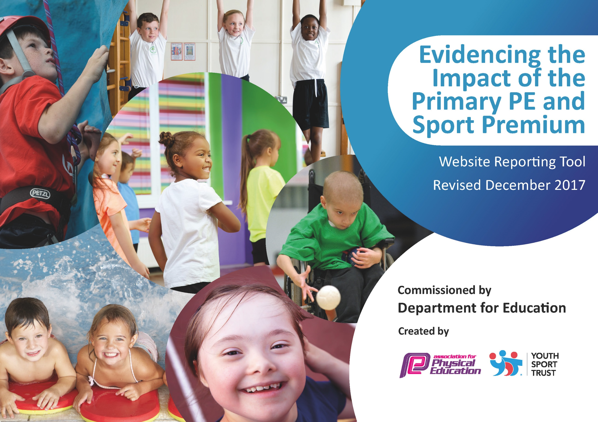

Schools must use the funding to make additional and sustainable improvements to the quality of PE and sport they offer. This means that you should use the Primary PE and Sport Premium to:

- develop or add to the PE and sport activities that your school already offers
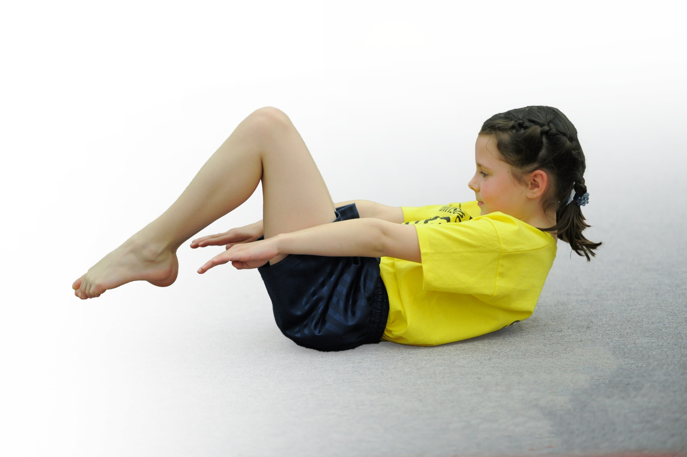
- build capacity and capability within the school to ensure that improvements made now will benefit pupils joining the school in future years

Please visit gov.uk for the revised DfE guidance including the 5 key indicators across which schools should demonstrate an improvement. This document will help you to review your provision and to report your spend. DfE encourages schools to use this template as an effective way of meeting the reporting requirements of the Primary PE and Sport Premium.

We recommend you start by reflecting on the impact of current provision and reviewing the previous spend.
Under the Ofsted Schools Inspection Framework, inspectors will assess how effectively leaders use
the Primary PE and Sport Premium and measure its impact on outcomes for pupils, and how effectively governors hold them to account
for this.

Schools are required to publish details of how they spend this funding as well as on the impact it has on pupils’ PE
and sport participation and attainment.
We recommend regularly updating the table and
publishing it on your website as evidence
of your ongoing review into how you are using the money
to secure maximum, sustainable impact. To see an example of how to complete the table please click HERE.

Support for review and reflection - considering the 5 key indicators from DfE, what development needs are a priority for your setting and your students now and why? Use the space below to reflect on previous spend, identify current need and priorities for the future.

Key achievements to date: | Areas for further improvement and baseline evidence of need:
- Competing with the “elite” schools that win the Preston tournaments, breaking into the top 3 in the Year3/4 Quads Kids Games.  - The success of the apprentice. She has started to work with children in the infants to address coordination and balance issues. She has also helped to give the girls more confidence in joining into sports during break and lunch times, as she is a good role model for them, whilst also breaking the stigma that some boys had about girls and sports. She has also been an asset to teachers in their P.E. lessons as she models the skills that they cannot.  - Children are becoming more competitive overall in school, which has rolled into their studies too. With sports becoming a bigger part of school life, the children are becoming more active and determined to improve. | - There is still some work to be done with improving the quality of the infant skills in terms of P.E. There are a lot of children that come into the school without much sporting activity and leave the infants with below standard skills.  - There aren’t any sporting competitions in school apart from Sport’s Day. This doesn’t prepare children well to tournaments outside of school. This also gives the children that aren’t picked for the tournaments and competitions (outside of school) a chance to be involved in one.

Meeting national curriculum requirements for swimming and water safety | Please complete all of the below*:
What percentage of your current Year 6 cohort swim competently, confidently and proficiently over a distance of at least 25 metres? | 62%
What percentage of your current Year 6 cohort use a range of strokes effectively [for example, front crawl, backstroke and breaststroke]? | 62%
What percentage of your current Year 6 cohort perform safe self-rescue in different water-based situations? | 62%
Schools can choose to use the Primary PE and Sport Premium to provide additional provision for swimming but this must be for activity over and above the national curriculum requirements. Have you used it in this way? | Yes/No
*Schools may wish to provide this information in April, just before the publication deadline.

Action Plan and Budget Tracking
Capture your intended annual spend against the 5 key indicators. Clarify the success criteria and evidence of impact that you intend to measure to evaluate for students today and for the future.

Academic Year: 2018/19 | Total fund allocated: £ | Date Updated: July 2019
Key indicator 1: The engagement of all pupils in regular physical activity – Chief Medical Officer guidelines recommend that primary school children undertake at least 30 minutes of physical activity a day in school |  |  |  | Percentage of total allocation:
 |  |  |  | 46.40%
School focus with clarity on intended impact on pupils: | Actions to achieve: | Funding allocated: | Evidence and impact: | Sustainability and suggested next steps:
- Introduce an outdoor sports activity for breakfast club (15 minutes) to encourage more attendance and getting involved in physical activities  - Do core strength, coordination and gross motor skills work with the infant children that haven’t developed or are weaker in these skills (20 minute group work)  - Introduce the Change 4 Life scheme to make pupils aware of and improve basic health and fitness (targeted group in each class)  - Introduce more sports at play time in the infants so pupils are exposed to as well as participate in active play (20 minutes)  - Introduce more physical activity clubs after school so children get an additional hour of sports a week. SENco to try to identify and invite pupils that need extra activity. | - P.E apprentice to take out groups of children to do sports activities  - Set up a timetable for the infants  - Get training and courses for apprentice from staff and outside agencies  -Train PE apprentice to take out small groups of 4 to 6 children to educate them on healthy choices and exercise using the Change 4 Life resources (with physical activities)  - P.E. coordinator and P.E apprentice to start new playtime games in the infant yard with PE equipment. Last year the clubs were not take up by the infant classes so this is another way for them to be active during school.  - Set up at least 3 PE clubs for Key Stage 2 with All 4 Sports, Born to Move and other school staff (including the apprentice) as infant intake is low for clubs. | - PE apprentice wage  £5460  - PE apprentice wage  - Therapy Sensory Circuit Resources £600  - PE apprentice wage  - PE apprentice wage  Born to Move  £500  All 4 Sports  £750 | Children enjoyed the activities in the morning but due to breakfast club becoming a paid club, numbers of participants started to decrease.  Apprentice worked with the children and their basic physical skills improved during the year. The children became more confident during PE lessons and activities.  Due to co-ordinator being off for a long period of time, this target wasn’t met as training to do the scheme was not done.  The infants are playing more sports during lunch and play and play times are more active.  There were a lot of sporting clubs in the school with most of them over-subscribed like the football and junior sports. However, the born to move and infant sports weren’t as popular. Football team won the 5th Division League Title. | - Another TA to be trained as a replacement for the apprentice by PE coordinator.  -T.A’s and some teachers did it for foundation stage and some went on the Sensory Training so can continue from PE apprentice.  -Once the scheme and plan is in place, it can be used by any member of staff in any class.  - Scheme to be carried on by the coordinator so new children can be trained each year. The outdoor PE resources may need to be restocked each year and five new games to be introduced each year to add variety and continue interest.  The use of outside agencies aren’t sustainable so the need to up skill some teaching assistants, who do after-school clubs, will be needed.
Key indicator 2: The profile of PE and sport being raised across the school as a tool for whole school improvement |  |  |  | Percentage of total allocation:
 |  |  |  | 0%
School focus with clarity on intended impact on pupils: | Actions to achieve: | Funding allocated: | Evidence and impact: | Sustainability and suggested next steps:
- Celebrating sports achievements in weekly and monthly assemblies to enhance the importance of sport and encourage all pupils to participate and become involved in and out of school.  Sporting activities like clubs and competitions to be highlighted on the TV in the entrance way. This gives children pride in representing our school as well as improving the profile even more. | - Achievements and results celebrated in assembly (parents invited to the monthly assemblies)  - The Apprentice to document all sporting achievements in the school with the children helping to create a power point to explain the events. |  | Pupils enjoy being part of a team and their self-esteem has risen due to this raised profile. Through this, more children are participating in sports and dance clubs outside of school, with one pupil recently joining Preston Harriers Athletics Club.  Children’s self-esteem grows when they see their achievements celebrated. | - Put sporting achievement on the main entrance screen to raise the profile of PE and sport for all pupils, visitors and parents. Also, start putting posts and pictures on school dojo and the school website so more people can see achievements  - Sustainable with any member of staff.

Key indicator 3: Increased confidence, knowledge and skills of all staff in teaching PE and sport |  |  |  | Percentage of total allocation:
 |  |  |  | 22.48%
School focus with clarity on intended  impact on pupils: | Actions to achieve: | Funding  allocated: | Evidence and impact: | Sustainability and suggested  next steps:
- To up-skill staff with the support of coaches that assist them in gaining confidence and knowledge in teaching PE and support so they can improve progress and achievement of pupils.  - P.E Coordinator to assist the apprentice in delivering P.E lessons across the school so pupils will make good progress and achievement. At the same time, teachers will be up-skilled in an activity that they have identified as a need. | - To set up a timetable for the coaches to assist 2 teachers a half-term on a specific sport/activity for the first term.  - To ensure CTK partnership is renewed and set up timetable for specialist coaches to attend  - To send two teachers on courses for specific training (one in the infants for gymnastics and the one in the juniors for football)  - To set up the role of the apprentice within P.E. lessons that progress each term. | All 4 Sports  £2250  CTK  £1000  Courses  £1000  - PE apprentice wage | Coaches were supportive of staff and assisted the apprentice and teachers in new techniques of teaching sports. Children benefited from this as children progressed well in their lessons.  As the coordinator was off for a long period of time, another teacher filled in and showed the apprentice the skills taught within her age group but this didn’t give the apprentice a broad understanding of the progress throughout each key stage. | - Sustainability will be achieved over the next few years as each teacher will be trained in one activity that they can become leaders in this sport and share their expertise with others.  -CTK partnership includes dance festivals, coaches and tournaments. The up-skilling of teachers in gaining knowledge and techniques is sustainable but the partnership itself is unsustainable without funding.  - A PE inset day will be needed to share practical ideas and knowledge.  -Sustainable as long as HLTA wage can be covered for the next 2 years.
Key indicator 4: Broader experience of a range of sports and activities offered to all pupils |  |  |  | Percentage of total allocation:
 |  |  |  | 17.29%
School focus with clarity on intended  impact on pupils: | Actions to achieve: | Funding  allocated: | Evidence and impact: | Sustainability and suggested  next steps:
- Continue to offer a wider range of activities within and outside the curriculum to give pupils different experiences in Sports  -To use the expertise of teachers and teaching assistants in teaching specialist sports in PE or after-school clubs to encourage pupils that aren’t as physically confident (yoga, golf, etc) | -To create a timetable that incorporates at least the main units of study every two years plus additional extra units that add variety to the curriculum.  -PE coordinator to train apprentice in the main units of PE.  -To work with the coaches to deliver at least one different unit of work.  - To ask teachers and teaching assistants with sporting/physical expertise to lead sessions.  - Ensure resources are stocked for main and newer units of P.E | CTK  -£1000  Resources  - £1000 | A lot of newer sports taught from a coaching company teaching tennis to the infants, bikeability in the juniors and in lessons there was golf, dodgeball and tag rugby added this year.  A T.A taught yoga to the children which they enjoyed thoroughly.  Resources were bought which ensured good lessons being taught throughout the school. | - PE coordinator to train apprentice in skills in every main unit that they will share with other teachers during their lessons so more staff will have a broader knowledge to teach pupils.  Coaches delivering new units will help broaden the knowledge of staff in sports/activities that we do not have the knowledge in and thus helps the expansion of the extra units the school will be able to teach.  - Staff to work together and share expertise and good practice so these activities can continue and the school will be less dependent on coaches as they will be more confident to lead and teach the sports.
Key indicator 5: Increased participation in competitive sport |  |  |  | Percentage of total allocation:
 |  |  |  | 13.83%
School focus with clarity on intended  impact on pupils: | Actions to achieve: | Funding  allocated: | Evidence and impact: | Sustainability and suggested  next steps:
-To continue the partnership with CTK that provide 10 tournaments/festivals across all classes throughout the year so pupils can participate in competitive sports outside of school. To continue to be part of the netball and football league set up by DB Sports (Preston Primary School Sports Council). To re-enter the sports tournaments with DB Sports, Preston Primary School Sports Council and Sports Games.  - To start in-school team sports tournaments throughout the year in different sports. | - Renew partnership with CTK  - Give out CTK booklet of sporting activities and put dates onto diary.  -Ensure all coaches have correct qualifications.  - The teams to have a designated training day.  - To organise one sports competition for each class throughout the year. | CTK  £500  £1500 including mini-bus costs throughout the year | A lot of children were involved throughout the year with the CTK tournaments ranging from Y1 to Y6. The final results meant that St Augustine’s won the cup for the third time.  We entered back into the leagues and won the boy’s football division 4 league and came second in the girl’s netball division 5 league, getting promoted.  Also, the Y3/4 Quad athletics team improved from last year coming second and only missing out by a few points but again winning another trophy. Three trophies in one year. Success!  Did not complete as coordinator was not in for a long period of time. | -As stated above, the partnership is unsustainable without funding (Key Indicator 3) unless we don’t pay for any coaches and instead just hold competitions there as a venue for a smaller fee.  - Three members of staff are already in charge of the training days but need T.A involvement for clubs in the infants.  -If this works, the timetable can be run year on year by the P.E coordinator.

