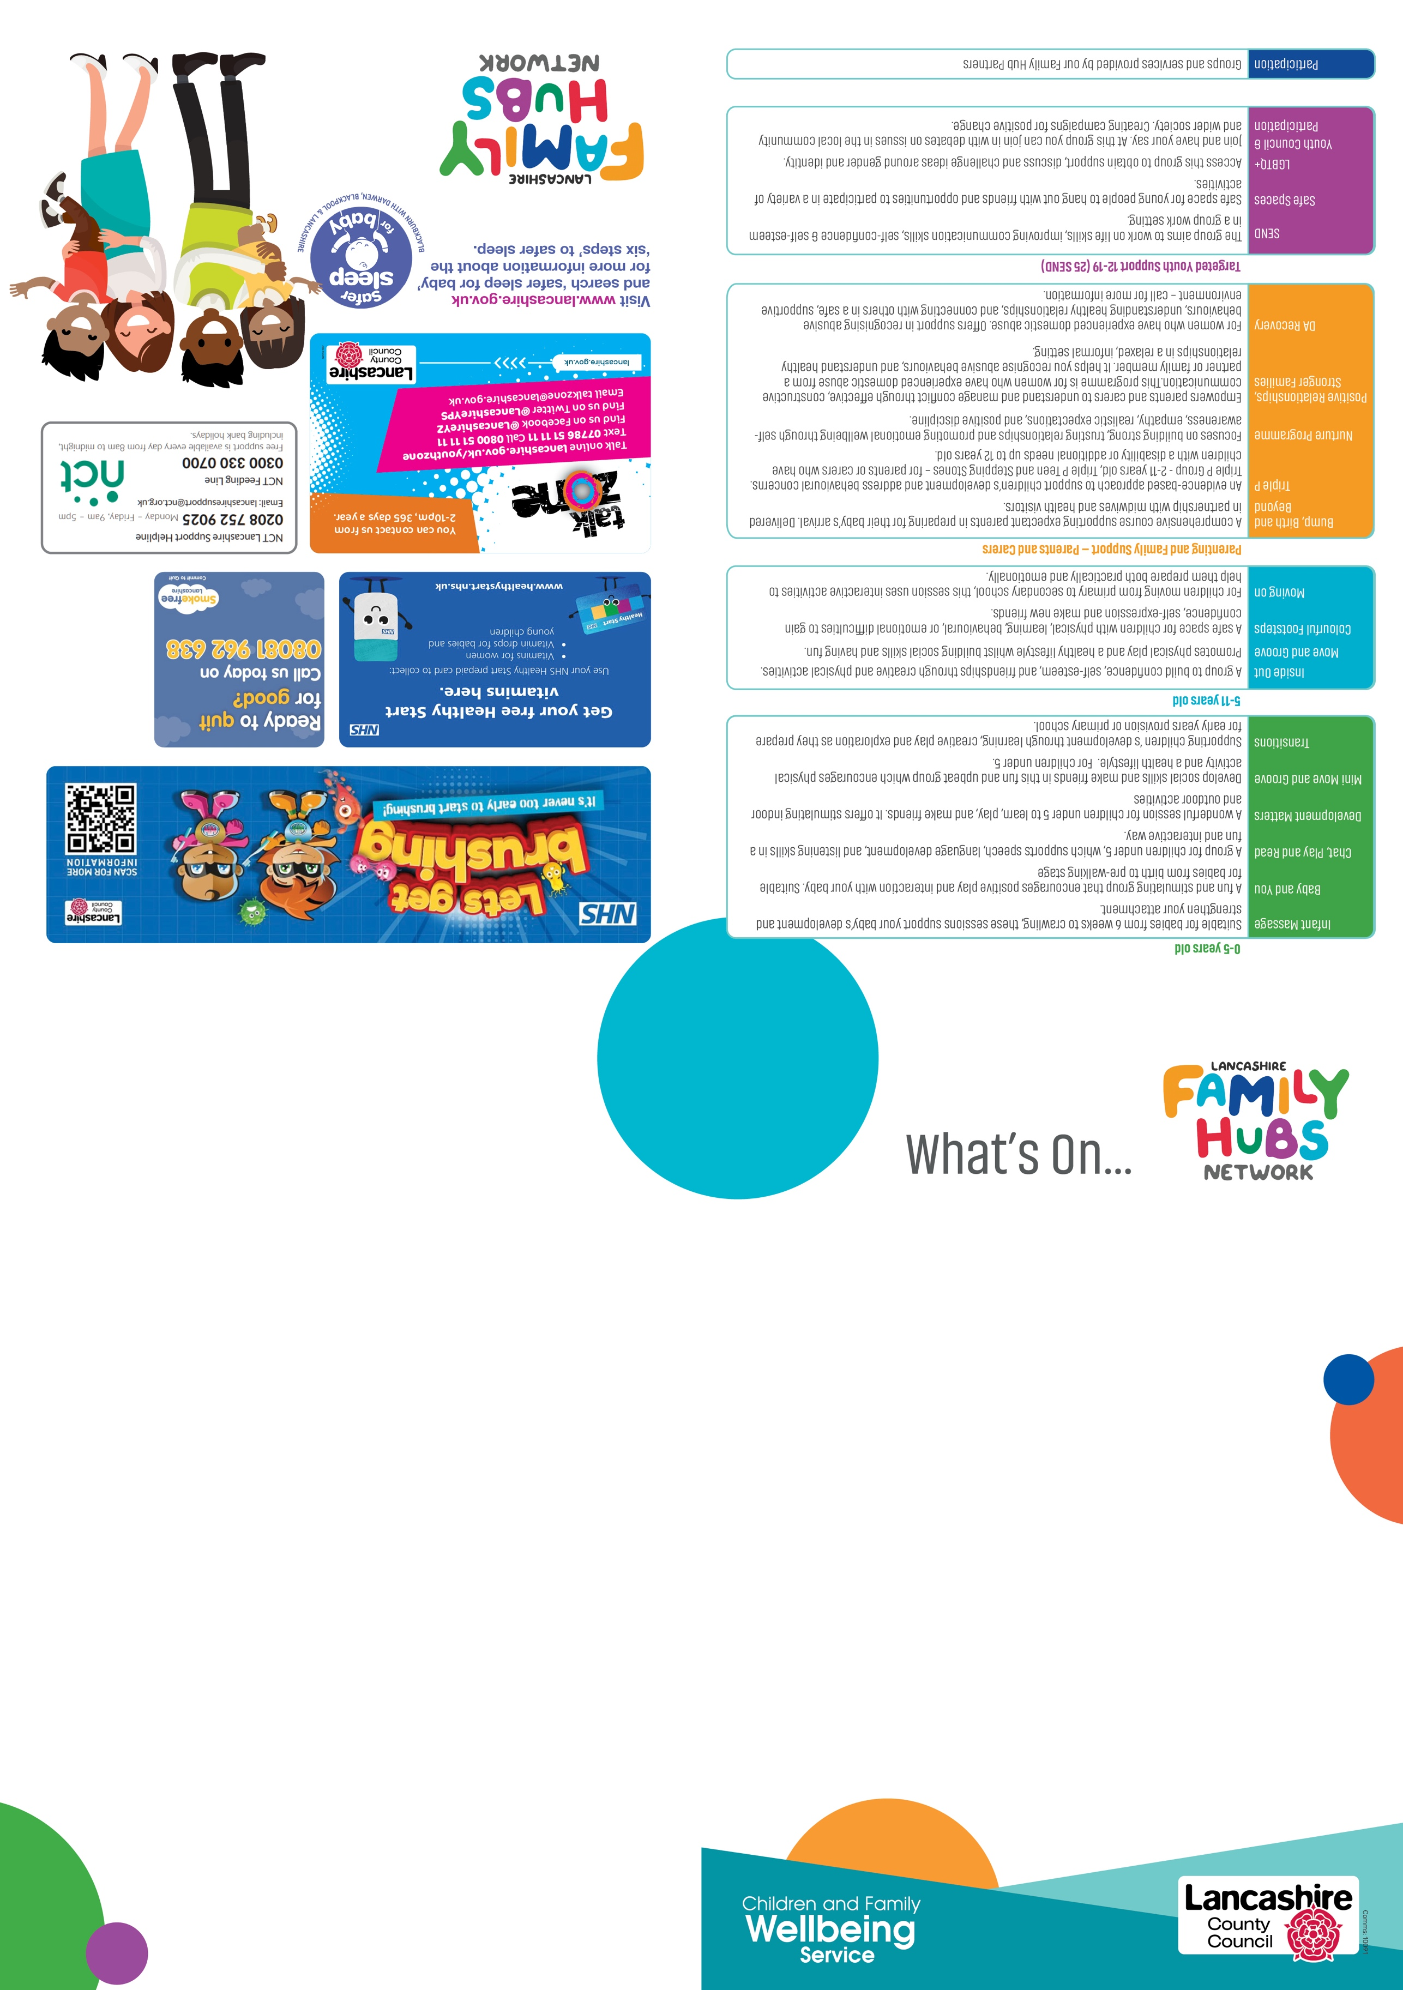

School Holiday Activities

During school holidays we offer various fun activities for all the family.
Booking is essential for some of these activities

Why not follow us on our Facebook page for up to date information:

Preston Family Hub

The dates, times & venues of our groups are correct at
the time of printing

PRESTON
Welcome
A warm welcome to you from everyone at Preston Children & Family Wellbeing Service.
Our "What's On Guide" aims to keep you as up to date on what specific groups and services are available at your nearest centre



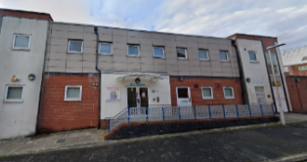
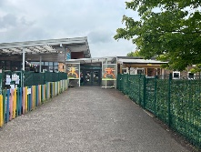

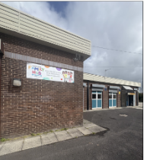

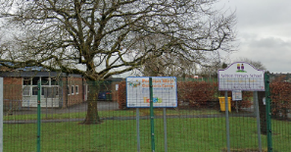

ALL OUR GROUPS ARE FREE!

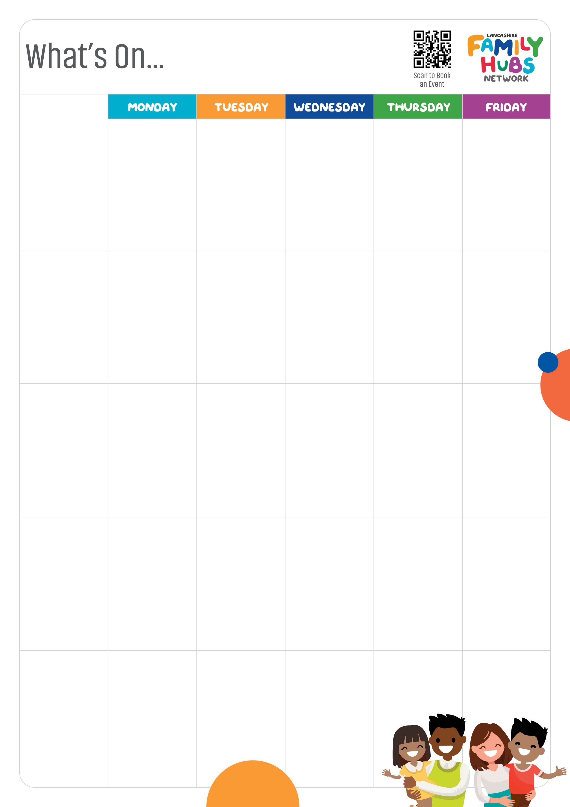
MOOR NOOK
FAMILY HUB & YOUTH ZONE

Burholme Road
Ribbleton
PRESTON
PR2 6HN

Triple P – Sessions running morning and afternoon
(Booking required)

Stoneygate CFW Services
Stoneygate Walk
PRESTON
PR1 3XU
Flourishing Together
5 - 11 yrs
3:30 - 5:00pm

Move & Groove 5-11 yrs
3:30 - 5:00pm

RIBBLETON
FAMILY HUB
Ribbleton Hall Drive
Ribbleton
Preston
PR2 6EE

Tel: 01772 539444

SEND Family Inside Out
3:30 - 5:00pm

HCRG Baby Weighing Clinic
9:15 - 11:15am

Speech & Language Advice Walk-In
11:00 - 11:45am

BBB - Sept 2025 (Booking required)

Mini Move and Groove 0-5yrs
9:30 - 11:00am

HCRG
Baby Weighing Clinic
1:00 - 3:00 pm

Family Nurture
3:30 - 5:00 pm

Dad's Group
3:30 - 5:00pm

Development Matters
(Messy Play) 0-5yrs
9:30 - 11:00am

Infant Massage
Birth to Crawling
10:00 – 11:00
(Booking required)

Development Matters,
(Stay & Play)
0-5yrs
9:30 - 11:00am

Development Matters
(Stay and Play)
0-5 yrs
10:00 -11:30am
Crafty Club
10-12 yrs
3:30 - 5:00pm
PRESTON EAST CFW SERVICES

Brookfield Primary School Site
Watling Street Rd
Preston, PR2 6TU

Tel: 01772 539420

Development Matters
Stay & Play 0-5 yrs
9:30 - 11:00am
NO GROUPS HERE TODAY

Mini Move and Groove
0-5 yrs
9:30 - 11:00am
HCRG
Baby Weighing Clinic
9:15 - 11:15am

Baby & You
(pre-walkers only)
9:30 - 11:00am
Development Matters,
(Messy Play) 0-5 yrs
9:30 - 11:00am

Development Matters,
(Stay & Play)
0-5yrs
1:00 - 2:30pm
Mini Move and Groove 0-5 yrs
1:00 - 2:30pm

Chat, Play and Read
9:30 - 11:00am

Parents To Be and Positive Relationships, Stronger Families
1:00 - 2:30pm
(Booking required)

Family Stay and Play All Ages
3:30 - 5:00pm

NO GROUPS HERE TODAY

Development Matters
(Messy Play) 0-5yrs
9:30 - 11:00am

Development Matters
Stay & Play 0-5 yrs
9:30 - 11:00am

NO GROUPS HERE TODAY

Mini Move & Groove
0-5yrs
9:30 - 11:00am

Music Group
1:00 - 2:00pm
0-5 yrs

Inside Out 5-11 yrs
3:45 - 4:45pm
(Booking required)

Development Matters
(Messy Play) 0-5 yrs
9:30 - 11:00am

Infant Massage (Booking required) 1:00 – 2:00pm followed by Baby Sensory 2:00 - 3:00pm

Inside Out 5-11 yrs
3:45 - 4:45pm
(Booking required)

Development Matters
Stay & Play 0-5 yrs
3:30 - 5:00pm

PRESTON WEST FAMILY HUB
Ashton Primary School Site
Ainsdale Drive
Preston
PR2 1TU

Tel: 01772 536419
RIVERBANK FAMILY HUB
Brieryfield Rd
Preston
PR1 8SR

Tel: 01772 531948

MILLBANK COURT
Edmund Street
PRESTON

One Stop Shop
Second Thursday of the month
2:00 - 4:00pm

Baby & You
(pre-walkers only)
1:00 - 2:30pm
Baby Sensory
0-1 yrs
1:00 - 2:30pm

Preston Children &
Family Wellbeing Service
September - December 2025

Story Session
0-5 yrs
10:00 - 11:30am

Development Matters
Stay & Play 0-5 yrs
1:00 - 2:30pm
Baby & You
(pre-walkers only)
9:30 - 11:00am
NCT Breastfeeding Peer Support Group
10:00 - 11:30am

One Stop Shop
Last Tuesday of the month
2:00 - 4:00pm

