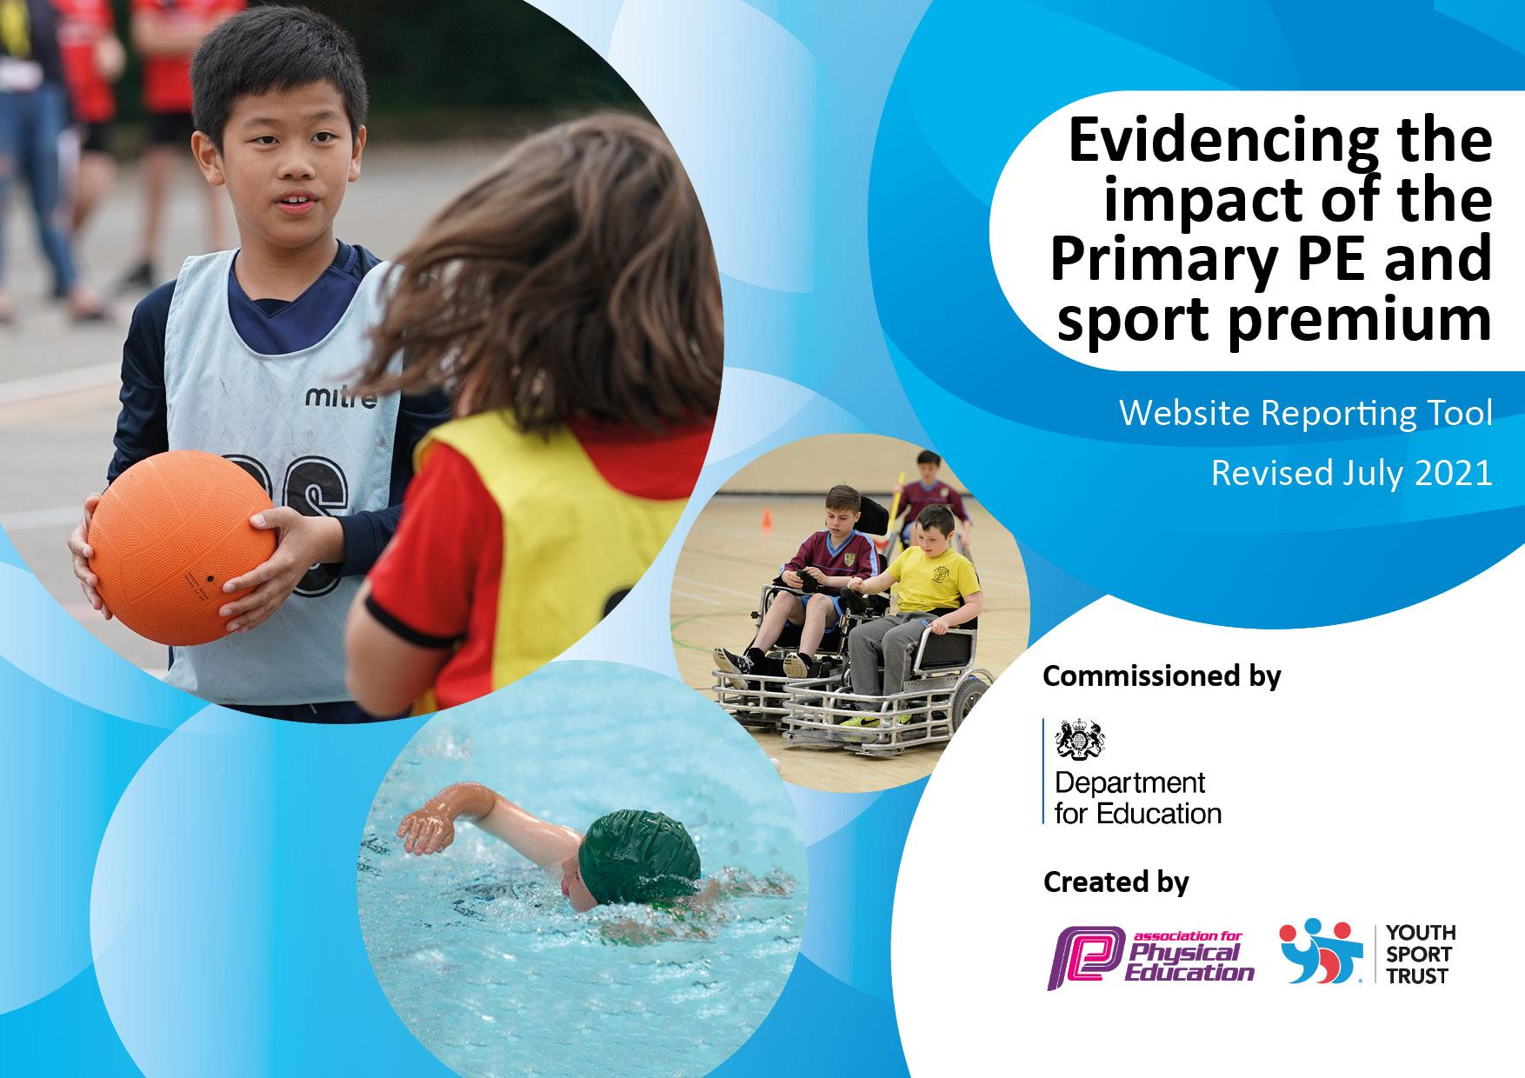
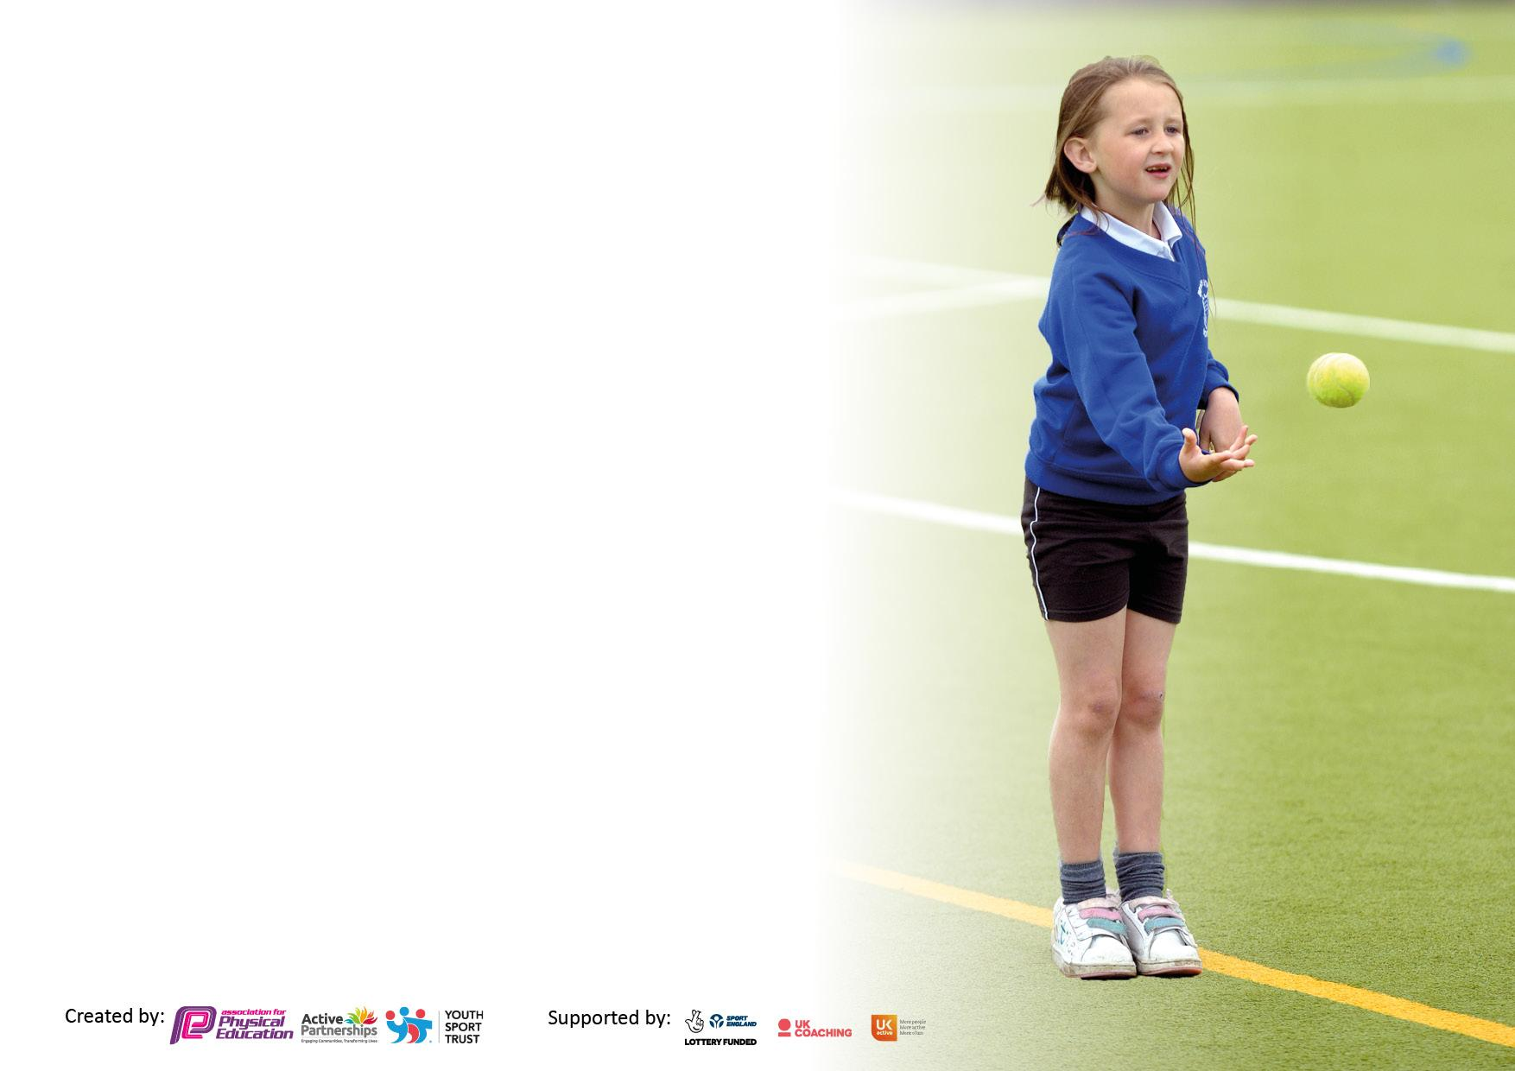

It is important that your grant is used effectively and based on school need. The Education Inspection Framework makes clear there will be a focus on ‘whether leaders and those responsible for governors all understand their respective roles and perform these in a way that enhances the effectiveness of the school’.

Under the Quality of Education Ofsted inspectors consider:
Intent - Curriculum design, coverage and appropriateness
Implementation - Curriculum delivery, Teaching (pedagogy) and Assessment
Impact - Attainment and progress

To assist schools with common transferable language this template has been developed to utilise the same three headings which should make your plans easily transferable between working documents.

Schools must use the funding to make additional and sustainable improvements to the quality of Physical Education, School Sport and Physical Activity (PESSPA) they offer. This means that you should use the Primary PE and sport premium to:

- Develop or add to the PESSPA activities that your school already offer
- Build capacity and capability within the school to ensure that improvements made now will benefit pupils joining the school in future years
- The Primary PE and sport premium should not be used to fund capital spend projects; the school’s budget should fund these.

Pleasevisitgov.ukfortherevisedDfEguidanceincludingthe5keyindicatorsacrosswhichschoolsshoulddemonstrate animprovement.Thisdocumentwillhelpyoutoreviewyourprovisionandtoreportyourspend.DfEencouragesschools to use this template as an effective way of meeting the reporting requirements of the Primary PE and sport premium.

We recommend you start by reflecting on the impact of current provision and reviewing the previous spend.

Schools are required to publish details of how they spend this funding, including any under-spend from 2019/2020, as well as on the impact it has on pupils’ PE and sport participation and attainment. All funding must be spent by 31st July 2022.

We recommend regularly updating the table and publishing it on your website throughout the year. This evidences your ongoing self-evaluation of how you are using the funding to secure maximum, sustainable impact. Final copy must be posted on your website by the end of the academic year and no later than the 31st July 2021. To see an example of how to complete the table please click HERE.
Created by: Supported by:

Details with regard to funding
Please complete the table below.

Total amount carried over from 2019/20 | £14,089.24
Total amount allocated for 2020/21 | £17,980
How much (if any) do you intend to carry over from this total fund into 2021/22? | £0.00
Total amount allocated for 2021/22 | £17740.00
Total amount of funding for 2021/22. To be spent and reported on by 31st July 2022. | £17740.00

Swimming Data
Please report on your Swimming Data below.

Meeting national curriculum requirements for swimming and water safety.

N.B. Complete this section to your best ability. For example you might have practised safe self-rescue techniques on dry land which you can then transfer to the pool when school swimming restarts.
Due to exceptional circumstances priority should be given to ensuring that pupils can perform safe self rescue even if they do not fully meet the first two requirements of the NC programme of study
What percentage of your current Year 6 cohort swim competently, confidently and proficiently over a distance of at least 25 metres?  N.B. Even though your pupils may swim in another year please report on their attainment on leaving primary school at the end of the summer term 2021.  Please see note above | 65%
What percentage of your current Year 6 cohort use a range of strokes effectively [for example, front crawl, backstroke and breaststroke]?  Please see note above | 65%
What percentage of your current Year 6 cohort perform safe self-rescue in different water-based situations? | 65%
Schools can choose to use the Primary PE and sport premium to provide additional provision for swimming but this must be for activity over and above the national curriculum requirements. Have you used it in this way? | Yes

Action Plan and Budget Tracking
Capture your intended annual spend against the 5 key indicators. Clarify the success criteria and evidence of impact that you intend to measure to evaluate for pupils today and for the future.

Academic Year: 2020/21 | Total fund allocated: | Date Updated: July 2020
Key indicator 1: The engagement of all pupils in regular physical activity – Chief Medical Officers guidelines recommend that primary school pupils undertake at least 30 minutes of physical activity a day in school |  |  |  | Percentage of total allocation:
 |  |  |  | 43%
Intent | Implementation |  | Impact
Your school focus should be clear what you want the pupils to know and be able to do and about  what they need to learn and to  consolidate through practice: | Make sure your actions to achieve are linked to your intentions: | Funding allocated: | Evidence of impact: what do pupils now know and what can they now do? What has changed?: | Sustainability and suggested next steps:
Provide equipment and resources to enhance the new SOW to ensure a broad and balanced PE  curriculum.  To engage all pupils in regular physical activity through use of outdoor play equipment at lunchtimes, playtimes and after school.  Provision of catch-up swimming sessions for all pupils in Year 3.  Provision of funding for initial groundworks for a MUGA to allow quality outdoor play through further physical activity sessions. | Resources shared with staff with both Playtime and Sports Leaders trained on how to utilise the new equipment.  Staff training on what new equipment is available and how this can be used to enhance learning in the two PE sessions a week, using the new SOW.  Two swimming session blocks were missed due to Covid 19, but taken from the funding  To ensure provision for end of 2020-2021 these were paid for and catch up sessions secured for Summer Term (Dependent on current situation)  Organised site visits from five different companies. Establish quotes and take to Governor’s meetings.  Apply for planning permission, so once this is granted, groundworks can commence Spring 2021. | £157.70  £2498.92  Netball posts/ Markings -£1000.00  Basketball Hoops / Nets / Markings  £1000.00  Football Nets/ Markings  £1000.00  Surface Markings  £500.00  Carry over funding allocated:  £3500.00  Key Indicator 1 Spend - £6156.6 | The children are able to access and use the new equipment as part of their PE sessions (within their class bubbles).  Children will actively engage in lessons and resources can also be used outside to enhance playtime and lunchtime provision.  This further engages the children to fulfil the 60 minutes of physical activity day.  Children will undertake sessions in Year 3 and use further sessions if they are not meeting the National Curriculum requirements.  Pupils will have access to more outside space and participate in high quality lessons working as a whole class bubble.  Further PE and Sport can be timetabled for classes across the whole school, including provision at playtimes and lunchtimes. | Equipment to be monitored and safety checks to take place annually.  Audit completed and location of resources shared with staff.  Similar resources may be purchased from the 2020-21 budget to achieve sustainability.  To continue to increase the amount of daily activity for every pupil.  Welfare staff to access PL Training taken from the SLA agreement with the SSGO.  Budget already allocated from 2020-21 SPF to cover additional provision.  The sessions that were not permitted to go ahead (due to Covid 19) have been taken from SPF from carry over 2019-2020  Plan to offer a range of sporting activities and clubs using the MUGA.  Clubs can be offered to a range of pupils including EYFS, KS1 PP and SEN due to extra space gained, aside the hall
Key indicator 2: The profile of PESSPA being raised across the school as a tool for whole school improvement |  |  |  | Percentage of total allocation:
 |  |  |  | 2%
Intent | Implementation |  | Impact
Your school focus should be clear what you want the pupils to know and be able to do and about  what they need to learn and to  consolidate through practice: | Make sure your actions to achieve are linked to your intentions: | Funding allocated: | Evidence of impact: what do pupils now know and what can they now do? What has changed?: | Sustainability and suggested next steps:
Provide Sports Leaders with uniform and Playground Leader training. | Sports Leaders can be easily identifiable, along with Playtime Leaders in tabards.  All children can access further sport and activities across both Key Stages provided by SL and PTL who have been trained. | £232.67  Key Indicator 2 Spend- £223.67 | Children leading opportunities across the school for further PE and sport.  Organising Inter house competitions (currently year group bubbles).  Training peers to lead activities at playtimes and lunchtimes | Continue to build on Sports Leaders and Play Time Leaders roles.  Sports Leaders spend Summer Term training new pupils from Year 5, ready for Autumn Term 2021 and the same applies with the PALs.  Complete further CPD with Welfare and Leaders to develop the offer further.

Key indicator 3: Increased confidence, knowledge and skills of all staff in teaching PE and sport |  |  |  | Percentage of total allocation:
 |  |  |  | 10%
Intent | Implementation |  | Impact
Your school focus should be clear | Make sure your actions to | Funding | Evidence of impact: what do | Sustainability and suggested
what you want the pupils to know | achieve are linked to your | allocated: | pupils now know and what | next steps:
and be able to do and about | intentions: |  | can they now do? What has
what they need to learn and to |  |  | changed?:
consolidate through practice:
Provide access to The PE Passport App so that teachers can utilise a new SOW, electronic assessment and use teaching videos to support increased knowledge, confidence and skills in the teaching of PE and sport across the school.  Purchase iPad’s and covers so that the Primary PE Passport App can be used to support the teaching of PE and Sport through detailed lesson planning, assessment and core tasks. | Purchase the Primary Passport App and access the virtual webinar training. This was then rolled out to CT’s to use in all PE and sport sessions across all key stages, including EYFS.  Teachers will all have sole access to an IPad in each classroom.  Attendance registers can be formulated, evidence can be collected electronically and each lesson can be adapted and evaluated by CT’s. | £550.00  £899.97  Key Indicator 3 Spend- £1449.97 | Teachers are able to access all materials including SOW, assessments, core tasks and evidencing in one place.  PE Lead can then evaluate success and need for interventions if required. | Buy into Primary PE Passport for next academic year and build on knowledge with further CPD sessions.  Complete Staff Audit on how this has impacted their teaching of PE and Sport, along with the impact it has had on the pupil’s access to high quality provision.  All CT’s (including PT) have individual IPads that will have the Primary PE Passport App added, therefore no more IPads need to be purchased, but the App will need to be on a rolling yearly subscription.
Key indicator 4: Broader experience of a range of sports and activities offered to all pupils |  |  |  | Percentage of total allocation:
 |  |  |  | 32%
Intent | Implementation |  | Impact
Your school focus should be clear | Make sure your actions to | Funding | Evidence of impact: what do | Sustainability and suggested
what you want the pupils to know | achieve are linked to your | allocated: | pupils now know and what | next steps:
and be able to do and about | intentions: |  | can they now do? What has
what they need to learn and to |  |  | changed?:
consolidate through practice:
To provide all Key Stage 2 children with a much broader experience of Outdoor Adventurous Activity sessions off site. | Secure places for all Year 6 pupils on a PGL visit for 3 days and 2 nights.  Secure places for all Year 5 pupils on a PGL visit for 3 days and 2 nights.  Secure places for all Year 3 and 4 pupils on a day visit to Rock and River Outdoor Education Centre. | £1890.00  £1960.00  £600.00  Key Indicator 4 Spend - £4450.00 | All children throughout KS2 can take part in Outdoor Adventure Activities, led by specialist OAA teachers from PGL Centres and Rock and River.  Children are offered a range of other activities that cannot be accessed through the normal PE and sport curriculum in school. | All children across Key Stage 2 are offered access to OAA specialist activities.  Phase in visits with a rolling programme for each year group for next academic year.  Year 6 – PGL visit (3 days/2 nights)  Year 5 – PGL visit (3 days/2 nights)  Year 4 – PGL visit (Taster Session-2 days/1 Night)  Year 3 – PGL/OAA Centre Day Visit.

Key indicator 5: Increased participation in competitive sport |  |  |  | Percentage of total allocation:
 |  |  |  | 13%
Intent | Implementation |  | Impact
Your school focus should be clear | Make sure your actions to | Funding | Evidence of impact: what do | Sustainability and suggested
what you want the pupils to know | achieve are linked to your | allocated: | pupils now know and what | next steps:
and be able to do and about | intentions: |  | can they now do? What has
what they need to learn and to |  |  | changed?
consolidate through practice:
To provide access to local competitions (virtually if required) through an agreed SLA with the School Games Organiser. | Confirm SLA agreement with the School Games Organiser and actively engage in all competitions offered. | £1800.00  Key Indicator 5 Spend - £1800.00 | Competitions attended virtually due to Covid 19:  Children from all KS2 classes have been able to take part in a virtual  Pentathlon. Events have been  undertaken within class bubbles and submitted to BwD LSGO as part of a borough wide competition.  Children from Year 2 have also taken part in a virtual Orienteering  competition.  Results of virtual competitions:  Year 5 & 6 Pentathlon - various medal placings  Year 3 & 4 Pentathlon - various medal placings  KS1 Orienteering - Bronze medal winners. | To continue to buy into the School Games Package.  Due to Covid 19 and the limited offer for the Premium based package, we will allocate the funds for a basic package for 21/22, but receive the Premium package as a gesture of good will.  This provides an end result for an after school club-opportunity to represent the school in a competition or a festival.  Increased participation for SEN and PP children through festivals.

Signed off by
Head Teacher: | Mrs Rebecca Ham
Date: | July 2020
Subject Leader: | Mrs Emily Gardner
Date: | July 2020
Governor: | Mrs Lisa Farnhill
Date: | July 2020

