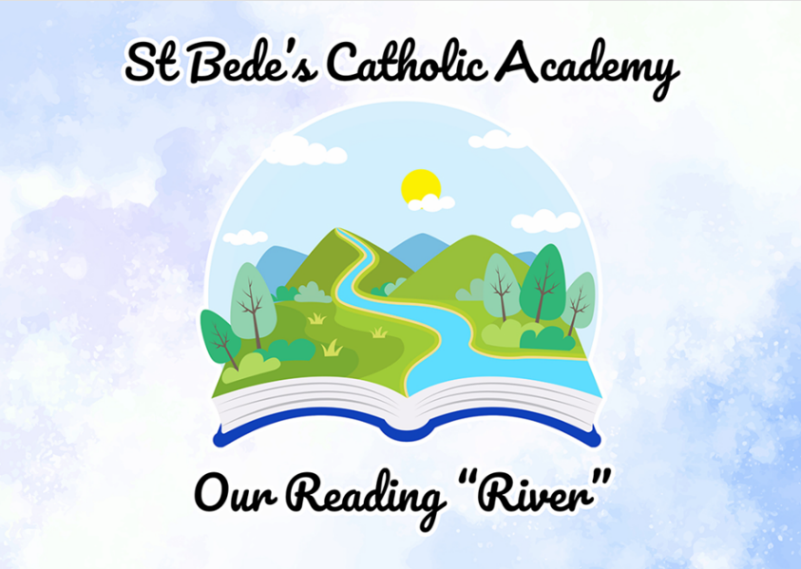
#

St Bede’s Catholic Academy
Our Reading “River”
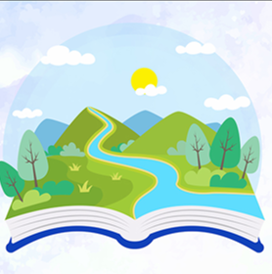 | At St. Bede’s, we want it to be a place where children are read to, enjoy listening to high-quality books and share their enjoyment of stories through discussions. We want to be a school where, over seven or eight years, children are ready to enjoy, discuss and work with core books. This is the ‘Reading Spine.’  Our ‘Reading River’ (or Spine) is one element of the approach we take to foster a love for reading in our children. The River is a spine of core books that create a living library inside the minds of pupils at St. Bede’s. It is a store of classic and essential reads that help our children engage at a deeper level and enter the world; of the story,. We have produced our very own ‘Reading River’ for every year group; giving children access to these high-quality texts. The texts that will be included are nursery rhymes, fairy tales, classic stories and poetry.  Because we know that children bring their own existing knowledge to what they are reading, our Reading Spine reflects the curriculum, social context and diversity of St. Bede’s. By doing so, we are helping our children to connect their knowledge in a meaningful way. Ultimately, while our children are continuing to enjoy a range of books throughout their school journey, they are also learning to become readers.  We use the Reading Spine books in every year group over the school year. From children mobbing into UK at St. Bede’s, to leaving in Year 6, they will have been immersed into the most fantastic books available to children.

How it works

Each year group has a set of texts chosen that make up the Reading River. The composition of the books/texts chosen for the Spine underpins (where possible) the context of the school, our curriculum and the diversity of its children. The purpose is to give some background knowledge for future topics and also cohesively link to current learning. This Reading “River” is not to be confused with the structured reading scheme which is well established.

Class | Picture Story Books | Poetry/ Nursery Rhymes | Fairy Tales | Reflecting Diversity
Lower Foundation Stage | 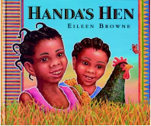  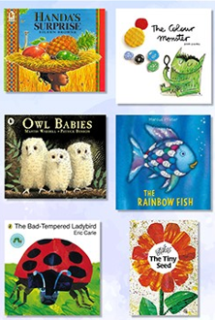  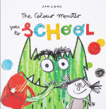 | 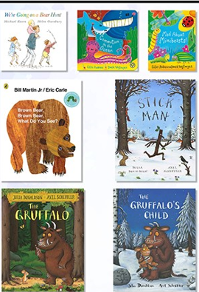  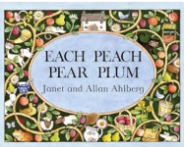  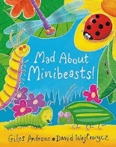  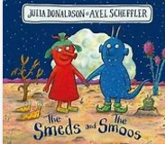  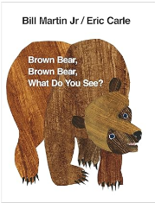  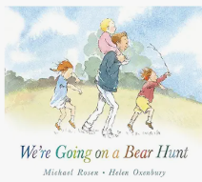  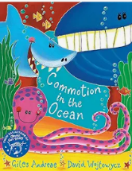  12345 Once I Caught a Fish Alive  Baa Baa Black Sheep  Hey Diddle Diddle  Hickory Dickory Dock  Humpty Dumpty  I’m a Little Teapot  Incy Wincy Spider  Jack and Jill  5 Little Ducks  Mary Had a Little Lamb  Old McDonald  10 in the Bed  Grand Old Duke of York  Twinkle Twinkle Little Star  Jelly on a Plate  Heads, Shoulders, Knees and Toes | 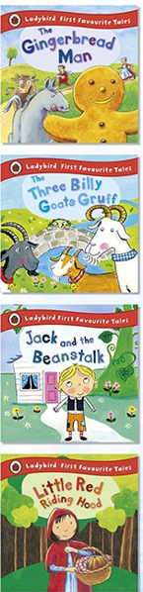 | 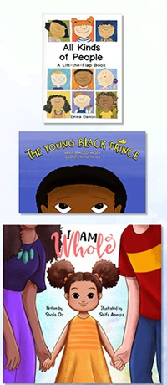  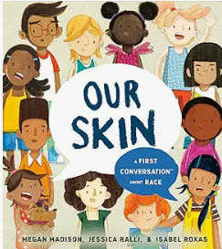  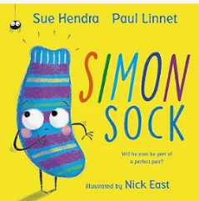  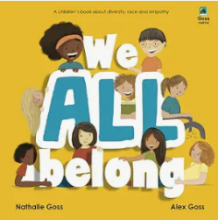  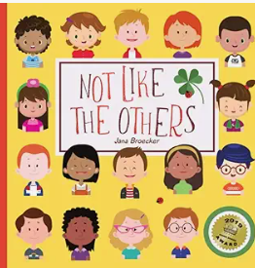  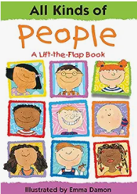

Class | Picture Story Books | Poetry/ Nursery Rhymes | Fairy Tales | Reflecting Diversity
Upper Foundation Stage | 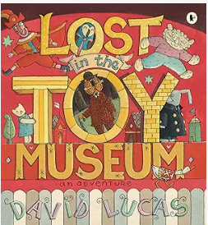  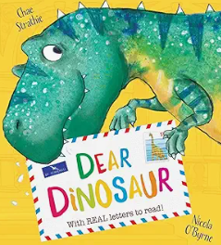  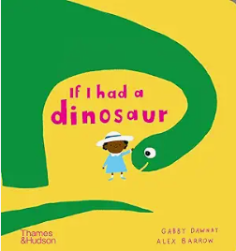  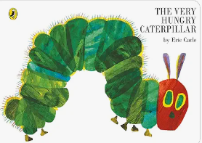  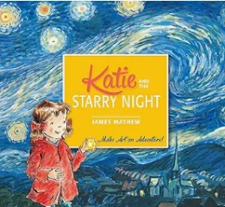  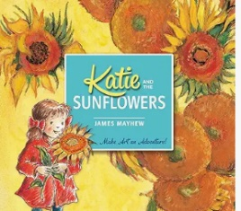  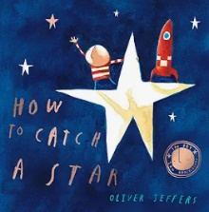  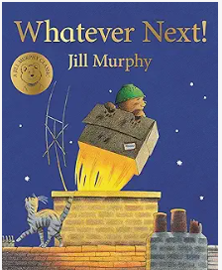  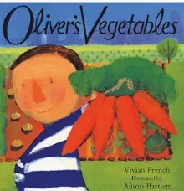  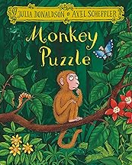  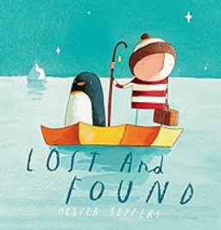  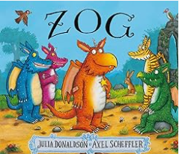  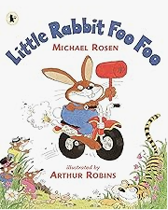 | 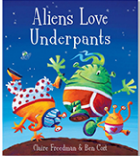  12345 Once I Caught a Fish Alive  Baa Baa Black Sheep  Hey Diddle Diddle  Hickory Dickory Dock  Humpty Dumpty  I’m a Little Teapot  Incy Wincy Spider  Jack and Jill  5 Little Ducks  Mary Had a Little Lamb  Old McDonald  10 in the Bed  Grand Old Duke of York  Twinkle Twinkle Little Star  Jelly on a Plate  Heads, Shoulders, Knees and Toes | 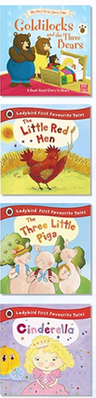 | 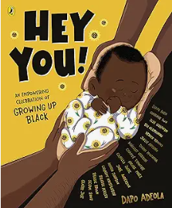  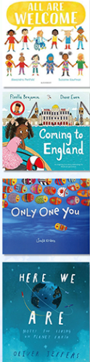

Class | Picture Story Books | Poetry/ Nursery Rhymes | Fairy Tales | Reflecting Diversity
Year 1 | 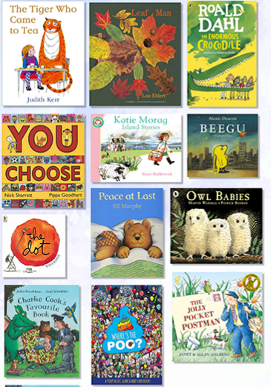  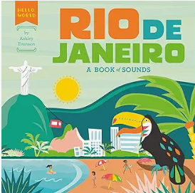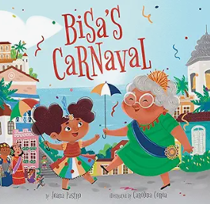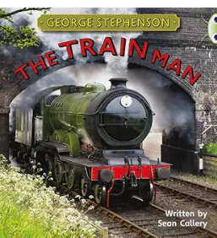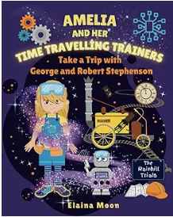 | 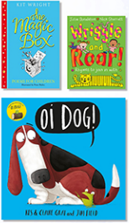  12345 Once I Caught a Fish Alive  Baa Baa Black Sheep  Hey Diddle Diddle  Hickory Dickory Dock  Humpty Dumpty  I’m a Little Teapot  Incy Wincy Spider  Jack and Jill  5 Little Ducks  Mary Had a Little Lamb  Old McDonald  10 in the Bed  Grand Old Duke of York  Twinkle Twinkle Little Star  Jelly on a Plate  Heads, Shoulders, Knees and Toes | 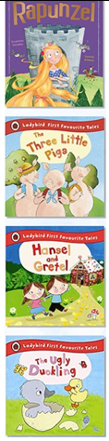 | 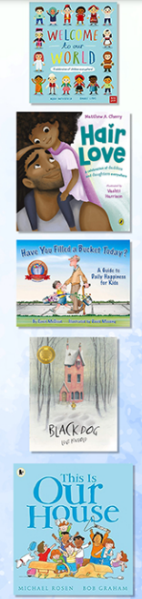  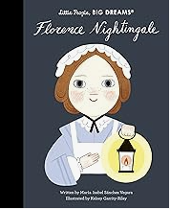  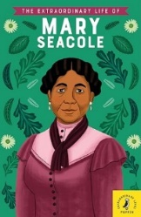  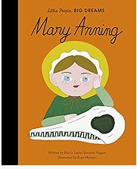

Class | Picture Story Books | Poetry/ Nursery Rhymes | Fairy Tales | Reflecting Diversity
Year 2 | 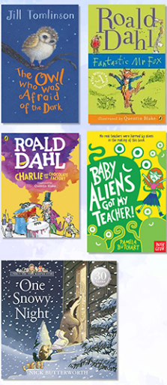 | 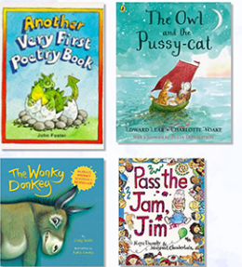  12345 Once I Caught a Fish Alive  Baa Baa Black Sheep  Hey Diddle Diddle  Hickory Dickory Dock  Humpty Dumpty  I’m a Little Teapot  Incy Wincy Spider  Jack and Jill  5 Little Ducks  Mary Had a Little Lam  Old McDonald  10 in the Bed  Grand Old Duke of York  Twinkle Twinkle Little Star  Jelly on a Plate  Heads, Shoulders, Knees and Toes | 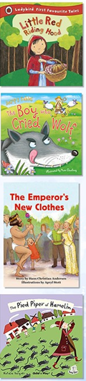 | 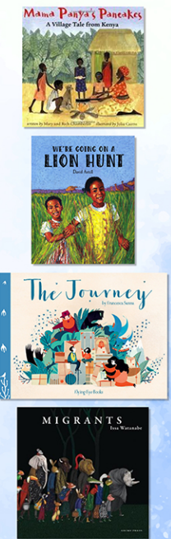

Class | Whole class novels, short stories and picture books | Poetry, Rhymes and Classical poetry | Traditional tales, Myths and Legends | Reflecting Diversity
Year 3 | 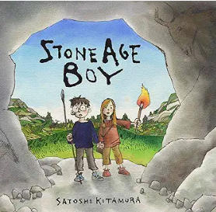  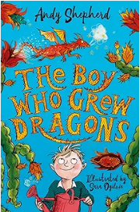  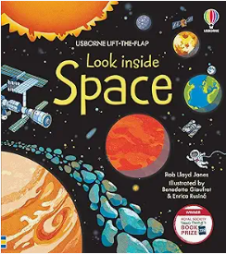  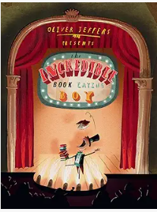  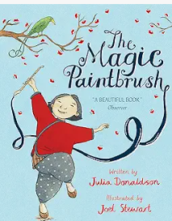  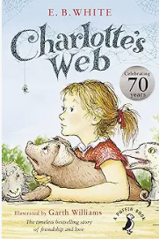  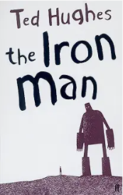 | 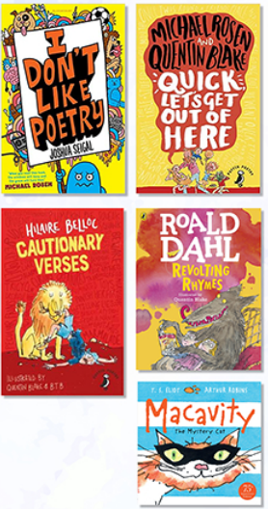 | 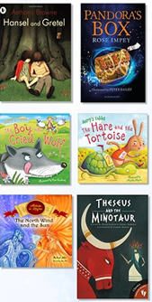  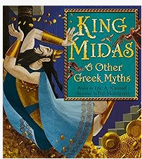  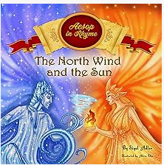 | 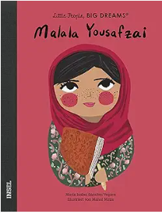  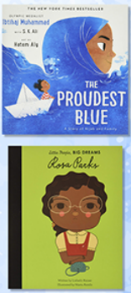  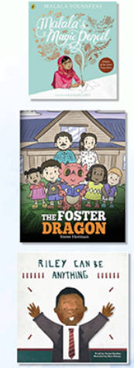

Class | Whole class novels, short stories and picture books | Poetry, Rhymes and Classical poetry | Traditional tales, Myths and Legends | Reflecting Diversity
Year 4 | 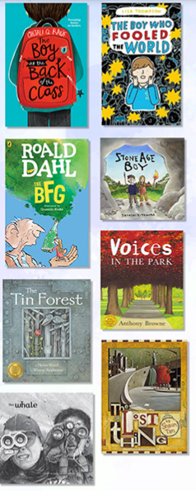 | 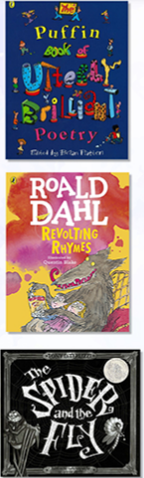  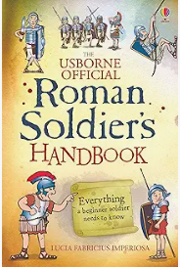  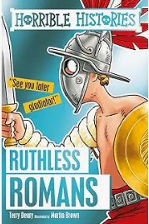 | 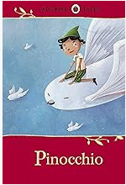  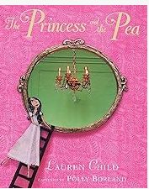  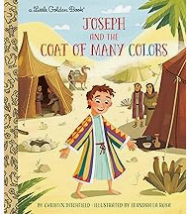  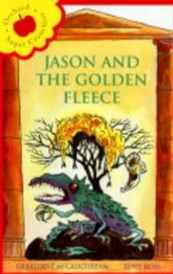 | 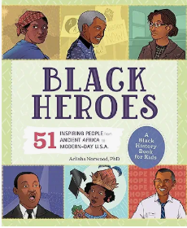  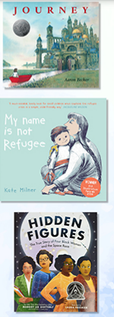  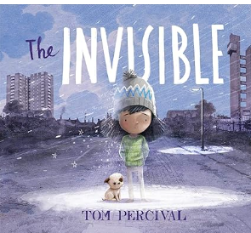  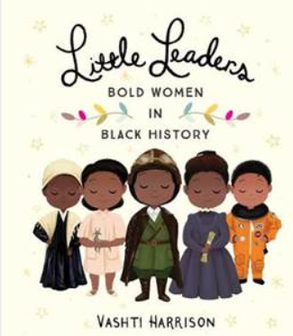

Class | Whole class novels, short stories and picture books | Poetry, Rhymes and Classical poetry | Traditional tales, Myths and Legends | Reflecting Diversity
Year 5 | 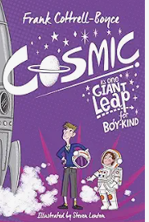  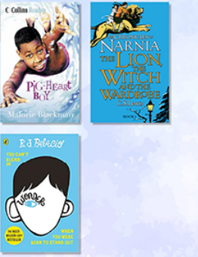  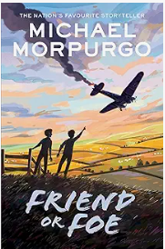 | 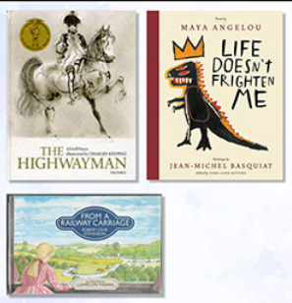 | 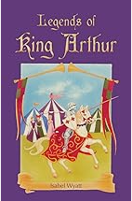  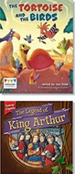  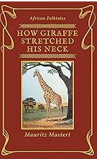 | 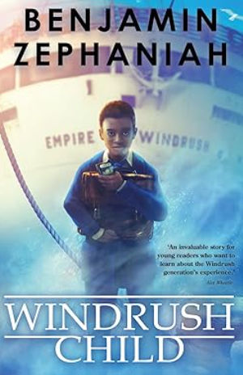  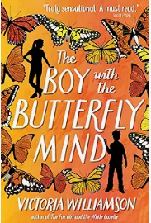  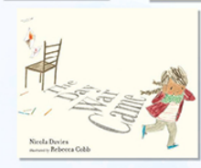  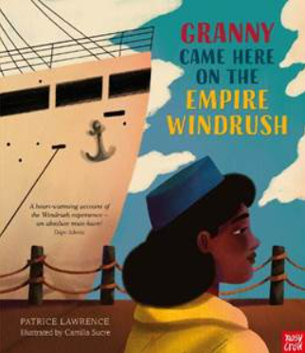

Class | Whole class novels, short stories and picture books | Poetry, Rhymes and Classical poetry | Traditional tales, Myths and Legends | Reflecting Diversity
Year 6 | 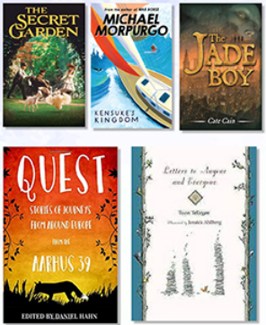 | 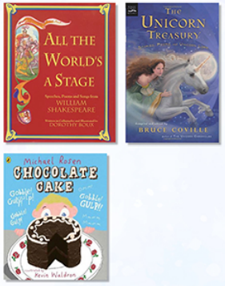 | 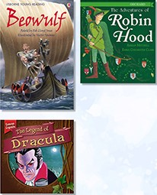 | 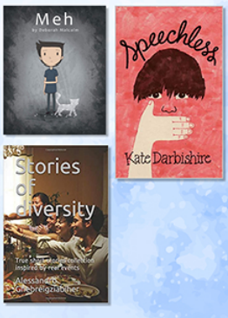

Whole Class Novels
(Sets of 30)

Year Group | Whole Class Novels
Year 2 | Fantastic Mr Fox  Charlie and the Chocolate Factory  Baby Alien got my Teacher
Year 3 | Iron Man  The boy who grew Dragons  Charlotte’s Web
Year 4 | BFG  The Boy at the Back of the Classroom  The Boy who fooled the world  The Breakfast club
Year 5 | Narnia  Wonder
Year 6 | Harry Potter and the Chamber of Secrets  Secret Garden  Kensuke’s Kingdom  The Final Year

