Pupil premium strategy statement

This statement details our school’s use of pupil premium (and recovery premium for the 2024 to 2025 academic year) funding to help improve the attainment of our disadvantaged pupils.

It outlines our pupil premium strategy, how we intend to spend the funding in this academic year and the effect that last year’s spending of pupil premium had within our school.

School overview
Detail | Data
School name | St Bede’s Catholic Academy
Number of pupils in school | 227 (including nursery)
Proportion (%) of pupil premium eligible pupils | 144 (63%) of pupils at St Bede's are PP.  The figure is 59% (118) based on just Reception to Year 6.  These figures are based on the oct 2024 census.
Academic year/years that our current pupil premium strategy plan covers (3 year plans are recommended) | 24-26
Date this statement was published | Spring 2025
Date on which it will be reviewed | Autumn 2025
Statement authorised by | Stuart McGee (CEO)
Pupil premium lead | B Rizzi-Allan (HT)
Governor / Trustee lead | Jane Woods
Funding overview
Detail | Amount
Pupil premium funding allocation this academic year | £138,970
Recovery premium funding allocation this academic year | £0
Pupil premium funding carried forward from previous years (enter £0 if not applicable) | £0
Total budget for this academic year  If your school is an academy in a trust that pools this funding, state the amount available to your school this academic year | £ 138,970

Part A: Pupil premium strategy plan

Statement of intent
At St Bede’s, we recognise that Pupil Premium pupils are not necessarily low ability and focus on supporting all disadvantaged pupils to achieve the highest levels. The context of St Bede’s means that the vast majority of our children are in the upper most deprived sections of the UK.
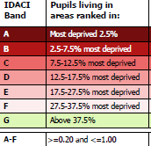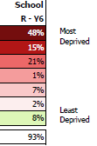
At St Bede's Catholic Academy, we proudly stand as a beacon of excellence, demonstrating that even in the face of significant challenges, our pupils can achieve remarkable success. Despite a very high percentage of disadvantaged pupils, we consistently perform at or above national averages, with our disadvantaged children outpacing their peers nationally.
This achievement is not by chance; it is the result of our unwavering commitment to high-quality teaching and learning. Our dedicated staff employ innovative and evidence-based interventions that cater to the diverse needs of our pupils, ensuring that every child has the opportunity to thrive.
We firmly believe in the principles of equity, and we work tirelessly to remove barriers that may hinder our pupils' progress. Our creative and strategic use of Pupil Premium funding has been instrumental in providing targeted support, fostering resilience, and enhancing the educational experiences of our disadvantaged pupils.
At St Bede's, we are not just closing the attainment gap; proving that with dedication and innovation, we can transform lives and futures.
We recognise that not all pupils who are socially disadvantaged are registered or qualify for free school meals. We reserve the right to allocate the Pupil Premium funding to support any pupil who we have legitimately identified as being socially disadvantaged. Many of our families are considered the “working poor” often in multiple employments and in unstable zero hours contracts.
The school makes use of available evidence from both its own experience and that of others, including research-based evidence from the EEF, when allocating funding that is most likely to have an impact on improving pupils' achievement
- This plan to is help close the widening and worsening gaps in attainment and progress of our pupil premium children that has accelerated during the national pandemic.
- This PP report is part of a whole school ethos
- Achievement data is reviewed regularly and robustly to monitor whether interventions or programmes are working effectively. The school does not simply use data retrospectively to see if something has been successful.
- This plan will help PP access wider opportunities with school hours and out of school hours.
- Class teachers know which pupils are eligible for the pupil premium to enable them to assume responsibility for accelerating progress of those individuals, this is monitored by SLT and PP champion.
- Pupil premium funding is used successfully to deal with a range of issues, for example: attendance, behaviour, confidence, reading, factors outside of school, professional training for staff on helping disadvantages pupils, effective teaching and learning, targeted support, further enrichment etc.
- This plan will ensure that attendance of PP children will at least be in line with the national average of all children.
- This strategy is a targeted and bespoke approach based on assessments of teachers. Identified children will be given support that will close gap in their learning and knowledge. We acknowledge that wider strategies that support with mental health and wellbeing, attendance and behaviour may also have a positive impact on the success of the child at school.
- School take a tiered approach to Pupil Premium spending. Teaching should be the top priority followed by a targeted approach and wider strategies

Challenges

This details the key challenges to achievement that we have identified among our disadvantaged pupils. Our disadvantaged children perform very well compared to national other children. We do however see some in school gaps which need to be closed.
Challenge number | Detail of challenge
1 | Early Identification of disadvantaged children who are not on track to pass phonics test. (From nursery and reception)
2 | 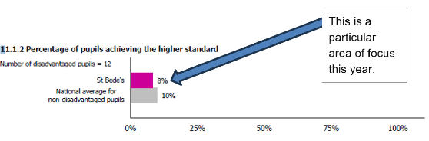  Disadvantaged children to continue to perform at least in line with national average in R/W/M and phonics attainment at end of KS2. We aim to match combined greater depth for all children nationally for our disadvantaged children. We are currently 8% (disadvantaged). National is 10% for other children.
3 | To reduce discrepancy between persistent absentees and all other pupils and PP children.
4 | To equip children with essential skills of speaking and listening that will equip them for confident communication and expression and active listening skills.
5 | To ensure that disadvantaged children at least match attainment of other pupils within St Bede’s for Good Level of Development.

Intended outcomes
This explains the outcomes we are aiming for by the end of our current strategy plan, and how we will measure whether they have been achieved.
Intended outcome | Success criteria
Outcomes and progress for all pupils and specifically for disadvantaged pupils are at least in line with national expectations at the end of KS1 and in year 1 phonics screening check for all children | Data shows that PP children are catching up with non-PP children.  Gap between attainment and progress for national data for all children is closing
Outcomes and progress for all pupils and specifically for disadvantaged pupils are at least in line with national expectations at the end of KS2 in expected standard and greater depth | Data shows that PP children are catching up with non-PP children.  Gap between attainment and progress for national data for all children is closing
Maintain high overall attendance so that it remains consistently better than local and national averages. Reduce the level of persistent absent among disadvantaged children so there is no I school difference with non-disadvantaged children | Children are happy and confident to come to school. Our attendance for all groups is at least in line with all groups national average for attendance. We continue with well below national, local authority and trust absences averages for disadvantaged children
To ensure that identified children has access a high degree of wider opportunities with school and school will support with wider opportunities that are provided within the local community. | Children are prioritised for wider opportunities and school removes barriers for attendance at ASC. School provided direct funding to outside organisations to allow children to attend at weekends and evening. School greatly subsides school visits and ensures that all children have at least two offsite visits per year.  Disadvantaged children have the opportunity to learn a musical instrument in addition to class based musical instrument instruction.  Heavily subsided educational visits.

Activity in this academic year
This details how we intend to spend our pupil premium (and recovery premium funding) this academic year to address the challenges listed above.

Teaching (for example, CPD, recruitment and retention)
Budgeted cost: £13,178
Activity | Evidence that supports this approach | Challenge number(s) addressed
Reading plus intervention to be delivered 3x weekly by all class teachers from year 3 upwards  £2550 | Children are assessed constantly and given a plan that matches their reading ability, the teacher is able to see area of weakness immediately and provided resources and interventions based on their needs | 2/1
CPD for all class based staff on reading fluency and latest RWInc phonic training.  £3236 | All class-based staff will receive training in reading fluency, reading comprehension and how we teach phonics.  All staff access to RWINC portal for up to date training on phonics.  Those staff delivering the phonics will be given the latest RWInc training and use the latest resources that emphasis fluency. | 1
Additional teacher to support in year 6 for one day  £7392 | All research suggests that expose to high quality teaching in smaller groups is highly effective in improving progress and attainment. | 2
Targeted KS1 and EYFS interventions to be carried out by staff. | Early invention is the best approach in reducing the disadvantaged gap | 1/2

Targeted academic support (for example, tutoring, one-to-one support structured interventions)
Budgeted cost: £29,150
Activity | Evidence that supports this approach | Challenge number(s) addressed
Increased hours of experienced teacher to support PP with small group/individual interventions  £3150 | EEF research and in school data has shown that high quality teaching in smaller class sizes can have a positive impact if attendance is maintained.  A rigorous monitoring and overview by all stakeholders ensure that the impact of these interventions is positive. Children work best with familiar faces in familiar environment. | 1-2
Pre -post teaching carried out by all staff | Addressing misconceptions quickly and carrying out pre-teaching has a positive impact on the outcomes in a lesson. This is a strategy that is school wide and carried out on a daily basis. | 1-2
Intervention’s manager to oversee all interventions and along with class teacher monitor their impact. | This ensures we have a “joined up” approach and have a clear oversight of what interventions are being covered, who is accessing the, Crucially, the SLT and interventions manager can monitor the impact of any interventions carried out. | 1-2
Non-school based enrichment for targeted children  £4000 | We budget for children who may want to join an outside club or society or activity, but financial constraints prevent the children from doing this. | 1-4
TA support X3  £22,000 | TAs are used (after full training) to carry out post and pre teaching activities and delivery of specific interventions. | 1-2

Wider strategies (for example, related to attendance, behaviour, wellbeing)
Budgeted cost: £ 77,427
Activity | Evidence that supports this approach | Challenge number(s) addressed
Attendance officer half day per week  £3537 | Our attendance is well above national average and our absence rates are well below national average. This graph shows the absence rates. The pink line represents the national attendance rates  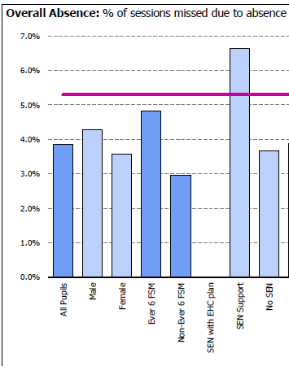 | 1-4
Art /play therapist in school half day per week  Children have access to child psychotherapist based in school one day per week  £9661 | The OFSTED framework highlights expectations round school to provide wider opportunities and to remove barriers to learning. School recognises the low level of children entering school and the very high depravation index and current pressure on NHS support services. We use of PP funding to ensure children get access to opportunities and support/ enrichment quickly.  When it becomes evident that a child needs more support to catch up to their peers. We discuss possible reasons and intervene that goes beyond supporting academic progress.  The providers identified are experts in their fields and have a proven track record in supporting children to be more successful in school. School monitors these interventions and measures the impact for each child on attainment and progress.  We have used the EEF model of a tiered approach in supporting PP children. | 1-4
Future steps occupational therapy programmes
£8919
Educational psychologist, termly support
£4500

School to pay for speech and language therapist to attend weekly.
£8500
£1 book club  £1000 | This allows children to purchase at school high quality text (they request) at a highly subsided price. | 1-4
Breakfast club subsidy  £3000 | Due to the school’s locality and socio-economic challenges, we subsidise breakfast club to ensure all children have access to a breakfast and to support working parents with morning childcare. | 1-3
TVMS  £6,800 | All KS2 children will learn a musical instrument.  All children will be receiving singing and music lessons by qualified professional  Children will have opportunity to join an afterschool choir. | 1-4
Subsidy of school trips/residentials/enrichment visits  £8000 | We commit to wider experiences in the local area and beyond. We do not make this cost prohibitive.  Educational visits are charged at a very low cost and targets our most disadvantaged and “working poor” families. | 1-3
Uniform and clothing £4000 | We are proud of our uniform and how smart our children are. At the start of an academic year, we provide a free jumper or blazer for each child. The rest of the uniform can be purchased from most supermarkets. The tartan skirt/pinafore is optional. | 1-4
Employment of parent support officer  £19510 | An invaluable role that allows us to form good relationship with vulnerable families and support with the heavy safeguarding workload. | 1-4

Total budgeted cost: £119,756

Part B: Review of outcomes in the previous academic year

Pupil premium strategy outcomes
This details the impact that our pupil premium activity had on pupils in the 2022 to 2023 academic year.
The data regarding pupil premium is very pleasing. In almost all areas of assessment our disadvantaged children are in line with or outperform all other (non-disadvantaged children) nationally. Our challenge is to reduce the in school gaps between advantaged and non-disadvantaged children.
Absence rates:
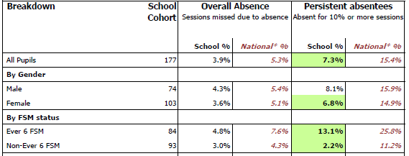
Good level of development at end of EYFS:
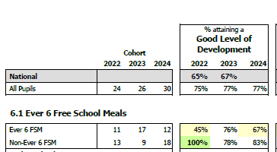
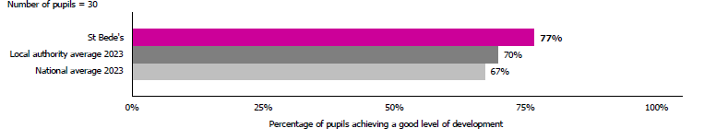
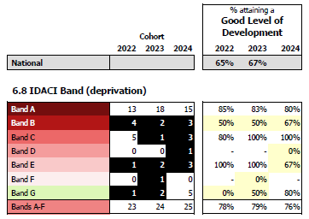

Year 1 and 2 phonic results:
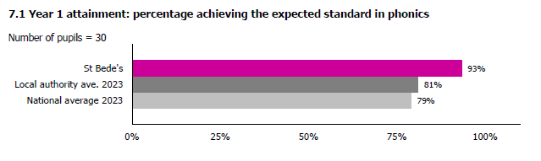
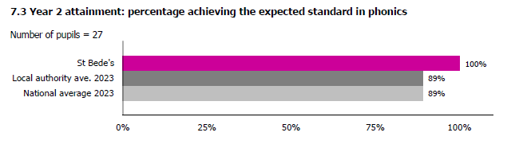

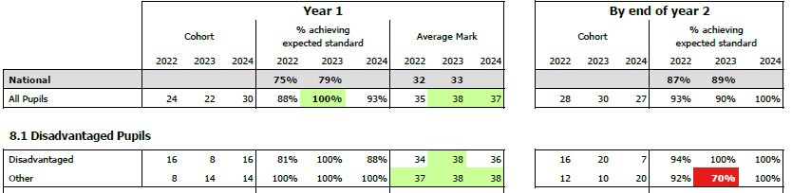
Year 4 times tables check.
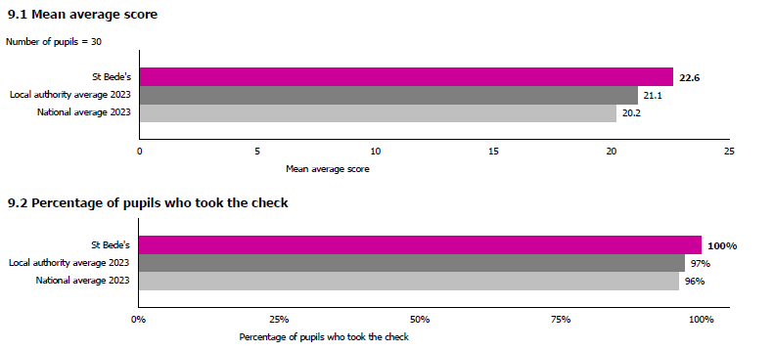

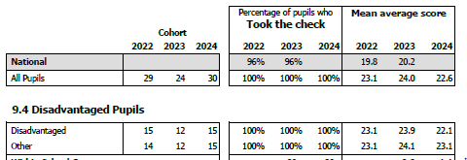
End of KS2

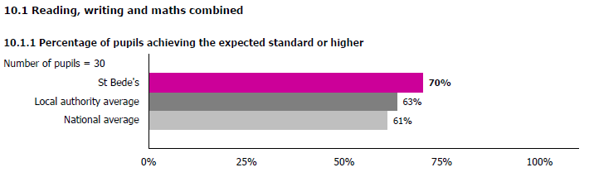
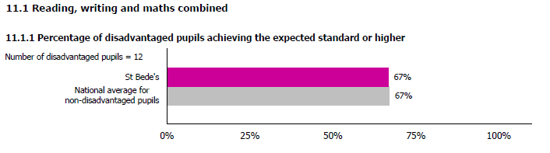
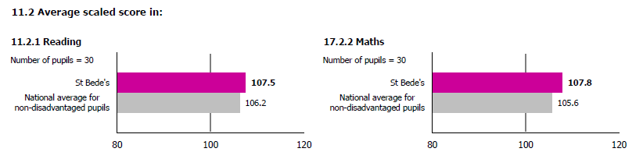
This is a particular area of focus this year.

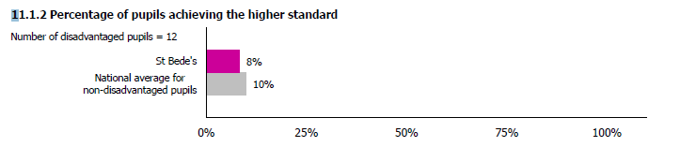

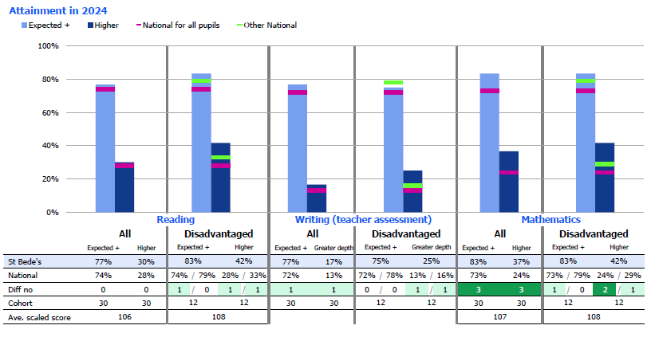

Externally provided programmes
Programme | Provider
Therapeutic occupational therapy interventions | Future steps occupational therapy
Child counselling, psychotherapy, art, play, trauma therapy | Bungalow Partnership
Reading Plus intervention | Reading plus
Times table rock star | TTRS
Ability to refer and assess children within two weeks, to have therapist deliver/design a programme in school within a month of a problem being identified. | NHS Tees speech and Lang service for stutters
Private Speech and language therapist – ½ a day a week | Emma Harrison SLT
Intensive 20-week Lang programme for reception age children | NELI  Nuffield early lang intervention
Private Ed PSY | Pegasus services

Service pupil premium funding (optional)
For schools that receive this funding, you may wish to provide the following information:
Measure | Details
How did you spend your service pupil premium allocation last academic year? | Teaching children in small, targeted groups.  Access to child counselling and other therapies continuing.
What was the impact of that spending on service pupil premium eligible pupils? | Improved attendance – children are happy to come to school. Children were able to access reading interventions.

Further information (optional)
“One measure of poverty is how little you have. Another is how difficult you find it to take advantage of what others try to give you.”
At St Bede's Catholic Academy, we believe in "always equity, rarely equality" when it comes to supporting our pupil premium students. We know that cultural and arts opportunities, along with teaching them “skills for success” (speaking, listening and other social skills) are essential for helping them learn and grow and become valuable contributing member so society. By offering experiences like art workshops and theatre trips, we aim to open new worlds for our pupils and help them engage with the wider curriculum. We explicitly teach the softer skills that more affluent children are immersed in daily. We explicitly give them the experiences that many more affluent children take for granted. Good academic attainment is vital, but we nurture, develop and teach the skills that will help our wonderful pupils become successful in life. These skills cannot be quantified by an exam result.
That said, we do face some challenges. It’s important for us to make sure these activities fit well with what we teach in class, and we also need to find reliable additional funding to keep these programmes going. Our goal is to empower all our pupils, especially those from disadvantaged backgrounds, so they can thrive in school and beyond and become valuable and productive member of 21st Britain.

