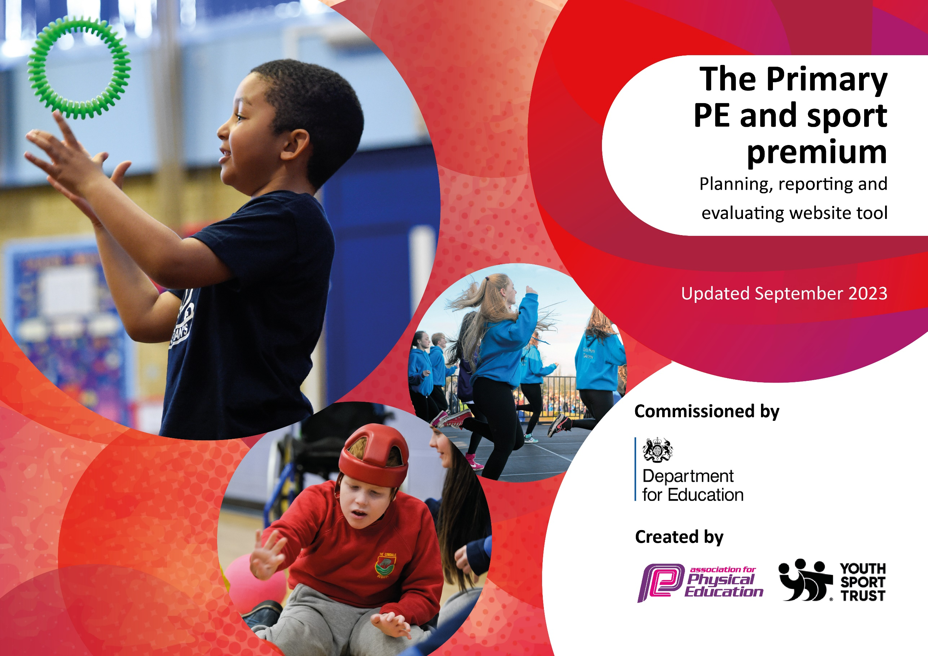

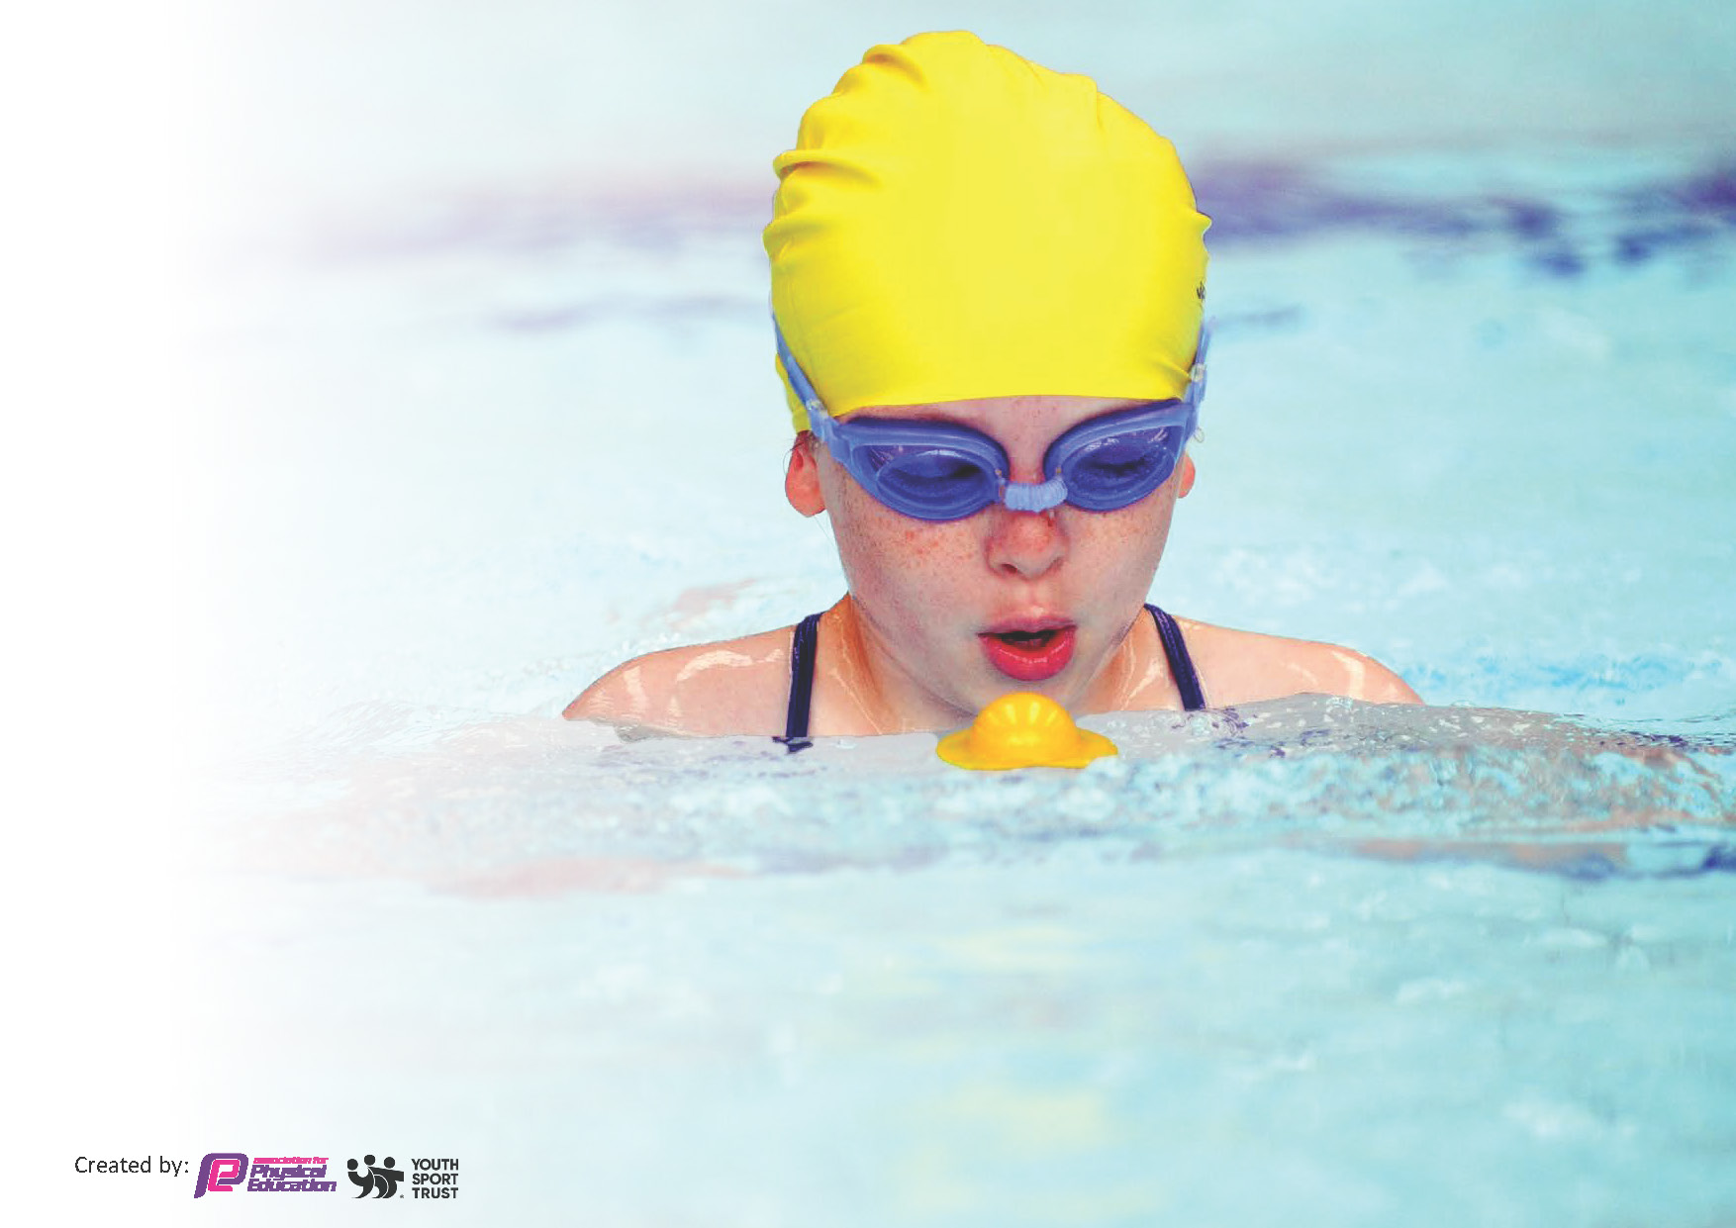
This template can be used for multiple purposes:
by:
- It enables schools to effectively plan their use of the Primary PE and sport premium.
- It helps schools to meet the requirements (as set out in guidance) to publish information on their Primary PE and sport premium.
- It will be an effective document to support Ofsted inspections enabling schools to evidence progress in Physical Education (PE) and evidence swimming attainment, which forms part of the PE National Curriculum. We would recommend schools consider.
the Intent, Implementation and Impact of any spend, as examined within the Education Inspection Framework.

It is important that your grant is used effectively and based on school need.

Schools must use the funding to make additional and sustainable.
improvements to the quality of the PE, School Sport and Physical Activity (PESSPA)
they offer. This means that you should use the Primary PE and sport premium to:

- Build capacity and capability within the school to ensure that improvements made now will benefit pupils joining the school in future years.
- Develop or add to the PESSPA activities that your school already offers.

The Primary PE and sport premium should not be used to fund capital spend projects; the school’s core budget should fund these. Further detail on capital expenditure can be found in the updated Primary PE and sport premium guidance.

The Primary PE and sport premium guidance, outlines 5 key priorities that funding should be used towards. It is not.

necessary that spending has to meet all the key priorities, you should select the priorities that you aim to use any funding towards.

Although completing this template is not a requirement for schools, schools are required to publish details of how they spend this funding. Schools must also outline what the impact this funding has had on pupils’ PE and sport participation and attainment and how any spending will be sustainable in the future. All funding must be spent by 31st July 2024.

The Department for Education has worked closely with the Association for Physical Education (afPE) and the Youth Sport Trust (YST) to develop this template and encourages schools to use it. This template is an effective way of meeting the reporting requirements of the Primary PE and sport premium.
Review of last year’s spend and key achievements (2023/24)

We recommend you start by reflecting on the impact of current provision and reviewing your previous spend.

Activity/Action | Impact | Comments
We employed qualified sports coaches to deliver our Pe curriculum during the day. We also offer sport coaching during breakfast club and at AFC. Our PP champion ensured there was fair access to sports clubs of SEND and PP children.  We formalised the “commando Joes “problem solving and character building through range of physical and mental problem-solving/resilience and team building activities.  We continue to teach swimming in blocks which has allowed us to begin the long process of recovering from pool closure that impacted on swimming lessons.  We committed to provide all children appropriate outdoor and indoor PE kits from PP funding to ensure all children were dressed well for the colder weather and we can carry out POE lessons in our extensive grounds.  Children all had access to outside providers sports provision, and we ensured that some opportunities were given to SEND children exclusively.  We also paid for some dance and swimming classes for children that were only available at the weekends. This was paid for by targeted PP funding. | Qualified Coaches: High-quality instruction improves pupils' physical skills and fitness levels.  Swimming Recovery: Block swimming lessons help pupils regain skills lost due to pool closures.  Increased Participation and Engagement  Breakfast Club and AFC Coaching: More opportunities for pupils to engage in physical activity.  Fair Access for SEND and PP Pupils: Ensures inclusivity, encouraging all children to participate.  Character and Resilience Development  Commando Joes Programme: Focuses on problem-solving, teamwork, and resilience, fostering essential life skills.  Improved Well-being and Health  Provision of PE Kits: Ensures all pupils can participate comfortably, promoting regular physical activity.  Access to Outside Providers: Broadens activity range and promotes social interaction for all pupils.  Targeted Support for Disadvantaged Pupils  Funding for Classes: PP funding for weekend dance and swimming classes enhances access for disadvantaged pupils.  Community and Parental Engagement  Inclusive Opportunities: Fosters a sense of belonging and encourages parental support for school initiatives.  Long-term Life Skills Impact  Holistic Development: Combines physical activity and character-building, equipping pupils with skills for future success. | At St. Bede's Catholic Academy, we're excited to share our ongoing commitment to sports and physical education! Starting now, every class will enjoy at least two hours of PE each week, taught by our fantastic teachers and in-house sports specialists.  This change highlights our dedication to making physical activity a key part of school life. Over the years, we've worked hard to develop and enhance our PE programme, ensuring that all our pupils get to try different sports and build important skills that help them grow.  By focusing on quality instruction and encouraging regular participation in physical activities, we hope to inspire every pupil to feel confident and enjoy being active. This commitment to PE is a big part of our mission to provide a well-rounded education that supports both mind and body, setting our pupils up for a healthy and active future.  We truly believe that investing in our PE programme is investing in our pupils' futures, giving them the tools and confidence they need to thrive both in school and beyond. Additionally, we are currently in the process of writing a new PE curriculum, which will be fully available in January 2025.

Key priorities and Planning
This planning template will allow schools to accurately plan their spending.

Action – what are you planning to do | Who does this action impact? | Key indicator to meet | Impacts and how sustainability will be achieved? | Cost linked to the action
Implementation of a comprehensive curriculum map, with cross curricular links.  Continue to provide transport to take children to and from sporting competitions.  Curriculum progression of skills published and utilised.  Increased swimming opportunities from years 4, 5 and 6.  To ensure those children who missed formal swimming lessons are given the opportunity to learn to swim.  Year 6 Sports leaders to take on an active role and help develop playtime play.  Sports opportunities at breakfast club, lunch time and afterschool club.  School will ensure that every teacher is more confident in PE delivery and gives high priority to physical activity each day.  Increased pupil participation in PE and Sports.  PP and SEND pupils to have opportunities to compete throughout the year.  Record of children attending extended school activities, data analysis. | Teaching staff, sports coaches.  School staff, children  Teachers and sports coaches  Teachers, swimming coaches  School staff, parents  Sports coach, KB, Sports leaders.  Sports coach, KB.  Teachers, KB, Sports coach, BHCET PE teachers.  Sports coach, teachers, KB | Key Indicator 1: Increased confidence, knowledge, and skills of all staff in teaching PE and sport.  Key indicator 2: The profile of PESSPA being raised across the school as a tool for whole school improvement.  Key indicator 3: Increased confidence, knowledge and skills of all staff in teaching PE and sport  Key indicator 4: Broader experience of a range of sports and activities offered to all pupils. | Children able to make links across the curriculum.  Another staff member trained to drive the minibus. Children able to experience a wider range of activities.  Teachers and sports coaches aware of progression, able children challenged. Skills built on through the year groups.  Pupils are able to progress more easily and will have access to deep water swimming/ lifesaving skills/ further distances.  Sports coach and sports leaders have run interhouse competitions promoting active play at breaktimes.  They have worked together to ensure equipment is available for playtimes.  Higher percentages of pupils participating in before and after school sports, promoting a healthier more active lifestyle.  Lesson sports stars board regularly updated.  Achievements from home are celebrated.  Twinkl planning implemented throughout school. Staff are confident using this resource when planning for PE (sports coach and BHCET teacher)  Children in EYFS and KS1 develop the fundamental skills required for KS2. Children in KS2 develop these skills and apply them. Skills progress and build across year groups.  All children are given opportunities through lessons, breakfast club and extra-curricular clubs. Children are more active and ready to learn.  PP children given priority to extracurricular sports.  Children and vulnerable groups can be analysed and tracked to ensure participation.  SEND given opportunities in safe environment | £17,650.(amount allocated)  £2630  Swimming tuition  Outdoor PE uniform £1635  £400 (equipment)  £1200 subsidy for outdoor activity centre. 50% was of set with PP funding. The total subsidy was £2400  Stockton sports partnership: £2,300  £11,000 (specialist sports teaching)

Children to complete in a range of competitive and non-competitive festivals throughout the year. | Teachers, KB, sports coaches, children | Key indicator 5: Increased participation in competitive sport | Children have enjoyed a range of competitive and noncompetitive competitions.  Opportunities for all including SEND specific.  Competition results and experiences recorded and published through a variety of media.  Supported transition for year 6 pupils who attended cluster sports day at OLSB.

Key achievements 2023-2024
This template will be completed at the end of the academic year and will showcase the key achievements schools have made with their Primary PE and sport premium spending.

Activity/Action | Impact | Comments
All year 4 children provided with opportunities to swim through lessons provided by local swimming baths.  All children in school have been provided with a sport kit.  New equipment has been bought and distributed around playtime boxes.  SEND children given the opportunity to visit Billingham forum for an ice festival.  Sports coaches continue to implement new curriculum.  Commando Joe | Children able to swim 5, 10, 25+ metres confidently.  Developed sense of water safety  All children dressed and ready6 for sport in school.  Children able to be active at playtimes, develop communication skills and collaboration.  Opportunities to experience a range of activities in a noncompetitive environment.  Children taught a series of skills that progress through key stages and are built upon.  Cross curricular links- curriculum map | We are delighted to be committing now two hours every week for the teaching of physical education.

Swimming Data
Meeting National Curriculum requirements for swimming and water safety.
Priority should always be given to ensuring that pupils can perform safe self-rescue even if they do not fully meet the first two requirements of the National Curriculum programme of study.

Question | Stats: | Further context  Relative to local challenges
What percentage of your current Year 6 cohort can swim competently, confidently and proficiently over a distance of at least 25 meters? |  | This cohort missed school swimming lessons.  Current year 4:  5m+: 93%  10m+: 70%  25m+:40%  50m+: 33%  Current year 5:  5m+: 96%  10m+: 68%  25+: 29%  50M+: 25%
What percentage of your current Year 6 cohort can use a range of strokes effectively [for example, front crawl, backstroke, and breaststroke]? |  | This cohort missed school swimming lessons.  Current year 4: 40%

What percentage of your current Year 6 cohort are able to perform safe self-rescue in different water-based situations? | % | This cohort missed school swimming lessons.  Current year 4: 33%
If your schools swimming data is below national expectation, you can choose to use the Primary PE and sport premium to provide additional top-up sessions for those pupils that did not meet National Curriculum  requirements after the completion of core lessons. Have you done this? | Yes/No | Time constraints and availability prevented current yr. 6
Have you provided CPD to improve the knowledge and confidence of staff to be able to teach swimming and water safety? | Yes/No | Swimming provided by trained swim teachers

Signed off by:

Head Teacher: | (Bernadette Rizzi-Allan)
Subject Leader or the individual responsible for the Primary PE and sport premium: | Kate Bennett (Sports/Pe coordinator)
Governor: | (Name and Role)
Date: | 16-9-24

