**St. Bede’s Prayer Book**

**‘Together with Christ, we grow in faith and knowledge.’**

At St. Bede’s praying is an essential part of our school community, it sets the rhythm of our day. We have included some of the main prayers we say in school to help you with praying at home as a family. Prayer is a shared experience and a special spontaneous conversation with God. At St. Bede’s we recognise that we all have our own way of being close to God. There is no right or wrong way to pray.

We regularly say traditional prayers both in our school parish community and in our school. Please help your child to become familiar with the prayers and enjoy the experience of praying together at home as a family.

The children will also learn prayers that link in with significant liturgical events such as Jubilee Prayers, prayers for new popes, bishops and parish priests and significant world events.

We hope you enjoy praying with your children at home as much as we do in our school community.

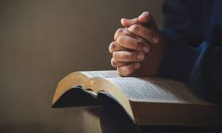

**The Sign of the Cross**

In the name of the Father and of the Son And of the Holy Spirit, Amen.

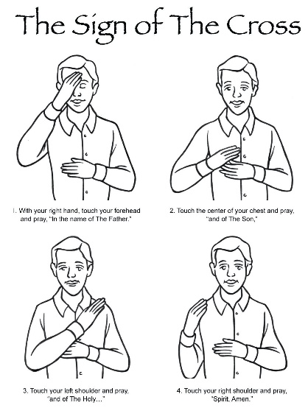**School Prayer**

**O Lord bless our school,**

**May we live happily together,**

**May our school be full of joy,**

**May love dwell here among us every day,**

**Love one another,**

**Love of all people everywhere,**

**Love of life itself,**

**And love of God.**

**Let us remember that as many hands build a house,**

**So every child can make St. Bede’s a better place.**

**Morning Prayer**

O my God you love me,

You’re with me night and day

I want to love you always

In all I do and say

I’ll try to please you Father

Bless me through the day

Amen

**Grace before meals**

Bless us, O Lord,

and these Thy gifts, which we are about to receive from Thy bounty,

through Christ our Lord. Amen.

Grace After Meals

Thank you**,** God,

for the food we have eaten**.**

Thank you, God,

for all our friends. Thank you, God,

 for everything,

Thank you, God.

Amen.

**Evening Prayer**

God our Father,

I come to say,

Thank you for your love today.

Thank you for my family,

And all the friends you give to me.

Guard me in the dark of night

And in the morning

Send your light.

Amen

**The Lord's Prayer**

Our Father who art in heaven, hallowed be thy name.

Thy kingdom come, thy will be done, on earth as it is in heaven.

Give us this day our daily bread,

And forgive us our trespasses as we forgive those who trespass against us,

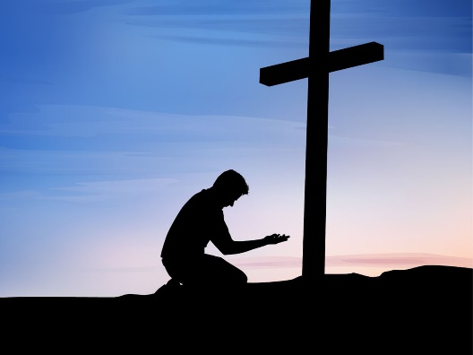And lead us not into temptation,

But deliver us from evil.

Amen

**Hail Mary**

Hail Mary, full of grace the Lord is with thee.

Blessed art thou amongst women, and blessed is the fruit of thy womb, Jesus.

Holy Mary, Mother of God, pray for us sinners, now and at the hour of our death,

Amen.

**Glory Be ...**

Glory be to the Father, and to the Son, and to the Holy Spirit.

As it was in the beginning, is now and ever shall be, world without end.

Amen.

**The Angelus Prayer**

V. The Angel of the Lord declared to Mary: **R. And she conceived by the Holy Spirit.**  
**Hail Mary……..**  
V. Behold the handmaid of the Lord: **R. Be it done to me according to your word.**  
**Hail Mary……..**  
V. And the Word was made flesh: **R. And dwelt among us.**  
**Hail Mary……..**  
V. Pray for us O holy Mother of God. **R. That we made be made worthy of the promises of Christ.**  
**Hail Mary……..**  
Let us pray: Pour forth, we beseech you, O Lord, your grace into our hearts, that we, to whom the Incarnation of Christ, your Son, was made known by the message of an angel, may by his passion and cross + be brought to the glory of his resurrection, through the same Christ Our Lord. **Amen.**

**Act of Contrition**

O my God,

because you are so good,

I am very sorry that I have sinned against you,

and by the help of your grace

I will not sin again.

Amen

**Act of sorrow**

O my God,

I thank you for loving me.

I am sorry for all my sins, for not loving others and not loving you.

Help me to live like Jesus and not sin again.

Amen

**Home Time Prayer**

God our Father, I come to say,

Thank you for your love today.

Thank you for my family and all the friends you give to me.

Guard me in the dark of night and in the morning send your light.

Amen.

**Eternal Rest (to remember those dear to us that have died)**

Eternal rest give unto them O Lord

And let perpetual light shine upon them.

May they rest in peace.

Amen.

**Prayers at home**

Night time prayer is important too. The end of the day is an opportunity to share a quiet time with your child or children and to thank God for the challenges of the day. Encourage your child to talk to God about whatever is on his or her mind. God loves to hear prayers for bike rides, a frog in the garden or even a successful tea party with dolls. We hope you enjoy the experience of praying with your child.

**Spontaneous Prayers:**

In addition to the traditional prayers that we say in school, we use everyday situations to ‘talk to God’ . For example, during the day we encourage children to say thank you to God. Thank you, God, for a lovely day, thank you God for my family, thank you God for………

Spontaneous prayers are simple, heartfelt expressions of faith that arise naturally in the moment, rather than being pre-written or memorised. They can be brief or longer, and often reflect the immediate needs, joys, or concerns of the individual. Examples include "Help", "Thank you, Jesus", or "Lord, forgive me".

Night prayer is very important too. The close of the day is an opportunity to share a quiet time and to thank God for the gifts or challenges of the day.

**St Bede’s Prayer Garden.**

At St Bede’s have a prayer garden to provide a dedicated space for children and staff to engage in quiet reflection, prayer and celebration. This space fosters a sense of connection with nature and God, allowing children to find solace and deepen their faith. It also provides a venue for class acts of worship and liturgies and celebration of the word.

