
St Bede’s Catholic Academy
Ensuring disadvantaged children access the full curriculum offer
Every teacher is a teacher of disadvantaged and SEND and every child has to be able to access the curriculum to allow them to succeed. Ensure you see the lesson through the eyes of the child.
High Quality Teaching in all subjects:
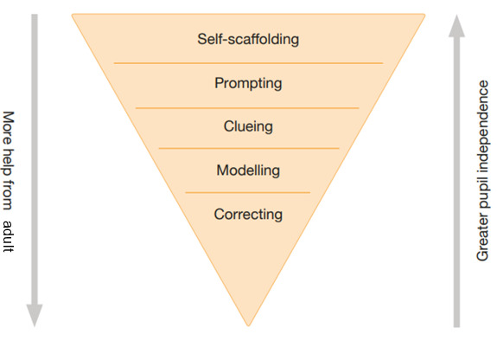
- flexible grouping
- Pedological cohesion of quality first teaching
- explicit instruction (chunked into small steps)
- using technology/manipulatives
- scaffolding
- teacher modelling
- effective/adapted questions
- retrieval and recap
- building on prior knowledge
- challenge
- making links to other learning.
- Cohesive high-quality curriculum offer
- Assessment based on core knowledge.

Adapting the environment:
- Change where the student sits in the classroom in response to recommendations from S&L/EP/SENDco
- Make use of cooperative grouping/jigsaw teaching.
- Limiting classroom decoration or displays in intervention rooms (this can help prevent children with ASD or sensory issues from being visually overloaded).
- Avoiding black on white presentation and varying the background colours (dyslexia friendly).
- Using a visual timetable throughout the day (ASD).
- Using visuals for classroom organisation (this will help scaffold spoken instructions, benefiting children with S&L and ASD, whilst also providing support to younger learners and EAL learners).
- Making a quiet workstation available for learners to use when they need it (this can help support learners with ADHD, ODD, and ASD).
- Promote positive relationships: focus on developing or re-establishing relationships between pupils, their peers and adults. Plan to support pupils who may find social communication difficult or who have difficulty trusting others.
- Promote active engagement: plan how you will support pupils who struggle to come back to school. Encourage metacognition and self-regulated learning so pupils become less reliant on others.
- Promote positive behaviour for learning: don’t assume pupils will automatically understand or be able to follow new rules and routines. Teach them explicitly and support their understanding with the use of visuals or social stories.
- Promote positive wellbeing: consider how you will prioritise positive wellbeing through a whole school approach and provide specific support for any pupils who return with increased levels of anxiety or emotional stress.
- Use writing slopes/iPad/dyslexia pens (dyslexic learners and those with motor skills difficulties can be helped by these).
- Specialised pencil grips.
- Ear defenders (children with sensory issues including those with ASD can benefit from these, as can children with ADHD or ADD, helping to block out some of the background noise).
- Wobble cushions (these can help ‘ground’ learners).
Adapting the input:
- Model new concepts.
- Verbalise your thought process whilst modelling activities, including strategies to remember what you need to do.
- Use technology where appropriate to scaffold the learner. This may include equipment, apps, or specialist software which can effectively support SEN.
- Provide students with advance organizers of key scientific concepts – Learn it! Link it!
- Deploy other adults in the classroom to effectively facilitate learning.
- Plan in the use of talk partners – this gives children with SEN access to peer support and the ability to rehearse their responses. Make sure the children know how to use talk partners appriopriately
- Incorporate flexible grouping
- Keep instructions clear and concise.
- Deliver instructions facing the children.
- Do not issue multiple instructions at once.
- Give children an opportunity to repeat instructions back to you.
- Accompany verbal instructions with visual aids (these can be symbols, images etc).
- Where appropriate, allocate other adults to re-word and re-frame instructions and information.
- Avoid idiomatic language – phrases such as ‘pull your socks up’ or ‘reach for the stars’.
Adapting the resource:
By adapting the resource, this can allow children to achieve the same goal
- Use pictures instead of chunks of text
- Put less information on a page
- Use overlays/acetate on text pages
- Use manipulatives
- Use large print activity sheets.
- Use overlays or windows on text pages to reduce the quantity of print that is visible
- Highlight key points on the activity sheet.
- Use ‘focused’ Learn it! Link it!
- Line indicators and highlighted margins
- Provide more space to put answers
- Highlight or colour code (directions, key words, topic sentences)
Adapting the task/outcome:
- Ensure tasks are effectively differentiated and ambitious in their outcomes for all students.
- Organise work for learners with SEN in smaller chunks with plenty of opportunities for revisiting and over learning, where appropriate. This might involve smaller follow-up tasks.
- Allow the student more time to complete tasks
- Require small amounts of work to be completed at a given time.
- Provide shorter but more frequent tasks
- Allow various ways for students to demonstrate their understanding of concepts.
- Provide opportunities for extension and practice – pre and post teaching
- Simplify the way questions are worded.
- Dictate/scribe
- Use adults to work with small groups
Further action:
- Pre and post teaching
- Verbal feedback
- Interventions
- Assessment
- Close monitoring of teaching quality
- Access to high quality curriculum.
IEP non-negotiables
Target books used as evidence record for IEP targets
Feedback sheet termly from professional recommendations
Every intervention to have a measurable entry and exit task reviewed termly.
No WB work. All work during an intervention is to be recorded in either Target book or an intervention book.
Daily ‘target time’
Staff must allow 5 minutes at the end of an intervention session to complete paperwork/register at back of target book.

