SEND Information Report
Approved on:
July 2023
Next review:
June-July 2024
St Bede’s Catholic Academy

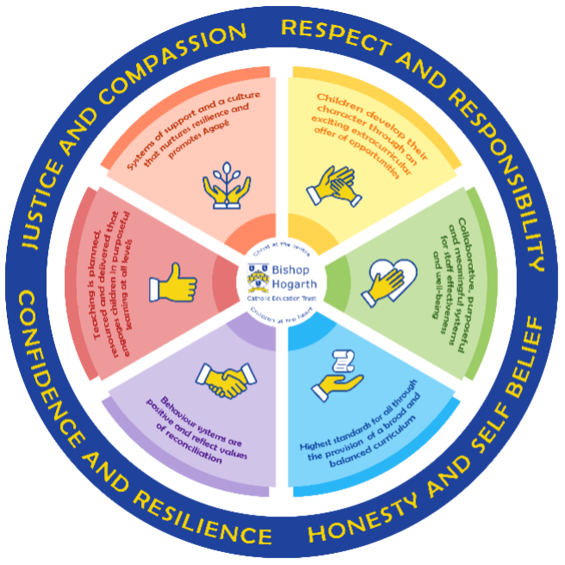
As part of the family of Bishop Hogarth Catholic Education Trust, our school has at its core, the virtues, and values of:
Respect for others and themselves, recognising that we are all created in the image of God and therefore must be compassionate towards others, especially the vulnerable. ​
Confidence in their own abilities, knowing that their talents are gifts from God and resilience to persevere when things become difficult. ​
Honesty in regard to the world around them and themselves and the ability to take responsibility for the times we may fall short of the mark. ​
Gratitude for all the amazing gifts from God and willingness to share their gifts both personal and material. ​

As an inclusive school, all teachers are teachers of pupils with Special Educational Needs & Disabilities. We deliver a curriculum and create an environment that meets the needs of every pupil within our school. We ensure that every pupil with Special Educational Needs and / or disabilities makes the best progress possible. We foster and promote effective working partnerships with parents / carers, pupils, and outside agencies. We consider the ‘whole’ child and strive to ensure that all our SEND pupils are prepared for adulthood.​

Our school’s approach to supporting pupils with SEND

St Bede’s Catholic Academy aims to offer children an educational experience where staff will strive to identify and remove barriers to learning. We aim to create an environment in which every child is encouraged to reach their potential and support children to succeed.

“Together with Christ we grow in faith and knowledge.”

St Bede’s is committed to constantly reviewing and evaluating its practices, systems and curriculum provision. We have a flexible approach to support all learning needs which enables us to access provision to suit every child in our care. We pay close attention to individual needs, personalised planning and the essential contribution of parents and carers to help us educate the whole child.
We focus clearly on outcomes for our children; we have a commitment to high achievement, high expectations and we strive to provide all our children with a high quality education matched appropriately to their particular needs. At St Bede’s, we believe that channelling our energies into the collaborative planning, personalisation, delivery and review of targets, will bring high aspirations into reality.
As every child is valued at St Bede’s, we put relationships first, seeking to properly know, care for and develop each individual child. We aim to teach in a way that helps children to love learning and we instil in our St Bede's family, our school character traits of confidence, respect, honesty, justice, compassion, resilience, responsibility and self-belief. We believe that every child has an equal right to a full and rounded education, enabling them to reach their full potential.
Where necessary, we strive to secure special educational provision for those learners who require it. By this, we mean provision that is ‘additional to and different from’ that is provided within the adapted curriculum to better respond to the four areas of need identified in the Special Educational Needs and Disability Code of Practice: 0-25 years.

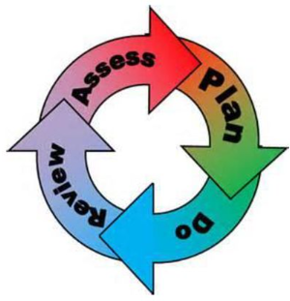
How will the school staff support my child?
The graduated response-Identifying, planning for and supporting pupils with SEND
Where a pupil is identified as having a special educational need, School will follow a graduated approach which takes the form of cycles of ‘Assess, Plan, Do, Review’. ​
• Assess a child’s special educational need. ​
• Plan the provision to meet your child’s aspirations and agreed outcomes. ​
• Do put the provision in place to meet those outcomes. ​
• Review the support and progress.

How does the school know if children need extra help and what do I do if I think my child has special educational needs?

- Assess
Your child will be identified as having SEN and/or a disability if they have significantly greater difficulty in learning than the majority of children of the same age or if they have a disability preventing or hindering the use of educational facilities provided for children of the same age.
If from our rigorous tracking and monitoring of your child’s progress, it becomes apparent that they are not making expected progress then you will be invited to a meeting with their teacher and the school’s SENDCo. Where appropriate, your child will be involved in this meeting. At the meeting, we will begin to explore the possible barriers to learning and you will be asked how you feel we can best support your child.
Observations and assessments will then be carried out and, if required, input from specialist services may be sought with your permission.
Where appropriate, your child may be placed on our school’s Targeted Support or SEND Support Register and a plan will be devised by the class teacher that will set achievable targets. These will be reviewed and updated at least half-termly.
EHCPs (Education, Health and Care Plans) will be used when a child’s needs are deemed more complex and require the input from a range of outside agencies. This could be in the form of Educational Psychologists, Occupational Therapists or other professionals with an area of expertise. An EHCP helps to determine the level of educational, social and health support the child needs.

- Plan
The first point of contact is the class teacher, who has overall responsibility for the welfare of your child. Additional provision is planned carefully and overseen by the SENDCo. It is implemented by a skilled team of teachers and supported by experienced teaching assistants.
At St. Bede’s, we have an extensive range of different SEND resources and interventions available. These are closely matched to the needs of our children and their progress is monitored by the class teacher, the SENDCo, the Interventions Manager and staff with specific curriculum responsibilities.
For many children, their targets will be linked to learning and will often be specifically related to literacy and numeracy. However, for other children they may be related to social interaction, communicating with children and adults or emotional difficulties. The most important factor is that the targets and support provided are particular to the needs of each individual child.
Where provision does not result in adequate progress, as outlined in the SEND Code of Practice, the SENDCo will be consulted for advice.

- Do
Our teachers are skilled at adapting teaching and learning to meet the diverse needs in each class. ​
Daily planning considers individual children’s needs and requirements and is annotated and adapted according to need. Explicit reference is made in the teacher’s planning to the needs of those children identified with SEND. ​
Adaptive teaching is approached in a range of ways to support access to the curriculum and ensure that all children can experience success and challenge in their learning. ​
Grouping arrangements consider the different skills and abilities of each child. This ensures that learning is maximised. ​

Additional adults support groups and individual children with the long-term goal of developing independent learning skills. The class teacher monitors this support to avoid students becoming over reliant on this. ​
We fully encourage parental support and offer opportunities for individual meetings with parents/carers to provide clarity and recommendations on how they can support their child at home.

- Review
If despite all steps taken, good progress is still not being made we will refer back to our graduated approach and increase/change support whilst continuing to monitor and review progress. It may also be necessary, at this stage, to consult with the expertise and specialist services secured by the school.
Consultation sessions are held in the Autumn and Spring terms where you can meet your child’s teacher to discuss and look at their work in different subject areas. A further opportunity is provided in the Summer term for you to discuss your child’s end of year report.
Parents that have children on the school’s Targeted Support or SEND Support Register, are also invited to termly reviews of their child’s Individual Education Plan. Your child will be involved in reviewing their targets with the class teacher or teaching assistant, and during the setting of new targets on a termly basis. If, of course, you would like to meet the SENDCo or your child’s class teacher at any point during the term, this can easily be arranged.
For every child who is in the care of the Local Authority, (a looked after child - LAC), a Personal Education Plan (PEP) will be devised. This Plan will establish clear targets and actions to respond effectively to each child’s needs and provide a continuous record of their achievements.
If your child has an EHC plan, you will be invited to an annual review of this plan.
Homework is given regularly and your child may have the opportunity to access computer programmes to support their learning at home. You are encouraged to support your child’s learning at home. Home school diaries are used to support communication between home and school and you are encouraged to use these where appropriate.

How will the curriculum at our school be matched to my child’s needs?
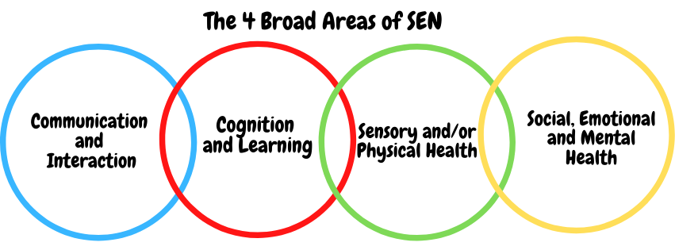SEN needs are classified under four broad areas of need. Below are the strategies, in class support and interventions that school may put in place to support your child.
Communication and Interaction
Strategies to support children with these needs include:

- Access to small group and/or individualised interventions to develop skills in communication and interaction with others, e.g. Time to Talk, Early talk, Talk Boost, NELI, Nursery Narrative, Socially Speaking, Lego Therapy
- Visual timetables
- Flexible approaches to timetable
- Modifications to lunch and/or break times, e.g. duties, time change
- Access to additional aids/technology/screening tools
- Explicit teaching of generalising skills from one context to another
- Careful planning of transitions, e.g. advance notice, familiar resources
- Peer mentoring and/or buddy systems
- Pre and post teaching
- Access to on-site Speech and Language therapist
- Guidance and recommendations from C&I specialists: speech and language, educational psychologist
- Access to a specialist teaching assistant with speech and language training
- Additional in and out of class support
- One-to-one support
- Flexible groupings (including small group work)
- Access to personalised, differentiated and specific resources and learning programmes
- Multi-sensory learning approaches
- Environmental considerations
- SMART targets for individual education plans
- management of modified of materials for national tests

Cognition and Learning
Strategies to support children with these needs include:
- High quality precision teaching techniques
- Individually focused evidence-based interventions: RWInc fast track, Reading Fluency, Catch-up Numeracy, Working memory techniques, target reading, Sound training, Numicon.
- Increased access to small group support in class
- Practical aids for learning: table squares, time/number lines, pictures, photos, accessible reading material suited to age, individualised success criteria
- Adapted knowledge organisers (Learn it! Link it!)
- Increased access to ICT programmes: Reading plus, Times Tables Rock Stars, Spelling Shed, Sum Dog, Teach your monster to read
- Access to technical aids: spell checker, ICT software and/or hardware
- Curriculum/delivery adaptations to meet the learning needs of individuals
- Frequent repetition and reinforcement using interleaving techniques in metacognition
- Pre and post teaching
- Shared writing and comprehension sessions
- Additional in and out of class support
- One-to-one support
- Flexible groupings (including small group work)
- Access to personalised, differentiated and specific resources and learning programmes
- Opportunities for staff training on SEND
- Multi-sensory learning approaches
- SMART targets for individual education plans
- Management of modified of materials for national tests: readers, scribe, ICT

Sensory/Physical
Strategies to support children with these needs include:
- Occupational Therapy interventions supported by Future Steps: SMART programme, EARTH handwriting, Calming & Regulating programmes, Just the Right State programme
- Concrete apparatus available to support learning: Numicon materials, overlays, reading guides, slopes, pencil grips, privacy screens, fidget aids
- Adapted and inclusive curriculum: alternative recording devices, modified PE curriculum, enlarged print, talking postcards, scribes
- Sensory resources available: wobble board, headphones/ear guards, chew buddy, resistance bands, ankle weights, weighted jackets
- Access to support for personal care: school nurse service
- Enlargement of resources and modified resources
- Transcripts and ICT software
- Adaption to school and learning environment
- Access to gross motor, fine motor and visual perception resources
- Multi-sensory learning approaches

Social, Emotional and Mental Health
Strategies to support children with these needs include:
- Access to individual work area
- Mentoring and Buddy system
- Individualised rewards system
- Access to counselling services: CAMHS, Forget Me Nots, Psychotherapy, Art therapy, Bungalow Project
- Mental Health First Aiders
- Increased access to additional adults in and out of the classroom
- Supported transition programme with chosen secondary school and for internal transitions
- Opportunities to develop Social and Emotional aspects of learning through small group work: Just the Right State programme (Future Steps)
- Future Steps Occupational Therapy services: Calming and Regulating programmes, SMART programme
- Promotion of wellbeing and good mental health through whole school topics and projects
- Healthy Minds support page on school website
- Offer of pupil responsibility to increase self-esteem and confidence: Head boy and girl, school council, house captains, eco-warrior, class monitors
- High expectations of behaviour and promotion of emotional resilience
- Commando Joe programmes
- Robust PSHE delivery
- Regular student voice and school council meetings
- PSA in school to support parents and carers

What training is provided for staff supporting children with SEND?

All teachers have Qualified Teacher Status and our teaching assistants have a minimum of a level 2 qualification. All staff are either teachers of or are supporting students with SEND.
St. Bede’s values staff training and organises courses and training programmes to ensure teachers and teaching assistants stay up to date with current research in teaching and learning.
Whole school training:
- Safeguarding and Child Protection
- DYT cognitive load theory
- Annual SEND updates
- How children learn
- First Aid
- Cultural Awareness training
- Mental health training
- Dyslexia and Dyscalculia
- Attachment training and ACE
- Teams
- How children read
- Sunflowers NHS occupational therapy
- White Rose Maths
- Future Steps chair-based regulation techniques
- EYFS new curriculum
- RWInc

Individual staff training:
- Safeguarding children with SEND
- Theraplay and sensory training
- EARTH handwriting
- Speech, language and communication
- Lego therapy
- Catch-up Numeracy
- Medical administration
- Self-harm and sexualised behaviour
- Anxiety and low mood
- Mental health and risk resilience
- Metacognition
- Communication and interaction in EYFS
- NELI
- ADHD
- ACE

How do we support transition in our school?

Transition within classes/key stages: ​
All relevant information will be passed on to the new class teacher in advance and a transition meeting will take place with the new teacher. Individual targets and requirements for all children with SEND will be discussed with the new teacher and agreed by the SENDCo.
Children who require additional support to ensure a smooth transition to their new class, will be included in a programme supported by the SENDCo and PSA.
If your child moves to a new school within or at the end of an academic year, the SENDCo will contact the new school’s SENDCo to ensure they know about any special arrangements or support that needs to be made for your child. If necessary a meeting will be arranged with other professionals. They will also transfer all records held for your child to the new school as soon as possible.

Transition to Secondary settings: ​
We work closely with all secondary schools in the area. The majority of our children move on to Our Lady and St. Bede’s Catholic Academy in Stockton.
The transition process will begin early, usually in Year 5, for some of our more vulnerable children. Meetings are held for the transfer of essential information relating to IEPs, EHCPs, Child and Family Services and pastoral matters.
Our Parent Support Advisor works closely with the SENDCo and Year 6 class teacher to support children who require additional provision during their transition period. We can also support you in organising meetings with secondary school staff if you wish to speak to them personally.
When reviewing an EHCP for children in Year 6, staff from the secondary school will always be invited to the review meetings.
During the last term, staff from OLSB’s come to meet our Year 6 children and in addition to this, our Year 6 children attend their chosen secondary school for two transition days.

Where can I get further information about services for my child?

The Local Offer
Please click the following link to see Stockton’s Local Offer
http://www.stockton.gov.uk/childrenandyoungpeople/childrenwithdisabilities/

What key school documents refer to support and provision for pupils with SEND?

- SEND Policy​
- Admissions Policy​
- Supporting Pupils with Medical Needs Policy​
- Accessibility Plan​

Accessibility​
St. Bede’s is an inclusive school and we will put in place appropriate support, whenever possible, to enable your child to be educated equally alongside their peers. This may include access to specialist staff and equipment to support participation in the curriculum:
- Access to specialist services who will support the child’s education and the school
- Modified curriculum resources to enable ease of access
- Improvements in facilities and school site to enable disabled access such as ramps, visual impaired resources, hearing impaired resources etc.
- Specialist transport for off site visits
- Access to remote learning equipment
- Specific training for teaching and support staff
- Provide a ‘scaffolded’ approach to learning

With due regard to our admission policy, parental choice and accessibility of the school building, all children with special educational needs who apply, will be accepted by the school. All of the ground floor of the school is fully wheelchair accessible. Disabled toilet facilities are located near the school entrance. Communication with parents whose first language is not English is supported by advice from the Local Authorities English as an additional language (EAL) team. Our Polish families are also supported by Mr Holce (school governor). Key documents are also translated for our Polish parents.
Activities Outside of School
- Staff who are arranging an offsite trip will discuss with parents and the SENDCo any requirements needed and the suitability of any trip which the school is taking part in.
- We will not stop your child from going on a trip due to their special educational needs and/or disability if the trip is suitable for your child and their safety and the safety of others is not compromised.
- The Head of School oversees all trips to ensure children are safe and included where possible.

Activities Outside of School​

What to do if you have a complaint, a compliment, or a query.

The school details and relevant contacts
Mrs B. Rizzi-Allan – Head of School
Mrs E. Duffield– Deputy Head and SENDCo

St. Bede’s Catholic Academy, Green Lane, Stockton-on-Tees, TS19 0DW
Tel: 01642 678071
Website – www.stbedesstockton.bhcet.org.uk
Email – admin@stbedesstockton.bhcet.org.uk

* SEND Code of Practice (graduated response) https://www.gov.uk/government/consultations/revision-of-the-send-code-of-practice-0-to-25-years
Stockton Borough Council website – www.Stockton.gov.uk
Bishop Hogarth Catholic Education Trust website – www.bhcet.org.uk
Academy contact - 01325 254525

​
Name of school SEND governor.
Ann Bostock

