The context of our school
We are one and a half entry school, part of the Bishop Hogarth Catholic Education Trust. We have 15.2% pupil premium. It is essential that our approach to teaching phonics and reading is accessible to all learners, regardless of background.

Trust Vision
Our schools will be places of excellence – providing service and witness to children, their families and the wider Catholic community, adding value as a family of schools and enriching the learning and experience of all our young people so they may achieve their full potential.

Mission statement
Love one another as I have loved you.
John 13: 34-35

Our mission statement roots the life of the school in the person of Christ and the teaching of the Catholic Church. In living out our mission statement, St Bede’s will:

- Assist the Church in making Christ known to all people.
- Assist parents, who are the primary educators of their children, in the education and religious formation of their children.
- Be at the service of the local Church – the diocese, the parish and the Christian home.
- Be a service to society.

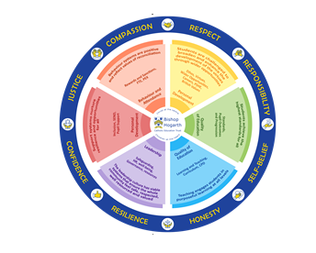
Our Virtues

By sharing in the values of Bishop Hogarth Catholic Education Trust, the St Bede’s community recognises the worth of individuals, responding with kindness and challenging prejudice, stereotyping and discrimination.

Respect for others and themselves, recognising that we are all created in the image of God and Self-belief in their character and their ability to achieve their goals and aspirations.

Compassion towards others, especially the vulnerable, promoting justice in their college community, local community and beyond.

Confidence in their own abilities, knowing that their talents are gifts from God and Resilience to persevere when things become difficult.

Honesty in regards to the world around them and themselves and to take Responsibility for the time we may fall short of the mark.

St Bede’s Vision for Writing.

At St. Bede’s, all of our pupils, irrespective of background or ability, will become effective and enthusiastic writers; to be able to write with grammatical accuracy; with appropriate style and flair; with an awareness of the reader; and, to be able to write at length, within whichever genre they choose to express themselves – today, tomorrow and in the many years ahead.

Our pupil’s journey to being an effective writer begins in Nursery at St. Bede’s. We fully understand that before our children can be expected to pick up a pencil and engage in refined fine motor tasks, they must first become confident and proficient in whole body, gross motor movements; running, jumping, climbing, crawling – the fundamental movement skills. The journey to the page begins in our carefully designed, physically enabling Early Years environment, where our children are encouraged to learn through movement; the physical language of learning.

Throughout Nursery and Reception children learn through carefully considered play opportunities that foster purposeful and progressive social interaction and ultimately, language; the next step in writing development. Before children can write, they must talk. At St. Bede’s we foster a language rich provision, where all adults’ model ‘talk’, recognising that immersing our children in language is a key step on the road to developing our young writers.

Statement of Intent

The Statement of Intent of St. Bede’s School is to create an environment which nurtures the whole child, allowing for each individual’s potential, giving him/her a framework for living where sound relationships can be established and where everyone has dignity, and is valued. To ensure that the curriculum provides opportunity for growth through the acquisition of skills and knowledge in catholic setting

This document is a statement of the aims, principles and strategies for the teaching of English Writing in St Bede’s Primary school. It has been devised through a process of consultations with all members of staff. This policy is for information to staff and all others working within the school. It will ensure effective communication between staff and with governors, parents, others schools and outside agencies.

Our English curriculum has reading at the heart of it, and writing is taught through carefully selected texts that motivate and inspire our children to pick up a pencil and get involved. Writing takes place on a daily basis, with children engaging in small writing activities at the beginning of a new unit of work, rehearsing new content and being guided to assess their own competency. As the unit progresses children are challenged to write at length demonstrating the key skills modelled and discussed during lessons. Their work is assessed each day and children are given personalised next steps tasks to address, enabling them to make constant progress.

The aims of this policy are:
- In planning, delivering and evaluating the English Curriculum, we aim to fulfill the requirements of the new 2014 National Curriculum while providing a broad, balanced and stimulating curriculum.
- To provide a English Curriculum to which every pupil in the school has equal access regardless of ability, gender or culture.
- To differentiate the curriculum, whenever necessary, in terms of learning objectives, learning outcomes and teaching styles thus enabling all children to reach their potential.
- To teach children effective communication, both verbal and non-verbal, through a variety of drama activities, including the communication of their ideas, views and feelings.
- To enable children to speak clearly and audibly and to take account of their listeners;
- To encourage children to listen with concentration, in order to identify the main points of what they have heard
- To teach children to be able to use the vocabulary and grammar of Standard English; and to help pupils formulate, clarify and express their ideas and opinions.
- To encourage children to adapt their speech to a widening range of circumstances and demands: to listen, understand and respond appropriately to others.
- To be able to understand and respond to the texts they read.
- To develop as effective writers using compositional skills - developing ideas and communicating meaning to a reader using a wide-ranging vocabulary and an effective style, organising and structuring grammatically.
- To teach children to use a widening variety of forms of writing for different purposes.
- To develop presentational skills using accurate punctuation, correct spelling and legible handwriting.
- To promote the self worth and self esteem of all who learn and work within our school community;

Implementation.

Teacher Planning and lesson design

Planning for English is a process in which all teachers are involved, wherein the foundation for planning is the School Improvement plan, developed through a process of collaboration between staff and approved by governors.

As a whole, English planning is carefully balanced to ensure full coverage of the National Curriculum.

In all year groups, writing genres have been planned out across the year to ensure a balanced and thorough approach.

We follow a specific, consistent planning structure for writing, regardless of genres,

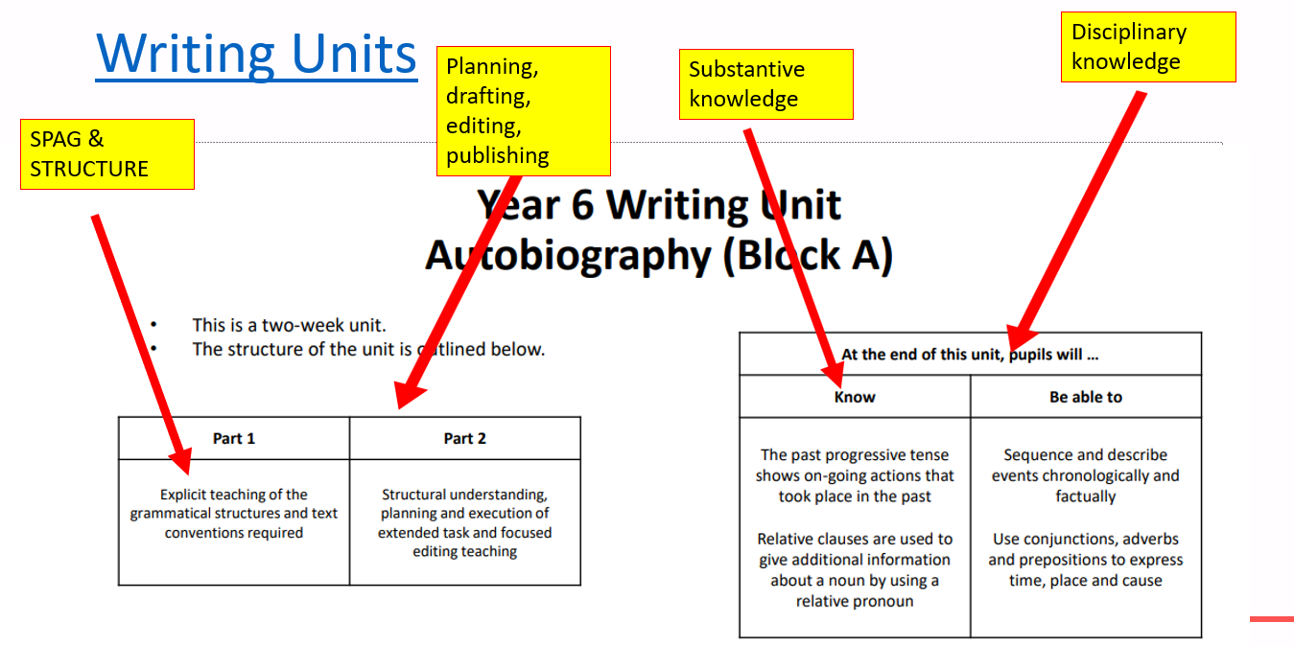
Example.
Each unit is planned over two weeks. Part one, deals with explicit teaching of grammatical structures and text conventions required. Part two focuses on the structural understanding, planning and execution of extended tasks and focused editing and teaching.

There are clearly defined substantive and disciplinary endpoints for all units, within all year groups.

The pedagogical approach for all units is the same (please see example below). This allows for the revisiting of existing knowledge to aid in keeping knowledge in the working memory and into the long term memory.
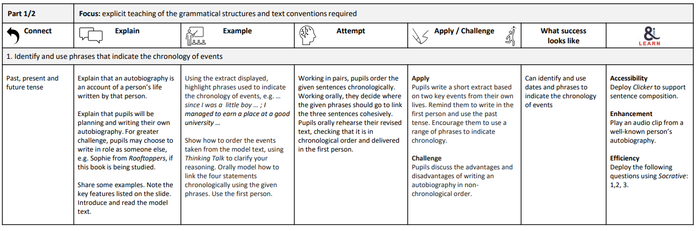
Through appropriate curricular provision, we respect the fact that children:
- Have different educational and behavioural needs and aspirations;
- Require different strategies for learning;
- Acquire, assimilate and communicate information at different rates;
- Need a range of different teaching approaches and experiences.

Teachers respond to children’s needs by:
- Providing support for children who need help with communication, language and English;
- Planning to develop children’s understanding through the use of all available senses and experiences.

All teachers have high expectations in the presentation of work in all areas of the curriculum. We follow the cursive handwriting style.

Every teacher has a professional responsibility to ensure that the needs of each child have been identified and that appropriate action to meet those needs is taken.

- Handwriting begins in the Foundation Stage and is an integral part of the teaching of phonics. St Bede’s School follows the Letter Join Scheme. This begins with activities reinforcing writing patterns and orientation. The scheme is developed throughout both Key Stages.

- Information Technology is used to support all areas of English. There are a range of programmes used to reinforce work throughout the school. Microphones and video cameras are also used to support teaching of English particularly speaking and listening skills.

- A marking policy has been adopted which offers consistency of approach and style allowing children to reflect on their learning and respond to feedback. This is done by marking in red and using green challenge comments/stamps.

- The green challenge stamp/comments need to be specific and directed- children are expected to respond to focused marking. Children are expected to respond to the comments in green response pens.

- Resources are readily available to all members of staff to provide for differentiation.

All children have an entitlement to a broad and balanced curriculum, which is differentiated to enable children to:

- Understand the relevance and purpose of learning activities;
- Experience levels of understanding and rates of progress that bring feelings of success and achievement.
- The skills that children develop in English are linked to, and applied in, every subject of our curriculum. The children’s skills in reading, writing, speaking and listening enable them to communicate and express themselves in all areas of their work at school.

Lessons have clear learning objectives; we differentiate work appropriately, and we use assessment to inform the next stage of learning.

Phonics and Early Reading Approach (see separate guidance)

Impact.

Recording and Reporting

FORMAL SUMMATIVE ASSESSMENT

Every teacher has a professional responsibility to ensure that the needs of each child have been identified and that appropriate action to meet those needs is taken.

- Summative assessment is carried out and recorded at the end of each term through the use of teacher formative assessment.
- Children’s spelling age is assessed at the beginning of the school year and passed on to the next teacher. Children are tracked in this to see if progress is being made.
- Children are assessed formatively through constant teacher assessment, using writing TAFS (key performance indicators). This formative assessment is collated together to create a termly summative level that is then entered into Bromcom. This is tracked constantly and any areas for discussion focused on in pupil progress meetings with the headteacher.

Tracking Attainment
Children are tracked in St Bede’s using Bromcom. The children’s levels for reading and writing are collated and tracked throughout the year by the class teachers, the SENCO and the Senior Leadership team. If a child is not deemed to be making progress they are planned for in class and monitored closely. Children are also given appropriate intervention strategies within the class. This will sometimes lead to the next stage of Cause for Concern.

Monitoring and evaluation

The English coordinator monitors this subject by:
- Analysing the tracking data given by class teachers using Bromcom.
- Interviewing children and staff and taking suggestions for improvements.
- Leading staff meetings in English.
- Supporting staff with new initiatives and introducing them to parents and teaching assistants.
- Monitoring English books for progression and use of the marking policy.
- Collecting in and monitoring target setting from individual teachers.
- Working with children in different age groups whenever possible.
- Tracking children having intervention support for English.
- Collecting in formative and summative assessment scores to track children’s progress.
- Collecting in and monitoring for progression termly and yearly planning.

Equal Opportunities

Our English policy enables us to ensure we are providing every child regardless of ability, culture or gender an equal entitlement to a curriculum matched to its needs.

- Special Educational Needs are identified and referred to the SENCO. If appropriate and in consultation with the parents the advice and support of the Learning Support Service is sought.
- More able and talented pupils are identified and provided with work differentiated to meet their needs.
- Pencil grips are provided for children with poor manipulation.

Early Years

Children are encouraged to:
- show an interest in letters and sounds
- show an interest in letters and mark making
- write their name or other words
- hold pencil correctly
- write cvc words
- write simple key words
- make simple sentences
- play writing games
- use the interactive whiteboard to write on
- work freely in the areas following child initiated writing activities
- Key words are introduced as the first step towards sentence construction.
- The pupils are encouraged to gain independence in constructing several coherent sentences.
- Simple punctuation is introduced e.g. full stops, capital letters

Key Stage 1

- Simple punctuation is introduced e.g. full stops, capital letters moving on to more complex punctuation when ready
- The children use a variety of aids to support their writing, class word banks, topic word banks, dictionaries, classroom display etc.
- The pupils are given opportunities to write in response to a variety of stimuli e.g. stories, poems, classroom activities, personal experience, visits/visitors, whole school topics
- They are taught to identify the purpose for which they write - for a range of readers e.g. teacher, family, peers, themselves.
- Pupils are taught to organise and present their writing in different ways: writing in a range of forms - e.g. stories, diaries, poems, lists, news, captions, records, messages etc.
- The children are taught to check their work using their success criteria.

Handwriting
- The pupils are taught to hold pencils correctly and comfortably in order to develop a legible style.
- They are taught the orientation of writing from left to right and from the top to the bottom of the page.
- Accurate letter formation of both upper and lower case is encouraged:
  - Starting and finishing letters correctly,
  - Regularity of spacing of letters and words
  - Correct size and position of ascenders and descenders.
- Our handwriting scheme is based on the Letter Join scheme.
- This is then developed into joined letters in words.
- Neat and careful presentation of work is encouraged at all times.
- The children are given a pen to write with when they have developed a fluent consistent style in Year Two.

Key Stage 2

Pupils are given opportunities to write for varied purposes and an extended range of readers e.g. teacher, the class, children in other schools, children from other countries, adults in the school and wider community, imagined audiences.

Writing in response to a wide range of stimuli: stories, plays, poems, their individual interests and experiences and the activities of the classroom across the whole curriculum.
The pupils are taught through the National Curriculum which encourage children:
- to use the characteristics of different kinds of writing
- argument, commentary, narrative, dialogue.
- to use varied forms of writing e.g. stories, poems, dialogue, scripts, diaries, reviews, reports, instructions, explanations, notes, letters
- to use features of layout and presentation

Opportunities are provided to plan, draft and improve their work on paper and on screen and to discuss and evaluate their own and others writing

Children are encouraged to use their own success criteria to improve and self-check their work

Punctuation
The children are taught to develop their use of punctuation marks in the course of their writing. This will include: full stops, question and exclamation marks, commas, inverted commas, apostrophes.

Spelling

We follow the CUSP curriculum spelling approach and this has been mapped out on a whole school LTP.
The pupils accumulate a bank of words in their personal dictionaries which are used in the course of their writing.

They also create glossaries of topic related words.
They are encouraged to check spelling through the use of dictionaries and are taught to use alphabetical order to 3 letters to enable speedy use.
They are taught:
- the meaning, use and spelling of common prefixes and suffixes
- the relevance of word families, roots and origins of words
- to spell complex polysyllabic words
- to memorise the visual patterns of words and recognise silent letters
- to use the apostrophe to spell shortened forms of words
- to use appropriate terminology e.g. vowel, consonant
In each class children are tested weekly on words previously learnt for homework.
An example of the resources used are:
- 200 Key Words
- Topic based words

Handwriting
- Pupils are given the opportunities to develop their handwriting style in a joined style.
- As they become increasingly confident and independent they are encouraged to develop greater control and fluency.
- They are taught to use different forms of handwriting for different purposes e.g. print for labeling, maps or diagrams, a clear, neat, cursive style for finished presented work, a faster script for notes.
- Tramlines are used at the lower end of KS2 to help with the correct and even formation of letters.
- The whole school has 2 weeks focus for handwriting in September.

