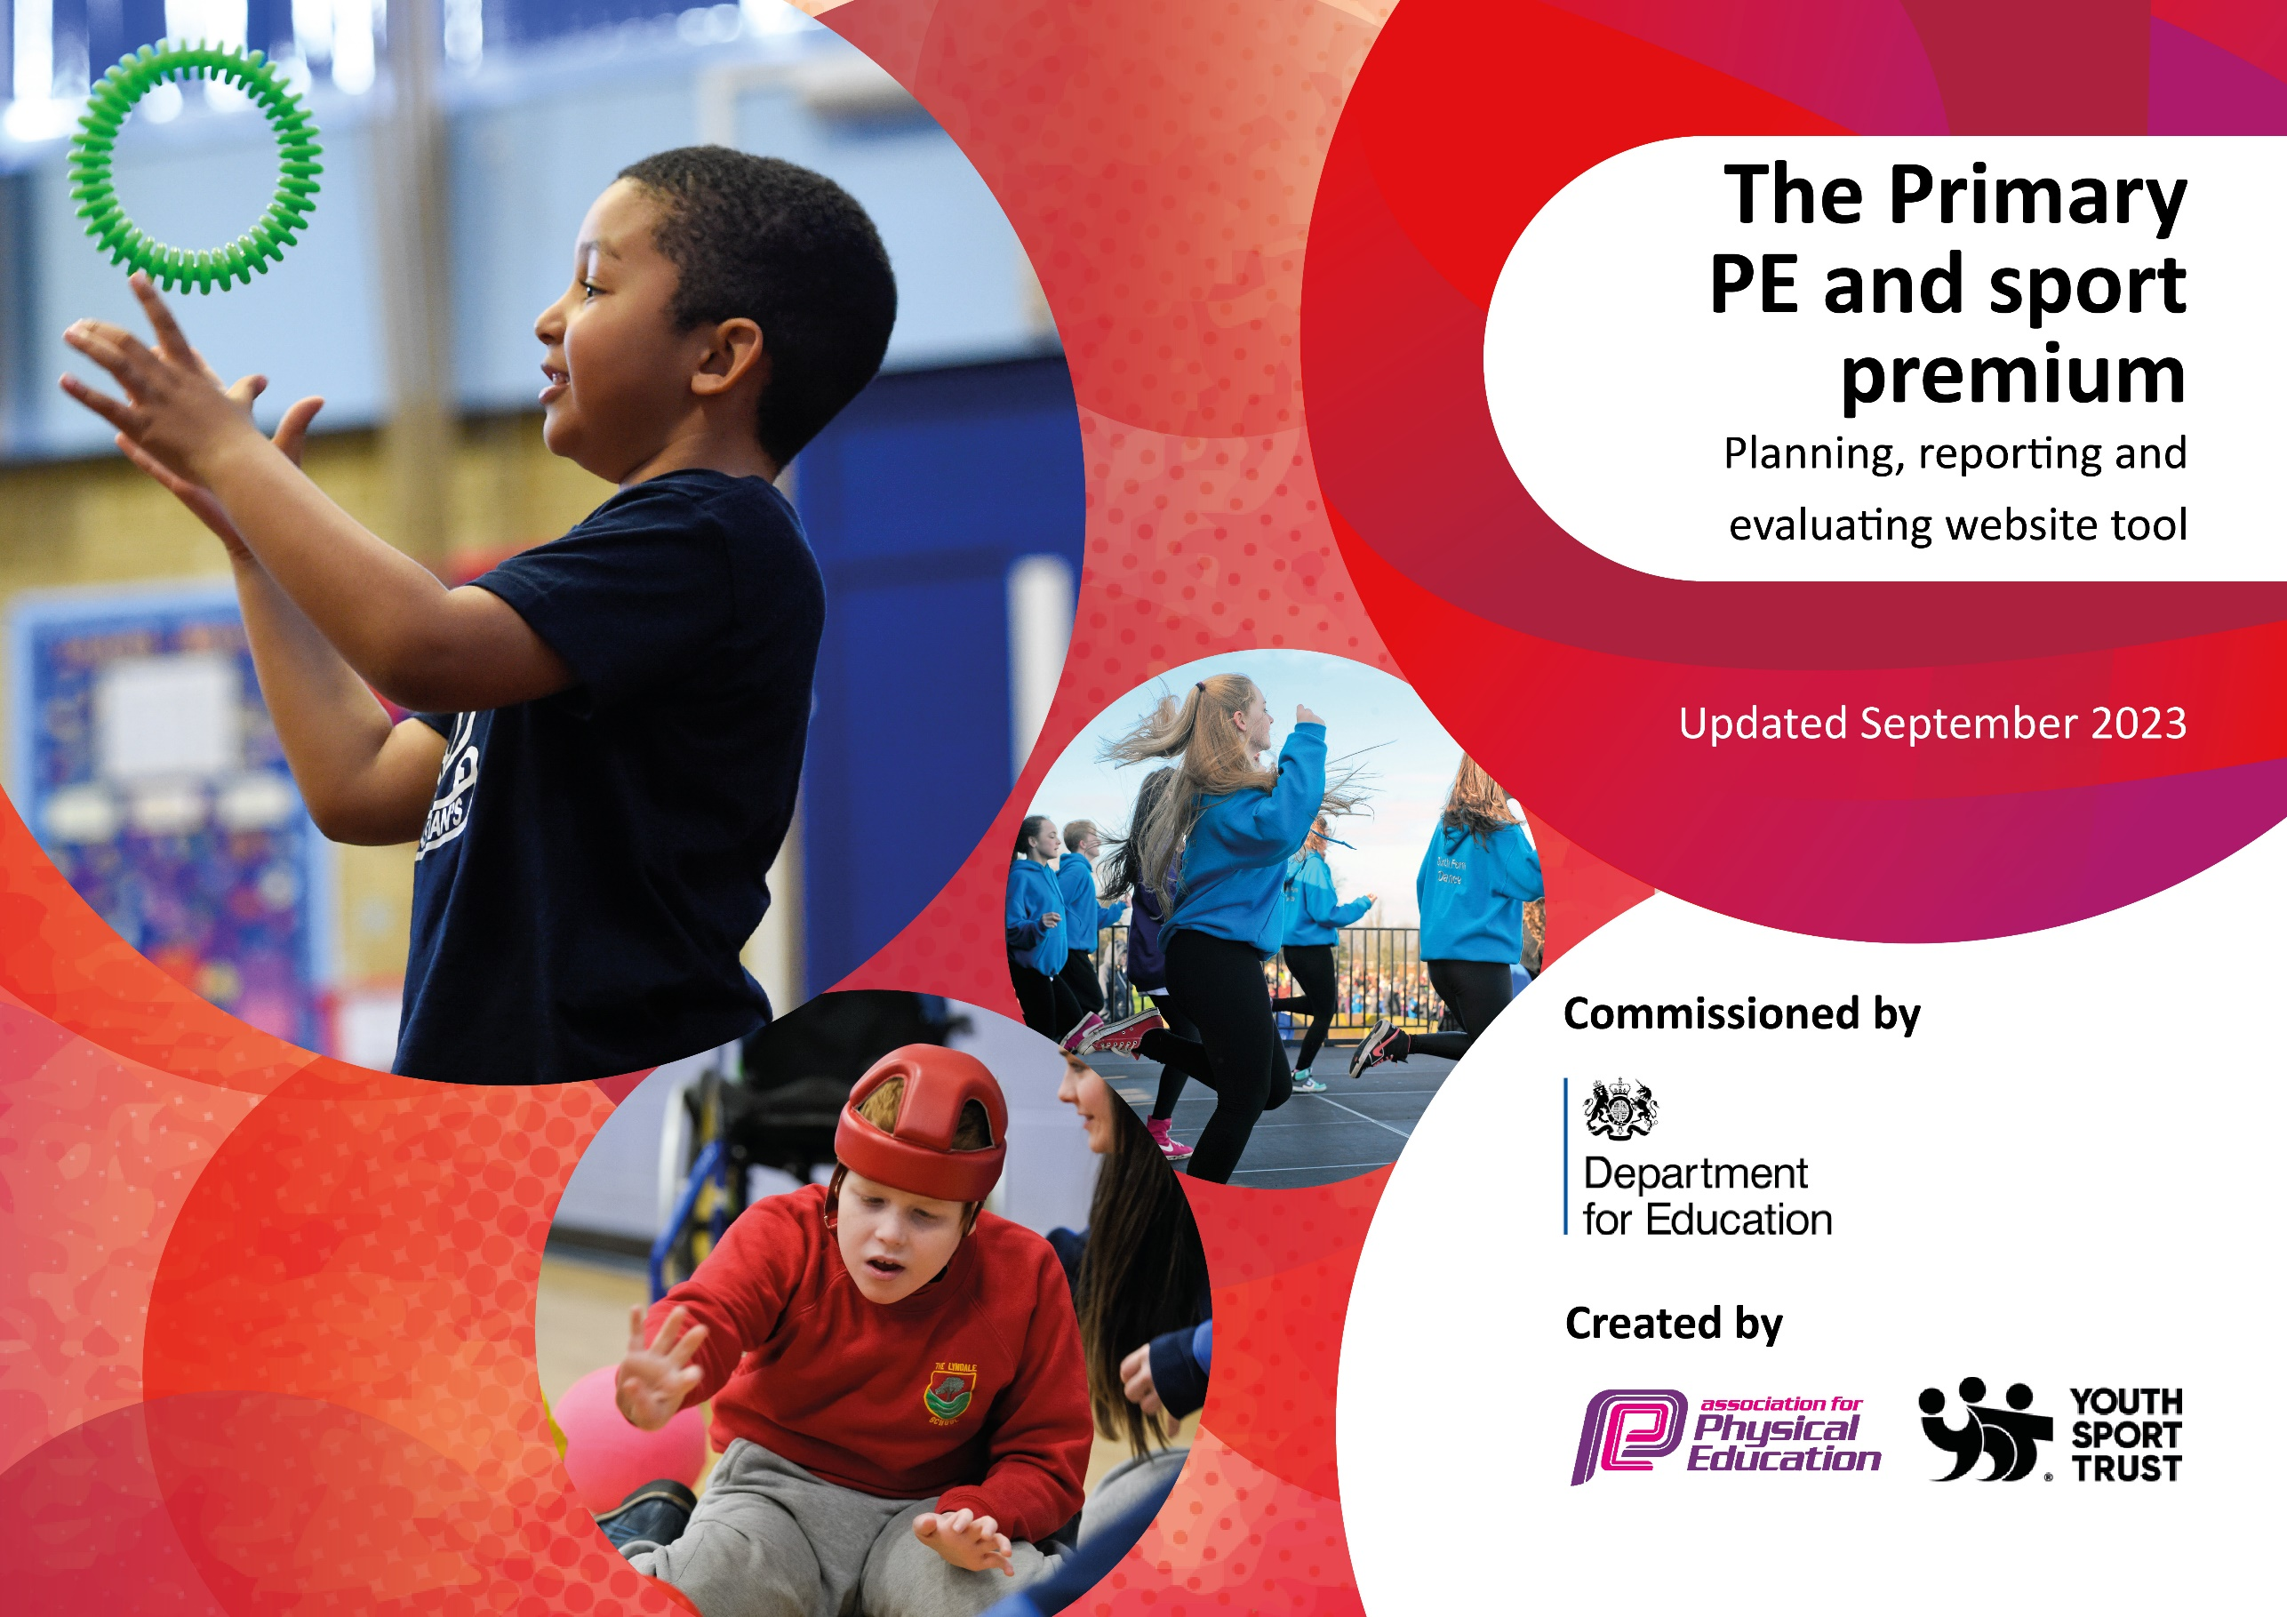

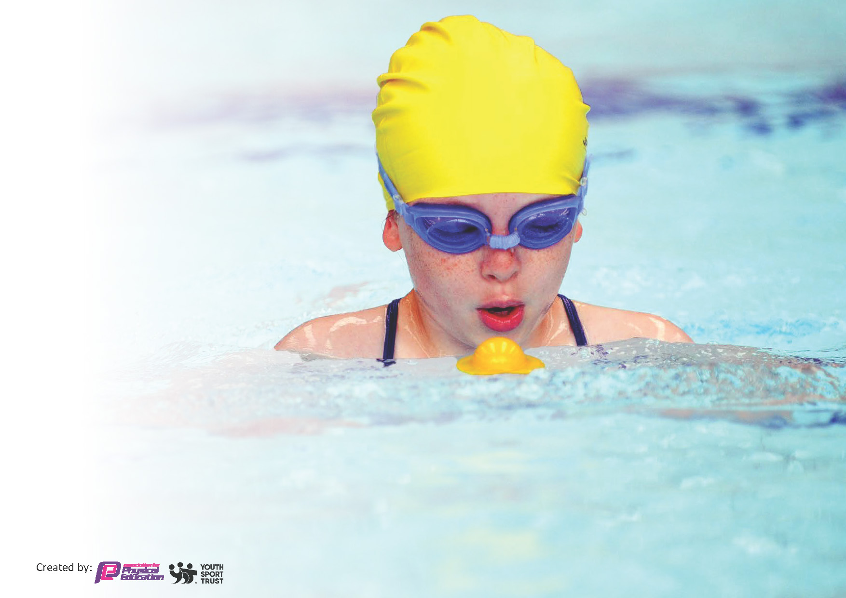
This template can be used for multiple purposes:
by:
- It enables schools to effectively plan their use of the Primary PE and sport premium
- It helps schools to meet the requirements (as set out in guidance) to publish information on their Primary PE and sport premium
- It will be an effective document to support Ofsted inspections enabling schools to evidence progress in Physical Education (PE) and evidence swimming attainment, which forms part of the PE National Curriculum. We would recommend schools consider
the Intent, Implementation and Impact of any spend, as examined within the Education Inspection Framework.

It is important that your grant is used effectively and based on school need.

Schools must use the funding to make additional and sustainable
improvements to the quality of the PE, School Sport and Physical Activity (PESSPA)
they offer. This means that you should use the Primary PE and sport premium to:

- Build capacity and capability within the school to ensure that improvements made now will benefit pupils joining the school in future years
- Develop or add to the PESSPA activities that your school already offers.

The Primary PE and sport premium should not be used to fund capital spend projects; the school’s core budget should fund these. Further detail on capital expenditure can be found in the updated Primary PE and sport premium guidance.

The Primary PE and sport premium guidance, outlines 5 key priorities that funding should be used towards. It is not

necessary that spending has to meet all the key priorities, you should select the priorities that you aim to use any funding towards.

Although completing this template is not a requirement for schools, schools are required to publish details of how they spend this funding. Schools must also outline what the impact this funding has had on pupils’ PE and sport participation and attainment and how any spending will be sustainable in the future. All funding must be spent by 31st July 2024.

The Department for Education has worked closely with the Association for Physical Education (afPE) and the Youth Sport Trust (YST) to develop this template and encourages schools to use it. This template is an effective way of meeting the reporting requirements of the Primary PE and sport premium.
Review of last year’s spend and key achievements (2022/2023)

We recommend you start by reflecting on the impact of current provision and reviewing your previous spend.

Activity/Action | Impact | Comments
Specialist coaches from Sporting Futures and Sensei will work alongside teachers to deliver the PE curriculum  Specialist coaches from Sensei gym will widen our PE curriculum by offering MMA to children from  EYFS-Y6  Children in KS2 will receive swimming lessons, through the Darlington SSP.  All pupils will receive high quality PE lessons.  From Reception, they will also have regular access to extra-curricular clubs and have access to structured sports activities on a lunchtime.  Sporting achievements are linked to the Trust values and celebrated.  Pupils are able to take part in a range of SSP inter-school events  Teachers have access to planning for lessons they need to teach independently.  Teachers have access to a clear progression of skills document  DFC Season Ticket and Matchday Experience  Visit from club mascot and DFC Foundation  The school signs up to the Darlington SSP SLA Competitions, some of which lead to Tees Valley Finals  We have taken part in Boys’ and Girls’ football leagues | Children have followed a clear progression of skills. PE lessons have a clear structure and give all children opportunities to succeed.  PESSPA is happening throughout the school day and events not just in PE lessons.  All children active for at least 30 minutes of the school day including target children who receive intervention through tailored sports club offers, 1:1/small group coaching MMA etc.  Teachers can deliver high quality lessons and feel confident in doing so.  Children have received high quality sessions in MMA and have links to a club.  Pupils from Year 1- Year 6 have had the opportunity to take part in a wide range of events and competitions.  Children from our school competed in the Tees Valley athletics competition, representing Darlington  Girls’ football team won a football tournament that was invitation only  Girls’ football team won their league.  We have received the Gold Award from School Games Mark

Key priorities and Planning
This planning template will allow schools to accurately plan their spending.

Action – what are you planning to do | Who does this action impact? | Key indicator to meet | Impacts and how sustainability will be achieved? | Cost linked to the action
Sporting Futures work along side class teachers to deliver P.E lessons to upskill teachers and provide CPD to staff  CPD for P.E lead provided through DSSP  MMA coaches work along side class teachers to deliver P.E lessons to upskill teachers and provide CPD to staff  60 active minutes initiative implemented in school including; daily mile, staff led walking bus for walk to school week, child led active ambassadors, sports and wellbeing leaders, active lessons, lunch clubs, range of play equipment.  Weekly high quality P.E lessons | Primary generalist teachers.  Pupils- receiving high quality P.E lessons  P.E lead  All staff- knowledge will be passed on via P.E lead.  Pupils – as they will take part.  Lunchtime supervisors, teaching staff and coaches - as they need to lead the activity, train and support pupils.  Coaches who deliver sessions | Key Indicator 1: Increased confidence, knowledge, and skills of all staff in teaching PE and sport.  Key indicator 2 -The engagement of all pupils in regular physical activity – the Chief Medical Officer guidelines recommend that all children and young people aged 5 to 18 engage in at least 60 minutes of physical activity per day, of which 30 minutes should be in school. | Primary teachers more confident to deliver effective PE supporting pupils to undertake extra activities inside and outside of school.  More pupils meeting their daily physical activity goal, more pupils encouraged to take part in PE and Sport Activities, children will have a good level of fitness. | £9215 cost for Sporting Futures to deliver P.E lessons along with teaching staff  £1500 cost of DSSP SLA.  £5965 MMA coaches to run P.E sessions.  £9215 cost for Sporting futures who lead lunch time clubs as well as train new sports and wellbeing leaders.  £300 cost for DFC football coach to run lunch club.  £5965 cost of MMA coaches to run lunch clubs and target least active pupils with intervention sessions.  £810 new sports eqipment

P.E lead to follow the criteria for the Gold School Games award and gather evidence to submit application. They will work with DSSP to achieve this.  All children offered opportunities to take part in a range of sports through P.E lessons, extracurricular clubs and through inter school sporting events. Offer based on pupil voice and events timetable.  Sports and wellbeing leaders initiative established.  Pupils will be given the opportunity to participate in a range inter-school events as part of the DSSP.  MMA offered as part of the curriculum.  Sporting futures deliver a range of extra-curricular clubs and a range of sports are taught throughout the P.E curriculum.  4-motion bike, scooter, skate sessions for LKS2- transport provided by school.  Sports and Wellbeing leaders will offer a range of sports activities and games.  Pupils will be given the opportunity to participate in a range inter-school events as part of the DSSP with competitive intent.  P.E lessons will develop skills to allow children to engage competitively in sport events.  Children will take part in the St Augustine’s cup.  Children will take part in Paul Bielby Football Affiliation events.  St Bede’s football teams will be provided with professional football coaching from DFC. | All pupils- see Gold award criteria to see impact on children.  -participation in a variety of sports experiences and celebrations.  P.E lead given time to develop initiatives, gather evidence and complete application.  Pupils who will develop skills in a range of sports and be provided with a range of sporting opportunities.  All children- who will develop competitive sports skills, have opportunities to take part in competitive events and receive professional coaching. | Key indicator 3: The profile of PE and sport is raised across the school as a tool for whole-school improvement.  Key indicator 4: Broader experience of a range of sports and activities offered to all pupils.  Key indicator 5: Increased participation in competitive sport. | St Bede’s achieved Gold award. Initiatives implemented this year to be imbedded next year.- see Gold award criteria to see impact on children.  Pupils view P.E as a valuable part of the curriculum.  Pupils recognise sport and exercise as part of the school day.  Sport is celebrated with parents.  Pupils have engaged in range of sports through their P.E lessons as seen on our long term plan.  Children participated in MMA sessions.  Children have been part of football training sessions  Children in LKS2 attended a term of skate board, biking and scooter sessions.  Children have taken part in lunch clubs led by SF coaches.  Children engage daily in a range of timetabled activities led by Sports leaders which cover a range of different sports.  Children have taken part in a range of competitive events through DSSP and have seen particular success in cross country and quad kids.  Children’s skills directly linked to competitive sport has improved.  Year 4 pupils were successful in the St Augustine’s football cup event coming 2nd.  UKS2 progressed to the Paul Bielby Champions of Champions event and came 2nd. | £1500 cost of DSSP SLA.  £9215 cost for Sporting Futures to deliver P.E lessons along with teaching staff lead lunch time clubs as well as train new sports and wellbeing leaders.  £120 Paul Bilby football affiliation.  £1500 cost of DSSP SLA.  £9215 cost for Sporting Futures  £4060 coaches to transport to events.  £300 cost for DFC football coach to run lunch club.  £5965 cost of MMA coaches to run lunch clubs and target least active pupils with intervention sessions.  £120 Paul Bilby football affiliation.  £4060 Transport cost which include travel to 4 Motion  £1500 cost of DSSP SLA.  £9215 cost for Sporting Futures  £4060 coaches to transport to events.  £300 cost for DFC football coach to run lunch club.  £120 Paul Bilby football affiliation.

Key achievements 2023-2024
This template will be completed at the end of the academic year and will showcase the key achievements schools have made with their Primary PE and sport premium spending.

Activity/Action | Impact | Comments
- Engage with Darlington School Sports Partnership  - Sports and Wellbeing leaders imbedded.  - Sporting Futures coaches lead P.E lessons with class teachers and lead lunch sports clubs.  - Sensei MMA coaches will lead P.E lessons with class teachers and lead lunch sports clubs as well as specific interventions.  - Invest in play and sports equipment | - Received Gold in the School Games Mark  - All pupils participate daily in the recommended amount of sports and physical activity  - Staff knowledge, competence and confidence in teaching P.E is improved.  - Inclusion is a priority across school and all children are provided with equal opportunities.  - P.E and sports has a high profile across school and children enjoy it and children access a range of sports and engage in a range of competitions.  - Children have access to a range of play and sporting equipment and have been supported to use this effectively.

Swimming Data
Meeting National Curriculum requirements for swimming and water safety.
Priority should always be given to ensuring that pupils can perform safe self-rescue even if they do not fully meet the first two requirements of the National Curriculum programme of study

Question | Stats: | Further context  Relative to local challenges
What percentage of your current Year 6 cohort can swim competently, confidently and proficiently over a distance of at least 25 metres? | 62% | Children typically attend swimming sessions each year of primary school from Year 4 however this cohort only were able to do this as Year 5s and Y6s.
What percentage of your current Year 6 cohort can use a range of strokes effectively [for example, front crawl, backstroke, and breaststroke]? | 76%

What percentage of your current Year 6 cohort are able to perform safe self-rescue in different water-based situations? | 76%
If your schools swimming data is below national expectation, you can choose to use the Primary PE and sport premium to provide additional top-up sessions for those pupils that did not meet National Curriculum  requirements after the completion of core lessons. Have you done this? | No
Have you provided CPD to improve the knowledge and confidence of staff to be able to teach swimming and water safety? | No

Signed off by:

Head Teacher: | Josie Wilson
Subject Leader or the individual responsible for the Primary PE and sport premium: | Lauren Anderson
Governor: | Rose-marie Rochester
Date:

