**English and Reading**

This term, we will be writing for a range of purposes including; non-chronological reports, stories from other cultures and persuasive writing. In reading, we will explore three fantastic books- including Paddington, Quangle Wrangle’s Hat and Coming to England.  
**At home**: KS1 children receive a new phonics book every **Thursday** and this should be read at home **daily.** It must be sent into school every day to allow teachers to listen to them read too and books must be **returned on a Wednesday** to allow them to be exchanged ready for Thursday. Further children should be reading for pleasure by choosing their own books which they can read themselves or be read to by an adult. We strongly encourage adults to read to their children regularly. Children are welcome to borrow any of the high-quality texts from our class library to take home.

**Mathematics**

This term children will cover skills across four key areas of maths; place value (within 100), Shape (2-D and 3-D shapes) and addition and subtraction (within 100). Further, they will be progressing through the Mastering Number programme specific to their year group.

**At home**: Have a look at some useful links to support maths at home and to further explore the maths coverage for your child.  
<https://stbedesdarlington.bhcet.org.uk/curriculum/subjects/maths>  
<https://www.bbc.co.uk/iplayer/episode/b0bp2xdl/numberblocks-series-3-mirror-mirror>

**Welcome to KS1! Please look below to see what your child will be learning in each subject this term.**

**KS1 Spring Term Focus and Homework**

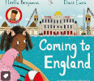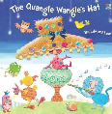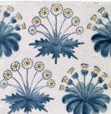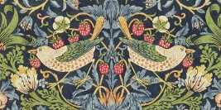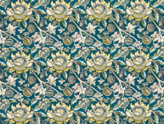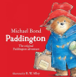

**Science**

Our science topics is Plants. We will be focussing on the different parts of a plant and their purpose. Also, we will investigate what plants need to grow, such as water, sunlight and the right temperature.

**At home:** Plant a seed at home and make sure you give it the right amount of water and sunlight to grow. What do you notice? Take some photos and track this each week.

**PE**

This term, children will be developing their ball skills and practicing how to control the ball.   
**At home:** Did you know? Primary age children should be active for at least 60 minutes a day. Whilst we ensure at least 30 minutes is happening at school, the other 30 minutes should be happening at home.

**Computing**

As part of the computing curriculum, learners will develop their understanding of instructions in sequences and the use of reasoning to predict outcomes. They will design an algorithm and test them so they can debug them. **At home:** Check out the Childnet website for digital safety information. <https://www.childnet.com/resources/parents-and-carers>

**Music**

We will focus on how to play in an Orchestra and look at the different instruments used such as Violin, Cello and Keyboard. Playing as a group is very important as you have to listen to each other. What can you learn about the orchestra?

**At home**: Here is a video that explains the different instruments that you may find in an orchestra. <https://www.bbc.co.uk/bitesize/articles/z222p9q>

**RSE/PSHE**

Children will complete unit ‘Emotional Wellbeing’ where children will understand and articulate their changing feelings.   
**At home:** Remember you can access the parent portal at <https://www.tentenresources.co.uk/parent-portal/life-to-the-full-primary/> to see what your child is learning as well as suggested home activities.

**History and Geography**

In History we are looking at the Great Fire of London. **At home:** Research the Great Fire of London ready to share with the class.

During our Geography lessons, we will be explorers discovering new countries. We will be using previous knowledge on human and physical features in our exciting discoveries. **At home:** Which countries have you visited? What do you know about them?

**Art and Design Technology**Children will be developing their print making skills inspired by William Morris.   
**At home:** Have a go at creating your own artwork at home, inspired by these artists.

During our Design & Technology lessons, children will be creating their own rainbow salad. We will be looking at the healthy ingredients we need.   
**At home:** Try creating your own salad and have a look at what ingredients you may need.

**gy**

**RE**

This term, children will cover three units; Books, Lent and Islam.

**At home:** Share pictures and memories of you reading your favourite books. Ask your children to share some of their favourite Bible stories that they have been learning e.g. The Good Samaritan.

Children will also strengthen their faith through our class Pilgrims of Hope Projects.

Please join us for Family Mass at St Thomas Aquinas Church on **26th January 2025.**