**English and Reading**

This term, we will be writing for a range of purposes including; a character description, retell of a narrative and stories from other cultures. In reading, we will explore three fantastic books- including The Street Beneath My Feet, The Rhythm of the Rain and Little People, Big Dreams David Attenborough.

**At home**: KS1 children receive a new phonics book every **Thursday** and this should be read at home **daily.** It must be sent into school every day to allow teachers to listen to them read too and books must be **returned on a Wednesday** to allow them to be exchanged ready for Thursday. Some children are now on accelerated reader and should be reading and quizzing books chosen from the library and these should be read at home daily. We strongly encourage adults to read to their children regularly. Children are welcome to borrow any of the high-quality texts from our class library to take home.

**Mathematics**

This term children will cover measurement looking at five key areas; length and height, money, fraction, time and capacity. Further, they will be progressing through the Mastering Number programme specific to their year group.

**At home**: Have a look at some useful links to support maths at home and to further explore the maths coverage for your child.  
<https://stbedesdarlington.bhcet.org.uk/curriculum/subjects/maths>  
<https://www.bbc.co.uk/iplayer/episode/m000z8hj/numberblocks-specials-double-back>

**Welcome to KS1! Please look below to see what your child will be learning in each subject this term.**

**KS1 Summer Term Focus and Homework**

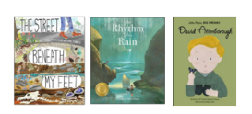

**Science**

Our science topics is Everyday Materials. We will be distinguishing between an object and the material from which it is made. ​Identify and name a variety of everyday materials, including wood, plastic, glass, metal, water and rock. ​Describe the simple physical properties of a variety of everyday materials. ​Compare and group together a variety of everyday materials on the basis of their simple physical properties.

**At home:** Can you test everyday materials to see which is the most waterproof? Take some photos and send into school.

**PE**

This term, children will be developing their cricket skills, learning how to hit and throw the ball.   
**At home:** Did you know? Primary age children should be active for at least 60 minutes a day. Whilst we ensure at least 30 minutes is happening at school, the other 30 minutes should be happening at home.

**Computing**

As part of the computing curriculum, learners will learners will listen to a variety of pieces of music and consider how music can make them think and feel. Learners will compare creating music digitally and non-digitally. **At home:** Check out the Childnet website for digital safety information. <https://www.childnet.com/resources/parents-and-carers>

**Music**

We will focus on how to Invent a Musical Story.

**At home**: Check out this website to show you how to composing music to tell a story . <https://www.bbc.co.uk/bitesize/articles/z73wmbk#zxr7tcw>

**RSE/PSHE**

Children will complete unit Religious Understanding this begins with an adapted version of the Prodigal Son story to show children that God loves us, and nothing we can do will stop Him from loving us. ‘**At home:** Remember you can access the parent portal at <https://www.tentenresources.co.uk/parent-portal/life-to-the-full-primary/> to see what your child is learning as well as suggested home activities.

**History and Geography**

In History we are looking at the Great Fire of London. **At home:** Can you make your own thatched roof house to test in school?

During our Geography lessons, we will be explorers discovering new countries. We will be using previous knowledge on human and physical features in our exciting discoveries. **At home:** Which countries have you visited? What do you know about them?

**Art and Design Technology**Children will have the opportunity to apply what they have previously learnt, particularly drawing and collage-making skills.  
**At home:** Have a go at creating your own collage.

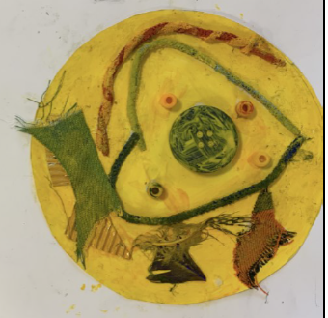  

During our Design & Technology lessons, children will be making a small wheeled trolley.   
**At home:** Try creating your own wheeled vehicle.

**gy**

**RE**

This term, children will cover three units; Pentecost, Reconciliation, and Universal Church

**At home:** Make and decorate a book mark which has a message of love that you would like to pass on to someone in your life. Talk to the children about the importance of spreading Good News.

Children will also strengthen their faith through our class Pilgrims of Hope Projects.

Please join us for Mass at St Thomas Aquinas Church on **Sundays**