The context of our school
We are one and a half entry school, part of the Bishop Hogarth Catholic Education Trust. We have 15.2% pupil premium. It is essential that our approach to teaching phonics and reading is accessible to all learners, regardless of background.

Trust Vision
Our schools will be places of excellence – providing service and witness to children, their families and the wider Catholic community, adding value as a family of schools and enriching the learning and experience of all our young people so they may achieve their full potential.

Mission statement
Love one another as I have loved you.
John 13: 34-35

Our mission statement roots the life of the school in the person of Christ and the teaching of the Catholic Church. In living out our mission statement, St Bede’s will:

- Assist the Church in making Christ known to all people.
- Assist parents, who are the primary educators of their children, in the education and religious formation of their children.
- Be at the service of the local Church – the diocese, the parish and the Christian home.
- Be a service to society.

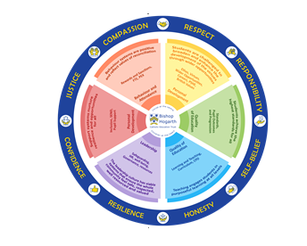
Our Virtues

By sharing in the values of Bishop Hogarth Catholic Education Trust, the St Bede’s community recognises the worth of individuals, responding with kindness and challenging prejudice, stereotyping and discrimination.

Respect for others and themselves, recognising that we are all created in the image of God and Self-belief in their character and their ability to achieve their goals and aspirations.

Compassion towards others, especially the vulnerable, promoting justice in their college community, local community and beyond.

Confidence in their own abilities, knowing that their talents are gifts from God and Resilience to persevere when things become difficult.

Honesty in regards to the world around them and themselves and to take Responsibility for the time we may fall short of the mark.

Introduction to Policy
“The more you read, the more things you will know. The more that you learn, the more places you'll go.”

Statement of Intent

The Statement of Intent of St. Bede’s School is to create an environment which nurtures the whole child, allowing for each individual’s potential, giving him/her a framework for living where sound relationships can be established and where everyone has dignity, and is valued. To ensure that the curriculum provides opportunity for growth through the acquisition of skills and knowledge in catholic setting

Reading is mapped effectively across the school to ensure full coverage of the National Curriculum Programme of Study.
At St Bede’s, we believe that it is important that our pupils are exposed to the power of words and structure of language at every opportunity in order to develop important basic skills. It is through their critical and imaginative engagement with texts that pupils’ reading of fiction, poetry and non-fiction texts enables them to make sense of the world and their place in it. We aim to inspire a life-long love of reading for pleasure in our children.
This document is a statement of the aims, principles and strategies for the teaching of reading in St Bede’s Primary School. It has been devised through a process of consultations with all members of staff. This policy is for information to staff and all others working within the school. It will ensure effective communication between staff and with governors, parents, others schools and outside agencies.

The policy will be reviewed as part of the school improvement plan.

Implementation.

We believe reading is the key to success and fundamental in developing independent learners in all areas of the curriculum. Reading development is closely related to that of writing and speaking and listening. It is by immersion in high quality texts, reflecting and talking about them and by experiencing the writing process for themselves that children come to understand the special relationship which exists between author and reader.
Reading to children.
These texts are shared with children via dedicated reading time by the class teacher. At St. Bede’s, we recognise the value and importance of dedicating time for children to be read to, no matter what age of the child.
A variety of texts: mapped out.
At St Bede’s we have selected and mapped out core reading texts for each year group, across the year. We have carefully considered these texts to ensure a wide and rich variety of texts, ensuring children have exposure to themes throughout their reading journey, such as: continuity of author, heritage texts, minority author or protagonists, strong female role models, specific social, ethical, moral issue and protected characteristics.
Each unit is two weeks long, and set in the context of one of the core texts. However, the core text is also supplemented throughout the unit by additional texts to offer opportunities to explore these through different genres, thus deepening children’s understanding further.

At St. Bede’s we recognise that reading comprehension ‘skills’ cannot always be isolated from one another and therefore it is important to teach pupils how to draw on key reading strategies to approach a task. We recognise that it is too binary to believe that this will not draw on a wider reserve of reading knowledge and competencies.
Lesson Design
At St Bede’s reading is taught through 3-4 weekly sessions.
Our lessons follow the same format, regardless of the text type being studied.
Vocabulary – a fluency reading exercise – explanation and teacher modelling – a worked example – attempt – children applying their learning and finally a challenge.
Unit structure example:
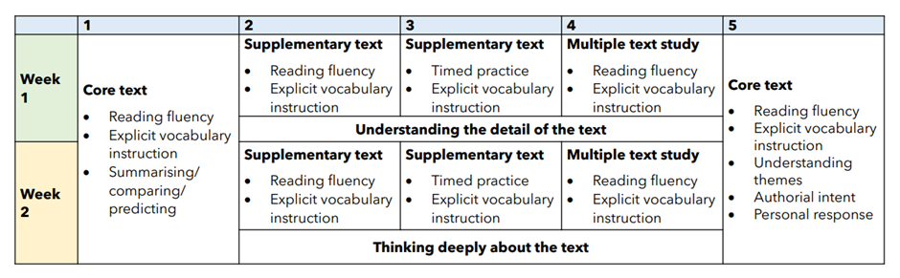

Vocabulary
The National Curriculum makes clear that learning vocabulary is key to ‘learning and progress across the whole curriculum’ since it allows pupils to access a wider range of words when writing and for them to understand and comprehend texts efficiently. For this reason, we begin each reading session with explicit teaching of tier 2/3 vocabulary.
Accelerated Reading.
In addition to daily Whole Class Reading session, once children can read longer texts independently and with fluency, they move to Accelerated Reader. Accelerated Reader gives children the opportunity to read for pleasure (by selecting their own books from their given starting point, which is based on ability) whilst also developing their fluency and comprehension skills. After each book is finished, children access online comprehension quizzes based on what they have read. Teachers are responsible for monitoring Accelerated Reader Quiz results.
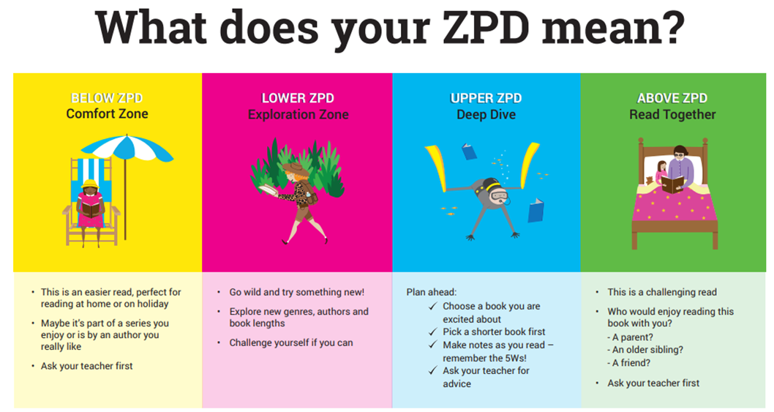
Success in quizzes is recorded on the class reading tree and rewarded. All reading leaves at the end of each half term are placed in a prize box. Names are drawn and awarded prizes. Children then take 'Star Reading Quizzes' a minimum of once every half term which monitor their ongoing reading development and define their ZPD (zone of proximal development). The Zone of Proximal Development (ZPD) defines the readability range within which pupils should read to best develop their reading, while avoiding frustration.

Parental Support: reading at home.
We believe that parents have a fundamental role to play in helping children to learn to read with confidence and fluency.
We follow a consistent ‘Out of this world reading scheme’ to encourage parents to support their child’s reading development and value the role parents play in their child’s reading development. Children bring home reading materials each evening and have a reading record, where parents are encouraged to record when they have read with children at home. The children move through the stages of the scheme and their achievements are celebrated and rewarded.

Impact

At St. Bede’s, we strive for all pupils to achieve their full potential and this is reflected in our pupil outcomes at the end of each Key Stage.

Our pupils achieve highly and make great progress is made from starting points. By the end of Reception, all children should be reading simple sentences with fluency and, by the end of KS2, pupils will be fluent readers with a rich vocabulary, able to access the broader curriculum with confidence as they have excellent reading skills.

Teachers promote a love of literature and have high expectations of all pupils, providing challenge and engagement through quality texts and learning sequences.

A range of assessment, monitoring and moderation is undertaken and results are seen in outcomes for all pupils and the pride they take in their work. Our pupils read to gain knowledge, as well as for pleasure, producing work of good quality across the curriculum. This is reflected in national test results. All pupils can enthusiastically articulate their learning and are ready for the next stage of their education

Inclusion
It is our aim to give every child the opportunity to experience success in learning and to be the best that they can be and this is why we are committed to whole class quality first teaching of age appropriate phonics.

Equal Opportunities
All children have an entitlement to access reading and spelling strategies at an appropriate level and are helped to do this.

Tracking Attainment

Children are tracked in St Bede’s using Bromcom. The children’s levels for reading and writing are collated and tracked throughout the year by the class teachers, the SENCO and the Senior Leadership Team. If a child is not deemed to be making progress they are planned for in class and monitored closely. Children are also given appropriate intervention strategies within the class. This will sometimes lead to the next stage of Cause for Concern.

Appendix 1

Curriculum Content

These aims will be delivered following the programmes of study defined in the distinct attainment targets of the National Curriculum
AT 1 Speaking and Listening
AT 2 Reading
AT 3 Writing

Speaking and Listening

Key Stage 1

Pupils are given opportunities to talk for a range of purposes including:
  - telling stories; real and imagined;
  - imaginative play and drama;
  - reading and listening to nursery rhymes and poetry; learning some by heart.
  - Reading aloud;
  - describing events, observation and experiences.
  - Speaking in groups of varying sizes.
  - Talking about and presenting work to different audiences
  - Circle time
  - Participating in class assemblies, school masses, plays etc.
  - Recording themselves using class microphones
  - Working together in the areas of the classroom
  - Pupils are taught to listen carefully and to show their understanding of what they see and hear by making relevant comments and following instructions.

Key Stage 2

The pupils are given opportunities to talk for a range of purposes including:

  - exploring, developing and explaining ideas;
  - planning, predicting and investigating;
  - sharing ideas, insights and opinions;
  - reading aloud, telling and enacting stories and poems.
  - Reporting and describing events and observations and presenting them to audiences.
  - Pupils are introduced to a wide range of audiences in class, school and the wider community.
  - Many opportunities are provided for pupils to participate in a wide range of drama activities; including improvisation, role-play, the writing and performing of scripted drama e.g. assemblies, school plays-drama club
  - Pupils are given the opportunity to listen to and respond to a range of people and to follow increasingly complex instructions.
  - They are introduced to a range of speakers from outside the school community.

Key Stage 1

In St. Bede’s we use a broad and balanced approach to the teaching of reading. This involves introducing the children to a wide range of exciting and stimulating literature to develop a love for books and providing a structured approach to the teaching of reading skills through the use of the best available scheme material.

- Pupils are given extensive experience of children’s literature through the book corner in classrooms and through units in literacy

- Pupils are encouraged from an early age to ‘read’ on their own, with others and to the teacher from a wide range of sources including:
  - Picture books.
  - Story books.
  - Poetry.
  - Plays.
  - Magazines.
  - Talking books.
  - Listening corner- books and cds.

- Pupils are encouraged to read their own stories to the teacher and to others.
- Pupils are introduced to information both in picture, print and on screen; to understand that print carries meaning.
- The materials read and discussed are chosen to stimulate pupils’ imagination, interest and enthusiasm.
- Some of the literature used covers the following categories and fits in with the literacy units:
    - Stories relating to their own experience
    - Poems and stories - imaginary or fantasy worlds
    - Books and poems written by significant children’s authors;
    - Retelling of traditional folk and fairy tales;
    - Stories and poems from a range of cultures;
    - Stories that are challenging in terms of length or vocabulary.
    - Non fiction books related to topics or science
- A base of reading schemes is used to develop reading skills to enable the children to become independent readers.
- We also use a variety of other schemes and relevant I. T. software to consolidate reading skills.

Key Stage 2

In Key Stage Two the development of reading continues using some of the same strategies as Key Stage one and in addition the children:

- Hear and read more challenging material.
- Are taught to use reference materials for different purposes.
- Are encouraged further to develop as enthusiastic, independent and reflective readers.
- Introduced to a wide range of literature and have opportunities to read extensively for their own interest and pleasure and for information.
- Reading is developed further through the use of progressively more challenging and demanding texts.
- Some of the opportunities for reading include: independent, shared reading, guided reading
- Sustained silent reading is encouraged throughout the Key Stage.
- Reading of plays and other texts are shared in groups and with the whole class using FASE.
- Pupils are provided with the opportunity to use a wide range of sources of information including I.T. based reference materials, newspapers, encyclopedias, dictionaries and thesaurus.

Reading material also includes:
- Challenging subject matter that broadens perspectives and extends thinking.
- a range of modern fiction by significant children’s authors
- long established children’s fiction
- good quality poetry, classic poetry
- Texts drawn from a variety of cultures: myths, legends and traditional stories.

Reading is part of the pupil’s everyday experience and is covered across the curriculum.

Appendix 2
Reading Rationale

Reading rationale
Reading at St Bede’s is of the highest priority.
We know, that children who do not crack the alphabetic code, by the age of six, are less likely to do as well as their peers. That is why we prioritise reading from entry to Nursery and it is why we work hard to identify children at risk of reading failure.

Stories are the beating heart of our Curriculum. We have a rigorously mapped out literature spine from Y1 to Y6. Our literature spine ensures coverage of wide-ranging variety of texts, ensuring our children are exposed to as many different experiences as possible. This is done through exposure to archaic language, non-linear time sequences, narrative complexity and resistant texts.
For spoken language, we recognise the importance of our children being able to speak and articulate themselves clearly. We ensure our children from the earliest stage, have opportunities for back and forth talk between adults, modelling the highest level of spoken language. We have a literature rich environment. We prioritise talk, story time, poetry and rhymes. We give our children many opportunities to play – purposeful play. A large proportion of our EYFS is given to purposeful, domestic play. Not only does this work as a safeguarding tool to know they know what should happen in a domestic setting and that they are safe but it also gives children a familiarity in which they can build their language.
We know, from research such as that of Isabella Becker about the vocabulary gap, the importance of vocabulary. This is why we have vocabulary mapped out across school. We have core vocabulary that children are required to be explicitly taught and need to learn.
Language comprehension starts upon entry. In EYFS, this would be known as story time. We read and share stories with our children; we point out retrieval, we would point out inference. Children are given an understanding of language that they would not ordinarily be exposed to. From there we have language comprehension story time in reception.
From there we have specifically taught, language comprehension skills taught from Y2-Y6 that focus on the domains of reading. We teach the key domains of reading through our literature spine, allowing children to re-read and by fully immersed in the text, ensuring a deep and thorough understanding.
Our literature spine is carefully mapped out to include ambitious texts. We know our children and our own school context. We are aware that our children are widely white British therefore we take into consideration the background knowledge of our children as well as looking for opportunities to expand their culture and social experiences.
In Y1-6, (Y1 From the Spring term onwards) we have a reading lesson three-four times per week, in this we utilise strategies such as FASE (fluent, articulate social and expressive) reading, echo reading, choral reading, partnered reading and performance reading. All children read and are exposed to the same text, regardless of their ability, background experience and are supported by teachers.
In addition to our reading lessons, we read on a 1:1 basis with all children. We believe this 1:1 opportunity for children to read with their teachers allows focused, tailored support for individual children and their individual needs. It allows for instant formative assessment as well as an opportunity for clarification and explanation of misconceptions. It allows for tailored questioning, related to ability. In addition to this, it gives children the valuable opportunity for back and forth talk with a highly trained professional, to share their love and enjoyment of the texts they have chosen.
For our younger children, who have not yet cracked the alphabetic code, they are given a separate phonics lesson. Sounds Write is the systematic, synthetic phonics programme we have chosen to adopt in school.
From their first day, of the second week in reception, all children start on this programme. We focus very highly on keeping up, not catching up. We know that where this approach is most successful, less children are in those intervention groups. That is why we ensure rigor, high quality teaching of phonics. Our phonics lead is given regular leadership time to ensure this through careful monitoring and tracking. She provides advice, guidance and as a model for other practitioners.
Early interventions are put in place for children who are not making the expected level of progress, identified as early as reception (keeping up not catching up) regardless of their barrier, be in vocabulary, disadvantage, attendance or cognitive impairment. We recognise these as barriers, but they are barriers that we overcome.

