

Send Information report

St. Bede’s Catholic Primary School

As part of the family of Bishop Hogarth Catholic Education Trust, our school has at its core, the virtues, and values of:

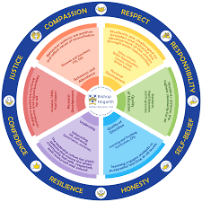Respect for others and themselves, recognising that we are all created in the image of God and therefore must be compassionate towards others, especially the vulnerable.

Confidence in their own abilities, knowing that their talents are gifts from God and resilience to persevere when things become difficult.

Honesty in regard to the world around them and themselves and preserving and showing self-belief to make changes.

The ability to take responsibility for the times we may fall short of the mark.

Gratitude for all the amazing gifts from God and willingness to share their gifts both personal and material.

As an inclusive school, all teachers are teachers of pupils with Special Educational Needs & Disabilities. We deliver a curriculum and create an environment that meets the needs of every pupil within our school. We ensure that every pupil with Special Educational Needs and / or disabilities makes the best progress possible. We foster and promote effective working partnerships with parents / carers, pupils, and outside agencies. We consider the ‘whole’ child and strive to ensure that all our SEND pupils are prepared for adulthood.

**Our school’s approach to support pupils with SEND.**

St Bede’s is committed to support the needs of pupils with special education needs and/or disabilities. We do our very best to ensure that all pupils, regardless of their specific needs, make the best possible progress in school. We are committed to being an inclusive school, with adaptions made to the curriculum and provision to meet the needs of all our pupils with SEND. Equality of opportunity must be a reality for our children. We make this a reality through the attention we pay to the individual needs of our children with SEND within our school setting, thus providing a learning environment which enables all children to achieve their full potential. We are committed to keeping all children, including those with Special Educational Needs and/or Disabilities (SEND), safe from bullying or any kind of discrimination. Every child matters and we are dedicated to celebrate their efforts as much as achievement.

All teaching and support staff develop strong, nurturing relationships with the children they work with each day. Teachers hold high expectations for all pupils in their care. Teachers are responsible for the progress of all pupils in their class. High-quality teaching is personalised to individual needs, making good use of high-quality resources to improve pupil progress. This is the first step in supporting pupils who may have a SEND need. Where appropriate, specific strategies are drawn up, in partnership with individual children, parents and carers and other professionals to support progress.

Class teachers carefully check on children’s progress and may decide that gaps in their understanding/learning need some temporary extra support to help them make the best possible progress. All children in school may access this as part of everyday classroom practice. At times, the class teacher may direct a teaching assistant to work with a child, as part of routine working practices or to support a specific need. Pastoral, emotional and social support is available for all from teachers, teaching assistants, our Head Teacher, SENCO and Emotional Literacy Support Assistants (ELSAs). Support for parents and families is available from our Head Teacher, Deputy Head Teacher and Parent Support Advisor and through our links to local authority and family support services.

We manage medical needs by working closely with parents and healthcare professionals and use the information and advice to develop and review pupils’ Individual Health Care Plans. We also listen to and act on their advice, providing staff training when needed. Please see the ‘[Supporting Children with Medical Needs Guidance’](https://assets.publishing.service.gov.uk/government/uploads/system/uploads/attachment_data/file/306952/Statutory_guidance_on_supporting_pupils_at_school_with_medical_conditions.pdf) policy for further information.

**How will the school staff support my child?**

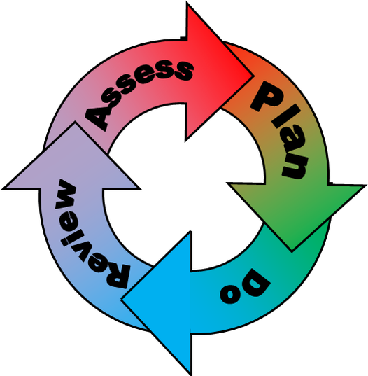The graduated response; Identifying, planning for and supporting pupils with SEND. Where a pupil is identified as having a special educational need, School will follow a graduated approach which takes the form of cycles of ‘Assess, Plan, Do, Review’.

• Assess a child’s special educational need.

• Plan the provision to meet your child’s aspirations and agreed outcomes.

• Do put the provision in place to meet those outcomes.

• Review the support and progress.

**How does the school know if children need extra help and what do I do if I think my child has special educational needs?**

1. **Assess**

At St. Bede’s, we observer, we analyse, we assess and we hold discussions with key staff and parents/carers to identify a child’s needs documenting areas of strengths and areas for support and development. Children are fully involved in this process. Children are identified as having a special educational need and/or a disability if they have significantly greater difficulty in learning than the majority of children of the same age or if they have a disability which challenges their use of educational facilities. With parental permission, special assessments may also be carried out and input may also be requested from specialist services. Assessments from other professional services include:

* Educational Psychologists
* Occupational Therapists
* Physiotherapists
* Services to support hearing impaired and visually impaired children
* Children and Adolescent Mental Health Services
* Paediatricians
* Schools Health Services
* Social Care Support
* Speech and Language Therapists
* Early Help Teams/Building Stronger Families
* Outreach services
* Mental Health Support Teams

We always welcome approaches from parents/carers concerned about their child’s needs and ensure that all professionals work together so that all children are provided with the best care and education possible. If your child’s needs are assessed by someone attached to or from outside of St. Bede’s, we will ensure that you have an opportunity to discuss any findings contained in feedback reports with a member of staff. We may then add useful strategies to your child’s Support Plan to support our provision and keep the effectiveness of these under review.

Our SENCO supports St. Bede’s by setting up robust systems to support our work in the area of SEND. They help class teachers with identification of difficulties and conduct, where appropriate, assessments of learning needs and with the development of personalised strategies to support progress.

In some cases, pupils may develop so that they no longer require specific SEND support. If this happens then the SENDCo will carry out observations, discussions with staff and parents/carers and look to remove the pupil from the SEND register.

For further support, you can contact the SEND Information, Advice and Support Officer, on 01325 405878 or [iass@darlington.gov.uk](mailto:iass@darlington.gov.uk). For additional information, please see details of Darlington’s full Local Offer of SEND support at [Darlington’s LA SEND Local Offer](https://livingwell.darlington.gov.uk/Categories/528).

1. **Plan**

At St. Bede’s through discussions and meetings with staff, parents and other professional colleagues we plan for the support that is needed to enable a child to thrive and make progress. We follow the graduated approach to assessment, planning and review of provision as recommended by the [Code of Practice (2014)](https://www.gov.uk/government/publications/send-guide-for-parents-and-carers.).

In the first instance, children of all abilities access Quality First Teaching to help them learn to the best of their ability. We employ a range of teaching and learning styles, adapted teaching materials, enhanced access to ICT equipment and resources, additional adult support, small group work, rewards, mentoring, counselling, sensory equipment and actions and extra-curricular activities as our core offer.

If children are identified as needing specific support, in collaboration with the child and parents/carers, staff create SEND Learner Profiles (SLP). The SLP details how we will work together to meet a child’s needs and achieve specific learning goals. SMART outcomes and targets are set. These are specific, measurable, achievable, relevant and time-bound. These plans are reviewed as a working document at half termly and termly intervals, but more formally with parents and carers at termly meetings. Here, tracking data and progress towards outcomes is considered. Where appropriate, refinements will be made to support plans and a revised SLP drawn up. These plans help to explore any barriers to learning and seek to help children to make the best progress possible.

Where appropriate, a child may be placed on our school’s SEN Support Register. If it is decided that a child’s needs require more detailed scrutiny, then a One Plan is implemented to monitor progress. This is a far more detailed document. It follows the format of an Education Health Care Plan. Progress data scrutiny, termly profile meetings and SLP/One Plan reviews with parents/carers help us to accurately gauge the impact of our support. In some cases, we may make a submission to the Local Authority (LA) for an Education, Health and Care Plan (EHCP) to be considered as part of the assessment process. These plans are used when a child’s needs are more substantial, persistent, complex and likely to require input from a range of outside agencies. This will often include input from social care and/or paediatric health services. The LA makes decisions about whether or not to formally assess and put a plan in place. The views of parents/carers and child’s views, along with school-based evidence, will always form an important part of this type of assessment.

1. **Do**

At St. Bede’s our teachers are skilled at adapting teaching and learning to meet the diverse needs in each class. Daily planning considers individual children’s needs and requirements and is annotated and adapted according to their need.

Explicit reference is made in the teacher’s planning to identify children with SEND. Adaptive teaching is approached in a range of ways to support access to the curriculum and ensure that all children can experience success and challenge in their learning.

Grouping arrangements consider the different skills and abilities of each child. This ensures that learning is maximised. We support children by providing additional adults support groups and individual children with the long-term goal of developing independent learning skills. The class teacher monitors this support to avoid students becoming over reliant on this. We fully encourage parental support and offer opportunities for individual meetings with parents/carers to provide clarity and recommendations on how they can support their child at home.

1. **Review**

As part of the planning process at St. Bede’s, we set clear time-frames for reviews. We discuss, measure and analyse and observe the impact of plans, support and interventions on progress, development, achievement and behaviours.

Progress of children with SEND is reviewed at least termly. We are able to support in our progress reviews by the Bishop Hogarth Trust’s Data Manager, who helps us with regular updates of any trends in data and the development of relevant areas for actions to address any highlighted issues. Parent/carer meetings twice annually to discuss your child’s progress. Teachers also a produce a annual written report. In addition, our SENCO’s holds termly coffee afternoons, where appropriate, to discuss the impact of the most recent strategies being put into place. Wherever possible we involve the children in reviewing their own provision. Their experience of support, their personal motivators and their individual learning style will be taken into account along with parent/carer views, to help refine the actions we take to support progress.

We constantly evaluate our method of identification, practice and impact our approach to supporting pupils with SEND which includes:

• Improved access to the curriculum for all children with SEND, through carefully planned long and short term interventions, adaptions to the curriculum and additional support

• Improved and sustained positive relationships with our parents, who continue to work in partnership with us to develop effective support plans and review progress

• Systems in place for the management of Individual Health Care Plans and medical needs

• Systems for accurate identification of pupils who have SEND

• Systems for planning and reviewing provision

• More robust identification system of SEND pupils and management of SEND register

• Smaller steps of progress identified through revised SLP system

• Referrals to Educational Psychologist service that have positively impacted on pupil progress, as suggested strategies are quickly embedded into learning plans

• Regular meetings involving SENCO, Educational Psychologist, Speech and Language Therapists continue to improve the promptness provision of more personalised and effective support

• Greater numbers than before of those children who have the most significant and complex needs now in possession of Education, Health and Care Plans (EHCPs)

• Positive Reviews of pupils’ EHCPs held to date, with good home-school relationships established and progress recorded.

**How will the curriculum at our school be matched to my child’s needs?**

SEN needs are classified under four broad areas of need. Below are the strategies, in class support and interventions that school may put in place to support your child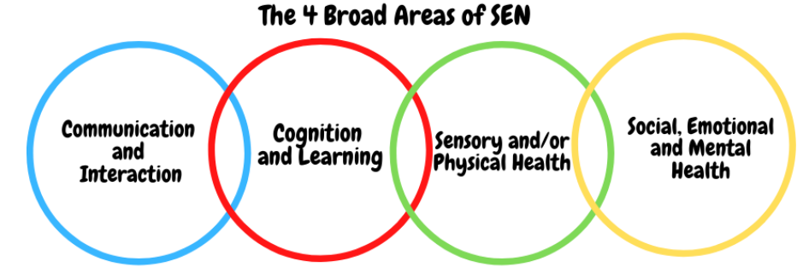**Communication and Interaction**

Strategies to support children with these needs include:

Access to small group and/or individualised interventions to develop skills in communication, interaction, emotional awareness, self-care and flexible thinking. E.g. ‘Time for Talk’

Flexible approaches to timetable

Modifications to lunch and/or break times

Access to additional aids and visual learning approaches

Access technology

Explicit teaching of generalising skills from one context to another

Careful planning of transitions

Conscious reduction of ‘teacher talk’

Sensory feedback support e.g. fidget toys, wobble cushions

Mentoring and/or buddy systems

Family support groups to improve home-school consistency of approach

The use of Social Stories to encourage positive behaviour and thinking for pupils with social and communication needs.

Creating and building relationships with pupils based on their experiences using ICAN; Babbling baby, Teacher talk, Chatting children (depending on child’s level of communication and interaction)

Strategies evolved from Speech and Language Training: ‘Teaching Vocabulary in the Primary Years’ and ‘Supporting Children to Understand Language’.

**Cognition and Learning**

Cognition and Learning Strategies to support children with these needs include:

Developmental support for short-and long-term memory through a range of recall strategies

Regular, individually focused intervention and flexible groupings

Increased, time-limited access to clearly focused small group support, managed by the class teacher

Practical aids for learning e.g. table squares, time/number lines, pictures, photos, accessible, age-appropriate reading material, coloured overlays or coloured tracking guides, Numicon

Phonic development programmes and interventions

Enhanced access to IT and technical aids

Adaptations to assessments to enable access e.g. readers, scribe, extra time allocation, where this reflects the child’s usual way of working ICT curriculum adapted to meet the learning needs of your child.

Frequent repetition and consolidation opportunities

Intervention programmes linked to year group learning goals

School curriculum clubs where children are invited to consolidate and practise curriculum skills in science, history and times-tables

Year six booster sessions led by teachers and teaching assistants

Links with home/hospital education

Support from Darlington Educational Psychology Service: ‘Identifying and Responding to Literacy Difficulties and Dyslexia’(April 2021) a document which supports school in identifying and providing reading and spelling needs.

**Sensory/Physical**

Sensory/Physical Strategies to support children with these needs include:

Physical aids to support access e.g. wheelchair and writing slopes

Concrete apparatus available to support learning

Access to changing facilities to support for personal care

Enhanced levels of individual supervision within class and during unstructured times e.g. when using play equipment in the outdoor area

Small step re-integration of children who have undergone surgery, evaluated in the light of past experience, linking closely with Paediatric Physiotherapy and Occupational Therapy staff

Adapted curriculum to enable full access e.g. alternative recording devices, modified PE curriculum Medical needs are supported in line with the following document[: ‘Supporting Children with Medical Conditions,’ DfE 2015](https://assets.publishing.service.gov.uk/government/uploads/system/uploads/attachment_data/file/803956/su%20pporting-pupils-at-school-with-medical-conditions.pdf).

Sensory Circuits for children with identified sensory needs

Activities to improve gross and fine motor skills e.g. ‘disco dough’ in EYFS, ‘funky fingers’ and ‘squiggle whilst you wiggle’.

Use of alternative coloured background on white boards.

**Social, Emotional and Mental Health**

Social, Emotional and Mental Health Strategies to support children with these needs include:

Access to movement breaks/individual work area/rest breaks

Mentoring

Access to support from our Emotional Literacy Support Assistant who is trained to provide emotional and social skill support to children.

Individualised rewards system

Early Help Assessments, to secure multi-agency targeted support, as appropriate

Personalised curriculum

Access to Mental Health Support Team professionals for targeted one to one support or through whole class focus group work on areas such as resilience and transition

Alternative curriculum opportunities

Additional opportunities to develop social and emotional aspects of learning

Specially designed games for the support of turn-taking and co-operative behaviour skills

Access to Child Adolescent Mental Health Service (CAMHS) advice

**What training is provided for staff supporting children with SEND?**

St Bede’s is committed to ensuring that staff training is monitored and kept up-to date in order for support to be of maximum benefit to all pupils. The school’s SENCO is a qualified teachers and is working towards the National Award for SEND Co-ordination (NASENCo). We fully comply with the requirements outlined in the Special Educational Needs Code of Practice (2014). We also make reasonable adjustments to our practices to comply with the Equality Act (2010) and Families Act (2014). Staff have been trained to cater for learners who may have difficulties with:

• Cognition and Learning

• Communication and Interaction

• Sensory and/or Physical Needs

• Social, Emotional and Mental Health

When new needs are identified and the school is unprepared to offer provision, staff are selected and training is arranged. Where necessary, the school draws on the services of outside agencies and specialists. St Bede’s school staff offer a wealth of expertise and are trained in and /or qualified to cover the following areas:

First Aid, administration of medication, use of epi-pens, diabetes training.

Phonics programmes: Read Write Inc/ Sounds Write

Support for children who have needs on the autistic spectrum

Support for children who have social, emotional or mental health needs via Mental Health First Aid Training

Bi-termly SEN update training for SENCO from the Local Authority’s SEND Team

PECS training in EYFS Speech and Language Training including Talk Boost and ICAN programmes.

SEN Range Training from Darlington Local Authority Service

We manage medical needs by working closely with parents and healthcare professionals. We listen to and act on their advice, providing staff training when needed. ‘Supporting Children with Medical Needs’ Guidance, 2015, informs our practice.

Educational Psychologists recommendations including ‘Venture into Play’

The Sunflower Programme training for sensory difficulties impacting on functional skills at school from occupational therapist.

Language Base Social Story training from Daisy Chain

**How do we support transition in our school?**

Transition within classes/key stages:

Children with SEND may need additional support to move into a new class, a new part of the school or a completely new school: we call these ‘Transitions.’ We have well established arrangements for class teachers and SENCO to meet with each other and new teachers, to share SLPs and information to plan for smooth transitions within school. Enhanced transition plans are made, if appropriate, and may include social stories, extra classroom visits, etc.

Transition to St. Bede’s Early years:

Children coming to St. Bede’s with additional needs are supported through the process in conjunction with Local Authority EYFS Inclusion staff. Visits by early years staff to pre-schools and nurseries to meet with children and families occur. Additional visits to St. Bede’s are planned and social stories provided to familiarise children with the setting and staff. An enhanced transition document and plan is produced.

Transition to Secondary settings:

Where a child is moving to a new school, or to secondary school, the new school’s SENCO is invited to meetings to draw up an individualised transition plan for the child in consultation with parents. With parental permission, a SLP is shared with the receiving school, whose SENCO then updates this key document to help their staff get to know the pupil and how best to support them from their first days in the new setting. Information sharing is proving particularly helpful with moves to secondary education, where staff want to get to the know the needs of their pupils who have SEND as quickly as possible to build relationships and to support pupil progress and well-being. Transition from St. Bede’s often includes earlier or more frequent visits to the school to familiarise children and to reduce anxiety. Examples include pupils who have needs on the autistic spectrum and/or pupils who experience high levels of anxiety. Other children who can particularly benefit from these arrangements are those who have mobility difficulties or sensory impairment, who require mobility training to ensure safety and boost confidence. Our Year 6 teacher and SENCO are all involved in helping to make the move to a new secondary school as smooth and positive as possible.

**What key school documents refer to support and provision for pupils with SEND?**

• SEND Policy

• Admissions Policy

• Supporting Pupils with Medical Needs Policy

• Accessibility Plan Accessibility

With due regard to our admission policy, parental choice and accessibility of the school building all children with special educational needs who apply will be accepted by the school. Please see our admission policy. All of our school is fully wheelchair accessible. Disabled toilet facilities are located throughout the school

We have a changing room for additional personal care needs. We access and buy specialist equipment as recommended by professionals e.g. Occupational Therapists. We have identified areas of school for work stations and safe spaces and break out areas. We have a sensory area that is constantly updated. We are constantly looking for new resources and ideas to assist children with self-regulation. Activities Outside of School Staff who are arranging an offsite trip will discuss with parents and the SENCO any requirements needed and the suitability of any trip which the school is taking part in. We will then discuss any additional requirements that we will need to put into place to ensure that all children can take part. We support children on off-site visits and are flexible in our approach to residential visits. <https://www.gov.uk/guidance/equality-act-2010-guidance>

What to do if you have a complaint, a compliment, or a query.

Our contact details are:

• You can telephone on: 01325 466411

• You can email at: [admin@stbedesdarlington.bhcet.org.uk](mailto:admin@stbedesdarlington.bhcet.org.uk)

Key contacts:

* Miss Cuff, Head Teacher
* Mrs Peacock, Deputy Head Teacher
* Mrs Webb, SENDCO

Name of school SEND governor.

* Marianne Taylor