SEND Information Report
Approved on:
July 2023
Next review:
June-July 2024
St Bede’s Catholic Primary School

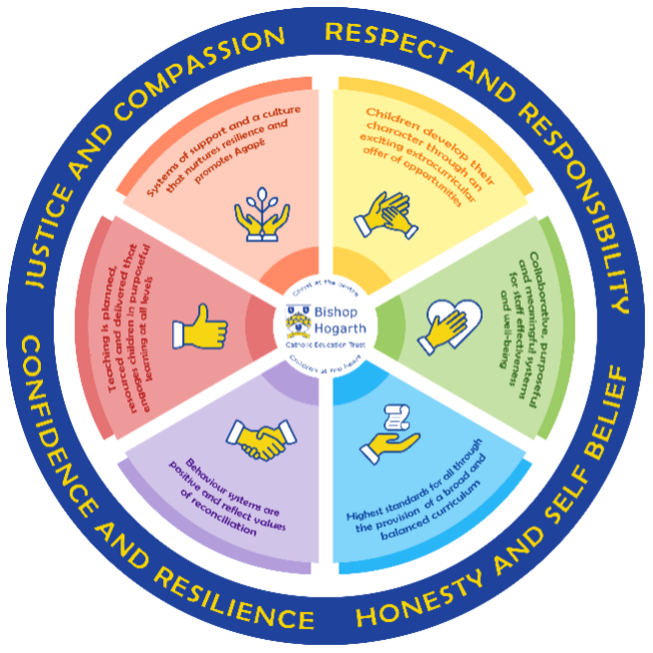
As part of the family of Bishop Hogarth Catholic Education Trust, our school has at its core, the virtues, and values of:
Respect for others and themselves, recognising that we are all created in the image of God and therefore must be compassionate towards others, especially the vulnerable. ​
Confidence in their own abilities, knowing that their talents are gifts from God and resilience to persevere when things become difficult. ​
Honesty in regard to the world around them and themselves and the ability to take responsibility for the times we may fall short of the mark. ​
Gratitude for all the amazing gifts from God and willingness to share their gifts both personal and material. ​

As an inclusive school, all teachers are teachers of pupils with Special Educational Needs & Disabilities. We deliver a curriculum and create an environment that meets the needs of every pupil within our school. We ensure that every pupil with Special Educational Needs and / or disabilities makes the best progress possible. We foster and promote effective working partnerships with parents / carers, pupils, and outside agencies. We consider the ‘whole’ child and strive to ensure that all our SEND pupils are prepared for adulthood.​

Our school’s approach to supporting pupils with SEND

Teachers are responsible for the progress of ALL pupils in their class. High quality teaching is personalised to meet every child’s need. This is the first step in supporting pupils who may have SEND (Special Educational Needs and Disabilities). All children are challenged to do their very best. This is enough for most pupils to make progress.
• All children will be taught a broad and balanced curriculum; differentiated to the needs of each individual. Where children require extra support, specialist resources or extension materials, these will be provided wherever possible.
• All children are known well by their class teacher, who develops strong relationships with them. Good behaviour and work is rewarded. ‘Behaviour Policy’
• Your child can express their views in several ways, including via their house captain, school council representatives or directly to staff, e.g. their ‘Safe Person’. Buddies and mentors and the student council representatives encourage all pupils to have a voice in school.
• We manage medical needs by working closely with parents and healthcare professionals. We listen to and act on their advice, providing staff training when needed. ‘Supporting Children with Medical Conditions Policy’ (review date November 2023)
• We run a wide range of extra curricular clubs including Dance, Games, Football and Cricket.
• There is also an SEN governor who has particular involvement with SEND policy and provision. Our Core Offer St. Bede’s has a wealth of expertise from its staff over and above the qualifications needed for their jobs. Specialist services are always used when the need arises and the school feels it needs more support or advice to ensure a child fulfils their potential. The following is a snapshot of our expertise, but is not an exhaustive list: Expertise in School
• SENCo – Miss Cuff
• Qualified First Aid Staff
• Wellbeing Lead
• Mental Health First Aid Staff
• Two Higher Level Teaching Assistants (HLTAs)
• Lexia (Literacy programme) • Word Wasps and Word Hornets (Literacy Programme)
• RWInc (Phonics programme)
• Accelerated Reader (Reading Programme)
• Power Maths (Numeracy programme)
• Zones of Regulation (Emotional Literacy Programme)
At St. Bede’s we involve other bodies; including health and social care, local authority support services, charitable and voluntary sector organisations in meeting the children’s SEN and supporting their families. Expertise/Specialist Services secured by School
• Educational Psychologist
• CAMHS – Children and Adolescent Mental Health Services
• Speech and Language Therapists
• Paediatric Occupational Therapists
• Paediatric Physiotherapists
• Local Authority (LA) advisory staff for children who experience hearing or visual impairment
• Local Authority SEND Team for general advice

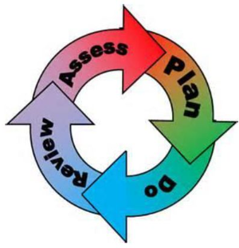
How will the school staff support my child?
The graduated response-Identifying, planning for and supporting pupils with SEND
Where a pupil is identified as having a special educational need, School will follow a graduated approach which takes the form of cycles of ‘Assess, Plan, Do, Review’. ​
• Assess a child’s special educational need. ​
• Plan the provision to meet your child’s aspirations and agreed outcomes. ​
• Do put the provision in place to meet those outcomes. ​
• Review the support and progress.

How does the school know if children need extra help and what do I do if I think my child has special educational needs?

- Assess
Identification – Your child will be identified as having SEN and/or a disability if they have significantly greater difficulty in learning than the majority of children of the same age or if they have a disability preventing or hindering the use of educational facilities provided for children of the same age within the Local Education Authority.
• First steps - if from our rigorous tracking and monitoring of your child’s progress, it becomes apparent that he/she is not making expected progress then you will be invited to a meeting with their teacher and Miss Hammerton (SENCo). Where appropriate your child will be involved in this meeting. At the meeting we will begin to explore the possible barriers to learning and you will be asked how we can best support your child.
• Observations and assessments will then be carried out and, if required, input from specialist services may be sought with your permission.
• Where appropriate your child may be placed on our school’s Targeted Support or SEN Support Register and a plan will be devised by the class teacher that will set achievable targets. These will be reviewed and updated at least half-termly.
• EHCPs (Education, Health and Care Plans) will be used when a child’s needs are deemed more complex and require the input from a range of outside agencies. This could be in the form of Educational Psychologists, Occupational Therapists or other professionals with an area of expertise, e.g. Autism. An EHCP helps to determine the level of educational, social and health support the child needs

- Plan
Our procedures are in line with the SEN Code of Practice.
The first point of contact is the class teacher, who has overall responsibility for the welfare of your child. Additional provision is planned carefully and overseen by the SENCo (Special Educational Needs and Disabilities Co-ordinator). It is implemented by a skilled team of teachers and supported by experienced teaching assistants.
SEND Resources
At St. Bede’s we have an extensive range of different SEND resources and interventions available. These are closely matched to the needs of our children and their progress is monitored by the class teacher, the SENCo and staff with specific curriculum responsibilities.
Where provision does not result in adequate progress, as outlined in the SEN Code of Practice, the SENCo should be consulted for advice.

- Do
Our teachers are skilled at adapting teaching and learning to meet the diverse needs in each class. ​
Daily planning considers individual children’s needs and requirements and is annotated and adapted according to need. Explicit reference is made in the teacher’s planning to the needs of those children identified with SEND. ​
Adaptive teaching is approached in a range of ways to support access to the curriculum and ensure that all children can experience success and challenge in their learning. ​
Grouping arrangements consider the different skills and abilities of each child. This ensures that learning is maximised. ​

Additional adults support groups and individual children with the long-term goal of developing independent learning skills. The class teacher monitors this support to avoid students becoming over reliant on this. ​
We fully encourage parental support and offer opportunities for individual meetings with parents/carers to provide clarity and recommendations on how they can support their child at home.

- Review
If despite all steps taken, good progress is still not being made we will refer back to our graduated approach and increase/change support whilst continuing to monitor and review progress. It may also be necessary, at this stage, to consult with the expertise and specialist services secured by the school.
Consultation sessions are held in the Autumn and Spring terms where you can meet your child’s teacher to discuss and look at their work in different subject areas. A further opportunity is provided in the Summer term for you to discuss your child’s end of year report.
Parents that have children on the school’s SEN Support Register, are also invited to termly meetings to review their child’s Individual Education Plan. Your child will be involved in reviewing their targets at appropriate times throughout the term, with the class teacher or teaching assistant, and during the setting of new targets on a termly basis. If, of course, you would like to meet with the SENCO or your child’s class teacher at any point during the term, this can easily be arranged.

How will the curriculum at our school be matched to my child’s needs?
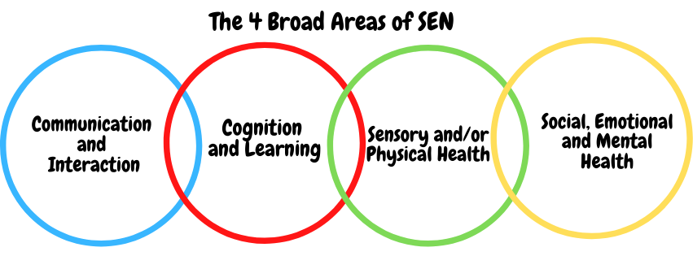SEN needs are classified under four broad areas of need. Below are the strategies, in class support and interventions that school may put in place to support your child.
Communication and Interaction
Strategies to support children with these needs include:
• Clarifying need on entry/ Identifying need.
• Increased use of ICT and access to technology
• Enhanced access to additional aids and visual learning approaches
• Mentoring and/or buddy systems for play and lunch times.
• Modifications to lunch and/or break times
• Conscious reduction of ‘teacher talk’
• Social skills training involving support staff and small group work.
• Support in the classroom and at break times.
• Explicit teaching of generalising skills from one context to another
• Careful planning of transitions Speech and language support from outside agency and delivery of suggested programmes by staff in school.
• Flexible approaches to timetable
• Referral to Speech and Language Therapy Services for additional targeted support with Staff experienced in support for the development of speech and language skills, under the guidance of the NHS Speech and Language Therapy Service
• Small group or individual work to support development of relationships and grief counselling.
• Access to small group and/or individualised interventions to develop skills in communication, interaction, emotional awareness, self-care, flexible thinking

Cognition and Learning
Strategies to support children with these needs include:
• High quality teaching, differentiated for individuals including careful deployment of support staff within lessons
• Training for staff.
• Needs of pupils known by all staff.
• Differentiated materials including coloured background and overlays, use of picture and word banks, visual clues to learning etc.
• Developmental support for short and long term memory through a range of specific strategies.
• Regular, individually focused intervention and flexible groupings
• Support staff deployed to encourage engagement
• Range of teaching and learning strategies.
• Increased, time-limited access to clearly focused small group support, managed by the Class Teacher and supported by SENCo
• Practical aids for learning eg table squares, time/number lines, pictures, photos, accessible, ageappropriate reading material, coloured overlays or coloured tracking guides, numicon
• Frequent repetition and consolidation opportunities, linking with yourselves via your Class Teacher to support additional practice at home
• Use of teaching assistants to scribe work for pupils
• Increased use of ICT and technology
• Access to advice and support from specialist staff.
• Access arrangements to assessments including scribe, readers and adapted texts. Support from outside agencies e.g. Educational Psychologist which form part of Individual Support Plan

Sensory/Physical
Strategies to support children with these needs include:
• Deployment of teaching assistants and lunchtime staff to support needs of the individual.
• Support is available for students who might have social, emotional or behaviour concerns. Staff will inform the school SENCo or Head Teacher of any concerns that they might have. Support is offered to children who might benefit from additional support and following parental consent, pupils attend by invitation. This is led by an experienced staff member and focuses on emotional development, relationships and bereavement.
• Alternative curriculum opportunities
• Access to time out/individual work area/mindfulness interventions
• Access to specially designed games for the support of turn-taking operative behaviour skills for example Lego therapy
• Monitoring of behaviour via whole school behaviour management system.
• Whole school reward system to promote behaviour for learning.
• Use of individual reward system tailored to interests of child
• Working with outside agencies to promote safe behaviours.
• Links to parents/ carers via staff with family liaison and attendance support.
• Mentoring
• Social skills support including group work with support staff to support development of friendships.
• Home/school agreement.
• Educational Psychologist/ CAMHS as appropriate.
• Early Help Assessments accessed via our SENCO, to secure multi-agency targeted support, as appropriate
• Individual support within lessons through differentiation of tasks or deployment of support staff.
• Whole school themed activities during Anti-Bullying week to promote inclusion of all pupils

Social, Emotional and Mental Health
Strategies to support children with these needs include:
• Adapted curriculum to enable full access e.g. alternative recording devices, modified PE curriculum
• Access to Sensory Support services for advice on planning for students with a visual or hearing impairment.
• Teachers will be made aware of the implications of physical and sensory impairments and adapt lessons accordingly.
• Physical aids to support access e.g. wheelchair, walking frame, hearing aids, large print materials
• Use of alternative coloured paper/ background on white boards, coloured overlays etc. if appropriate
• Liaison with outside agencies for specific equipment to aid access to the curriculum.
• Provision of specialist ICT equipment.
• Occupational Therapist/ Physiotherapist targeted programmes. Concrete apparatus available to support learning
• Access to support for personal care
• Enhanced levels of individual supervision within class and during unstructured times, eg when using play equipment in the outdoor area
• Medical needs are supported in line with the following document: ‘Supporting Children with Medical Conditions’ DfE 2014

What training is provided for staff supporting children with SEND?
•All teachers have Qualified Teacher Status and our teaching assistants have a minimum of a level 2 qualification.
•All staff are either teachers of or are supporting students with SEND.
•St. Bede’s values staff training and organises courses/training programmes to ensure teachers and teaching assistants stay up to date with current research into teaching and learning.

How do we support transition in our school?
We recognise that some students need more support at transition points, such as when • moving between Key Stages or when moving to a new school setting.
At such times we offer personalised transition programmes to support individual SEND children. We strive to provide continuity of support and reduce your child’s potential anxiety by working closely with staff in the next Key Stage/school. We work closely with all secondary schools in the area.
The majority of our children move on to Carmel College in Darlington . We work closely with other agencies in order to provide an enhanced transition for children moving to Key Stage 3.
This includes individual transition plans which provide opportunities for additional visits to a new setting.
SEN Transition meetings take place prior to the start of the next academic year to ease the transition process.

Where can I get further information about services for my child?

The Local Offer
Further information to support this document can be found at the following links:
• SEN Code of Practice (graduated response) https://www.gov.uk/government/consultations/revision-of-the-send-code-ofpractice-0-to-25-years
• Local Authority’s Local Offer https://livingwell.darlington.gov.uk/Categories/528
• St. Bede’s Complaints procedure for SEND https://stbedesdarlington.bhcet.org.uk/policies/

What key school documents refer to support and provision for pupils with SEND?
Our school aims to treat all its pupils fairly and with respect.
This involves providing access and opportunities for all pupils without discrimination of any kind. Access to the curriculum for pupils with a disability is achieved in the following ways:
• Our school offers a differentiated curriculum for all pupils.
• We use resources tailored to the needs of pupils who require support to access the curriculum.
• Curriculum progress is tracked for all pupils, including those with a disability.
• Targets are set effectively and are appropriate for pupils with additional needs.
• Pupils who have a disability have a personalized support plan in place to meet their needs

- SEND Policy​
- Admissions Policy​
- Supporting Pupils with Medical Needs Policy​
- Accessibility Plan​

Accessibility​

Activities Outside of School​
Access to the physical environment achieved with the following modifications:
• Ramps
• Elevators
• Corridor width
• Disabled parking bays
• Disabled toilets
• The environment is adapted to the needs of pupils as required. Our school uses a range of communication methods to ensure information is accessible. This includes:
• Internal signage
• Large print resources

What to do if you have a complaint, a compliment, or a query.

The school details and relevant contacts
………….– Head Teacher
…………….– Deputy Head Teacher and SENco St Bede’s Catholic Primary School, Kingsway, Darlington, DL1 3ES
Tel: 01325 466411 Website – https://stbedesdarlington.bhcet.org.uk/
Email – admin@stbedesdarlington.bhcet.org.uk
senco@stbedesdarlington.bhcet.org.uk
Darlington Borough Council website – https://www.darlington.gov.uk/
Bishop Hogarth Catholic Education Trust – https://bhcet.org.uk/ Academy contact – Mike Shorten 01325 254525
​
Name of school SEND governor.
To be completed

