**Please look below to see what your child will be learning in each subject this term.**

**UKS2 Summer Term Newsletter**

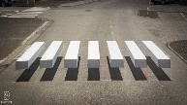

**Mathematics**

This term children will cover skills across four key areas of maths; multiplication and division, factions, decimals and area, perimeter and volume.

Decimals:

<https://www.bbc.co.uk/bitesize/articles/zsbd7p3>

Shape:

<https://www.bbc.co.uk/bitesize/topics/zmxpwsg/articles/zk7dg7h>

Statistics:

[https://www.bbc.co.uk/bitesize/topics/zhpy239/articles/zqv8bqt \](https://www.bbc.co.uk/bitesize/topics/zhpy239/articles/zqv8bqt%20\)

Converting units

<https://www.bbc.co.uk/bitesize/topics/zq76khv/articles/z63qdp3>

**History and Geography**

This term children will explore all about Victorian Britain, with our end of year trip taking place on Monday 19th May- a trip to Beamish!

During our Geography lessons, children will identify the cause and effect of Tsunami’s looking closely at the 2011 Japanese Tsunami. Have a go at creating your own Tsunami model at home. 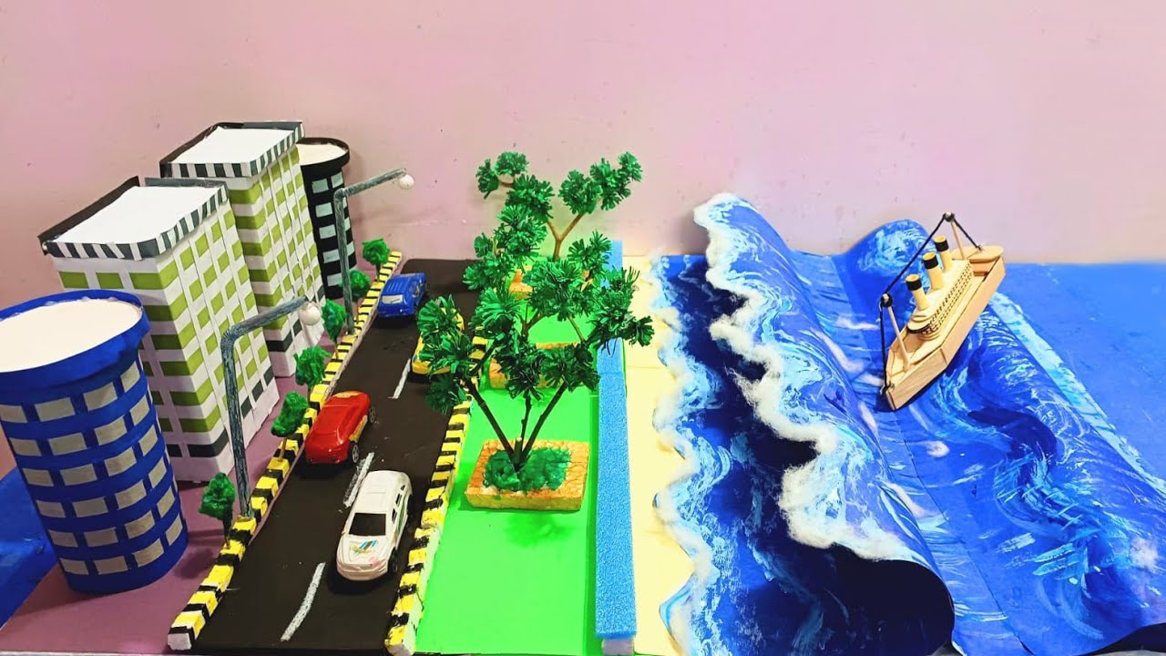

**Art and Design Technology**

This term we are looking at **creative Responses: Drawing and Textile**. We will revisit some of the key skills previously taught, including the use of a tjanting tool whilst using a range of mediums to create texture and details.

During our Design & Technology lessons, children will research,

design and create their own pasta Bolognese. Why not try and cook this meal together at home.

**Spanish**

This term children will consolidate their learning on the area they live and all about themselves, developing their confidence to initiate and sustain conversation. Children will complete their project - ‘All About Me’.

**Science**

This term, children will focus on sound, living things and their habitats as well as evolution and in heritance. Have a look at some fantastic resources on BBC bitesize for these units: <https://www.bbc.co.uk/bitesize/topics/z6xktcw>

**PE**

This term, children will develop their flexibility, strength, technique and control through a variety of sports including cricket and athletics. Children will have the opportunity to take part in a football tournament and athletics competition. If you take part in a club outside of school please share any sporting successes!

**Computing**

Children will explore the concept of variables in programming through games in Scratch. Children will use variables to create a simulation of a scoreboard. Children will review and apply their knowledge of variables and design to improve their games in Scratch.

**Music**

By using chords in compositions, we can create music that is more harmonically interesting. We can also create accompaniment for a melody using chords. Children will explore how chords are used within the music in this unit by listening and responding to La Bamba.

**RSE/PSHE**

Children will take part in 3 workshops lead by the Darlington Mental Health team around building confidence. Y6 children will also have a special visit by the school nurse who will run a workshop on transitions.

**English and Reading**

This term we will cover five genres of writing; **News reports**, **Shakespeare’s sonnets, Discursive writing and speeches**, **Poems, First person stories with a moral**. Support your children at home by using these fantastic creative writing guides on BBC bitesize- <https://www.bbc.co.uk/bitesize/topics/zvvxb7h>

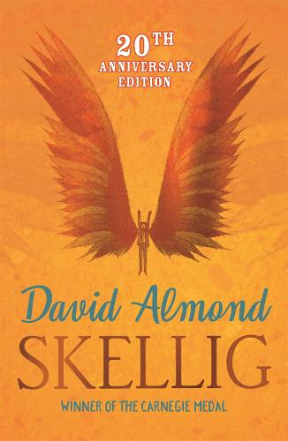This term, children will complete their class novel, Skellig as well as exploring two new books; Dare to be You and extracts from Oliver Twist. We encourage children to read as often as they can at home to develop their fluency, comprehension and expression.

**RE**

This term, children will cover three units, Witnesses, Healing and Common Good. Children will continue to develop their faith through our class Pilgrims of Hope Project. Children will attend Mass with their class and as a whole school.

We are looking forward to celebrating St Bede on Friday 23rd May.

Please join us for Family Mass at St Thomas Aquinas Church on **Saturday 17th May.**