**Please look below to see what your child will be learning in each subject this term.**

**UKS2 Spring Term Newsletter**

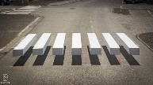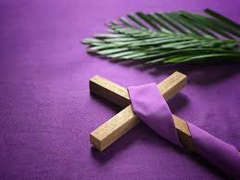

**History and Geography**

This term children will explore all about Victorian Britain.

During our Geography lessons, children will identify the cause and effect of Tsunami’s looking closely at the 2011 Japanese Tsunami. Have a go at creating your own Tsunami model at home. 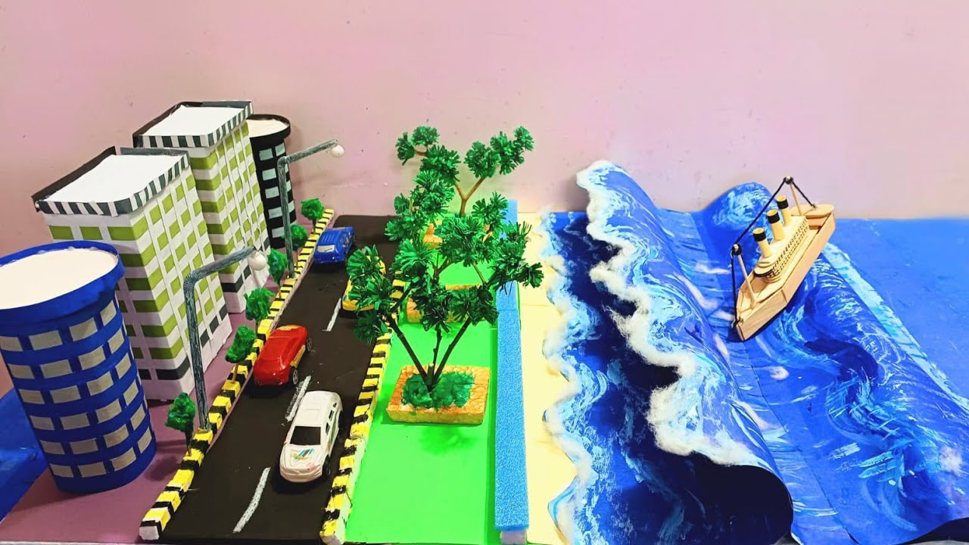

**Art and Design Technology**

This term we are exploring painting, drawing and textiles. We will research into key artists such as Patrick Hughes and his work on optical illusions. Why not have a go at drawing your own optical illusion.

During our Design & Technology lessons, children will research,

design and create their own pasta Bolognese. Why not try and cook this meal together at home.

**Spanish**

This term children will continue to explore all about the area they live and about themselves, developing their confidence to initiate and sustain conversation. Children will then complete a project ‘All About Me’.

**Science**

This term, children will focus on electricity and sound. Why not have a go at completing some investigations around lamp brightness (<https://www.stem.org.uk/resources/elibrary/resource/446797/investigating-lamp-brightness> ) and sound waves (<https://www.stem.org.uk/resources/elibrary/resource/456557/sound-waves>)

**PE**

This term, children will develop their flexibility, strength, technique and control through a variety of sports including football and netball. Children will have the opportunity to take part in a football tournament and swimming gala.

**Computing**

Children will continue to create websites for a chosen purpose. We will look at what makes a good web page and use this information to design and evaluate our own website using Google Sites. Why not have a go at home <https://workspace.google.com/intl/en_uk/products/sites/>

**Music**

This term, children will continue to develop ensemble skills and explore the relationship between music and technology. Nowadays, music and songs are often created and composed using a DAW (Digital Audio Workstation). Can you tell the difference between the live sounds and digital sounds?

**RSE/PSHE**

Children will take part in 3 workshops lead by the Darlington Mental Health team around building confidence. Y6 children will also have a special visit by the school nurse who will run a workshop on puberty.

**English and Reading**

This term we will cover three genres of writing; Autobiography, Extended third person narrative (Adventure stories), and explanatory text. Support your children at home by using these fantastic creative writing guides on BBC bitesize- <https://www.bbc.co.uk/bitesize/topics/zvvxb7h>

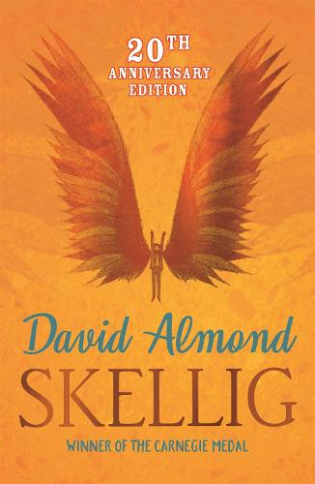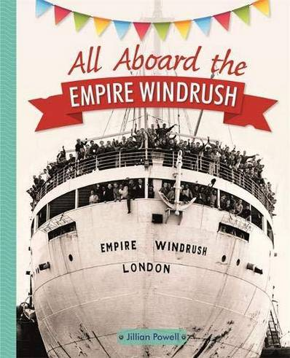This term, children will example two fantastic books- All Aboard the Empire Windrush and Skellig. We encourage children to read as often as they can at home to develop their fluency, comprehension and expression.

**Mathematics**

This term children will cover skills across four key areas of maths; multiplication and division, factions, decimals and area, perimeter and volume.

Decimals:

<https://www.bbc.co.uk/bitesize/articles/zsbd7p3>

Multiplying and dividing: <https://www.bbc.co.uk/bitesize/topics/zwbtrmn>

Fractions:

<https://www.bbc.co.uk/bitesize/topics/zpwbqyc>

Coordinates:

<https://www.bbc.co.uk/bitesize/topics/zw8vwsg>

**RE**

This term, children will cover three units; Sources, Relating Unity and Death and New Life. Children will continue to develop their faith through our class Pilgrims of Hope Project. Children will attend Mass with their class.

Please join us for Family Mass at St Thomas Aquinas Church on 26th January at 10:30.