Year 2
Mental Maths Homework
Test date- Thursday 19th September 2024
Counting in twos

With your children practise counting in twos using fingers…

2, 4, 6, 8, 10, 12, 14, 16, 18, 20, 22, 24

Let children see that all of these numbers are multiples of two and that a multiple of two always ends in an even number (2, 4, 6, 8, 0)
Repeat this activity but this time saying…

One two is 2
Two twos are 4
Three twos are 6
Four twos are 8
Five twos are 10
Six twos are 12
Seven twos are 14
Eight twos are 16
Nine twos are 18
Ten twos are 20
Eleven twos are 22
Twelve twos are 24

In the test the children will be asked questions like:
What are three twos?
What are five twos?
If there are two buses with two children on each bus how many children are there altogether?
If I have five bowls and each bowl has five apples in how many apples altogether?

Useful online activities:
2 times table task set on MyMaths
Youtube- 2 Times Table Song (Cover of Can’t Stop The Feeling! By Justin Timberlake)
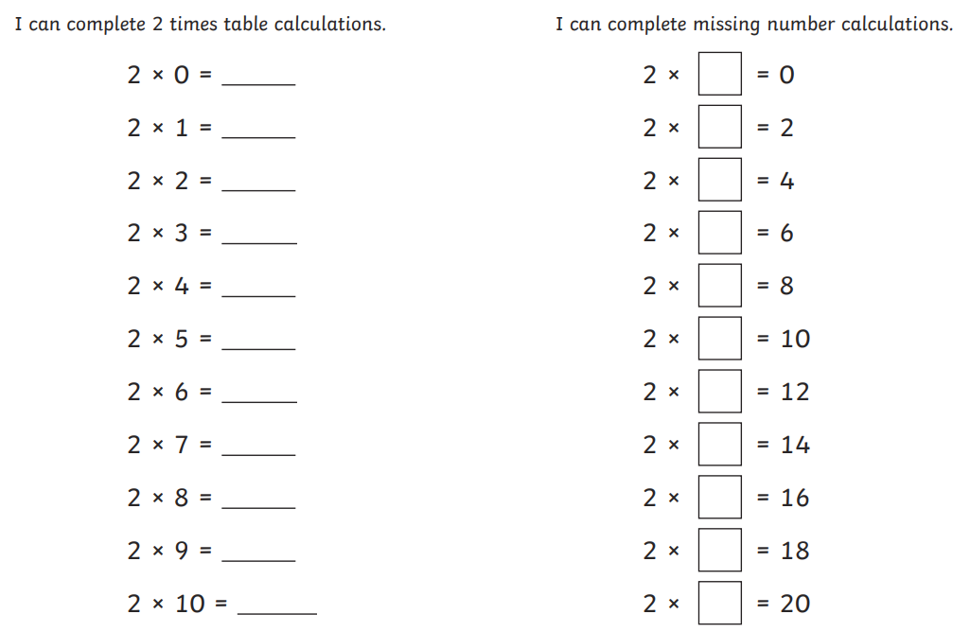
Hit the Button game on the Topmarks website

