Year 2
Mental Maths Homework

Mental Maths Test on
Thursday 16th October 2025

10 more and 10 less than
This week we are practicing finding ten more than and ten less than a given number. Children need to develop strategies for mentally finding 10 more or less than a two-digit number without having to count in order to aid rapid recall.
🟨 Using a Number Square (100-square grid)
A number square is a grid of numbers from 1 to 100 arranged in rows of 10. Each row represents a group of ten numbers.
How it helps:
- 10 more is the number directly below the given number.
- 10 less is the number directly above the given number.
Example:
If the number is 34:
- Look at the number square.
- 10 more is 44 (one row down).
- 10 less is 24 (one row up).
This visual method helps children see the pattern and understand that moving vertically changes the tens digit.

🔢 Focusing on the Tens Digit
This method helps children understand the structure of two-digit numbers.
Steps:
- Identify the tens and ones digits.
  - For 34, tens = 3, ones = 4.
- Add or subtract 1 from the tens digit to find 10 more or 10 less.
  - 10 more: tens becomes 4 → 44.
  - 10 less: tens becomes 2 → 24.
- Keep the ones digit the same.
Why it works:
- Adding or subtracting 10 only affects the tens place.
- This builds place value understanding.

🧠 Teaching Tips:
- Use physical number squares or interactive ones on tablets.
- Practice with counters or highlighting numbers.
- Ask children to predict before checking on the square.

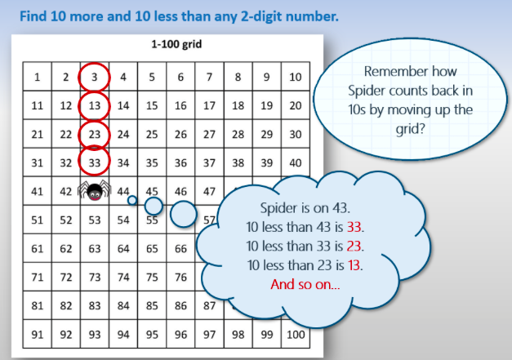

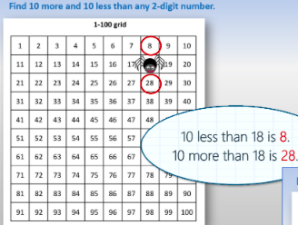

Now you have a turn!
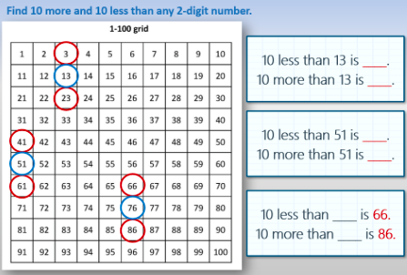

There is a fresh 100 square on the back of this sheet for you to practise some of your own!

There is a Twinkl video on Youtube to explain this further. It is called 10 More 10 Less - Addition and Subtraction Video for Kids | Twinkl Kids Tv

