Year 2
Mental Maths Homework

Mental Maths Test on
Thursday 20th November

2D Shapes
This week for our mental maths homework we will be revising shapes, focusing on 2D shapes and their properties. We will be learning to identify and describe the properties of 2D shapes including their symmetry; identify the number of edges and vertices and compare some common 2D shapes.

Ask your children to search their environment for circles, squares, triangles and rectangles. What shape are the windows? Can you see a rectangle on the TV? How many circles can you see in your bedroom? Which shape can you see the most in your house? If confident, see if they can find some of the less common shapes below! Challenge them to compare the similarities and differences.

I have attached a photo of The Shape Song that the children are familiar with below. I have also set some MyMaths tasks to support this.

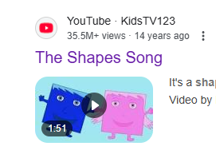
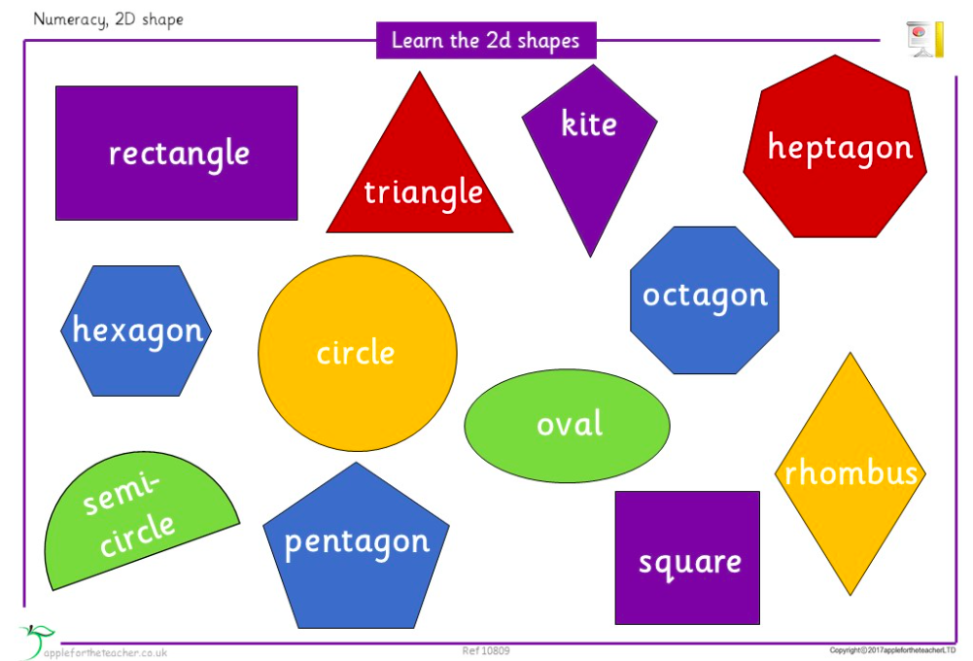

Some practise questions:

I am a 2D shape with 4 straight edges which are all the same length. What am I?

I am a 2D shape with 4 straight edges. Two of them are long and two of them are short. I also have 4 corners, what am I?

Have some fun colouring different shapes on the homework attached. Remember, this doesn’t have to be returned to school, just for the children to use as extra practice for their test.
