Year 2
Mental Maths Homework

Mental Maths Test on
Thursday 21st November

Odd and Even numbers

Children are becoming more familiar with odd and even numbers. We have been identifying odd and even numbers up to 100, using the number square to look for patterns. Odd numbers cannot be shared between 2, but even numbers can.
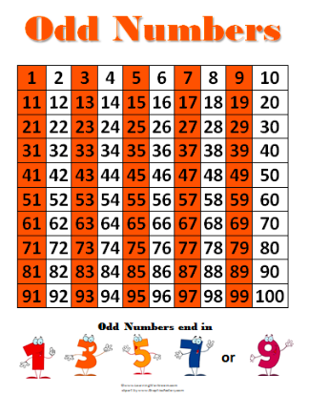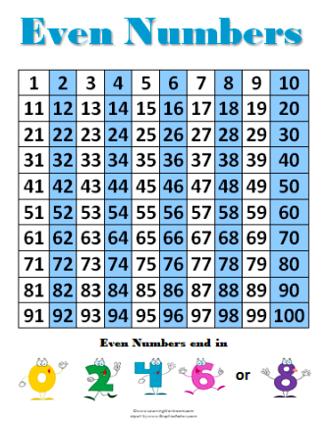

Using the patterns, children can see easily that all odd numbers end in a 1, 3, 5, 7 and 9; and all the even numbers end in a 2, 4, 6, 8 and 0. So even the biggest numbers are easy to identify because you just have to look at which number it ends in. 1,233 for example must be odd because it ends in a 3!

Is 23,456 odd or even? It’s even of course! It ends in 6.

For the test children will be given a number and children will decide whether it’s odd or even.

For extra practise, work through the homework attached to develop understanding and reasoning of odd and even numbers. Remember to check My Maths for new quizzes!

