Year 2
Mental Maths Homework

Mental Maths Test on
Thursday 12th December 2024

Counting in threes

With your children practise counting in threes using the number square, counting three along each time…

3, 6, 9, 12, 15, 18, 21, 24, 27, 30, 33, 36

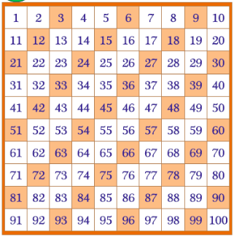

Reinforce that all of these numbers are multiples of three. Can they spot any patterns?
Repeat this activity but this time saying…

One three is 3
Two threes are 6
Three threes are 9
Four threes are 12
Five threes are 15
Six threes are 18
Seven threes are 21
Eight threes are 24
Nine threes are 27
Ten threes are 30
Eleven threes are 33
Twelve threes are 36

In the test the children will be asked questions like:
What are three threes?
What are five threes?
If there are two buses with three children on each bus how many children are there altogether?

Extra activities:

Listen to 3 times table song on Youtube .

TT Rockstars
Hit the Button

