Year 2
Mental Maths Homework

No mental maths test next week - we will be too busy having lots of Christmas fun!

I have attached some Christmas reading comprehension (and answers for grown ups). This is not compulsory but would be beneficial to the children to practice answering comprehension questions. I will be sending out weekly comprehension from January.

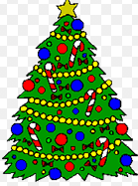

THE SPELLING TEST WILL BE ON THURSDAY 19th DECEMBER

Have a wonderful Christmas break from all of us in Year 2!

