St. Bernard’s Catholic Primary School
Special Educational Needs Information Report

“You are precious in my eyes”

Last Updated: November 2025

Name of the Special Educational Needs/Disabilities Coordinator: Mr R Turner
Mrs Christina Terry ( maternity leave)

Headteacher: Mr R Turner

SEND Governor: Mrs Lesley Wells-Earp

Contact details:
Telephone: 017720728153
Email: office@stbernards.mecmat.org / rturner@stbernards.mecmat.org

The kinds of SEND that are provided for.
The governing body of maintained schools must publish information about the implementation of the Governing Body’s policy for pupils with Special Educational Needs.

The kinds of Special Educational Needs and Disabilities that are provided for at St Bernard’s.

St Bernard’s is a mainstream primary school.
The SEND Code of Practice describes the four broad categories of need:

- Communication and Interaction
- Cognition and Learning
- Social, Emotional and Mental Health difficulties
- Sensory and/or Physical Needs

These four broad areas give an overview of the range of needs that can be planned for.

St Bernard’s Aims for provision and inclusion:

Our overarching aim is to create an atmosphere of encouragement, acceptance, celebration of achievements and sensitivity to individual needs, in which all pupils can thrive. This can be broken down as follows;
- To ensure that every child has an equal opportunity to participate in all aspect of school life, irrespective of race, gender or special need.
- To provide equal access to the National Curriculum and to plan for and provide a curriculum which is accessible to all the needs of the pupils.
- To raise staff awareness of the needs to differentiate work effectively and to provide regular training, coaching and development for all staff.
- To establish good home school communication.
- To involve the pupil wherever possible in the planning and target setting of their programme of work.
- To monitor and review individual needs regularly, and to maintain clear records of any action taken.
- To review needs and provision termly for budgeting, planning and resourcing for SEND.
- To foster an atmosphere in our school which will promote a happy, sensitive, nurturing and secure environment to ensure the most effective learning for all children, including those with SEND.

The policies for identifying children and young people with SEND and assessing their needs.
At St Bernard’s, we continue to develop a graduated approach to identify children who require additional support with their learning. The following chart explains our thinking:

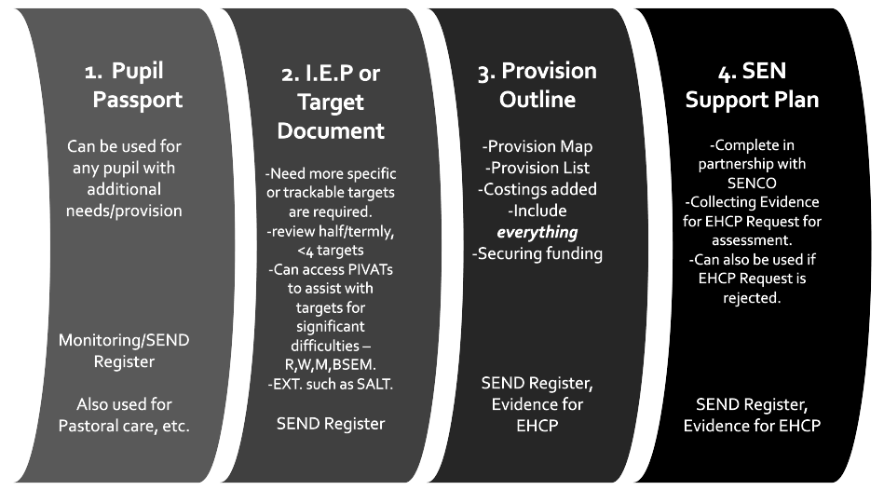

EHCP
Educational Health Care Plans are a legal document. Children with an EHCP will have specific plans written for them depending on their individual needs. These are approved by the Local Authority (Lancashire County Council).

Individual Target Documentation; Pupil Passports, IEPs & Provision Maps
If children are identified as requiring SEND Support (with or without an EHCP), they will have one or more significant areas of need. SEND specialists and/or in-school SEND Support (SENCO) will assess and observe the children using a range of tools and this information will be used to write a specific IEP/Pupil Passport. Assessments will help to identify gaps in learning and PIVATs will be used to assist with adequately assessing pupils with significant SEND Learning Needs. Structured intervention aims to support children to successfully close these gaps. Careful tracking will identify children’s small steps of progress and this progress will be celebrated. IEPs and/or Pupil Passports will be reviewed termly. The summer term plans will pass onto the teacher for the autumn term to inform intervention at the beginning of the next academic year. This is key to a successful transition. IEPs and Pupil Passports are working documents and should be kept up to date in order to best support our SEND pupils’ developing needs.

Additional Learning Support
For children who are identified as requiring additional learning support, teachers, parents and the SEND team will discuss the best options. The graduated response model, ‘Assess, Plan, Do, Review’, will be applied for assessing and planning all interventions.

Intervention
Intervention needs to be understood as two different terms; ‘structured intervention’ and ‘catch up intervention’.

Structured intervention could be explained as an opportunity for children who have been identified as needing additional support to ‘close the gap’ through small group work, 1:1 teaching or teaching assistant led intervention. Children who are receiving structured intervention could be placed on our SEND register.

Catch up intervention could be explained as an opportunity for children who are slightly behind their peers to receive small group or 1:1 tuition with either the class teacher or the teaching assistant. This intervention will be based on decisions teachers make on a daily basis. Children who are receiving ‘catch up’ intervention will not be placed on the school’s SEND register.

Provision mapping
On a termly basis, the leadership team & SENDCO review the progress of all children on the SEND register for the purpose of provision mapping. Provision mapping is the term we use to describe how we plan to meet the needs of our learners with the resources we have available.

What arrangements does the school make for consulting with the parents & carers of children/young people with special educational needs and disabilities and involving them in their child's/young people's education?
Parental involvement in school is highly regarded. We encourage parents and carers to share information about their child at parents’ evenings, which take place twice a year. Teachers are available to discuss a child’s progress with parents at convenient times.

Induction for new parents takes place in the summer term. Parents have a chance to meet their child’s class teacher and share any information that they wish. Each year group also holds a ‘Welcome to the new year group’ parent/carer meeting, where information about the year ahead is shared. Newsletters are available on the school website.
Parents/carers are notified early if we have any concerns and there is always a willingness to listen to issues brought forward for discussion. The class teacher will explain to the parents/carers what additional support is being provided in class in regards to adaptive teaching and interventions to support their child.
Parents/carers of children with EHC plans (Education, Health and Care Plans) contribute and take part in their child’s Annual Reviews. Parents complete a written report for the review and also receive copies of all relevant paperwork concerning their child.

What arrangements does the school make for consulting with children/young people with special educational needs and disabilities about, and involving them in, their education?

Pupil participation:
Children, who are capable of forming views, have a right to receive and make known information, to express an opinion, and to have that opinion taken into account in any matters affecting them. The views of the children in school are given due weight according to their age, maturity and capability.
We encourage pupils to participate in their learning by:
Asking the child if s/he would like to attend review meetings where they can discuss their learning. Asking the child to verbalise their feelings relating to their own strengths and areas for development.

Arrangements for assessing and reviewing children’s and young people’s progress towards outcomes.
Class teachers monitor the children in their class continually throughout the academic year and inform parents/carers at two parents’ meetings and twice annually through school reports. Parents are encouraged to share information and queries with the school.
All parents of children who have additional learning support meet with the SENCO as required. Parents of children with EHC plans (Education, Health and Care Plans) will also have annual reviews where annual targets will be reviewed.

How will the school prepare and support my child/young person to join the school, transfer to a new school or the next stage of education and life?
Transitions can be difficult for a child with SEND. We take steps to ensure that transition from year group to year group or from one key stage to another is as smooth as possible. The transition to high school is carefully planned with the needs of the children at the centre of our thoughts. Transferring to our school will involve clear communications between schools to share information.

The approach to teaching children and young people with SEND
All our class teacher’s planning involves adaptive teaching to enable all of the children in their class to access the curriculum to their full potential. The planning gives opportunities to work on individual targets where appropriate, with relevant equipment and resources to aid their learning. Individual and small groups of children are supported within class where appropriate. Children are encouraged to become independent learners while receiving a broad and balanced curriculum.
Careful provision mapping based on assessment outcomes informs the deployments of additional adults to work with children with additional needs.

How adaptations are made to admissions, the curriculum and the learning environment for children with SEND?
The school has a clear admission policy that is fully inclusive of children with SEND. No child with SEND is treated less favourably than any other child in any aspect of school life. The school’s broad and balanced curriculum has been designed to be exciting, appropriate and accessible for all learners. Our website contains further curriculum details. The school does not have full wheelchair access as the accommodation is double storey. There is a disabled toilet in the main building. The Governors of St. Bernard’s are committed to the concept of inclusion and to the adaptions necessary to ensure that parents, pupils, staff and other visitors to school have as little difficulty as possible in accessing the building.

The school seeks advice from professionals such as physiotherapists and occupational therapists to support children to be able to access the building and grounds and to be fully involved with school life as and when appropriate.

What training have the staff supporting children/young people with SEND had or may they have?
What specialist services or expertise are available at or accessed by the school?
The school has access to a specialist SEND teacher (SENCO) who can provide training and guidance for all our teachers.

In order to maintain and develop the quality of teaching and provision and to respond to the strengths and needs of all the pupils, all staff are encouraged to undertake training and development. The SENCO identifies SEND training through conducting staff skills audits and through evaluating the specific needs and requirements of individual children.

How do you evaluate the effectiveness of the provision made for children and young people with SEND?
St Bernard’s regularly and carefully monitors and evaluates the quality of provision we offer all pupils. Pupil progress is monitored on a termly basis in line with the SEN Code of Practice between the Headteacher, SENCO and SEND Governor. The SENDCO discusses interventions with the relevant class teachers and teaching assistants to identify the effectiveness of the interventions. This promotes an active process of continual review and improvement of provision for all pupils.
SEND provision and interventions are recorded within each class teacher’s termly pupil progress meeting paperwork.

How will my child/young person be included in activities outside the classroom, including school trips?
All year groups organise trips related to the curriculum areas and visitors are invited into school to enhance the children’s learning. Children have the opportunity to become involved in sporting activities outside of the school environment and to compete against other schools in the local area and wider afield. All children have the opportunity to participate fully on school trips.

How are the school resources allocated and matched to children/young people's special educational needs and disabilities?
How are decisions made about the type and quantity of support my child/young person receives?
Over a number of years, the school has acquired a wide range of resources to aid children in their learning, the development of their fine and gross motor skills, plus opportunities to develop social interaction. Children’s needs are assessed as individuals and teachers and support staff are guided by professional’s recommendations. Careful provision mapping based on assessment outcomes informs the deployments of additional adults to work with children with additional needs.

What support will there be for my child/young person's overall well-being?
The school employs a specialist ELSA learning mentor who has a specific focus on children with emotional, social and behavioural needs. The school also has a Pastoral Leader who supports children and families who have experienced bereavement or loss.
Children in upper KS2 children have been trained as ‘play leaders’ and arrange games and activities for the children on the Infant playground during dinner timers. There are members of staff who have first aid qualifications and all members of staff are fully aware of the procedures for handling and administering medication.

How do you involve other bodies, including health and social services, local authority support services and voluntary organisations, in meeting the needs of children/young people with SEND and in supporting their families?
As a school, we have multi-disciplinary and interagency co-operation in place to ensure provision meets the needs of our children with SEN. We link with other schools, nurseries, Health and Social Service Departments, and the LEA.

We work on a regular basis with the following:

- Link Educational Psychologist
- Parent Partnership Officers.
- Speech Therapist
- Physiotherapists
- Occupational Therapists
- Ophthalmologist
- Social Services
- School Doctor
- School Nurse
- Area SENCO cluster meetings
- IDSS - Inclusion and Disability Support Service
- CAHMS
- CAF team

What arrangements do you make in relation to the treatment of complaints from children/young people and their parents/carers with special educational needs concerning your provision made?
Should a parent or carer have a concern about the special provision made for their child they should follow the normal school complaints procedure.
St Bernard’s works very hard to demonstrate an open-door policy with all staff available to talk to parents at a mutually convenient time.

Where can I find the contact details of support services for the parents of children/young people with SEND?
http://www.lancashire.gov.uk/children-education-families/special-educational-needs-and-disabilities/help-for-parents-and-carers/information-advice-and-support.aspx
Lancashire County Councils Local Offer - http://www.lancashire.gov.uk/send
https://www.mencap.org.uk/advice-and-support/children-and-young-people/education-support/sen-support?gclid=CJTn4_2nn9MCFUwz0wod8LoP_w
http://www.autismlinks.co.uk/support-groups/group-support-north-west/lancashire-parent-partnership-service?region=
http://www.twinklehouse.co.uk/

Where can I find information on where the local authority's local offer is published?
Lancashire County Councils Local Offer - http://www.lancashire.gov.uk/send

