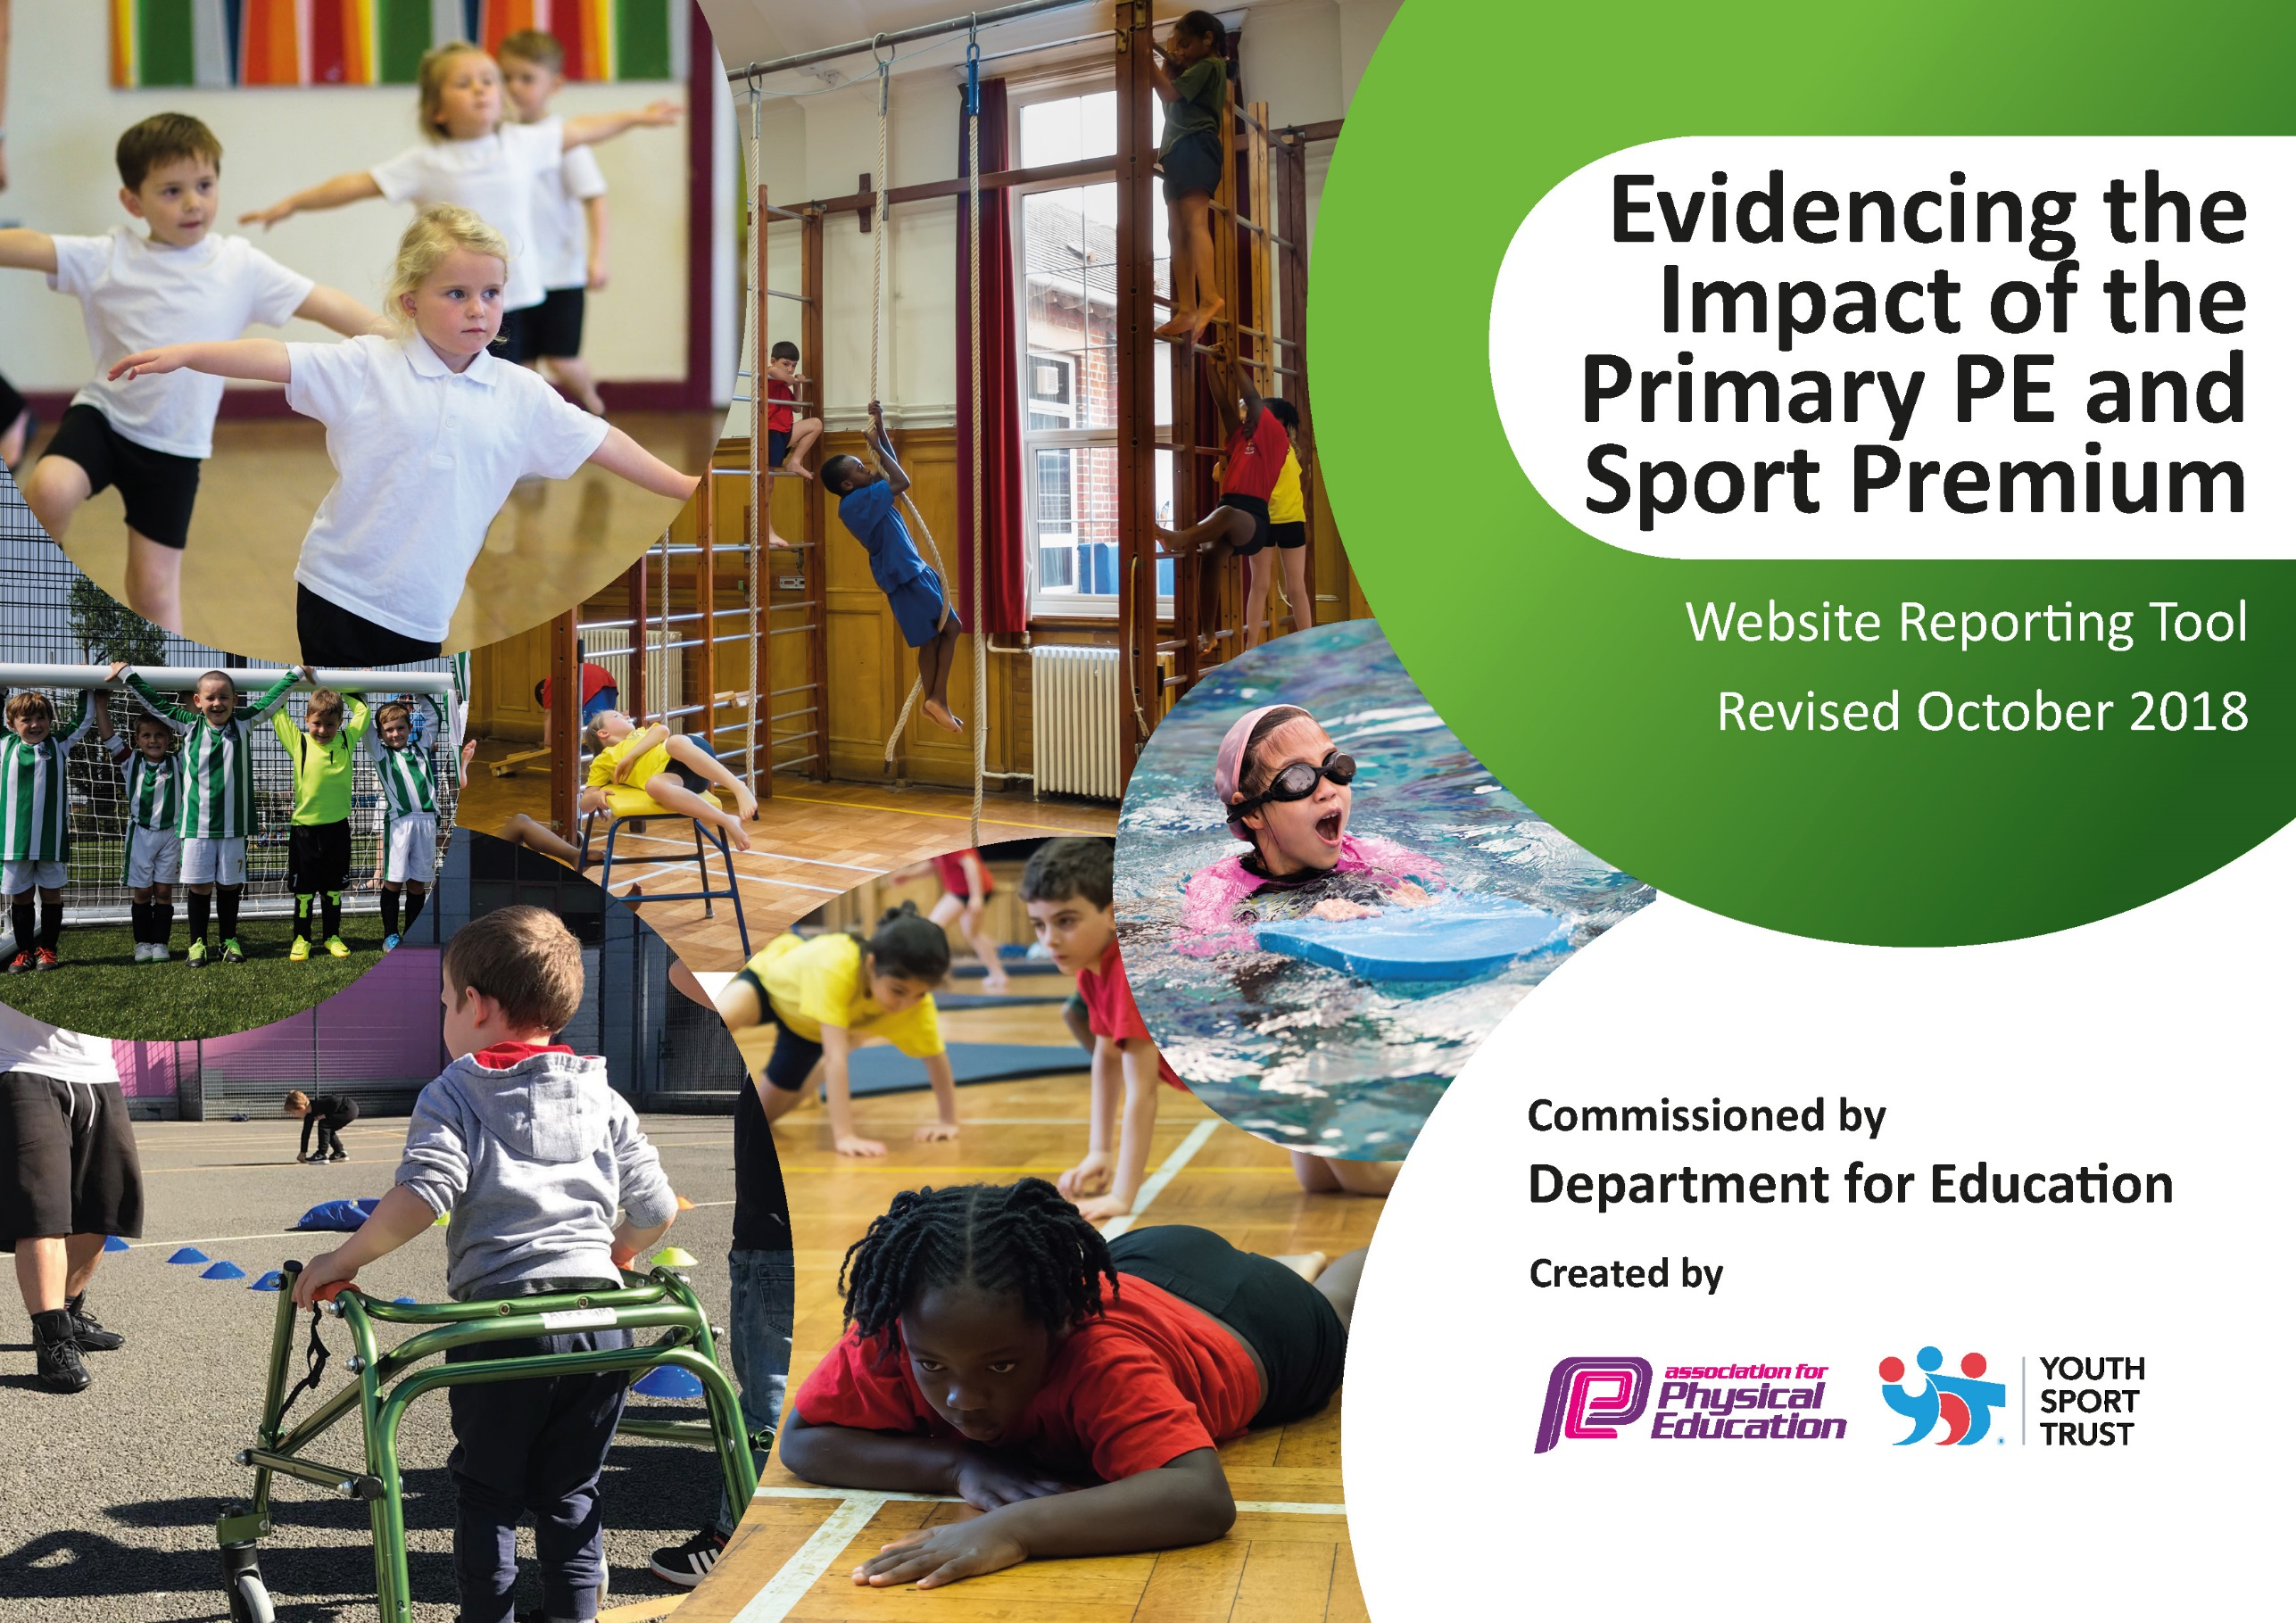
hools must use the funding to make additional and sustainable improvements to the quality of Physical Education, Sport and Physical Activity (PESPA) they offer. This means that you should use the Primary PE and Sport Premium to:

- Develop or add to the PESPA activities that your school already offer
- Build capacity and capability within the school to ensure that improvements made now will benefit pupils joining the school in future years

Please visit gov.uk for the revised DfE guidance including the 5 key indicators across which schools should demonstrate an improvement. This document will help you to review your provision and to report
your spend. DfE encourages schools to use this template as an effective way of meeting the reporting requirements of the Primary PE and Sport Premium.

We recommend you start by reflecting on the impact of current provision and reviewing the previous
spend. Under the Ofsted Schools Inspection Framework, inspectors will assess how effectively leaders use the Primary PE and Sport Premium and measure its impact on outcomes for pupils, and how effectively governors hold them to account for this.

Schools are required to publish details of how they spend this funding as well as on the impact it has on pupils’ PE and sport participation and attainment by the end of the summer term or by 31 July 2020 at the
latest.
We recommend regularly updating the table and publishing it
on your website throughout the year, as evidence of your
ongoing review into how you are using the money to
secure maximum, sustainable impact. To see an
example of how to complete the table please
click HERE.

Sports Premium –Spending, Evidence and Impact 2019-2020

Key achievements to date: | Areas for further improvement and baseline evidence of need:
- Gold School Games Mark Award  - Lots of participation in sports competitions  - Teams participating in most competitions (where available)  - Phunky Fit Club established to target non-active children  - Committed Sports Coaches delivering quality PE  - Daily Mile established  - Re-signed to Copeland Schools Sports Partnership welcoming a range of new coaches into school to deliver sessions  - New equipment for active playtimes | - Encourage Active Travel to and from school  - Improve Woodland area for outdoor learning.  - Aim for 100% children being able to swim 25 metres by end of Y6  - Achieve Platinum Mark Award  - Re-subscribe to Active Maths  - Participate in Wheel Chair Basket Ball

Meeting national curriculum requirements for swimming and water safety | Please complete all of the below:
What percentage of your current Year 6 cohort swim competently, confidently and proficiently over a distance of at least 25 metres?  N.B. Even though your children may swim in another year please report on their attainment on leaving  primary school. | 96%
What percentage of your current Year 6 cohort use a range of strokes effectively [for example, front crawl, backstroke and breaststroke]? | 96%
What percentage of your current Year 6 cohort perform safe self-rescue in different water-based situations? | 96%
Schools can choose to use the Primary PE and Sport Premium to provide additional provision for swimming but this must be for activity over and above the national curriculum requirements. Have you used it in this way? | Yes- we have structured our swimming lessons in such a way that they have the maximum impact on teaching children to swim.

Action Plan and Budget Tracking
Capture your intended annual spend against the 5 key indicators. Clarify the success criteria and evidence of impact that you intend to measure to evaluate for students today and for the future.

Academic Year: 2019/20 | Total fund allocated: £17,440 | Date Updated: July 2020
Key indicator 1: The engagement of all pupils in regular physical activity – Chief Medical Officer guidelines recommend that primary school children undertake at least 30 minutes of physical activity a day in school |  |  |  | Percentage of total allocation:
 |  |  |  | 48%
School focus with clarity on intended impact on pupils: | Actions to achieve: | Funding allocated: | Evidence and impact: | Sustainability and suggested next steps:
We intend to meet the OMO guidelines of achieving 30 minutes of physical activity a day in school | Children completing a mile at least 3x per week  Teachers share ideas for ‘Active Maths and English’ lessons  Active playtimes with sports equipment available and Play leaders on hand to organise games. | £500 | Children now spend their playtimes being on the go playing games or using the equipment.  The daily mile and other activities are marked out.  Children are more active during lesson times and they aren’t sat still for long periods of time. | Upkeep playground and equipment replaced when necessary.  Involve wider staff in ‘Active Lesson’.  CPD
Professional Sports Coaches for PE Sessions and after School Clubs | All children timetabled for coaches-  Gymnastics/Dance  Multi- skills  Football  Cricket  Squash | £7,866 | Children are proficient in certain areas of sports. They are able to attend competitions.  Children have won at competitions and qualified to attend the ‘School Games’.  Children enjoy the sports so much they are engaging in it at playtimes and in some cases it has lead to children joining clubs outside of school e.g. squash | Involve all staff as CPD  Continue to rotate children’s exposure to all coaches so they experience a wide range of sports with high quality teaching.
Key indicator 2: The profile of PESSPA being raised across the school as a tool for whole school improvement |  |  |  | Percentage of total allocation:
 |  |  |  | 2%
School focus with clarity on intended impact on pupils: | Actions to achieve: | Funding allocated: | Evidence and impact: | Sustainability and suggested next steps:
Maintain sports success celebrated in school through assemblies, notice boards, newsletter, face-book and website.  All children will have the opportunity to participate in sports competitions in order to have the opportunity to feel proud of themselves.  School Games Values linked to all learning. | Ensure any sporting events inter/intra are celebrated throughout school. | Co-ordinator time. | Children recognise School Games values being rewarded.  Children are proud of the recognition they receive. | Continue to update and highlight significant achievements.
Maintain ACPAT spreadsheet use. | Use ACPAT to track pupil progress in physical activity and identify target children.  Use ACPAT to track how social, thinking and healthy lifestyles impact a child’s learning. | £300 | Staff will use ACPAT to track children’s progress and identify children who need their skills further developed.

Key indicator 3: Increased confidence, knowledge and skills of all staff in teaching PE and sport |  |  |  | Percentage of total allocation:
 |  |  |  | 2%
School focus with clarity on intended  impact on pupils: | Actions to achieve: | Funding  allocated: | Evidence and impact: | Sustainability and suggested  next steps:
Continue to attend Copeland Cluster PLT meetings in order to be up to date with all new initiatives.  Staff CPD where available in order to improve teaching. | PE co-ordinator attended all meeting including a zoom meeting during lockdown.  All staff have the opportunity to work alongside different coaches to gain new skills.  Training for Y5 play leaders. | £300 | Schools in the area sharing good practice and keeping up to date with government initiatives.  Children more active, purposeful play.  Ownership for children and extra knowledge for staff.  Better subject knowledge and confidence to teach. Information can be passed on. | Continue to attend throughout the cluster.  Pass training on from class to class.  Continue links with partnership to keep costs low.
Key indicator 4: Broader experience of a range of sports and activities offered to all pupils |  |  |  | Percentage of total allocation:
 |  |  |  | 31%
School focus with clarity on intended  impact on pupils: | Actions to achieve: | Funding  allocated: | Evidence and impact: | Sustainability and suggested  next steps:
New equipment for sports clubs/lessons | Identify from pupil surveys and order new equipment/offer as new clubs | £500 | Many children attending clubs. More opportunities. | Continue to use the equipment to offer extra-curricular clubs.
Gymnastics, cricket, football, judo, netball, tennis, hockey, rounders, tri-golf and multi-skills.  Phunky Fit Club | Teachers and coaches to offer all of these sports in lessons or after school clubs across the age ranges.  Club run throughout the year for different year groups every half term targeting in- active children. | £500 | All classes YR to Y6 have the opportunity to attend after school sports club.  Positive feedback from children | Maintain teaching of a range of sports and introduce new ones.
Swimming opportunities to be offered. | Swimming 4 and 5 children will attend swimming weekly for 30 sessions. | £4485  (transport and lessons) | By the end of Y5 all children will be able to swim 25m unaided.  Children have commented on going swimming more outside of school.  This exercise adds to their 60 minutes of activity a day. Children have commented on how they feel better after and more able to concentrate in class. | Maintain swimming lessons in y4 and 5 but target the children who still can’t swim in Y6.
Key indicator 5: Increased participation in competitive sport |  |  |  | Percentage of total allocation:
 |  |  |  | 18%
School focus with clarity on intended  impact on pupils: | Actions to achieve: | Funding  allocated: | Evidence and impact: | Sustainability and suggested  next steps:
Maintain the amount of sports competitions we enter ensuring all children have a competitive sports experience.  Lunch time cricket club which allows children to prepare for competition. | Pay for transport to attend sporting fixtures further away from school. | £2375  £800 to SSCO programme | ACPAT will show all KS2 children have an opportunity to attend a sporting event.  Pupil feedback demonstrates positive experience that wants them to enter another competition | Without funding we would have to ask for parental contribution towards the cost of transport.

