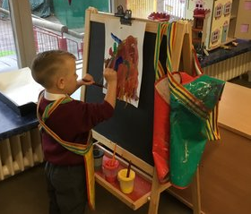
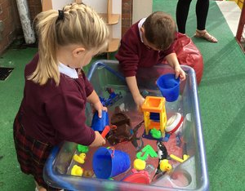
St Bridget’s Catholic Primary School

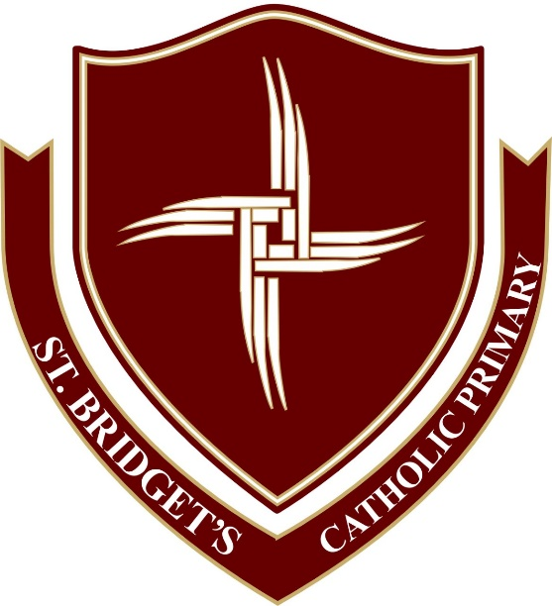

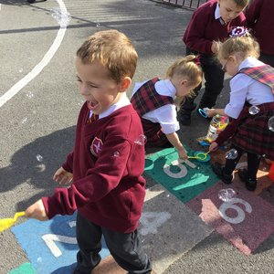
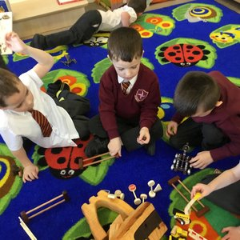

Reception Parents’ Information 2020-2021

St. Bridget’s Reception Class.
Beginning school is a major event in the life of a four year old and it won’t be long before your child will be starting with us at St Bridget’s Catholic Primary School. There will be lots of new things to learn and of course you will want to ensure that your child is well prepared for this important event. We aim to make it a happy and memorable experience. We hope that this booklet will provide some useful information that will help your child settle quickly into school.

Contents.
Welcome from the Head teacher …………………………………….………………………………………………………….. 3
Meet the staff …………………………………………………………………………………………………………………….………. 4
Parents as partners …………………………………………………………………………………………………………………….. 5
Preparing your child for school ……………………………………………………………………………………………….….. 7
The school day ……………………………………………………………………………………………………………………………. 9
School dinners and snack time …………………………………………………………………………………………………… 10
Learning in the Early Years Foundation Stage and the EYFS Curriculum ………….……………………….…. 11
Clothes to wear for school ………………………………………………………………………………………………………….. 13
Things to bring for school ……………………………………………………………………………………………..……………. 14
Illness and absence ……………………………………………………………………………………..……………………………… 15

Welcome from the head teacher
We are a warm, welcoming school where every child is at the heart of everything we do. We aim to nurture and nourish all children with the learning and skills they need to develop into kind, caring and compassionate people of the future.
We pride ourselves on our strong ethos and values, such as love, respect and honesty, which underpin everything we do. All staff at St. Bridget’s are highly experienced and, lucky for us, have worked in our school for many years. They understand the different complexities and needs of our children and adapt accordingly so every child is loved and valued.
The behaviour in our school is exemplary and children are taught to understand how to show respect to others and compassion to those more vulnerable.
A strong partnership between home and school is an invaluable union which we hope to forge throughout your child’s time at our school. We offer many opportunities for parents to come into school to get involved, from parent afternoons in Reception to whole school parent workshops.
We offer not only an education for your children but other exciting opportunities for them to build life skills. Children will go on class trips, key stage trips, residentials and have the chance to experience shows, workshops and sporting events such as tag rugby, football, netball, hockey and cross country.
We also provide wraparound care to allow for times when parents need to drop their children off at school early or need them to stay after school. Breakfast club runs from 7am and afterschool club is available until 5pm.
We value feedback from our parents and always strive to solve any problems as soon as possible.
I look forward to us growing together with your children in creating a happy, stimulating and memorable time at St. Bridget’s.
Suzanne Smith
Head teacher
Meet the Staff

Mrs Bear
Reception Senior Teaching Assistant
Mrs Boggon
Reception teacher

Mrs Smith
Head teacher
Mrs Parr
Business Manager
Parents as Partners
We recognise the importance of parents and carers in a child’s developing stages. As a primary care provider you are your child’s first educators and we greatly value any input, opinions and information you can share with us about your child’s learning and progress.
All communications can be made through each class Dojo page and this is where homework is also set. We encourage you to discuss and complete the tasks set together. Tasks will relate to work being carried out in school, giving your child opportunities to further practise their speaking and listening skills, phonics and mathematics. You will also be able to direct message the class teacher on Dojo and learn about things going on in school and see pictures of what your child has been doing that week on the class story.
We also produce a ‘Learning Journal’ within the classroom that records your child’s learning and achievements during school. The children are familiar with these books and they represent both child-initiated activities and directed tasks. These are always available for you to look through. We also encourage you to contribute to these by making small observations at home. (For example if your child’s target is to identify numbers to 10, you may notice him or her using the remote control to change the channel correctly to channel 3. This is showing us that your child can recognise the number three independently.) The children also have a Maths, Literacy, RE and Read Write Inc book.
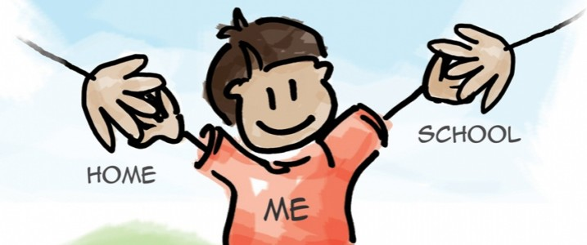

Parents as Partners (continued)
We provide many other opportunities for parents and carers to take an active part in their children’s education. These include:
- Termly parent afternoons to share our class’ success and topic work
- Parents’ Workshops where parents are welcomed to join in with our sessions e.g. Maths workshop
- Read Write Inc meetings including ‘Stay and Read’ sessions
- Educational Visits where parent-helpers are invited
- Sports events
- Regular newsletters and text messages
- Class web pages and Facebook page updated regularly with news, topic webs and photos

Most importantly our family ethos is central to our school and as such, we operate an ‘Open-Door Policy’ where parents are encouraged to meet with staff to discuss any concerns at the earliest opportunity. Mrs Boggon and Mrs Bear are usually available at 8:50 a.m. and 3:00 p.m. to answer any questions.
Phone calls to the school office are most welcome, where Mrs Parr will offer their assistance, or will arrange an appointment with members of staff, if requested.

Preparing Your Child for School
Your child will be in a class of no more than 30 Reception children. It will make starting school much easier and happier if they are independent and can do many things for themselves.
What should he/she be able to do?
Can he/she …
- Dress and undress themselves?
- Use the toilet independently and ask to go there?
- Tidy up after himself/herself?
- Recognise their name? Please tell your child’s teacher if their name is abbreviated in any way.
- Feed himself/herself?
- Share toys and equipment?
- Handle a pencil?
- Sing some nursery rhymes?
- Practise counting to 10?
- Listen well and follow simple instructions?
How can I help my child prepare for school?
- Encourage your child to be as independent as possible even if it takes longer for them to get ready.
- Get them used to a routine of reasonably early to bed and up early enough for you and your child to have a stress free time to get ready for school.
- Never threaten them with school! Be positive. Show it to them as an enjoyable experience.
What can I do with my child before they start school?
- Give your child as many varied experiences as possible: drawing, painting, cooking, singing, making models, playing games, jigsaws, etc.
- Get them used to: pencils, crayons, felt pens, chalks, paints, play dough, scissors.
- Share stories, books and rhymes. Read to them.
- Count everything and share things out.
- Use lots of one-to-one correspondence – cup, plate, knife, fork and spoon for each person.
- Talk to them all the time. Name familiar things and discuss what they see around them and what things are for. Talk about what they see when they are out and about. Watch people work and discuss what they are doing.

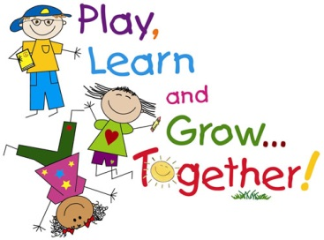

The School Day
Morning Procedures
Children are brought into school via the Reception playground. Children and their parents are invited into the classroom from 8:50 and make sure their child is settled. However, we do ask that you please leave by 9 a.m. to enable us to start our activities promptly. The school day is from 9.00 a.m. until 3.00 p.m.

Collecting your child
At the end of the school day you are able to access the Reception playground from 2:50 p.m. The children will be handed over at the classroom door by a member of staff. It is vital that you inform us if someone different is collecting your child. If we are unsure we will keep hold of your child until we are able to contact you.

Extended hours
Breakfast Club:
- A breakfast club is held every morning from 7am to 8.50am at a cost of £5 before 8am and £3 after 8am.
After school club:
- The After School Club runs from 3.00pm to 5.00pm each school day. It costs £3 per hour.

First Day at School
- Arrive on time.
- Leave cheerfully.
- Don’t linger about looking through windows (first day tears are nothing to worry about!).

School Dinners Snack time
Infant children are offered a piece of fresh fruit at break time as part of the Fruit for Schools scheme. We do encourage children to try a range of healthy foods as part of the curriculum so please be sure to let us know if your child has an allergy to any foodstuffs.
Children are encouraged to bring in a bottle of water with their name on it. As we have to meet food standards for schools this must be WATER and NOT juice or flavoured water. The bottles are kept in the classroom and the children have access to them at all times. The bottle will be returned to you each day for washing and refilling. All children will be provided with a drink at lunchtime as part of the Universal Free School Meal Offer.

Our kitchen staff prepare hot meals for us every day in our school kitchen. A menu is sent to parents each week by ParentMail and you can then choose your child’s dinners for the week online.
School dinners are free for all children in Reception, Year 1 and Year 2.
OUR SCHOOL IS A NUT-FREE AND KIWI-FREE ZONE. We have children in school who have nut and kiwi allergies. We ask you, please, never to send any nuts, nut products or kiwi into school.

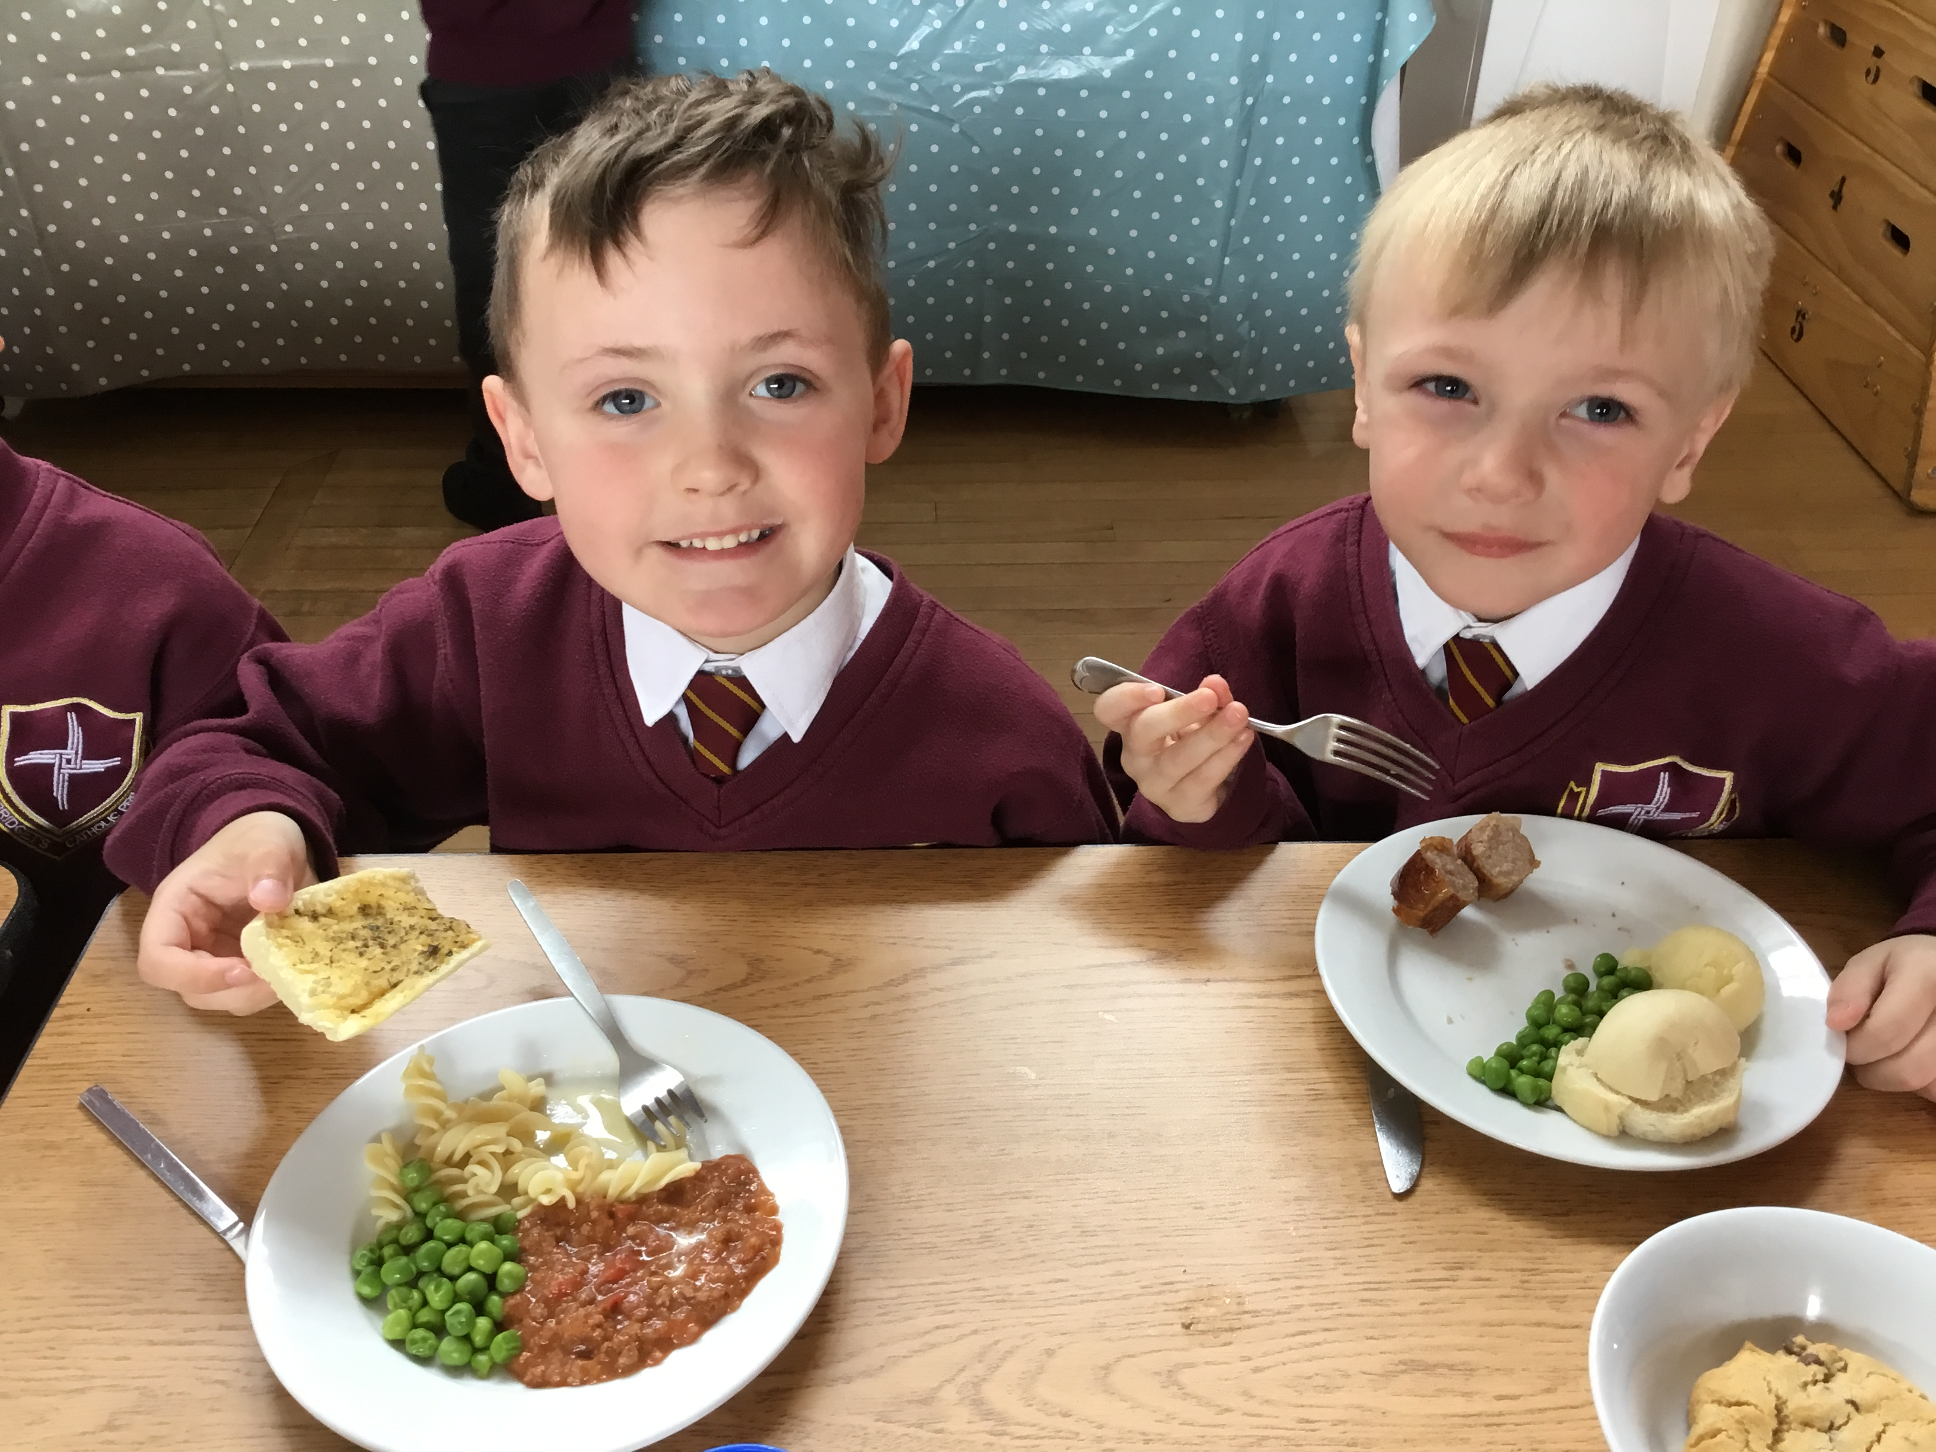

Learning in the Early Years Foundation Stage
The Early Years Foundation Stage is where the excitement begins! We pride ourselves on being an exciting and engaging place to be – encouraging our children to be independent learners through a range of activities. We follow a thematic curriculum which allows us to be creative with our lessons and let the children lead their own learning.

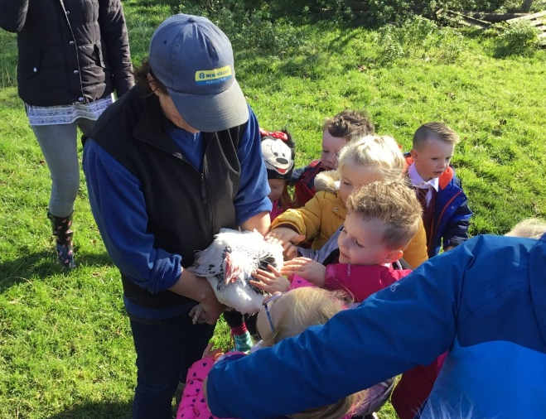
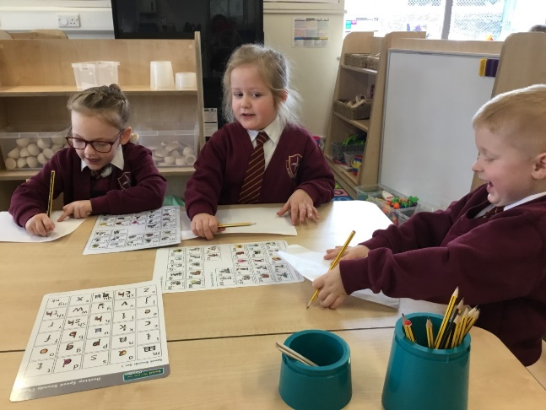
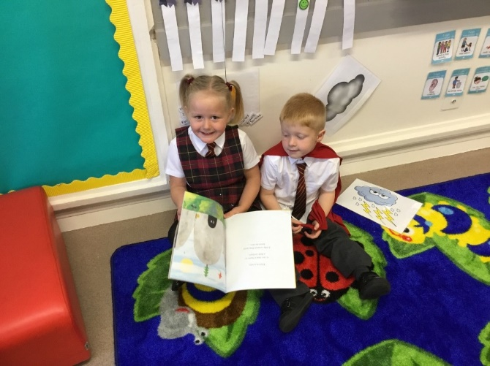
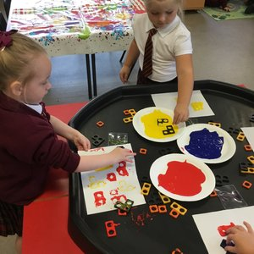

As our Reception children enter the classroom they learn primarily through a variety of play and real-life experiences. Our teaching is delivered through carefully planned and guided tasks. The children access their environment freely; however they understand that they must complete ‘key jobs’ throughout the week which will scaffold and extend their learning. Their development is tracked through detailed observations and child-initiated interaction. This information is then transferred into your child’s learning journey – a diary of information and photographs. We use these to record individual interests, progress and plan the next steps of your child’s learning.
The EYFS Curriculum
In Reception our children follow the Early Years Foundation Stage Framework (EYFS). Learning is planned against the ‘Early Years Outcomes’. Within the ‘Early Years Outcomes’ there are three prime areas of learning and four specific areas. This framework provides the basis of how we structure the setting, the activities and opportunities we provide; as well as how we assess your child’s development. For each of these areas your child will have an ‘Early Learning Goal’ to work towards by the end of the Reception year.
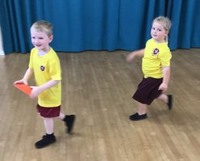
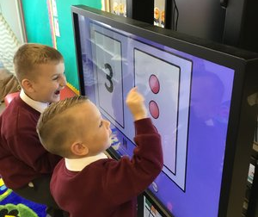
Prime areas
- Communication and language
- Personal, social and emotional development
- Physical development
Specific areas
- Literacy
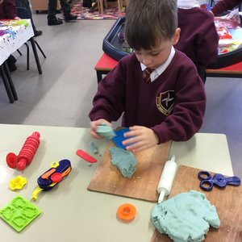
- Mathematics
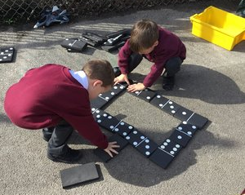
- Understanding the World
- Expressive arts and design
Characteristics of Learning
- Playing and exploring
- Active learning
- Creative and thinking critically
Clothes to Wear for School
Here is a summary of the uniform required:

Boys’ Uniform: Girls’ Uniform
V-Neck jumper (with logo) V-Neck jumper or cardigan (with logo)
School tie (from school) School tie (from school)
White shirt (not polo shirt) White shirt (not polo shirt)
Grey trousers (not black) Tartan skirt/tartan pinafore/grey trousers (not black)
Black school shoes only (not trainers) Black school shoes only (not trainers)
Black socks only White or black socks/black tights only

Please note that only black school shoes are acceptable. Children can bring trainers to school for PE and sport but they are not part of the uniform, regardless if they’re black.

You will receive a separate information sheet regarding the official uniform suppliers.
For physical activities Reception children need black pumps (not trainers) that can be managed independently. Our P.E. uniform is burgundy shorts and a gold t-shirt, with logo. There is also a tracksuit available for purchase.
As our learning environment is both indoors and outdoors, we ask that you make sure your child is equipped for these areas at all times of year. Please ensure their clothing is practical and suitable for the seasonal changes. Waterproof jackets and winter clothing for cold weather; sun hat and protective clothing in the summer months. We ask that sun cream is applied before the children get to school so that they are ready for the day. Please make sure that all items of clothing are very clearly marked with your child’s name.

Things to Bring to School

- Wellies – we play out in all weathers!
- Suitable coats – nothing too special as it is likely to get sandy, muddy or wet.
- Spare clothes – just in case we have an accident.
- Hats, scarves and gloves.
- Sun hats.
- Water bottles.
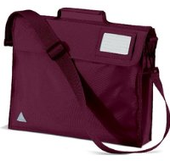
- Book bags, reading records and reading books – these are checked and changed regularly.

Illness and Absence

Illness and Absence
If your child is unwell and absent from school, please phone as soon as possible after 8.30 am on the first day of absence to let us know and to keep us up to date with progress if the illness runs over more than one day. Children who have infectious conditions should not come to school until a doctor has certified them fit and those who have sickness or diarrhoea bugs should not return to school until 48 hours after the last ‘incident’.
In the event of your child being unwell at school, we will contact you so that you can take him/her home, so please make sure that we always have up to date telephone numbers for you and for any emergency contact you choose to nominate.
Head lice: Please be aware that ALL schools have problems with head lice from time to time, so if your child succumbs, it is no reflection on you or your child’s cleanliness. If nits are spotted, we will telephone you to give you the opportunity to collect your child and commence immediate treatment. This is all done very discretely and the children will be completely unaware of any problem.
If your child has medical needs, you will be asked to complete a Health Care Plan to give us the information we require to provide the best possible care.
In school, we can administer prescribed medication such as antibiotics – where the dose is four times a day – and inhalers. You will need to complete a form each time medicines are brought into school and this should be handed to an adult, along with the medicine. Please do not put medicines in your child’s bag.
Please be aware that we do not administer medicine such as Calpol or Ibuprofen. If your child requires these, then please consider whether he/she really is fit enough to be in school.
Government legislation now prevents Headteachers from authorising holidays in term time. If you have a specific reason that requires your child to be absent, other than illness, please address requests for leave to the Headteacher.
If you have any questions, please do not hesitate to contact our school using the information below. We thank you for taking time to find out about our school and we look forward to welcoming your child into our school life.
St Bridget’s Catholic Primary School
St Bridget’s Lane
Egremont
Cumbria
CA22 2BD

Telephone: 01946 820320

Email: admin@st-bridgets-pri.cumbria.sch.uk

School website: http://www.st-bridgets-pri.cumbria.sch.uk

Facebook: St. Bridget’s Catholic Primary School

Head teacher: Mrs Suzanne Smith

Chair of Governors: Mr Paul Farran

