Autumn 1
EYFS – Year A | EYFS- Year B | Year 1/2- Year A | Year 1/2- Year B | Year 3/4 –Year A | Year 3/4- Year B | Year 5/6- Year A | Year 5/6- Year B
Reading Spine  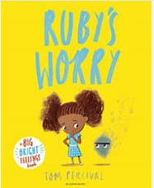 | Reading Spine  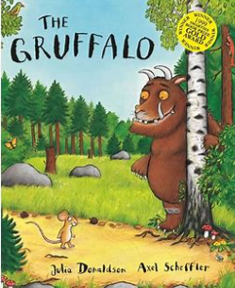 | Reading Spine   | 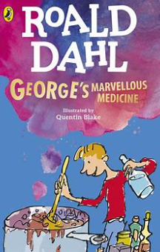  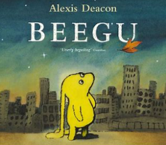  Reading Spine | Reading Spine  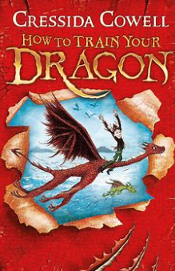 | Reading Spine  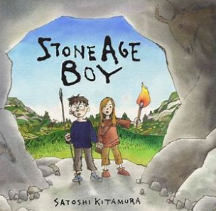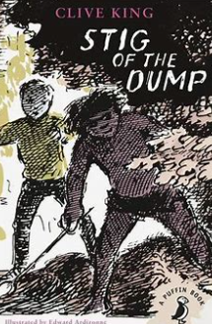 | Reading Spine  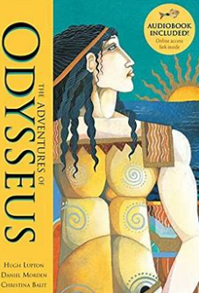 | Reading Spine  
Writing Focus  Responses to illustrations  Personal Narratives  Letters/Cards  Writing in role  Sharing emotions  Story Maps | Writing Focus  Class journal  Thought bubbles  Animal and woodland labels and poems  Shopping lists  Character description  Gruffalo crumble recipe | Writing Focus  Character descriptions- Traction Man  Diary Entry  Information text about a real life superhero | Writing Focus  Setting description  Stories with Familiar Settings- Beegu comes to St. Bridget’s | Writing Focus  Dragon descriptions  Instructions- How to Train your Dragon  Adventure/Fantasy Story | Writing Focus  Stories with Familiar Settings- When Om comes to Parton  Non Chronological Report- The Stone Age | Writing Focus  Letter Writing  Descriptive Narrative  Diary Entry | Writing Focus  Diary Entry  Play Script  Persuasive Letter
SPAG Focus  Retelling stories  Use new vocabulary  Write recognisable letters  - Spell words using phonics knowledge  - Write simple phrases and sentences that can be read by others. | SPAG Focus  Retelling stories  Use new vocabulary  Write recognisable letters  - Spell words using phonics knowledge  - Write simple phrases and sentences that can be read by others. | SPAG Focus  Character descriptions:  Full stops/capital letters  Expanded noun phrases  Similes  Diary:  Full stops/capital letters  Conjunctions  Time adverbials  Information text:  Headings/subheadings  Conjunctions  Past tense | SPAG Focus  Setting descriptions:  Expanded noun phrases  Varied sentence types  Conjunctions  Present tense  Stories with familiar settings:  Expanded noun phrases  Conjunctions  Varied sentence types  Past tense | SPAG Focus  Dragon descriptions:  Expanded noun phrases  Varied sentence types  Instructions:  Headings/subheadings  Time adverbials  Imperative verbs  Prepositions  Adventure/fantasy stories:  Paragraphs  Prepositional phrases  Subordinate clauses  Fronted adverbials  Expanded noun phrases  Varied sentence types  Inverted commas for speech | SPAG Focus  Stories with familiar settings:  Paragraphs  Prepositional phrases  Subordinate clauses  Fronted adverbials  Expanded noun phrases  Sentence types  Inverted commas  Non chronological report:  Headings/Subheadings  Fronted adverbials  Past tense | SPAG Focus  Letter:  Conjunctions  Relative clauses  Parenthesis  Modal verbs  Tenses  Fronted adverbials  Descriptive Narrative:  Sentence structure to build suspense  Compound words  Similes  Expanded noun phrases  Conjunctions  Parenthesis  Diary:  Building cohesion  Conjunctions  Adverbials  Contraction for informality | SPAG Focus  Diary:  Cohesive devices  Conjunctions  Adverbials  Play Script:  Presentational features  Parenthesis  Dialogue to convey character  Persuasive letter:  Adverbials  Relative clauses  Modal verbs  Fronted adverbials
Oracy  Express ideas and feelings through talk | Oracy  Use talk to organise play, thinking and problems. | Oracy/Drama  Freeze frames- superhero situations. | Oracy/Drama  Hot seating- Beegu at St Bridget’s  Role play a scene- Making a potion | Oracy/Drama  Hot seating in role of Hiccup  Jam sandwich experiment- acting out instructions | Oracy/Drama  Acting out a live news report in role of a reporter  Freeze frames- life in the stone age | Oracy/Drama  Seeking information by asking questions to clarify. | Oracy/Drama  Create a play script to act out in small groups
Cross-curricular links/non fiction  Feelings and emotions | Cross-curricular links/non fiction  Journeys | Cross-curricular links/non fiction  Real life superheroes  Magnets | Cross-curricular links/non fiction  Earth and Space | Cross-curricular links/non fiction  Anglo Saxons and Vikings | Cross-curricular links/non fiction  Stone Age to Iron Age | Cross-curricular links/non fiction  Ancient Greece | Cross-curricular links/non fiction  Anti-bullying

Autumn 2
EYFS – Year A | EYFS- Year B | Year 1/2- Year A | Year 1/2- Year B | Year 3/4 –Year A | Year 3/4- Year B | Year 5/6- Year A | Year 5/6- Year B
Reading Spine  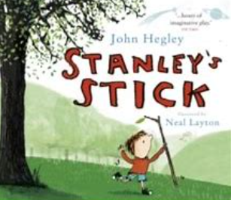 | Reading Spine  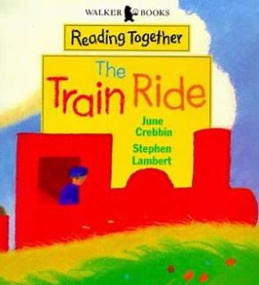 | 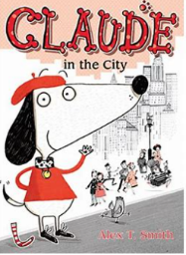  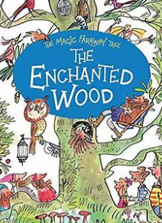  Reading Spine | 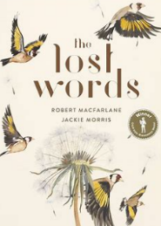  Reading Spine  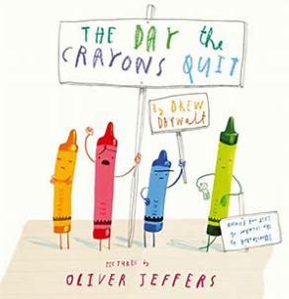 | Reading Spine  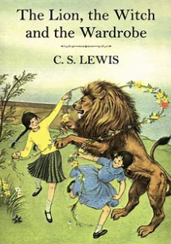  War Poetry- Poppies, In Flanders Fields | Reading Spine  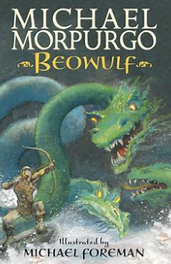  Narrative Poetry- The Highwayman | Reading Spine  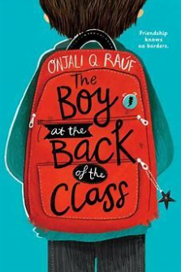 | Reading Spine  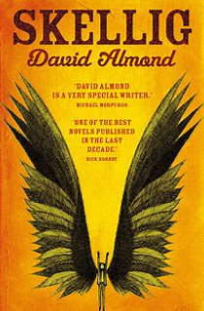
Writing Focus  Shared journal  Safety notices  Speech/thought bubbles | Writing Focus  Rewriting stories  Postcards  Creating new stories | Writing Focus  City setting descriptions  Alternative ending narratives | Writing Focus  Letter writing  List poetry | Writing Focus  Diary writing  Letter writing  Newspaper reports- The Christmas Truce | Writing Focus  Play scripts  Suspense narrative  Narrative poetry | Writing Focus  Narrative writing from a different character’s perspective  Persuasive writing in support of refugees  Writing Christmas Poetry | Writing Focus  Character descriptions  Debates: Home schooling vs. going to school
SPAG Focus  Retelling stories  Use new vocabulary  Write recognisable letters  - Spell words using phonics knowledge  - Write simple phrases and sentences that can be read by others. | SPAG Focus  Retelling stories  Use new vocabulary  Write recognisable letters  - Spell words using phonics knowledge  - Write simple phrases and sentences that can be read by others. | SPAG Focus  City setting descriptions:  Capital letters/full stops  Expanded noun phrases  Questions/exclamations  Alternative ending narrative:  Expanded noun phrases  Conjunctions  Varied sentence types  Past tense  Adverbs | SPAG Focus  Letter writing:  Expanded noun phrases  Conjunctions  Varied sentence types  Past tense  Adverbs  List poetry:  Expanded noun phrases  Synonyms  Similes  Commas in lists | SPAG Focus  Diary writing:  Paragraphs  Adverbials  Contractions  Expanded noun phrases  Letter writing:  Paragraphs  Conjunctions  Simple, compound, complex sentences  Fronted adverbials  Prepositional phrases  Expanded noun phrases  Newspaper reports:  Presentational features  Inverted commas for quotes  Time adverbials | SPAG Focus  Play scripts:  Brackets  Prepositional phrases  Subordinate clauses  Fronted adverbials  Expanded noun phrases  Suspense writing:  Prepositional phrases  Subordinate clauses  Fronted adverbials  Expanded noun phrases  Varied sentences types  Inverted commas  Narrative poetry:  Expanded noun phrases  Rhyming patterns  Similes and metaphors | SPAG Focus  Narrative:  Subordinate clauses  Expanded noun phrases  Parenthesis  Colons and semi colons  Dialogue to advance the action and create character  Persuasive writing  Relative clauses  Subjunctive form  Colons and semi colons  Modal verbs  Fronted adverbials  Passive voice  Poetry  Subjunctive form | SPAG Focus  Character descriptions:  Expanded noun phrases  Commas for clarity  Subordinate clauses  Fronted adverbials  Parenthesis  Debates:  Formal language  Paragraphs  Adverbials  Compound/complex sentences  Colons and semi colons  Modal verbs
Oracy  Express opinions  Speak clearly and in full sentences | Oracy  Develop use of tenses when sharing stories  Recount stories and events | Oracy/Drama  Freeze frames- what can we do in the city? | Oracy/Drama  Presenting ideas- role on the wall. | Oracy/Drama  Create a scene in groups about evacuating from London during WW2. | Oracy/Drama  Acting out a play script that has been created. | Oracy/Drama  Group presentations- why should we always welcome refugees? | Oracy/Drama  Class debate: Home schooling vs. going to school.
Cross curricular/non fiction  Safety | Cross curricular/non fiction  Trains and the local area | Cross curricular/non fiction  Places- what is it like in the city? | Cross curricular/non fiction  Empathy and feelings | Cross curricular/non fiction  WW2 | Cross curricular/non fiction  Bravery | Cross curricular/non fiction  Refugees | Cross curricular/non fiction  Coping with illness and loss

Spring 1
EYFS – Year A | EYFS- Year B | Year 1/2- Year A | Year 1/2- Year B | Year 3/4 –Year A | Year 3/4- Year B | Year 5/6- Year A | Year 5/6- Year B
Reading Spine  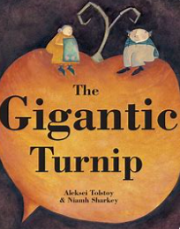 | Reading Spine  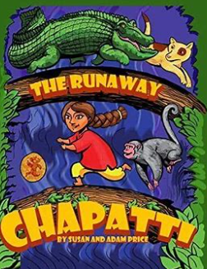 | Reading Spine  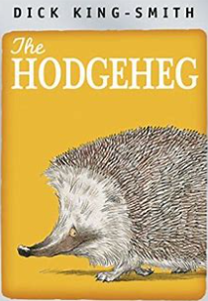 | Reading Spine  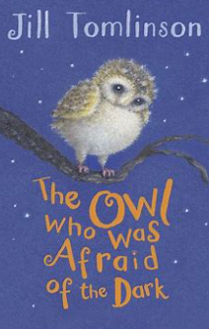 | Reading Spine  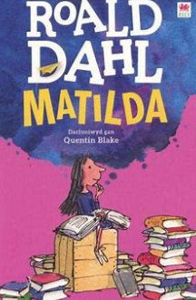 | Reading Spine  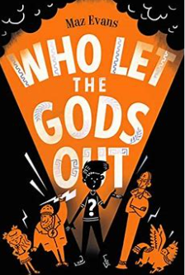 | Reading Spine  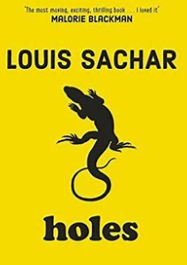 | Reading Spine  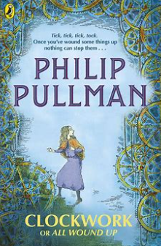
Writing focus  Alternative endings  Recipe writing  Story maps  Bookmaking | Writing focus  Recipe writing  Fact files  Letters  Writing questions | Writing focus  Setting descriptions- the park and the road  Road safety instructions | Writing focus  Stories- Plop’s adventure  Diary writing  Sound collector poetry- night time sounds | Writing focus  Short stories- Matilda’s revenge on Miss Trunchbull  Debates- should children be put in the chokey?  Kennings based on a character | Writing focus  Myths and Legends  Information text- Ancient Greeks | Writing focus  Descriptive narrative- the desert  Non chronological report- Yellow Spotted lizards  Poetry- Six ways to look at the moon | Writing focus  Horror writing- The Ghost of the Bloody Finger (flashbacks)  Explanation texts
SPAG Focus  Retelling stories  Use new vocabulary  Write recognisable letters  - Spell words using phonics knowledge  - Write simple phrases and sentences that can be read by others. | SPAG Focus  Retelling stories  Use new vocabulary  Write recognisable letters  - Spell words using phonics knowledge  - Write simple phrases and sentences that can be read by others. | SPAG Focus  - Setting descriptions  - Capital letters/full stops  - Expanded noun phrases  - Coordinating and subordinating conjunctions  - Exclamations  - Instructions  - Commands  - Imperative verbs  - Adverbs  - Capital letters/full stops | SPAG Focus  Stories  Varied sentence types  Conjunctions  Adverbs  Expanded noun phrases  Diary:  Past tense  1st person perspective  Conjunctions  Adverbs  Expanded noun phrases  Poetry:  Onomatopoeia | SPAG Focus  Short stories  Subordinate clauses  Fronted adverbials  Expanded noun phrases  Prepositional phrases  Inverted commas  Pronouns to avoid repetition  Debates  Formal language  Paragraphs  Adverbials  Simple/compound/complex sentences  Kennings  Verbs | SPAG Focus  Myths and legends  Expanded noun phrases  Fronted adverbials  Inverted commas  Pronouns to avoid repetition  Prepositions  Information texts  Presentational devices  Headings/subheadings  Expanded noun phrases  Fronted adverbials | SPAG Focus  Descriptive narrative:  Expanded noun phrases  Prepositional phrases  Fronted adverbials  Non chronological reports  Presentational devices  Formal tone  Passive/active voice  Poetry:  Metaphors | SPAG Focus  Horror narrative  Sentence structure to build suspense  Varied conjunctions  Expanded noun phrases  Parenthesis  Dialogue to convey character and advance the action  Explanation text  Formal tone  Active/passive voice  Subjunctive form
Oracy  Talk about stories | Oracy  Using talk to extend play and socialise | Oracy/Drama  Out and about- can we use our instructions to keep safe in the local area? | Oracy/Drama  Perform our poems emphasising onomatopoeia words | Oracy/Drama  Take part in a class debate  Perform our poems | Oracy/Drama  Group work- create presentation to share with this class on the Ancient Greeks | Oracy/Drama  Perform our poems | Oracy/Drama  Devise a re-enactment in groups of a horror narrative
Cross curricular/non fiction  Traditional tales | Cross curricular/non fiction  Traditional tales | Cross curricular/non fiction  Road safety | Cross curricular/non fiction  What makes us different? | Cross curricular/non fiction  Rights of a child | Cross curricular/non fiction  Ancient Greece | Cross curricular/non fiction  Civil rights | Cross curricular/non fiction  Explanations

Spring 2
EYFS – Year A | EYFS- Year B | Year 1/2- Year A | Year 1/2- Year B | Year 3/4 –Year A | Year 3/4- Year B | Year 5/6- Year A | Year 5/6- Year B
Reading Spine  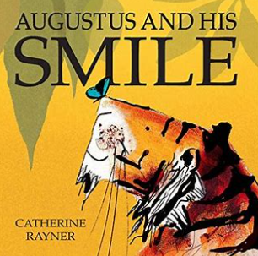 | Reading Spine  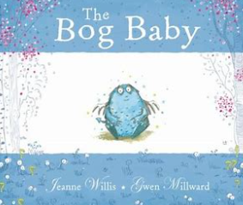 | 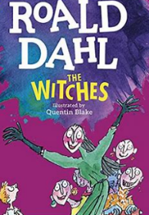  Reading Spine  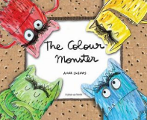 | Reading Spine  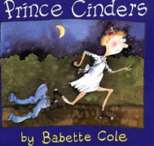  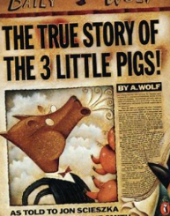 | Reading Spine   | Reading Spine  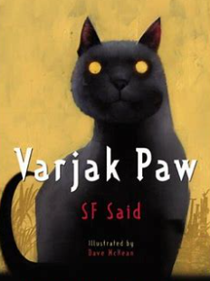 | Reading Spine  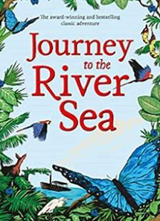 | Reading Spine  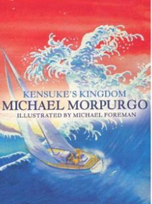
Writing Focus  Book making  Message writing  Letters  Cards | Writing Focus  Instructions  Lists  Creating stories  Recounts | Writing Focus  Character description- The Witches  Shape and simile poetry about the colour monsters | Writing Focus  Twisted fairy tales  Newspaper articles | Writing Focus  Newspaper reports  Information texts- Ethiopia | Writing Focus  Mystery stories  Recount | Writing Focus  Diary  Balanced argument  Persuasive leaflet | Writing Focus  Adventure narrative  Non chronological report- Kensuke’s Island  Haikus
SPAG Focus  Retelling stories  Use new vocabulary  Write recognisable letters  - Spell words using phonics knowledge  - Write simple phrases and sentences that can be read by others. | SPAG Focus  Retelling stories  Use new vocabulary  Write recognisable letters  - Spell words using phonics knowledge  - Write simple phrases and sentences that can be read by others. | SPAG Focus  Character descriptions  Expanded noun phrases  Adverbs  Capital letters/full stops  Conjunctions  Apostrophes for possession and contraction  Shape and simile poems  Adjectives  Synonyms  Similes | SPAG Focus  Twisted tales  Varied sentence types  Conjunctions  Adverbs  Expanded noun phrases  Newspaper reports  Presentational features  Time adverbials  Adverbs  Expanded noun phrases | SPAG Focus  Newspaper reports  Adverbials  Conjunctions  Prepositional phrases  Direct quotes  Presentational devices  Information texts  Facts and opinions  Subheadings  Expanded noun phrases  Fronted adverbials | SPAG Focus  Mystery stories  Expanded noun phrases  Fronted adverbials  Inverted commas  Pronouns to avoid repetition  Prepositional phrases  Recounts  Expanded noun phrases  Fronted adverbials  1st person perspective  Past tense/perfect present | SPAG Focus  Diary  Perfect and progressive tense  Subjunctive form  Active voice  Expanded noun phrases  Fronted adverbials  Balanced argument  Fronted adverbials  Modal verbs  Subjunctive form  Persuasive Leaflet  Expanded noun phrases  Rhetorical questions  Presentational features | SPAG Focus  Adventure narrative  Different sentence structures  Compound words  Expanded noun phrases  Parenthesis  Fronted adverbials  Dialogue to convey character and advance the action  Non chronological report  Formal language  Passive voice  Headings/subheading  Colons and semi colons  Haikus:  Syllables
Oracy  Expressing feelings | Oracy  Talk to extend play and social skills. | Oracy/Drama  Create a worry monster jar- present these to the class.  Create a witches’ brew in small groups and present to the class. | Oracy/Drama  Interviews with Mr Wolf  Hot seating- Prince Cinders’ thoughts and feelings | Oracy/Drama  Create a rolling tableaux of Solomon’s journey home when the bus broke down. | Oracy/Drama  Devise one of Varjak’s adventures in small groups. | Oracy/Drama  Balanced debates. | Oracy/Drama  Performance poetry- Haikus
Cross curricular/non fiction  Creation | Cross curricular/non fiction  Love | Cross curricular/non fiction  Feelings and emotions | Cross curricular/non fiction  Alternative perspectives | Cross curricular/non fiction  Ethiopia/Africa | Cross curricular/non fiction | Cross curricular/non fiction  South America/Rainforest | Cross curricular/non fiction  Hope and safety/other cultures

Summer 1
EYFS – Year A | EYFS- Year B | Year 1/2- Year A | Year 1/2- Year B | Year 3/4 –Year A | Year 3/4- Year B | Year 5/6- Year A | Year 5/6- Year B
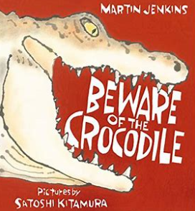  Reading Spine | 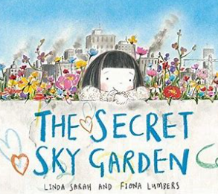  Reading Spine | 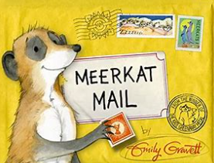  Reading Spine |   Reading Spine | 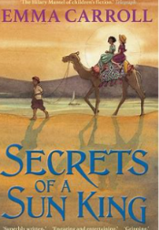  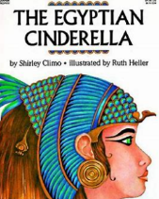  Reading Spine | 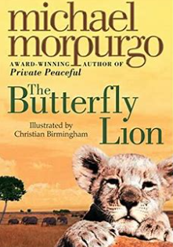  Reading Spine | 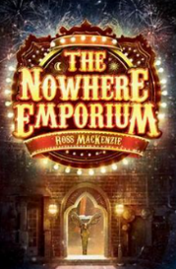  Reading Spine | Reading Spine  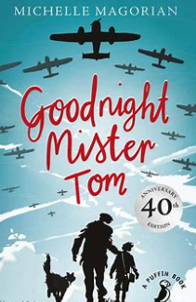  War Poetry- The Charge of the Light Brigade
Writing Focus  Crocodile descriptions  Warnings  Fact files  Map labels  Statements and questions | Writing Focus  Persuading on a local issue  List poems  Thought bubbles in role  Character sketches  Character descriptions | Writing Focus  Diary entry  Non chronological reports  Letter in role | Writing Focus  Instructions  Recounts | Writing Focus  Twisted fairy tales  Persuasive leaflets- visit Egypt | Writing Focus  Letters  Balanced argument | Writing Focus  Suspense narrative  Instructions- how to use the Nowhere Emporium | Writing Focus  Letter from Willie  Live newspaper update: the Blitz  War poetry
SPAG Focus  Retelling stories  Use new vocabulary  Write recognisable letters  - Spell words using phonics knowledge  - Write simple phrases and sentences that can be read by others. | SPAG Focus  Retelling stories  Use new vocabulary  Write recognisable letters  - Spell words using phonics knowledge  - Write simple phrases and sentences that can be read by others. | SPAG Focus  Diary entry  Expanded noun phrases  Time adverbials  Varied sentence types  Adverbs  Non chronological reports  Headings/subheadings  Expanded noun phrases  Nouns  Verbs  Letter in role  Expanded noun phrases  Time adverbials  Varied sentence types  Adverbs  Past tense | SPAG Focus  Instructions  Commands  Imperative verbs  Adverbs  Capital letters/full stops  Recounts  Adverbs  Adjectives  Verbs  Capital letters/full stops  Exclamations  Past tense | SPAG Focus  Twisted fairy tales  Adverbs  Fronted adverbials  Expanded noun phrases  Inverted commas for speech  Reporting clauses  Sentence types  Subordinate clauses  Persuasive leaflet  Headings/subheadings  Fronted adverbials  Expanded noun phrases  Superlatives | SPAG Focus  Letters  Adverbs  Fronted adverbials  Expanded noun phrases  Inverted commas for speech  Reporting clauses  Sentence types  Subordinate clauses  Balanced arguments  Persuasive features  Subordinate clauses | SPAG Focus  Suspense narrative  Range of punctuation  Expanded noun phrases  Cohesive devices  Dialogue to advance the action  Sentence structures to build suspense  Instructions  Imperative verbs  Adverbs  Active/passive voice  Parenthesis | SPAG Focus  Letters  Cohesive devices  Conjunctives  Relative clauses  Contraction for informality  Newspaper updates  Headlines  Direct quote  Formal language  Fronted adverbials  Colon and semi-colons  War poetry  Structural poems  Rhyme  Repetition
Oracy  Giving warnings/ safety role play | Oracy  Talking about local environmental issues | Oracy/drama  Rolling tableaux- the journey of the mail | Oracy/drama  Devise in small groups a trip to the moon | Oracy/drama  Role on the wall for Rhodopis- present ideas to the class | Oracy/drama  Whole class debate- should animals be kept in zoos? | Oracy/drama  Devise in small groups- where could we end up? | Oracy/drama  Creating a live news update in the role of a reporter
Cross curricular/non fiction  Dinosaurs | Cross curricular/non fiction  Minibeasts | Cross curricular/non fiction  Animals | Cross curricular/non fiction  Earth and Space | Cross curricular/non fiction  Egypt | Cross curricular/non fiction  Empathy | Cross curricular/non fiction | Cross curricular/non fiction  WW2

Summer 2
EYFS – Year A | EYFS- Year B | Year 1/2- Year A | Year 1/2- Year B | Year 3/4 –Year A | Year 3/4- Year B | Year 5/6- Year A | Year 5/6- Year B
Reading Spine  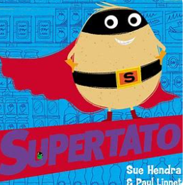 | Reading Spine  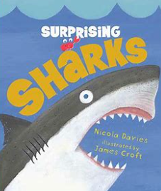 | Reading Spine  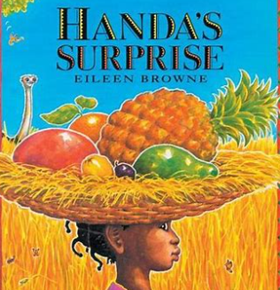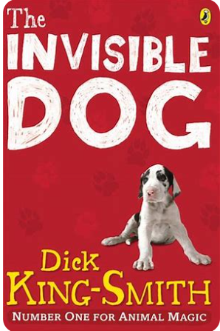 | Reading Spine  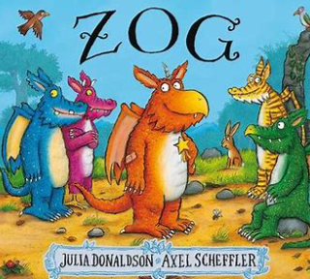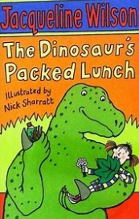 | Reading Spine  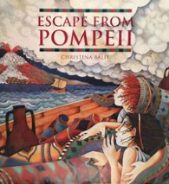  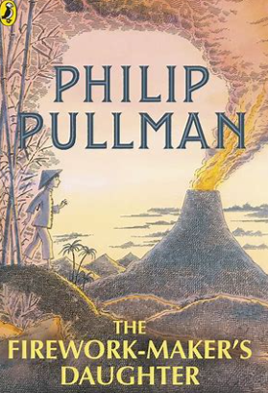 | Reading Spine  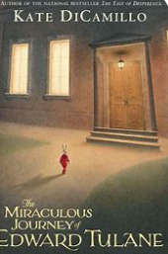 | Reading Spine  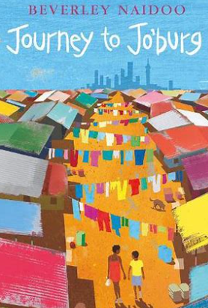 | 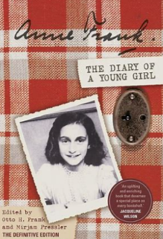  Reading Spine
Writing Focus  Lists  Simple sentences  Speech bubbles  Labels  Retelling | Writing Focus  Questions  Labels  Fact files  Letters | Writing Focus  Instructions- how to make a fruit salad  Non chronological report:  Africa | Writing Focus  Narrative (retelling of Zog)  Report writing- school report for Zog | Writing Focus  Suspense narrative  Explanations- how volcanoes are formed | Writing Focus  Explanations- cracking contraptions  Diary | Writing Focus  Biography- Nelson Mandela  Descriptive writing | Writing Focus  Diary in role  Autobiography
SPAG Focus  Retelling stories  Use new vocabulary  Write recognisable letters  - Spell words using phonics knowledge  - Write simple phrases and sentences that can be read by others. | SPAG Focus  Retelling stories  Use new vocabulary  Write recognisable letters  - Spell words using phonics knowledge  - Write simple phrases and sentences that can be read by others. | SPAG Focus  Instructions  Commands  Imperative verbs  Adverbs  Full stops/capital letters  Present tense  Non chronological reports  Headings/subheadings  Fact/opinion  Full stops and capital letters | SPAG Focus  Narrative retelling  Range of sentence types  Conjunctions  Adverbs  Expanded noun phrases  Report writing  Headings/subheadings  Verbs  Nouns  Capital letters/full stops | SPAG Focus  Suspense narratives  Adverbs  Fronted adverbials  Expanded noun phrases  Inverted commas  Reported clauses  Varied sentence types  Subordinate clauses  Explanations  Formal language  Fronted adverbials  Conjunctions  Expanded noun phrases | SPAG Focus  Explanations  Formal language  Fronted adverbials  Conjunctions  Expanded noun phrases  Diary  Conjunctions  Fronted adverbials  Contraction for informality  Apostrophes for possession  Expanded noun phrases | SPAG Focus  Biographies  Formal language  Adverbials  Clauses  Parenthesis  Colon and semi colons  Modal verbs  Passive voice  Descriptive writing  Expanded noun phrases  Range of punctuation  Creating atmosphere | SPAG Focus  Diary  Perfect and progressive tense  Subjunctive form  Active voice  Expanded noun phrases  Fronted adverbials  Autobiography  Formal language  Adverbials  Clause structure  Parenthesis  Active voices  Subjunctive form
Oracy  Talk about superheroes | Oracy  Share information with friends | Oracy/drama  Use instructions to create a fruit salad | Oracy/drama  Hot seating as Zog | Oracy/drama  Explain to the class in groups how volcanoes are formed | Oracy/drama  Rolling tableaux of Edward’s travels | Oracy/drama  Civil rights debate- why was apartheid so wrong? | Oracy/drama  Devising performances about Anne Frank being stuck in the attic.
Cross curricular/non fiction  Superheroes | Cross curricular/non fiction  Under the sea | Cross curricular/non fiction | Cross curricular/non fiction | Cross curricular/non fiction  Volcanoes and earthquakes | Cross curricular/non fiction | Cross curricular/non fiction  Civil rightd | Cross curricular/non fiction  WW2

