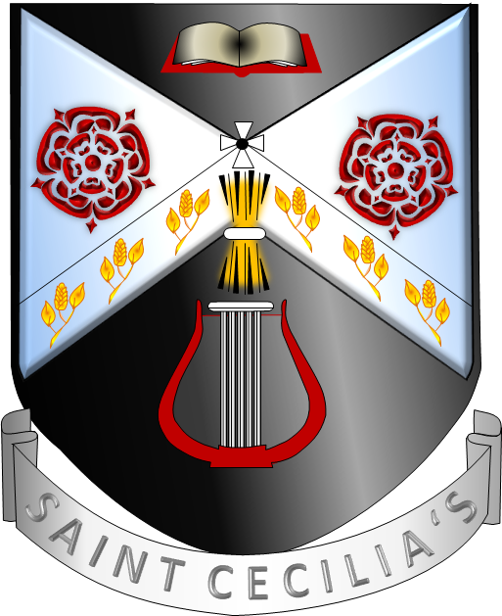

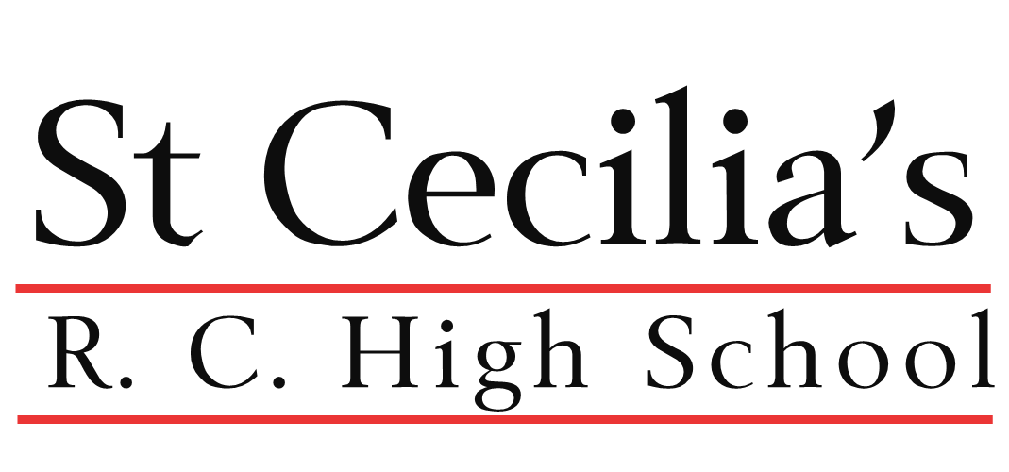

Discover l Develop l Rejoice

Discover Develop Rejoice

Transition Booklet

School Prayer
Lord, each of us have different talents and abilities

We ask you to inspire us to discover and develop the best within us.

Lead us to be both humble and generous in using our talents.

Help us to rejoice in the talents of all within our school community.

Amen.

As a school community, we would like to welcome you into our family. We are looking forward to meeting you in September!
This booklet is designed to aid your transition into secondary school, prepare you for the lessons, and answer any questions you may have.
Bring this booklet in on your first week in school and show it to your Head of Year for a prize!
ABOUT ME:
What are your favourite things? Food, music, TV… | What are some of your biggest achievements? | What are your most positive traits? E.g., kindness, hard-working
What interesting facts should we know about you? | What is your favourite subject? | What are your hobbies? E.g., sports/instruments/dancing?
What are you most excited for at St Cecilia’s? | What are you most nervous about when joining St Cecilia’s? | Which subject are you excited to try?

Name:

Primary School:

Draw a picture of yourself or
glue an image:

What will my first day be like?

You will start school at 8:45am with a Welcome Assembly in the Hall and your parents/guardians are welcome to come in with you. Don’t worry about getting lost: when you arrive at school there will be helpers to direct you to the Hall.
After the Welcome Assembly, you will be taken to your form rooms by your Form Teacher. You will already know which form you are in, but don’t worry if you forget – your name will be read out by your form tutor!
You will then spend time in your forms where you will get to know your Form Teacher and everyone in your form again. You will be given your timetable and dinner account number.
On your first day you will need to bring stationery, as per the list, in a pencil case. You will need a bag to carry your items. Please ensure that all your possessions and uniform are clearly marked with your name.
If you are bringing money to school for your bus fare, you will need a purse/wallet or somewhere to keep your money safe. You must keep your money with you at all times. If you do use a purse or a wallet you need to make sure it is named clearly. Do not bring a lot of money to school - you will not need it.
You do not need to bring your PE kit on the first day.
You will finish school at 3:15pm.

What do we expect from you?
We will recognise your valuable contributions to our school in many ways, both inside and outside of the classroom.
Whenever you display one of our ‘St Cecilia’s Virtues’ (below) you will be awarded with an achievement point.

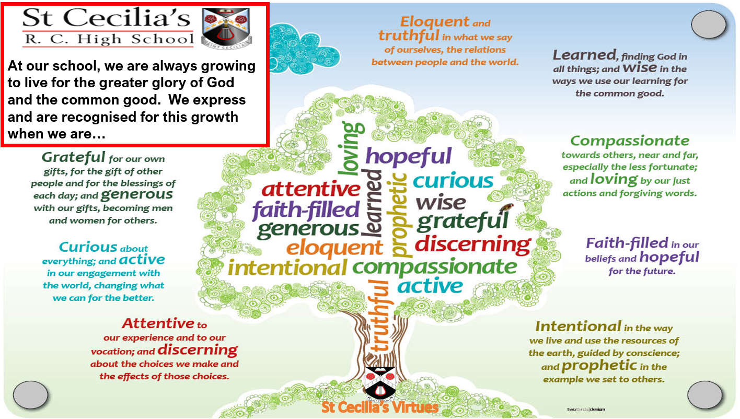
In addition, we will also recognise when you display any of our ‘attributes of learning’ within the classroom, and award you an achievement point for doing so (see below).
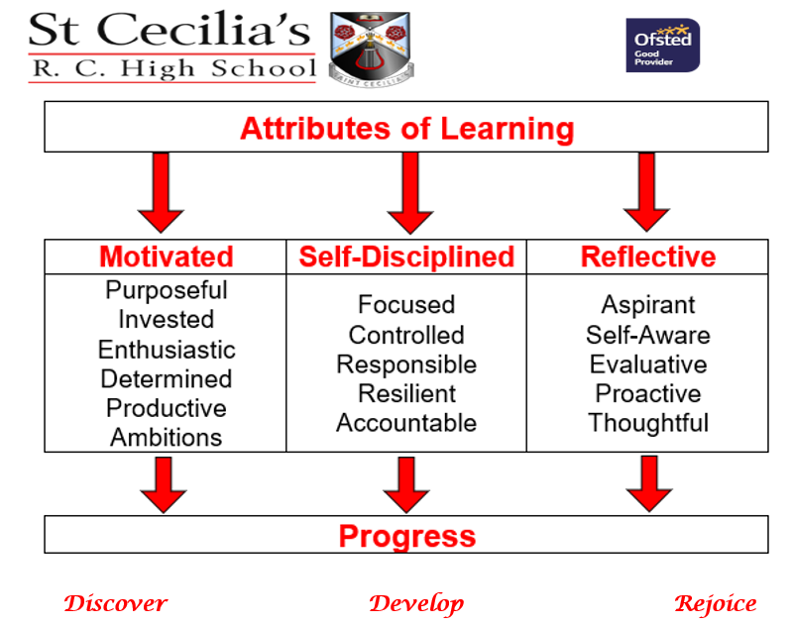

Achievement points result in some incredible rewards at our school. In addition to half termly rewards assemblies, certificates and prizes, here are some of the rewards you will be receiving if you are some of our highest achievement point earners:

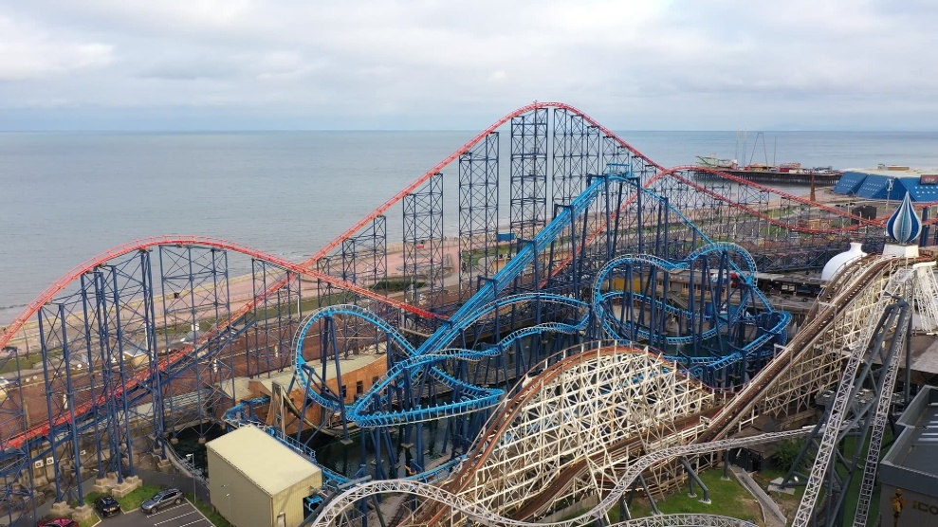

Still have questions?
For more information on Transition please scan the QR code below or follow the link to the Transition menu on our website. You may see other QR codes in this booklet – scan for extra help!

Transition Overview | St Cecilia's RC High School (st-cecilias.co.uk)

Reading
Reading is extremely important to us. Developing your vocabulary and understanding is key to unlocking your potential. Not only do we focus on morphemes (parts of words) to aid learning newer, bigger and more exciting language – we also focus on reading entertaining books in both lesson and outside of lesson. You’ll find challenges, competitions and ERIC lessons (Everybody Reading in Class).
We have provided you with “After the War” by Tom Palmer; we will be using it in lessons at the beginning of Year 7. It would be really useful if you read it and enjoy it.
Here are some activities to be completed as you read. If you bring this booklet in with you in Year 7, you will receive stars (which result in exciting opportunities, such as trips and prizes!) Please keep your book safe. We would like to keep them to regift them next year!
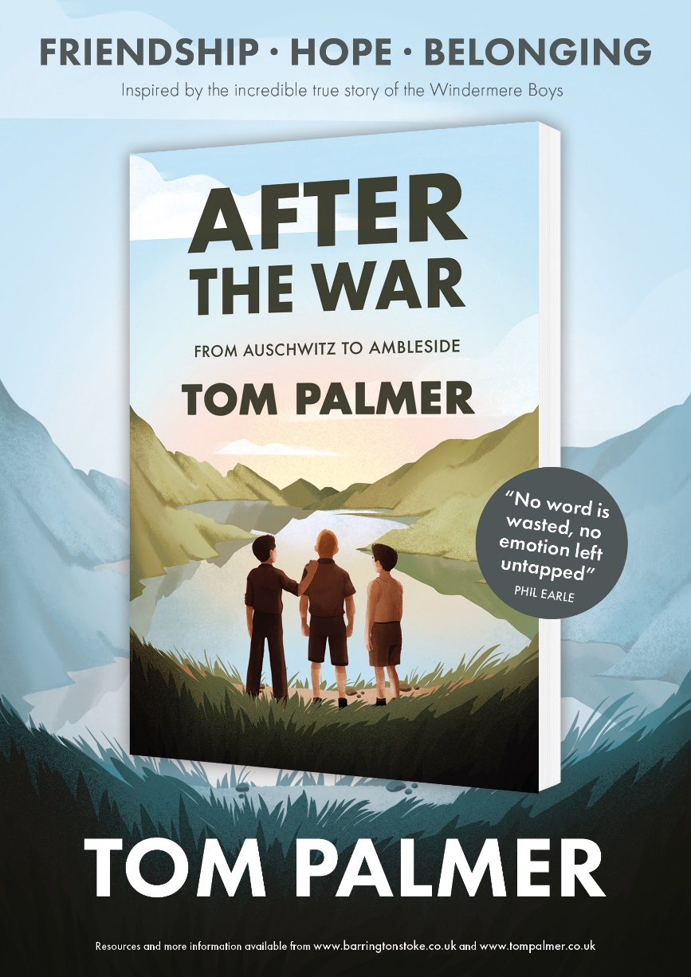

Predictions
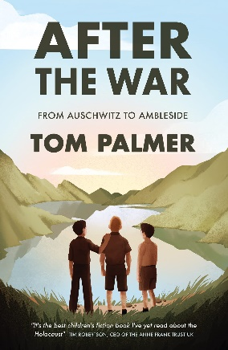

Pre-reading Challenge – this knowledge will be important for when you study Geography, History and RE!
History Link: Research Questions

- What is the holocaust?

- What is an evacuee?

- Why were Polish children evacuated to England in World War 2?
RE Link: Research Questions

- One of the main characters is Jewish.
Write down everything you know about being Jewish (and research to find out more!)
Geography Link: Research Questions – In Year 8 you will have the opportunity to visit the Lakes with school.
- Where is the Lake District in the UK? How far away is it from where you live? Have you ever visited?

- How far away is Poland from the Lake District?
- Do you think moving from Poland to the Lake District may be very different? How is the Lake District different from where you live?
START READING! Chapters 1-3 challenges:
Transform it - Summarise each chapter in 3 images:

Create a short diary entry below as Yossi. Explain what has happened to you, how you are feeling, and what you think of the Lake District.
________________________________________________________________________________________________________________________________________________________________________________________________________________________________________________________________________________________________________________________________________________________________________________________________________________________________________________________________________________________________________________________________________________________________________________________________________________________________________________________________________________________________________________________________________________________________________________________________________________________________________________________________________________________________________________________________________________________________________________________________________________________________________________

Read Chapter 4 and 5. Using the description of the setting at the beginning of chapter 5, draw what you imagine the Lakes to look like. You could then add quotes from the chapter to label what you have drawn.
Read Chapter 6 and 7
Summarise some of the memories Yossi has that have made an impact on him – explain why each memory could be seen as positive or negative:
Write about a positive memory from Primary School:

Timeline: As you read the next few chapters, create a timeline of events:

Chapter 12
Chapter 11
Chapter 10
Chapter 9
Chapter 8
Chapter 13
Chapter 18
Chapter 17
Chapter 16
Chapter 15
Chapter 14
The ending and the Epilogue:

After reading chapter 19, what happened and how did you feel?

What do you think this book could teach us, as a reader?

Read the epilogue. Create an information poster below on the information:
Write a review!
Once you have completed the novel, create a review on the book. Some things you may talk about are:
- Best/worst parts of the novel
- Why others should read it
________________________________________________________________________________________________________________________________________________________________________________________________________________________________________________________________________________________________________________________________________________________________________________________________________________________________________________________________________________________________________________________________________________________________________________________________________________________________________________________________________________________________________________________________________________________________________________________________________________________________________________________________________________________________________________________________________________________________________________________________________________________________________________________________________________________________________________________________________________________________________________________________________________________________________________________________________________________________________________________________________________________________________________________________________________________________________________________________________________________________________________________________________________________________________
Summer Activities:
English Challenge

In Primary school, you will have focussed on phonics. Building on this, we centre our learning of new vocabulary around morphemes.
A morpheme is a part of a word (this could be a root word, prefix or suffix).
An example of this could be: “un” meaning “not”. This will help you to understand that “unhappy” means “not happy”.
Whilst you probably knew what “unhappy” meant – other words, you may struggle with. Let’s break down another:
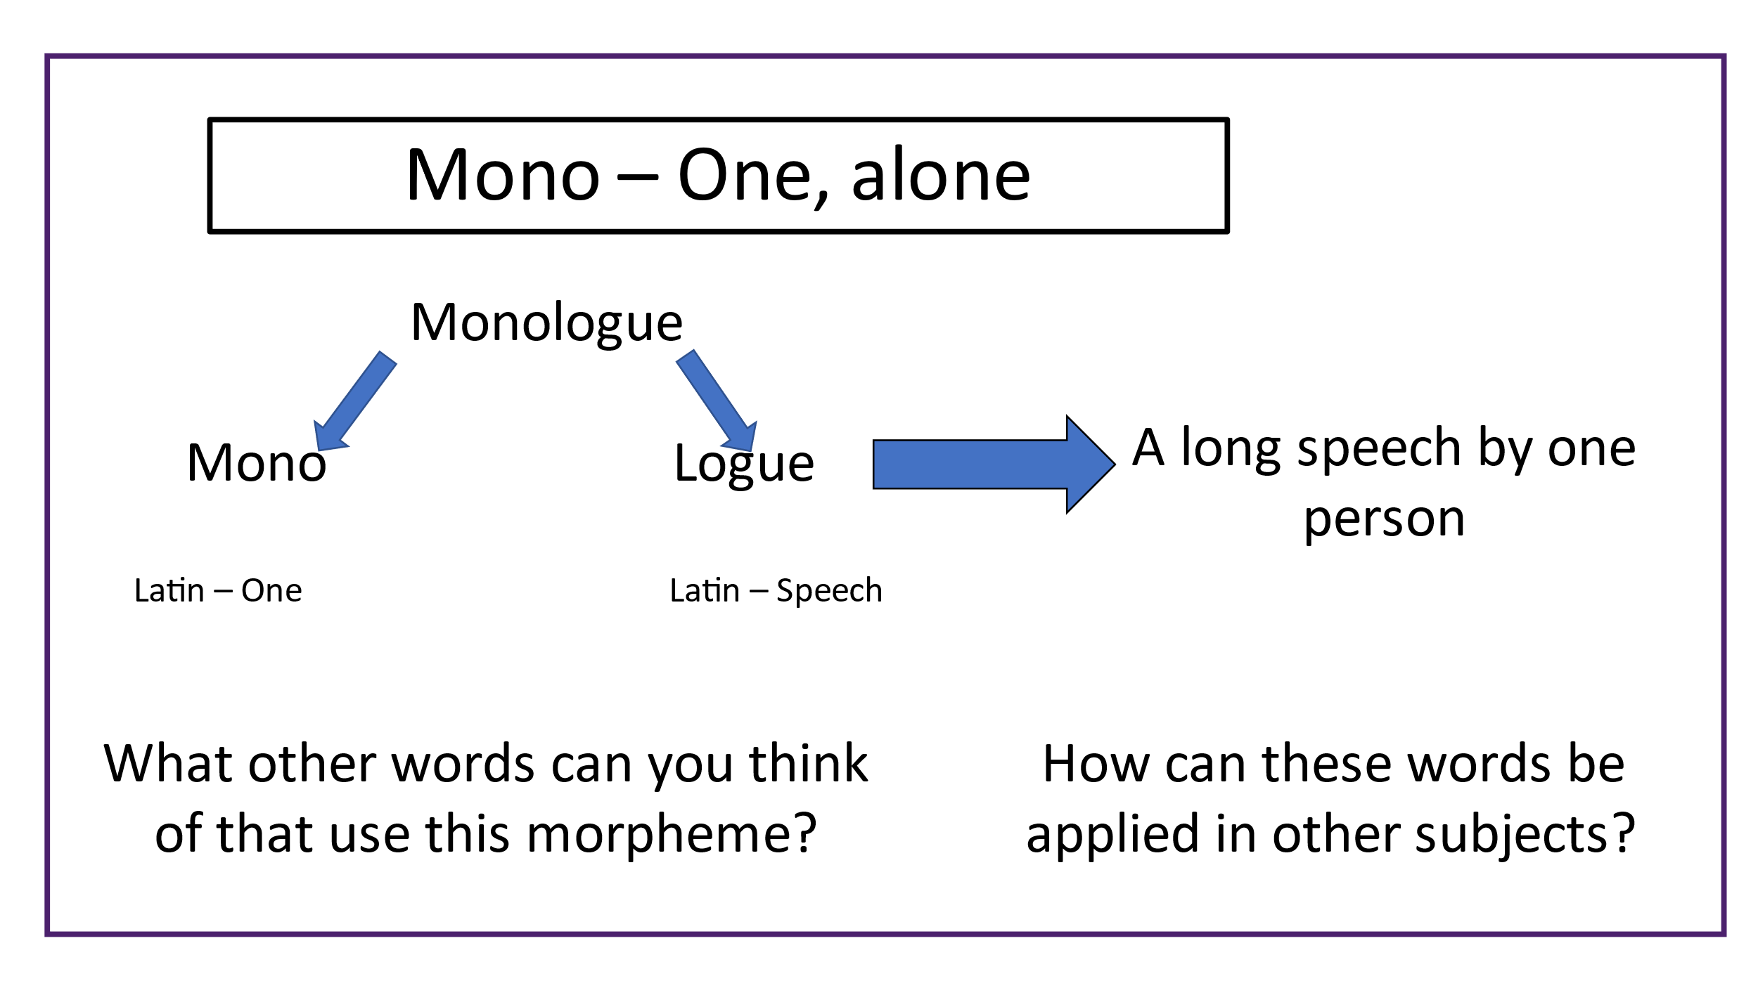
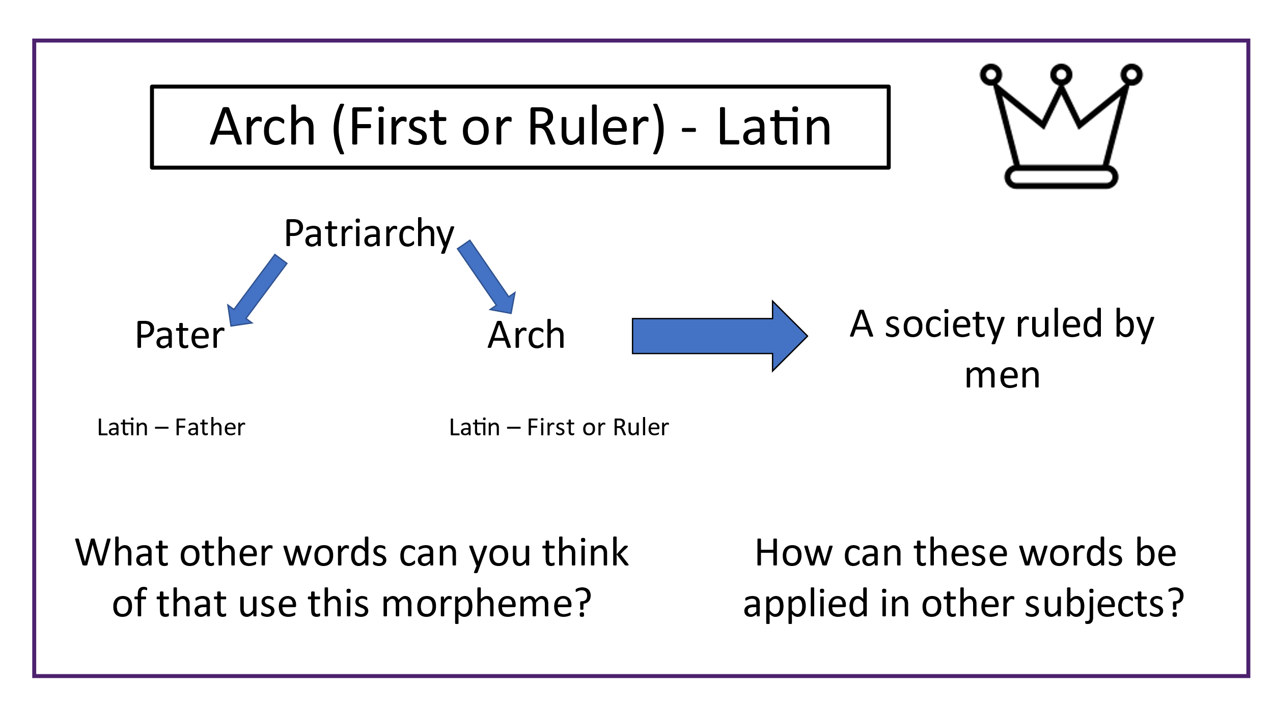
Creative Writing Competition

This competition will be open until the end of September. It is only for Year 7 and you will receive achievement points for entering.

The theme is: New Beginnings!

If you follow the QR code, you will find some examples from our current Year 7 and 8. If you need inspiration, these should help!

If you would like to enter before you arrive to school, enter via the email address: intake2023@st-cecilias.lancs.sch.uk

Some TOP TIPS for writing:
Remember to use paragraphs | Remember to use capital letters and full stops | Can you use similes? Metaphors? Other techniques
Create characters or use yourself | Write in the same tense (present or past) | Make sure to describe your setting
Use speech and make sure to use speech marks | Try to use a variety of sentence length | Think of interesting openings, building tension and exciting endings!

Maths Challenge

Science Challenge

Fun Science Experiment:
Crystal Suncatchers
For a unique suncatcher craft, try making these Crystal Suncatchers using Epsom Salt!

Materials
Epsom Salt
Clear Recycled Plastic Lids- use the clearest you can find
Water
Empty Jar
Bowl or glass measuring cup
Fork
Microwave (optional)
Tray
String
Exacto/Pin

Instructions
If you are doing this experiment on its own, start with the following steps:
Step One | Measure
You will be using a ratio of 1:1 water to Epsom Salt for this project. Add 1 cup of Epsom salt to an empty glass jar.
Step Two | Heat the Water
Add 1 cup of water to a microwave safe bowl. Heat the water in the microwave for 45 seconds. Alternatively use very hot tap water and skip the microwave.
Step Three | Combine
Pour the water into the jar with the salt. Do this quickly so that the water is warm. Stir the salt and water for 1-2 minutes to dissolve the salt.
Step Four |Make Your Suncatchers See steps 5-9 below.
Step Five Place several plastic lids on a flat-bottomed tray in a sunny location where they can remain undisturbed.
Step Six Pour off some of the excess liquid from your jar/crystal garden into the recycled plastic lids. Use just enough to cover the bottom of the lid. DON’T OVERFILL!
Step Seven Place your lids in sunny location. Depending on how much liquid has been added it will take a few hours or a day to start crystallizing. I know it will look like lids full of water at first but be patient!
Step Eight When the liquid has completely evaporated your crystal suncatcher is ready! You will be able to see lovely crystal structures from both side of the lid.
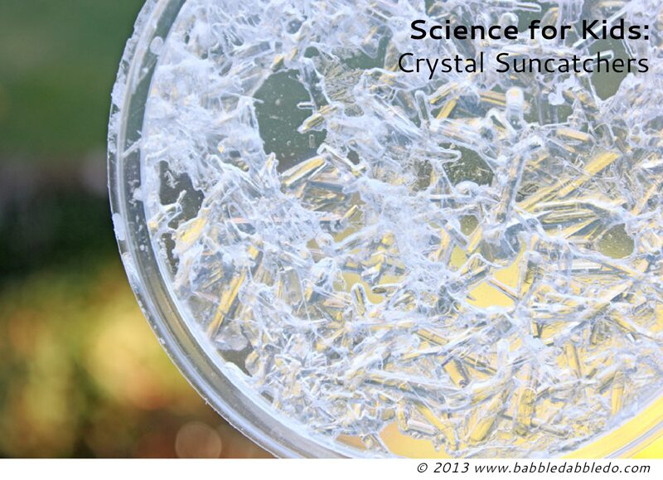
Step Nine VERY carefully poke a small hole in the edge of the lid and thread a piece of string through the hole. Tie in a knot and hang your suncatcher up!

We want to hear from YOU!

We want to hear from you – email me from your parent or guardian’s email address with any updates on the activities you have been doing over summer and anything else you get up to.

We would like to make a display in school to welcome you all!

Complete the postcard attached – update me with your favourite bits of the book and what you have done over summer. You may decorate the postcard as you’d like!

EMAIL: intake2023@st-cecilias.lancs.sch.uk

