SEND Information Report
Approved on:
July 2023
Next review:
June-July 2024
St Chad’s Catholic Primary School

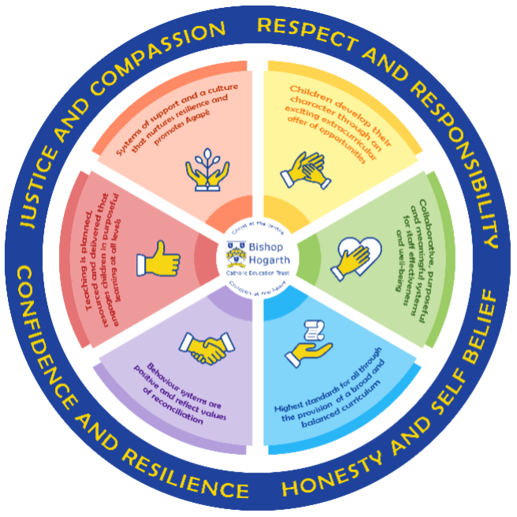
As part of the family of Bishop Hogarth Catholic Education Trust, our school has at its core, the virtues, and values of:
Respect for others and themselves, recognising that we are all created in the image of God and therefore must be compassionate towards others, especially the vulnerable. ​
Confidence in their own abilities, knowing that their talents are gifts from God and resilience to persevere when things become difficult. ​
Honesty in regard to the world around them and themselves and the ability to take responsibility for the times we may fall short of the mark. ​
Gratitude for all the amazing gifts from God and willingness to share their gifts both personal and material. ​

As an inclusive school, all teachers are teachers of pupils with Special Educational Needs & Disabilities. We deliver a curriculum and create an environment that meets the needs of every pupil within our school. We ensure that every pupil with Special Educational Needs and / or disabilities makes the best progress possible. We foster and promote effective working partnerships with parents / carers, pupils, and outside agencies. We consider the ‘whole’ child and strive to ensure that all our SEND pupils are prepared for adulthood.​

Our school’s approach to supporting pupils with SEND

Inclusive education means supporting all pupils to learn, contribute and participate in all aspects of school life alongside their peers. Our curriculum includes, not only the formal requirements of the Early Years Foundation Stage Curriculum / National Curriculum, but also a range of additional opportunities to enrich the experiences of all pupils.

The Curriculum also included the social aspects that are essential for lifelong learning, personal growth and development of independence.

In order to meet the needs of all pupils at St Chad’s we endeavor to provide a safe and nurturing environment where all children can thrive and succeed. We work hard to ensure the children’s need are met to ensure they reach their full potential and aspire to be the very best they can be.

Prior to starting school our EYFS team will liaise closely with nursery staff and parents to gain a clear understanding of your child and their needs. Staff visit nurseries to meet the new starters and gain a better understanding of their personalities. This allows staff to plan an EYFS curriculum at a level and pace that closely matches the needs of the children. Where appropriate the Senco will discuss the needs of the children prior to them starting school. Regular communication with parents continues throughout their time in school, where staff and parents work closely together to ensure they are accessing the National Curriculum at level and pace that is appropriate to their abilities. This may be through termly parents’ consultations or more informal meetings as required.

Our aim is to help the children become independent, resilient learners who are not afraid of making a mistake and learning from it. Across the school children are encouraged to take responsibility for their own learning and identify how they can improve. Children are encouraged to ask questions, challenge themselves and take a risk to help develop as confident, independent learners.

Success is celebrated on a regular basis with children praised for not just what they have learnt but their perseverance, focus, attitude and determination to succeed. We pride ourselves on our mission statement to ‘Come as you are and walk with us’ as diversity is welcomed, respected and encouraged.

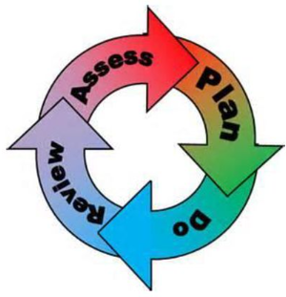
How will the school staff support my child?
The graduated response-Identifying, planning for and supporting pupils with SEND
Where a pupil is identified as having a special educational need, School will follow a graduated approach which takes the form of cycles of ‘Assess, Plan, Do, Review’. ​
• Assess a child’s special educational need. ​
• Plan the provision to meet your child’s aspirations and agreed outcomes. ​
• Do put the provision in place to meet those outcomes. ​
• Review the support and progress.

How does the school know if children need extra help and what do I do if I think my child has special educational needs?

- Assess
Children are assessed on a regular basis in all areas of the curriculum using a range of informal and formal assessments. At times it may be beneficial for some children with additional needs or experiencing specific difficulties to undergo more specialised assessments from a range of professionals. Parental permission is needed for children to undergo assessments from outside agencies.

The attainment and progress of every child, including those with SEND, is tracked on a termly basis. This helps identify children who may have an additional need and is also used to review and measure outcomes set on support plans.

We have an ‘open door’ policy where parents can express any concerns as well as termly parents’ consultations. Contact details can be found on the school website. Support plan review meetings are held on a termly basis which parents are invited to and encouraged to attend.

All children at St Chad’s Catholic Primary School receive Quality First teaching daily. Teaching assistants provide additional support in class. Children remain in class for all lessons so that they can access this support. Activities and resources are differentiated accordingly so they can access the curriculum. Children that are identified as SEND receive regular, weekly interventions linked to their personal outcomes- the majority of these take place outside of lesson times. CPD is offered to staff to ensure that they are confident to deliver and support in these sessions. At times outside agencies are used to provide intervention to an individual child or group of children. Where possible we aim to upskill our staff to deliver interventions so they are easily accessible to all the children who need them.

- Plan
Class teachers and the school SENDCO will act upon the advice of any professionals involved and meet with parents/ carers and children to determine the most appropriate outcomes to be identified on the child’s support plan to best meet their needs and ensure that they make progress. A holistic view of strengths and areas of difficulty will be identified and outcomes matched to ensure that support is in place to address the areas of difficulty. The support plan will identify what needs to be in place to meet the child’s needs and ensure that they make progress.
- Do
Our teachers are skilled at adapting teaching and learning to meet the diverse needs in each class. ​
Daily planning considers individual children’s needs and requirements and is annotated and adapted according to need. Explicit reference is made in the teacher’s planning to the needs of those children identified with SEND. ​
Adaptive teaching is approached in a range of ways to support access to the curriculum and ensure that all children can experience success and challenge in their learning. ​
Grouping arrangements consider the different skills and abilities of each child. This ensures that learning is maximised. ​

Additional adults support groups and individual children with the long-term goal of developing independent learning skills. The class teacher monitors this support to avoid students becoming over reliant on this. ​
We fully encourage parental support and offer opportunities for individual meetings with parents/carers to provide clarity and recommendations on how they can support their child at home.

- Review
Time is allocated in every staff meeting for a discussion about SEND children take place so that staff can share relevant and up to date information. All staff have a termly SEN support plan review meeting, where staff review outcomes following assessments, evaluations of interventions and observations. This helps to evaluate the impact of the provision and set new outcomes or carry out further assessments on a child.

A small percentage of children and young people with significant and/or complex needs may require an assessment that could lead to an Education, Health and Care Plan.

How will the curriculum at our school be matched to my child’s needs?
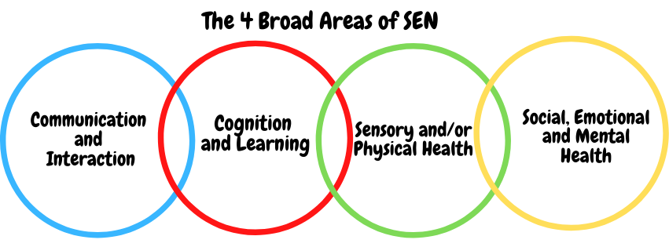SEN needs are classified under four broad areas of need. Below are the strategies, in class support and interventions that school may put in place to support your child.
Communication and Interaction
Strategies to support children with these needs include:
- Access to small group and/or individualised interventions.
- TA support.
- Access to interventions on social and emotional stories.
- Access to low stimulus area/safe space.
- Enhanced access to additional aids, such as sensory tools, visual timetables, ear defenders and workstations.
- Access to technology-Laptops, software.
- Access to Speech and Language Therapist.
- Access to Educational Psychologist.
- Access to Daisy Chain service.
Cognition and Learning
Strategies to support children with these needs include:
- Quality first teaching Training for staff.
- SEN Support Plans for those identified as SEN with targets and strategies for support.
- Scaffolding, Modelling and Chunking.
- Range of metacognitive and cognitive strategies to support learning.
- Practical aids for learning, working memory boards, task cards, overlays etc.
- Increased adult support if needed.
- Adaptations to assessments to enable access e.g. laptops, additional time.
- Support from outside agencies e.g. Educational Psychologist Cognition & Learning Team
- Small group or individual intervention.
- Phonic/reading development programmes- e.g. Read Write Inc, Fast Track Tutoring and Accelerated Reading, precision teaching
- Pre and post teaching of vocabulary and new concepts.
- Frequent repetition and reinforcement – retrieval practice.
Sensory/Physical
Strategies to support children with these needs include:
- Access to Sensory Support services for advice on planning for pupils with a visual or hearing impairment.
- Liaison with outside agencies for specific equipment to aid access to the curriculum.
- Occupational Therapist/ Physiotherapist targeted programmes.
- Access to Speech and Language.
- Concrete apparatus available to support learning.
- Therapy programmes delivered in school, designed by specialists e.g. Occupational Therapists, Physiotherapists etc.
- Adapted curriculum to enable full access e.g. alternative recording devices, modified PE curriculum.
- Access to sensory breaks, Proprioceptive activities and movement breaks
Social, Emotional and Mental Health
Strategies to support children with these needs include:
At St Chad’s Catholic Primary School, we are committed to ensuring that children have a high level of support for their personal and social development. The thoughts and feelings of the children in our school are of paramount importance to us. We take the time to listen to children and parents about any additional support that they may need. When it is felt that additional support or intervention is necessary to support a child’s social or emotional development then we can offer:
- A school with caring and dedicated staff.
- A curriculum and school ethos that has children’s social and emotional well-being at the heart of it.
- Forest School to develop children’s resilience and independence.
- Getting Along/ Friendship Interventions
- Lego Therapy / Lego Express / Talk About
- Close liaison with external services where referrals for specialist advice can be made.
- The opportunity for children to select a member of staff as a key person to go to as and when necessary.
- Assembly themes that focus on social and emotional well-being of all, including visiting speakers and production companies to cover themes such as Anti-bullying.
- A behaviour system which embraces a restorative approach and a reward system that encourages children to be kind, caring and considerate to others.
- Working with outside agencies via Early Help to promote safe behaviours.
- Behaviour Support Plans.
- Access to CAMHS and Educational Psychologist.
- Outreach to support SEMH needs.
- Emotional resilience nurse.
- Access to the Early Help Team (LA).
- Access to EWEL team
- School Nurse
- Anti-Bullying Week / Cyber Bullying Awareness
- Emotional intelligence support activities
What training is provided for staff supporting children with SEND?
St Chad’s is committed to ensuring that staff training is monitored and kept up to date in order that this support is of maximum benefit to pupils. The school’s SENDCO is a qualified teacher and holds the National Award for SEND co-ordination (NASENCo). We fully comply with the requirements outlined in the Special Educational Needs Code of Practice (2014). We also make reasonable adjustments to our practices to comply with the Equality Act (2010).

Staff have been trained to cater for learners who may have difficulties with:
- Cognition and Learning
- Communication and Interaction
- Sensory and/or Physical Needs
- Social, Emotional and Mental Health

Where new needs are identified for which the school is unprepared to offer provision, staff are selected and training is arranged. Where necessary, the school draws on the services of outside agencies and specialists.

How do we support transition in our school?

Transition within classes/key stages: ​
Effective transition at all stages is essential to ensure that children feel safe within the learning environment. At St Chad’s, we have systems in place to ensure that transition is as smooth as possible for all of our pupils.
Transition to EYFS:
Transition from Nursery to Reception Class is a big step for both our children and their parents. We aim to support our families through this important stage in a number of ways. Children who attend our nursery are also part of the Reception class as we operate an EYFS unit. The children will have the same teacher for nursery and reception.
For children who attend other Nursery or Pre-School provision we recommend that families come for a visit to our school and spend time with the staff and children. Following this our staff will visit children in their own nurseries and discuss any needs with staff. All children who are starting Reception in September will be invited to attend ‘Moving Up’ Day.
Transition between classes in our school
Staff communicate effectively to help ensure a smooth transition between classes and key stages. Time is allocated in staff meetings at the end of the school year to ensure support plans are shared and children’s needs are discussed. Children spend time in their next class on move up day and additional transition time can be arranged if needed.
Transition to Secondary settings: ​
Once Secondary School places have been allocated, a Transition Worker works between our cluster of schools throughout the Spring and Summer Terms in Year 6. The transition worker liaises with children and families in order to ensure they are fully prepared for the next stage of their education. All our feeder schools have transition days where your child can meet staff and classmates. They will also have opportunities to participate in sample lessons.
As part of our transition package, the SENCO will ensure that all SEND information is passed onto the next school to ensure that they are fully aware of any additional needs your child may have. The SENCO will work closely with families to ensure that the needs of the individual are met to the best of her ability. For example, extra transition visits for both parents and pupils, involvement of SENDIASS or support around the social or emotional well-being of the pupil.
Where can I get further information about services for my child?

The Local Offer
At St Chad’s we engage with County Durham’s services and their ‘Local Offer’. The Local Offer includes what is available in the County Durham area for children and young people with special educational needs and disabilities (SEND) during their time in education.
It includes:
- sources of support, advice and information
- education, health and care provision
- arrangements for identifying and assessing children and young people with SEN
- how services can be accessed (including eligibility criteria) and how decisions are made
- arrangements for supporting children and young people move between school phases
- services to support young people in preparing for adulthood and independence
- leisure activities
- arrangements for disagreement resolution, complaints, mediation and appealing to the SEN Tribunal
- information on the review and development of the Local Offer itself

For information about County Durham’s Local Offer please follow the link:
https://www.durham.gov.uk/article/3722/About-the-Local-Offer-in-County-Durham

What key school documents refer to support and provision for pupils with SEND?

- SEND Policy​
- Admissions Policy​
- Supporting Pupils with Medical Needs Policy​
- Accessibility Plan​

Accessibility​
We are committed to providing a fully accessible environment which values and includes all pupils, staff, parents and visitors regardless of their education, physical, sensory, social, spiritual and emotional needs. We are committed to challenging negative attitudes about disability and accessibility and to developing a culture of awareness, tolerance and inclusion.

Supporting children with disabilities:
The facilities to assist access are outlined in our Accessibility Plan which you can find in the ‘School Policies’ section of our website.

Our Accessibility Plan and actions, will be reviewed and adjusted on an annual basis and a new Accessibility Plan will be produced every three years.

The Accessibility Plan contains relevant actions to:
- Improve access to the physical environment of the school, adding specialist facilities as necessary.
- Increase access to the curriculum for pupils with a disability. This covers reasonable adjustments within teaching and learning, specialist aids and equipment and the wider curriculum of the school, such as after school clubs, visits etc.
- Improve the provision of information to pupils, staff, parents and visitors with disabilities. All information will be made available in various formats within a reasonable time frame.

Activities Outside of School​
St Chad’s Catholic Primary is an inclusive school and we will put in place appropriate support, whenever possible, to enable pupils to be educated alongside their peers.

- This may include extra staffing and/or equipment.
- Staff who are arranging an offsite trip will discuss with parents and the SENDCo any requirements needed and the suitability of any trip which the school is taking part in.
- We will not stop pupils from going on a trip due to their special educational need and/or disability if the trip is suitable for the pupil, and their safety and the safety of others is not compromised. Please refer to our school Equality Act policy.

What to do if you have a complaint, a compliment, or a query.
We are always seeking to improve the quality of education we provide for the children with SEN and are keen to hear from parents about their child’s experience. Compliments are always greatly appreciated and can be passed on either directly to staff, the SENCO or the Head Teacher. Compliments are formally recorded via our regular questionnaires to parents or in the form of a letter or email to the Head Teacher. Positive comments will be published on our website. We hope that complaints about our SEND provision will be rare, however, if there should be a concern the process outlined in the school Complaints Policy should be followed. Any complaints will be dealt with as quickly and efficiently as possible.
In the first instance parents should speak to the class teacher.
Make an appointment with the school SENCO/HT.
If matters are unresolved please seek further advice from SENDIASS . Durham SEND Information Advice and Support Service is a statutory service supporting parents/carers of children with special educational needs and disabilities (SEND) and children and young people with SEND.
To make a formal complaint please follow the procedure in the Complaints Policy which can be found in our School Policies section.
These concerns are either sorted out informally, often as a result of discussions, or become formal complaints. The period of consideration will vary with the degree and complexity of the complaint and the urgency with which it needs to be settled.
If your concern is directly related to decisions around an EHC assessment or EHCP this will be managed directly by the Durham Statutory Casework Team.
If you would like to discuss your SEND requirements in detail please contact the school to arrange an appointment. Further information can be found in the Complaints Policy in the School Policies section of your website or by visiting the Durham County Council Local Offer website.

The school details and relevant contacts
Headteacher: Miss J. Ellison
SENDCo: Miss R. Walton
SEND Governor: Mr S. Jackson
St Chad’s Catholic Primary School
The Baltic
Witton Park
Bishop Auckland
Co. Durham
DL14 0EP
Tel: 01388 603632

Website: https://stchads.bhcet.org.uk/
Email: admin@stchads.bhcet.org.uk
Bishop Hogarth Trust: www.bhcet.org.uk

