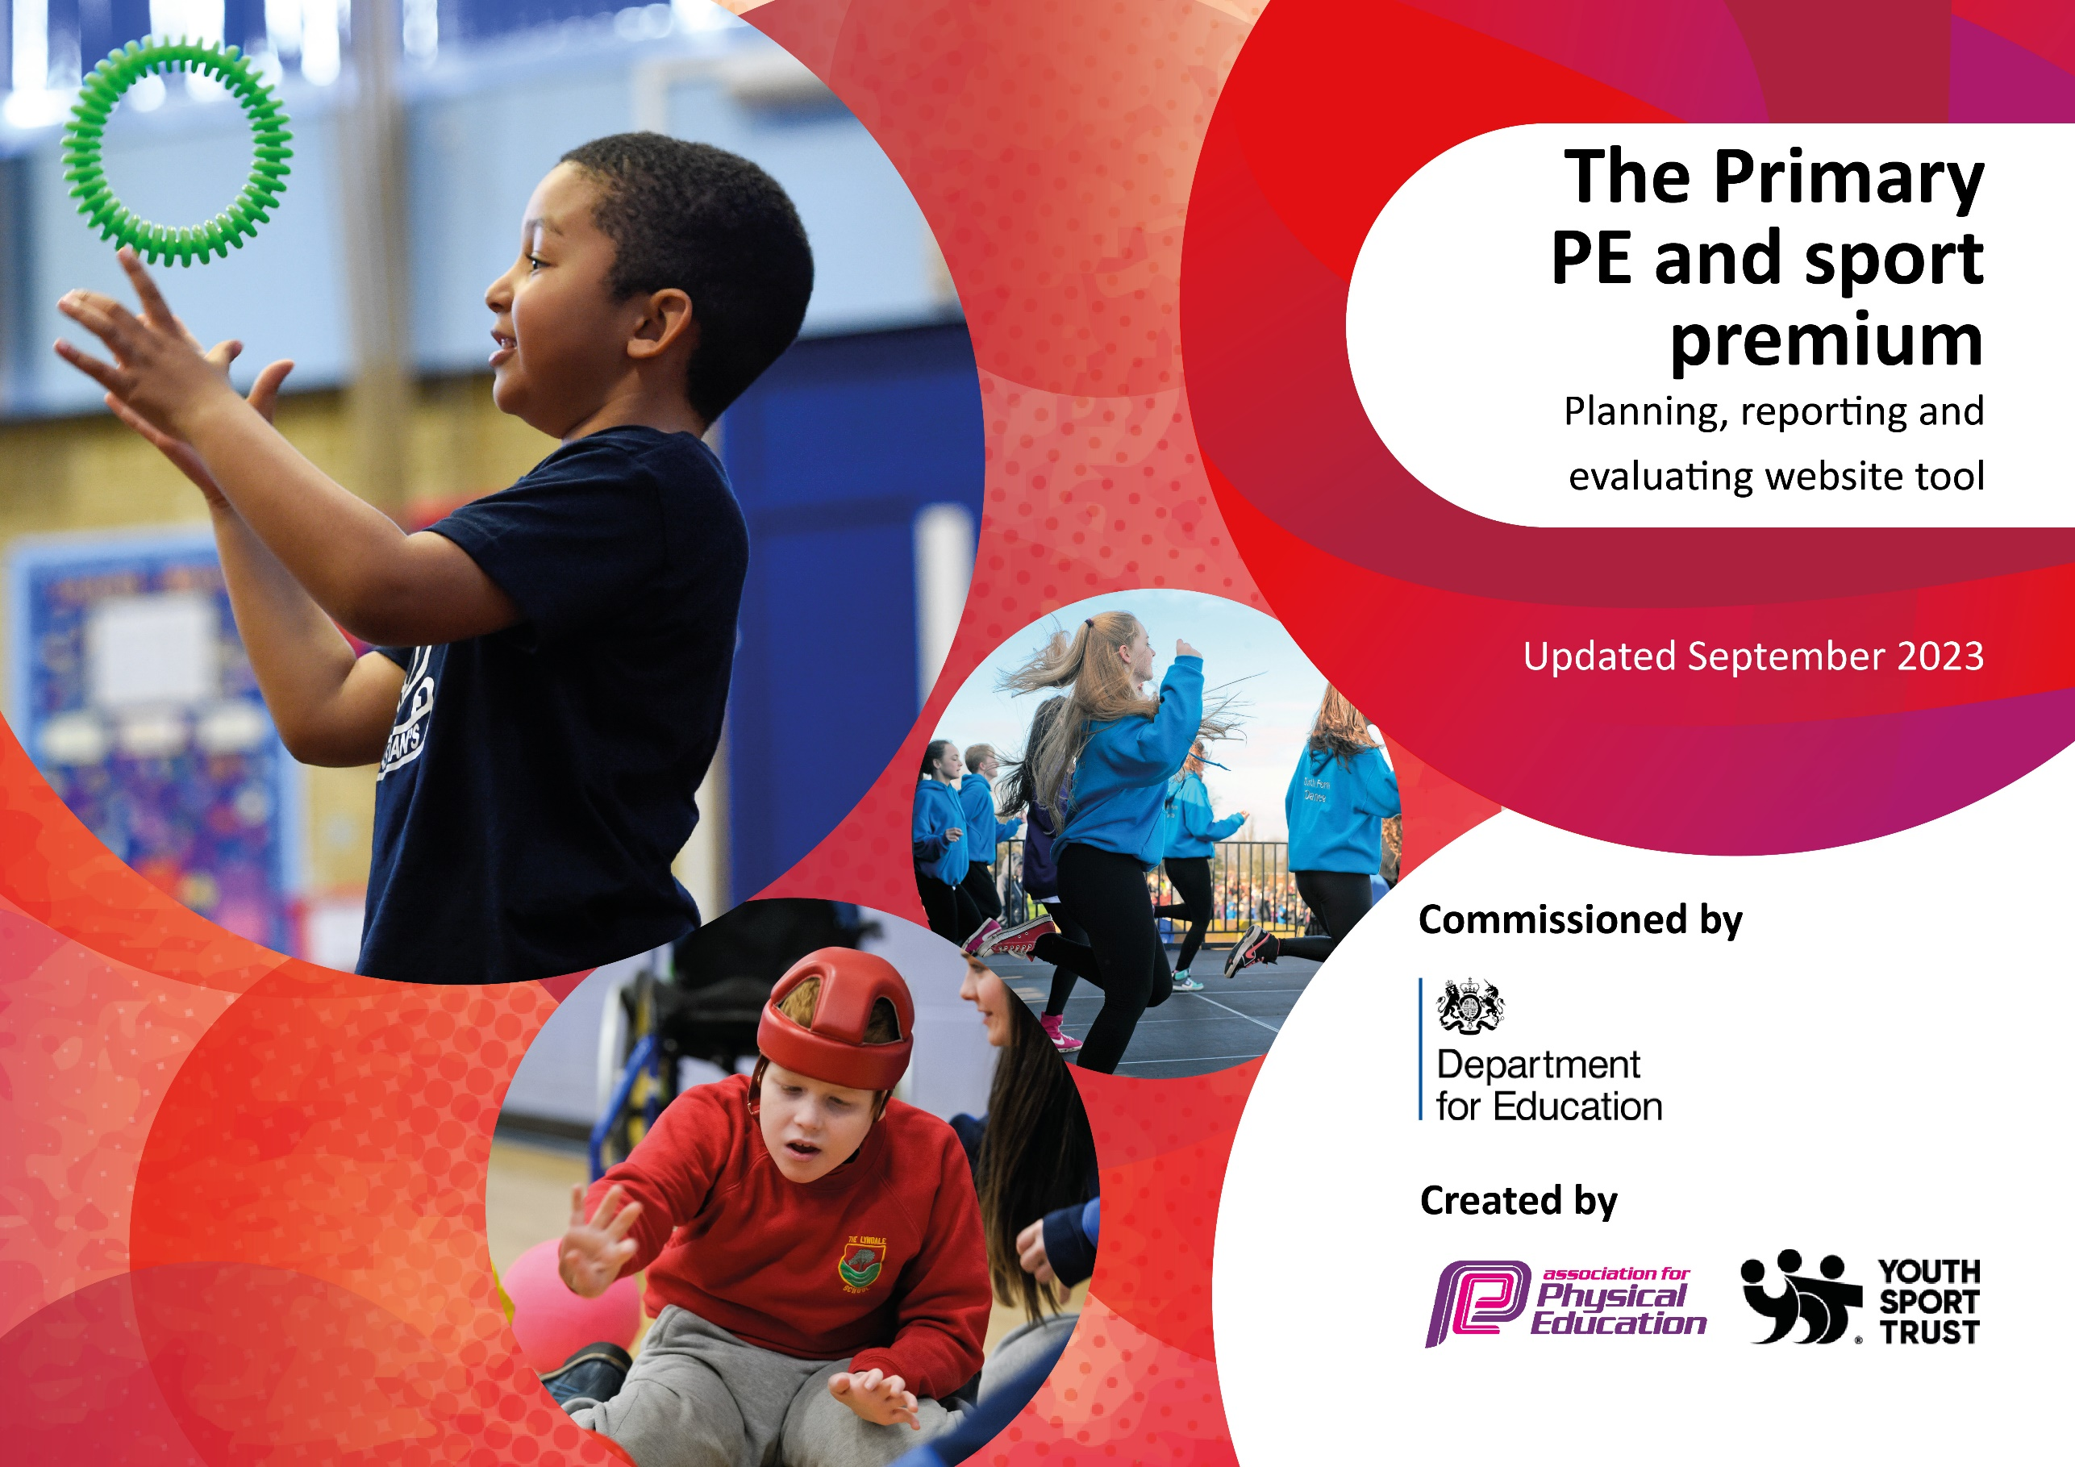

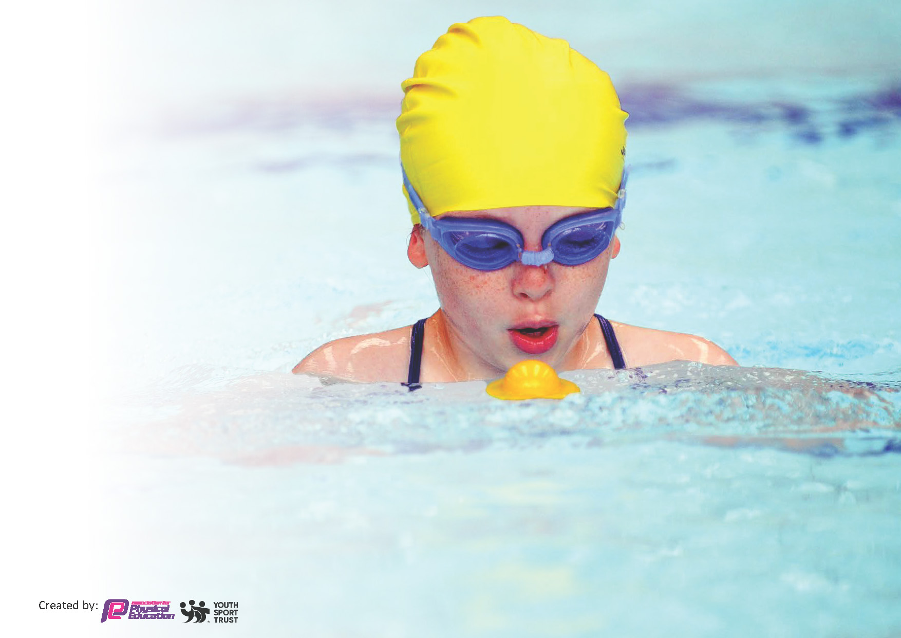
This template can be used for multiple purposes:
by:
- It enables schools to effectively plan their use of the Primary PE and sport premium
- It helps schools to meet the requirements (as set out in guidance) to publish information on their Primary PE and sport premium
- It will be an effective document to support Ofsted inspections enabling schools to evidence progress in Physical Education (PE) and evidence swimming attainment, which forms part of the PE National Curriculum. We would recommend schools consider
the Intent, Implementation and Impact of any spend, as examined within the Education Inspection Framework.

It is important that your grant is used effectively and based on school need.

Schools must use the funding to make additional and sustainable
improvements to the quality of the PE, School Sport and Physical Activity (PESSPA)
they offer. This means that you should use the Primary PE and sport premium to:

- Build capacity and capability within the school to ensure that improvements made now will benefit pupils joining the school in future years
- Develop or add to the PESSPA activities that your school already offers.

The Primary PE and sport premium should not be used to fund capital spend projects; the school’s core budget should fund these. Further detail on capital expenditure can be found in the updated Primary PE and sport premium guidance.

The Primary PE and sport premium guidance, outlines 5 key priorities that funding should be used towards. It is not

necessary that spending has to meet all the key priorities, you should select the priorities that you aim to use any funding towards.

Although completing this template is not a requirement for schools, schools are required to publish details of how they spend this funding. Schools must also outline what the impact this funding has had on pupils’ PE and sport participation and attainment and how any spending will be sustainable in the future. All funding must be spent by 31st July 2024.

The Department for Education has worked closely with the Association for Physical Education (afPE) and the Youth Sport Trust (YST) to develop this template and encourages schools to use it. This template is an effective way of meeting the reporting requirements of the Primary PE and sport premium.
Review of last year’s spend and key achievements (2022/2023)

We recommend you start by reflecting on the impact of current provision and reviewing your previous spend.

Activity/Action | Impact | Comments
Pupils will recognise the importance of regular physical activity and associate it with physical and mental health benefits.  Raise the awareness of Physical Education with pupils and staff the impact it has on the whole child and their future.  Further staff development from a specialist coach to gain a detailed understanding of the subject knowledge and skills of the PE curriculum.  All pupils will be offered a broad range of activities beyond the curriculum to experience and further develop their physical and sports education.  All pupils to have opportunities to apply skills by participating in competitive sport. | Through regular practice pupils will develop an understanding the personal impact and improve confidence to be active. They will be aware of the effect regular physical activity will have on their bodies.  All pupils will be able to identify the benefit of physical education and the impact of being active to maintain good health for the future.  As a result of explicit teaching of the PE and sports curriculum, pupils will have the knowledge and skills of different sports, they will have the ability to identify their own strengths and weaknesses and what they can do to develop their skills.  Pupils will continue to develop their understanding of various sports including their personal strengths and by participating they will stay healthy.  Pupils will know the rules and skills required for different sports. They will understand how it can develop them personal including resilience and confidence. | The Daily Mile is in place and enjoyed by pupils. This will continue next year to develop confidence to be active.  Weekly PE lessons ensures regular physical activity and develops the understanding of physical and mental health benefits.  The movement breaks continue to support the pupils in their learning as it gives them a ‘brain break’ to then refocus on tasks.  Teachers continue to find the programme extremely useful including as a CPD tool to develop their own skills. A more advanced package of Go Well will also contribute towards upskilling staff next year.  The specialist coach was a sports apprentice who is now employed as a TA. She will still use her skills to uplevel staff in at least one PE lesson per week. She continues to lead and organise various events alongside the PE lead.  This has been extremely successful and will continue in the next academic year.  All pupils have participated in an off-site sports activity or event.  Pupils learn skills and rules during lessons. More opportunity for competitive sports to be offered next year.  The profile of this will be raised next year with a reviewed package from Go well.

Key priorities and Planning
This planning template will allow schools to accurately plan their spending.

Action – what are you planning to do | Who does this action impact? | Key indicator to meet | Impacts and how sustainability will be achieved? | Cost linked to the action
- All pupils will engage in regular physical activity.  - All pupils will undertake at least 30 minutes of physical activity a day in school.  - Coaching blocks selected to target specific year groups. Children in Year 1,2,3,4, 5 & 6 will be given curriculum coaching by coaches through Go Well –  - Additional events selected including Intra School Competition, Quidditch Day  - Wider variety of extra-curricular sports available to pupils.  - Introduce lunchtime play leaders to lead sport sessions/activities for pupils.  - Places to be booked on events and competitions. Events to be chosen linked to children’s ability (whole class activities as well as team competitions)  - Full programme of CPD to upskill and support staff members throughout school including Commando Joes  - Transport to and from events | All pupils.  They will participate in daily physical activity.  Teachers/Teaching Assistants/Pupils and external coaches  Teachers/Teaching Assistants/Pupils and external coaches  Lunchtime supervisors / teaching staff, coaches - as they need to supervise and support the activity pupils – as they will take part  Teachers/Teaching Assistants/Pupils and external coaches  Teachers/Teaching Assistants/Pupils and external coaches  Teachers/Teaching Assistants/Pupils | Key Indicators 1,2  Key Indicators 1,2  Key indicator 1  Key indicator 1  Key Indicators 2,3,4,5  Key indicators 4,5 | - The ambitious PE curriculum is embedded across school.  - PE Lead co-ordinate curriculum offer and extended provision to ensure all pupils have access to regular physical activity. Monitor provision.  - Active lunchtime programme implemented by young leaders  - Pupils confident and skilled in different sports activities.  - Improved level of engagement, physical and well-being.  - Pupils will continue to develop their understanding of various sports including their personal strengths and by participating they will stay healthy.  - Improved level of engagement, physical and well-being.  - Effective signposting to sporting clubs by staff and Go Well  - More pupils meeting their daily physical activity goal, more pupils encouraged to take part in PE and Sport Activities.  - Pupils will know the rules and skills required for different sports. They will understand how it can develop them personal including resilience and confidence.  - Staff develop subject knowledge and expertise of the PE curriculum.  - They assess effectively identifying gaps in understanding  - Teachers prepare pupils to engage in competitions  - Pupils participate in a wide variety of external events  - Confidence and resilience developed as they engage in competitive sports. | £2100  £5930  £350  £783  £2100  £4587  £1500

Key achievements 2023-2024
This template will be completed at the end of the academic year and will showcase the key achievements schools have made with their Primary PE and sport premium spending.

Activity/Action | Impact | Comments
Coaching blocks selected to target specific year groups. Children in Year 1,2,3,4, 5 & 6 will be given curriculum coaching by coaches through Go Well.  Additional events selected including Intra School Competition, Quidditch Day  Enhancement of Playground Activities via the introduction of a young leaders programme where pupils from Years 5 and 6 lead playground activities.  Regular opportunities for 30 minutes’ daily physical activity has ensured that pupils are moving and engaging in physical activity.  Places to be booked on events and competitions. Events to be chosen linked to children’s ability (whole class activities as well as team competitions)  Full programme of CPD to upskill and support staff members throughout school.  Teachers assess Pupils more effectively. | There was a fully organised annual programme of events/competitions including whole class events and festivals. All pupils could participate as the programme allowed staff to adapt and meet the needs of all. It has developed a range of skills in an appropriate manner.  Young leaders organised activities allowing children in KS1 and KS2 to be active and learn new skills. There were few behaviour issues as pupils were engaged during playtimes  All pupils will be able to identify the benefit of physical education and the impact of being active to maintain good health for the future.  Pupils given the opportunity to engage in competitive events including new sporting activities.  Staff confidence in delivering PE lessons will increased and this enthusiasm is having a positive effect of pupils’ attitude towards PE. Pupils are enjoying their PE lessons and are experiencing a wider range of sports while still developing good depth in their skills and understanding. Teachers can assess pupils’ skills and further support the development of skills for future PE lessons  100% of pupils took part in an event or competition outside of their regular PE lesson.  . | This was extremely successful including St Charles receiving the Gold Maks Sports award. Coaching will continue next year.  This was at the early stages of development. The pupils participated in some training sessions and began to lead activities across KS1 and KS2. It will continue to be developed in the next academic year.  Pupils engaged in daily activities including the daily mile, Jumpstart Johnny and other activities including movement. Pupil voice identified that they know how to stay active and healthy and the benefits.  All pupils including SEN and disadvantaged participated in a variety of events and activities both in school and externally. Some pupils made it to regional finals for running.  Staff are developing skills and knowledge to deliver PE lessons including new ideas for different activities. This will continue next year.

Swimming Data
Meeting National Curriculum requirements for swimming and water safety.
Priority should always be given to ensuring that pupils can perform safe self-rescue even if they do not fully meet the first two requirements of the National Curriculum programme of study

Question | Stats: | Further context  Relative to local challenges
What percentage of your current Year 6 cohort can swim competently, confidently and proficiently over a distance of at least 25 metres? | % | Use this text box to give further context behind the percentage.  e.g., 30% - we are struggling to get pool space due to our local pool closing so we have had to use a much smaller local school pool. We have had to limit the number of pupils attending swimming lessons during one term which means some pupils have attended fewer swimming lessons than others.
What percentage of your current Year 6 cohort can use a range of strokes effectively [for example, front crawl, backstroke, and breaststroke]? | % | Use this text box to give further context behind the percentage.  e.g., Even though your pupils may swim in another year please report on their attainment on leaving primary school at the end of the summer term 2024

What percentage of your current Year 6 cohort are able to perform safe self-rescue in different water-based situations? | % | Use this text box to give further context behind the percentage.
If your schools swimming data is below national expectation, you can choose to use the Primary PE and sport premium to provide additional top-up sessions for those pupils that did not meet National Curriculum  requirements after the completion of core lessons. Have you done this? | Yes/No
Have you provided CPD to improve the knowledge and confidence of staff to be able to teach swimming and water safety? | Yes/No

Signed off by:

Head Teacher: | Lisa Thompson
Subject Leader or the individual responsible for the Primary PE and sport premium: | Madeline Schofield
Governor: | (Name and Role)
Date: | July 2024

