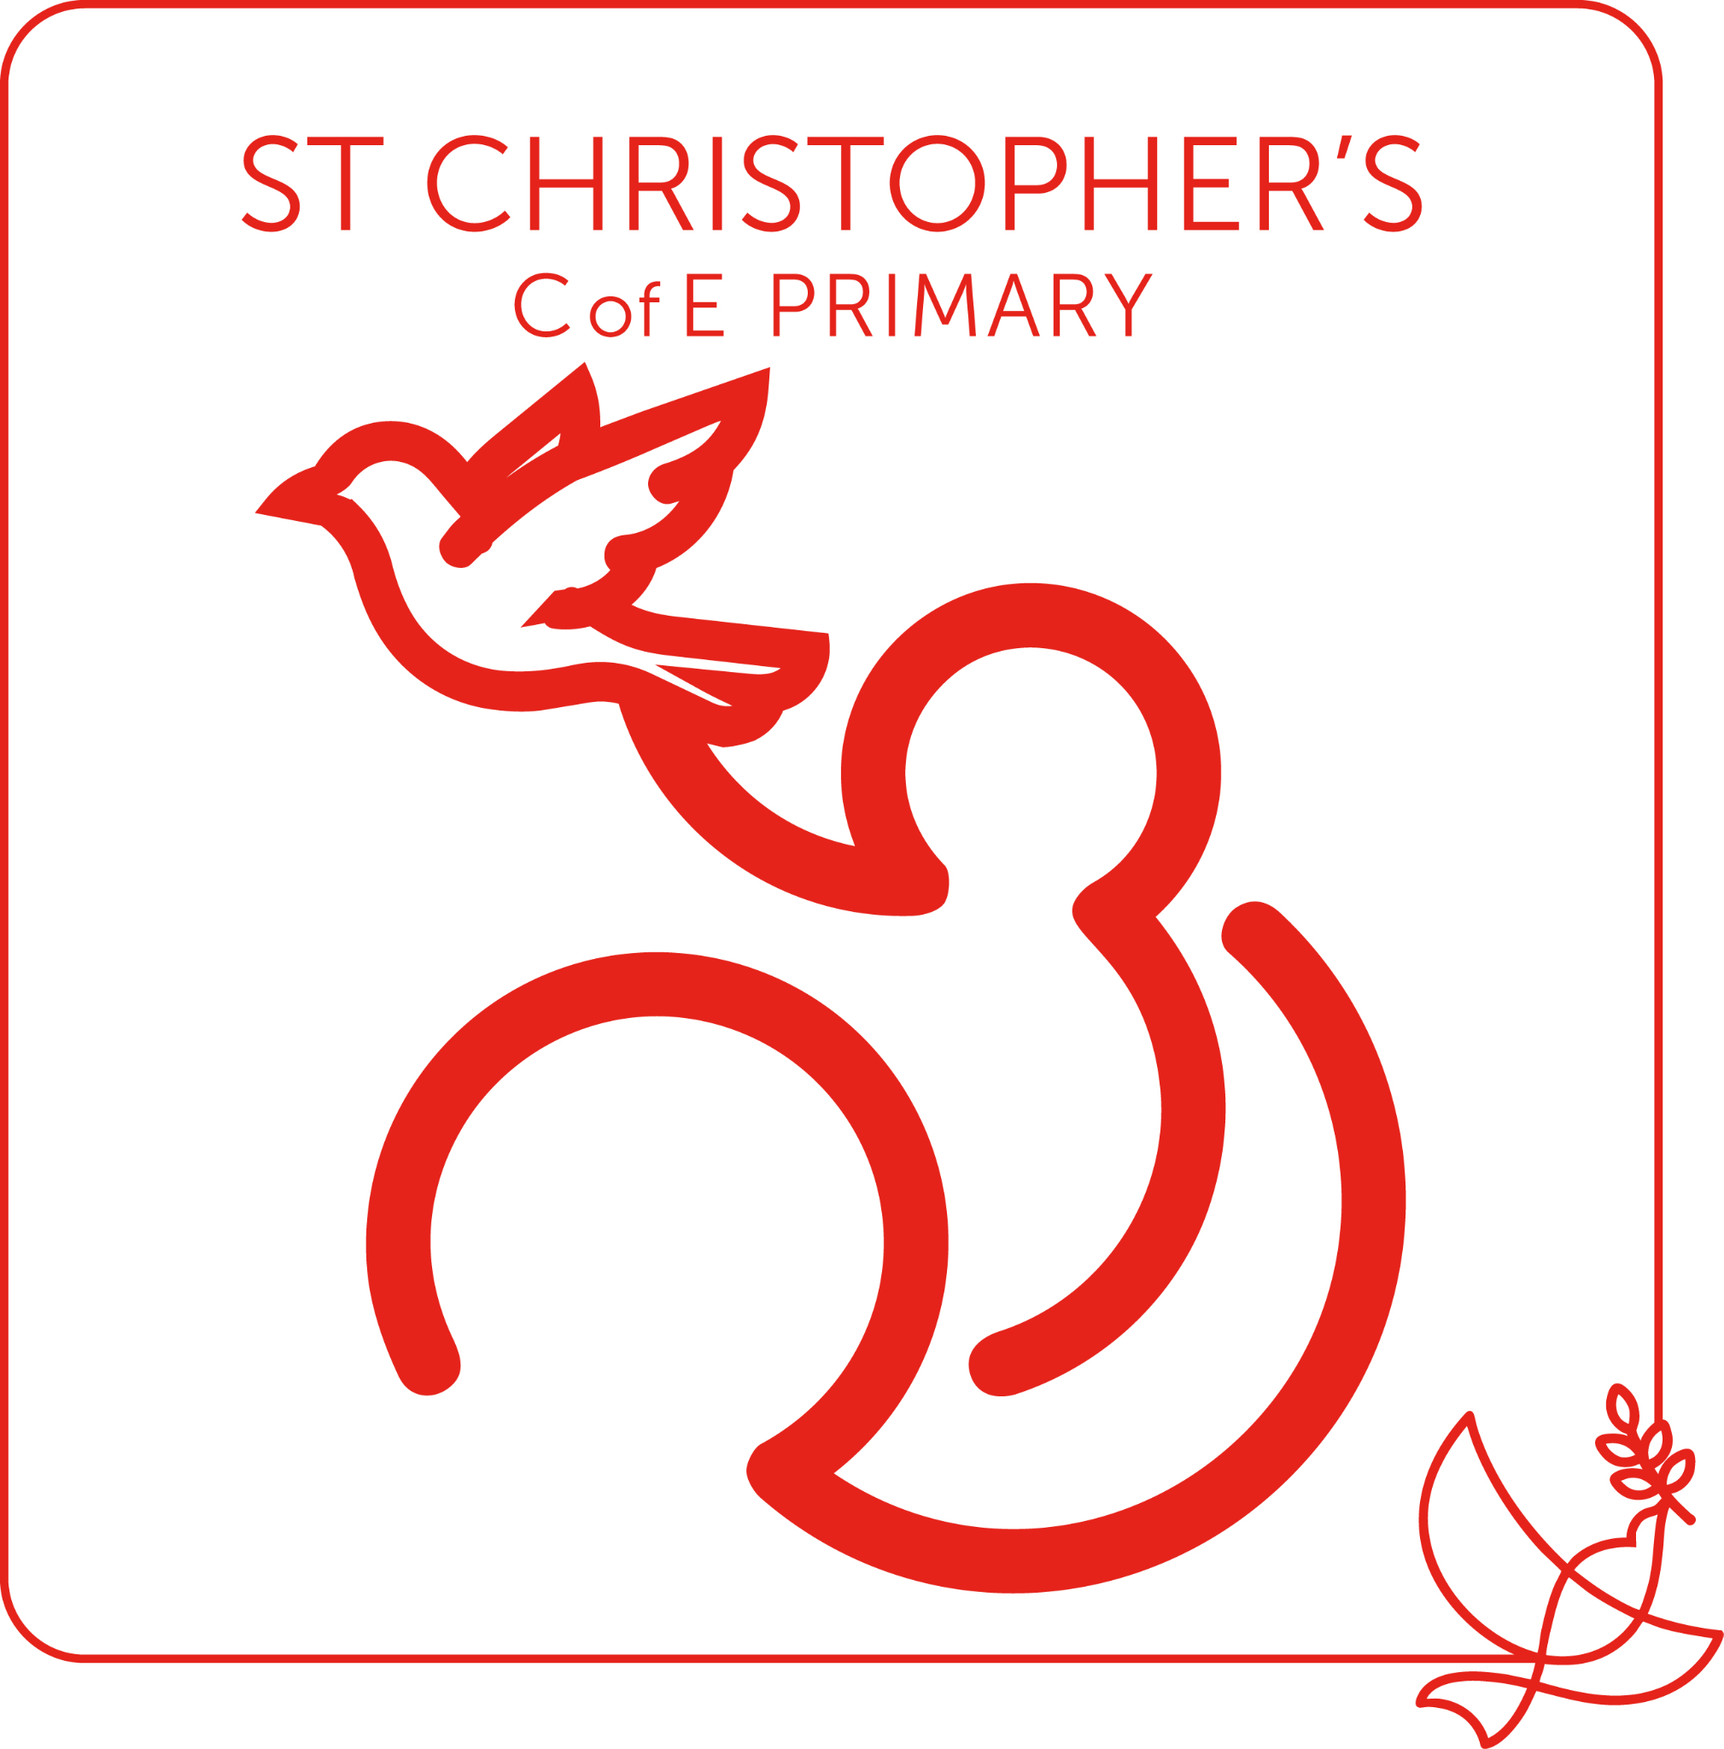

Additional Behaviour Management Information

Document Owner: Chloe Brown
Release Date: September 1st 2026
Review Date: September 1st 2027

Our Christian ethos

At St Christopher’s CofE Primary School we uphold and nurture our Christian ethos by encouraging:

Positivity: “Always be joyful.” 1 Thessalonians 5:16.
Respect: “Treat others as you want them to treat you.” Matthew 7:12
Independence: “I can do all things through him who strengthens me. Philippians 4:13
Determination: “And let us not grow weary of doing good, for due season we will reap, if we do not give up.” Galatians 6:9
Equity: “God doesn’t have any favourites.” Romans 2:11
School and classroom rules

The behaviour curriculum is codified and taught explicitly, with consistent expectations, to ensure that all children receive their entitlement to the education they deserve.

We have high behavioural expectations across the school that are consistently promoted and reinforced throughout all aspects of school life by all members of staff. Our behaviour curriculum- known throughout the school as ‘STAR Behaviour’, has been developed by our staff, SLT and governors and is specified for our pupils. Our ‘STAR Behaviour’ curriculum is outlined within our St Christopher’s Playbook and outlines our shared commitment to the Principles of the Classroom.

Principles of the Classroom
1. Behaviour is a curriculum.
2. Children must be taught how to behave.
3. Teach, don’t tell, behaviour.
4. Make it easy to behave and hard not to.
5. No one behaviour strategy will work with all students.
6. Good relationships are built out of structures and high expectations.
7. Students are social beings.
8. Consistency is the foundation of all good habits.
9. Everyone wants to matter.

There is an expectation in our school that children will:
- Track the adult when they use the instruction “T on me.”
- Listen carefully and concentrate when other people are speaking.
- Speak politely to children and adults.
- Follow instructions the first time that they are asked.
- Be kind and helpful to others.
- Move quietly and sensibly around the school showing ‘STAR walking’.
- Give their very best at all times.
- Maintain focus in class. We expect this from 100% of children, 100% of the time.
- Enter the classroom sensibly and settle quickly.
- Put their hand up to answer or ask a question, and not ‘call-out’.
- Ask for permission from a member of staff before leaving the classroom.

These expectations will be consistently reinforced by staff at all times. At no time should children be allowed to fall short of these expectations without there being an appropriate consequence as outlined within this policy.

Strategies for encouraging positive behaviour

To encourage positive behaviour, staff will provide a good role model to children and employ a variety of strategies within the classroom. These will include:

- Consistent implementation of our STAR Behaviour expectations and use of the linked STAR Behaviour verbal instructions and reminders such as “STAR walking”, “STAR sitting”, and “T on me”.
- Making the class and school rules and expectations clear to all children.
- Using positive and specific verbal praise for appropriate behaviour.
- Recognising good social behaviour and rewarding it appropriately such as through the awarding of Class Dojo points or by moving children’s names up the Dojo Ladder.
- Organising the classroom environment to promote effective learning.
- Minimising the potential for disruption including those from visitors to the classroom by employing the “Door ignore” expectation. This is where children are expected to ignore visitors unless spoken to and instead maintain focus on their learning.
- Being aware of race, gender and learning issues in their responses to children’s behaviour, respecting cultural differences, and avoiding stereotypes.
- Being sensitive to children’s individual needs in a learning or social context.
- Being alert to bullying behaviour (see Anti-Bullying Policy).

Whole school reward system

Nursery to Year 3-
Children are given regular and frequent praise and rewards by staff to acknowledge those that show positive behaviour in line with our behaviour policy and to those that show ‘good’ effort within their work. Additionally, class teachers use a visual ‘Class Dojo Ladder’ in a prominent position within their learning environment which is reset each morning so that children begin on ‘Ready to Learn’. Children’s names can be moved up or down on the ladder as a visual reminder as to how their behaviour has been perceived by the adults in the classroom. Each step on the ladder corresponds to either an appropriate and proportionate consequence (for those children descending the ladder), or a reward (for those children ascending the ladder). The following table outlines the rewards and consequences given to children depending on which ladder rung they finish the day on.

Step | Examples of types of behaviour observed (but not limited to) | Reward/ Sanction  (communicated to the child briefly so that it does not disrupt the flow of teaching)
 | The child shows consistently exceptional behaviour and attitude to their own and others learning. | Children show a member of SLT a piece of work that they are proud and SLT to send a postcard home/ +5 Dojo Points
 | The child shows sustained good behaviour and attitude to their own and others learning. | Show a partner class teacher a piece of work that they are proud of/ +3 Dojo Points
 | The child remains on task throughout each session and is respectful of our class and school rules. | Dojo Sticker/ +2 Dojo Points
Ready to learn | All children will start each morning on ‘Ready to Learn’. | +1 Dojo Point
 | The child may have made a significant or constant disruption to class learning. | A clear verbal warning starting with the child’s name in a calm voice. Loss of social time.
 | The child may have continued to persistently disrupt the class despite reminders and previous sanctions, or refused to follow instructions given to them by staff. | Removed to a partner class and parents informed by class teacher on Class Dojo or in person at the end of the day. If the child refuses to leave the classroom, they should be moved further down the ladder and a member of SLT called to collect the child if necessary.
 | The child may have left the classroom without permission, or deliberately hurt another child. They may have been removed to their ‘partner class’ and continued to cause a disruption, or they may have persistently refused to follow our school rules despite repeated verbal reminders.  Serious Misbehaviour- See page 7. | Removed to SLT corridor and SLT phone call home. If child refuses to leave the classroom, the class teacher should phone down to a member of SLT to collect them.

Year 4 to Year 6-
Children are given regular and frequent praise and rewards by staff within their class to acknowledge those that show ‘good’ behaviour in line with our behaviour policy and to those that show ‘good’ effort within their work. Children are awarded additional Dojo points at the end of each school day to reflect their behaviour according to the following criteria.

Examples of types of behaviour observed (but not limited to) | Dojo Points Awarded/ Reward/ Sanction
The child shows consistently exceptional behaviour and attitude to their own and others learning. | +5 Dojo Points  Children show a member of SLT a piece of work that they are proud of and SLT to send a postcard home.
The child shows sustained good behaviour and attitude to their own and others learning. | +3 Dojo Points  Show a partner class teacher a piece of work that they are proud of.
The child remains on task throughout each session and is respectful of our class and school rules. | +2 Dojo Points
The child follows our classroom rules causes no disruptions to their own or others learning. | +1 Dojo Point
The child may have made a significant or constant disruption to class learning. | -2 Dojo Points  Lose social time
The child may have continued to persistently disrupt the class despite reminders and previous sanctions, or refused to follow instructions given to them by staff. | -3 Dojo Points  Removed to a partner class and parents informed by class teacher on Class Dojo or in person at the end of the day.
The child may have left the classroom without permission, or deliberately hurt another child. They may have been removed to their ‘partner class’ and continued to cause a disruption, or they may have persistently refused to follow our school rules despite repeated verbal reminders. | -5 Dojo Points  Removed to SLT corridor and SLT phone call home

Whole School-
Children accumulate Dojo Points throughout the year with the following awards being given to children in our weekly ‘Celebration Assembly’ once they reach the following targets:

Bronze Award- 250 Dojo Points
Silver Award- 500 Dojo Points
Gold Award- 1000 Dojo Points
Platinum Award- 1500 Dojo Points

Star of the Week

Each week, every class teacher will choose a ‘Star of the Week’ from their class who has particularly stood out for their work, effort or behaviour and who has received the most Dojo Points over the course of the preceding week. These children will be awarded the ‘Star of the Week’ award by their class teacher in the weekly Celebration Assembly.
PRIDE Hand Award

A child will be chosen from each class every week to receive the PRIDE Hand award in our weekly Celebration Assembly. The PRIDE Hand will be awarded to children that have shown a particular aspect or value of PRIDE throughout the week. Teachers will ensure that a range of children receive an award by focussing on a different aspect of PRIDE each week.

PRIDE ‘Shooting Star’ Award

Our PRIDE ‘Shooting Star’ is an award given to one child within the school each week and is chosen by members of SLT to recognise an individual that has demonstrated a particular PRIDE value in a wider-school context. Children may be nominated by class teachers, staff members, visitors to the school, or members of our wider-school community to receive the award, or it may be selected directly by a member of SLT.

Sanctions for discouraging unacceptable behaviour

Unacceptable behaviour will lead to the following sequence of consequences. In certain cases, some or all of the steps in the sequence may be bypassed, depending on the severity of the behaviour and/ or the location of the behaviour in question.

All staff and children need to be aware of the sequence of consequences. Children must be clear that their actions will have consequences for themselves and others and to understand why a sanction is being used.

Serious Misbehaviour

There may be instances where our school behaviour curriculum and behaviour management system does not prove effective and children demonstrate what is deemed as ‘serious misbehaviour’.

Serious misbehaviour is defined as:
- Repeated breaches of the school rules that lead to unreasonable high level disruption of children’s right to learn.
- Any form of bullying, harassment or discrimination such as racist, sexist or homophobic behaviours (please see Anti-bullying Policy).
- Physical violence or verbal aggression directed towards an adult or pupil.
- Use of object/weapons to hurt others.
- Serious/ continued bullying incidents.
- Vandalism leading to significant damage of school property and resources.
- Possession of any article a staff member reasonably suspects has been, or is likely to be, used to commit an offence, or to cause personal injury to, or damage to the property of, any person (including the pupil).

Steps following serious misbehaviour:

Following an investigation, consideration will be given to the context and seriousness of the behaviour when consequences and strategies are decided. Potential consequences could include the following:

- Removal
- Multi-agency involvement
- Suspension

Suspension and permanent exclusions

Good behaviour at St Christopher’s is essential to ensure that all pupils benefit from the opportunities provided by the school. If our school approaches towards behaviour management have been exhausted, then suspensions and permanent exclusions will sometimes be necessary as a last resort. This is to ensure that other pupils and teaching staff can work in safety and are respected.

A suspension may be used to provide a clear signal of what is unacceptable behaviour as part of the school’s behaviour policy and show a pupil that their current behaviour is putting them at risk of permanent exclusion. A permanent exclusion is when a pupil is no longer allowed to attend a school. The decision to exclude a pupil permanently will only be taken: in response to a serious breach or persistent breaches of the school's behaviour policy; and where allowing the pupil to remain in school would seriously harm the education or welfare of the pupil or others such as staff or pupils in the school.

The decision to suspend will be made by the Headteacher (and in her absence the Deputy).
If the decision is made to suspend, a meeting with the child’s parent/s will be held. This will always be followed by a letter to the parent explaining the reasons for suspension, the length of suspension, the arrangements for accessing school work, and the arrangements for the child’s ‘back to school’ meeting.

