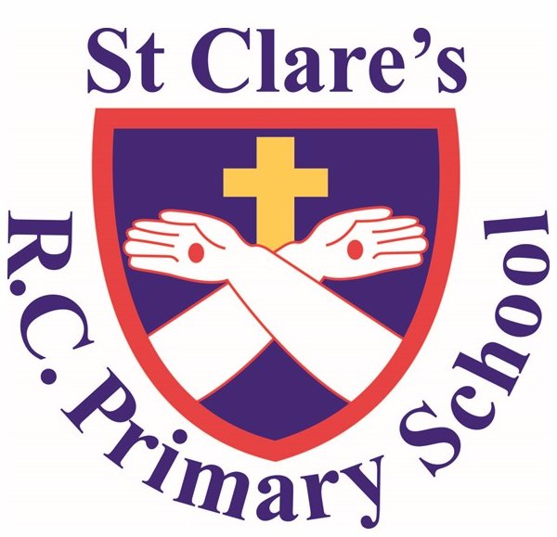

Art & Design Policy

'Guided by Jesus Christ, our teacher, we journey together, learning to dream, believe and achieve'

Introduction

Art has a significant and valuable role to play in the overall ethos of this school. The purpose of studying art at St Clare’s follows the purpose outlined in the National Curriculum:

“Art, craft and design embody some of the highest forms of human creativity. A high-quality art and design education should engage, inspire and challenge pupils, equipping them with the knowledge and skills to experiment, invent and create their own works of art, craft and design. As pupils progress, they should be able to think critically and develop a more rigorous understanding of art and design. They should also know how art and design both reflect and shape our history, and contribute to the culture, creativity and wealth of our nation.”

- National Curriculum
Aims and Objectives
The school believes that art is a vital part of the education of all children and will try to ensure that art always has a high profile. Whilst it may be an enjoyable activity, it is not seen as being solely therapeutic or as a hobby. It is important that art is taught as a subject in its own right. However, it can be used to enrich and extend the teaching of other subjects. The school’s aim is to provide an art curriculum which will enable all children to reach their full potential in learning in art and design.

The national curriculum for art and design aims to ensure that all pupils:
- produce creative work, exploring their ideas and recording their experiences
- become proficient in drawing, painting, sculpture and other art, craft and design techniques
- evaluate and analyse creative works using the language of art, craft and design
- know about great artists, craft makers and designers, and understand the historical and cultural development of their art forms.

Pupils should be taught to develop their techniques, including their control and their use of materials, with creativity, experimentation and an increasing awareness of different kinds of art, craft and design.

Pupils should be taught:
- to create sketch books to record their observations and use them to review and revisit ideas
- to improve their mastery of art and design techniques, including drawing, painting and sculpture with a range of materials [for example, pencil, charcoal, paint, clay]
- about great artists, architects and designers in history.

Curriculum Organisation

To achieve that aim, Art is taught in half-termly blocks by the class teacher. Art is taught 3 times per year, often with a particular artist focus.

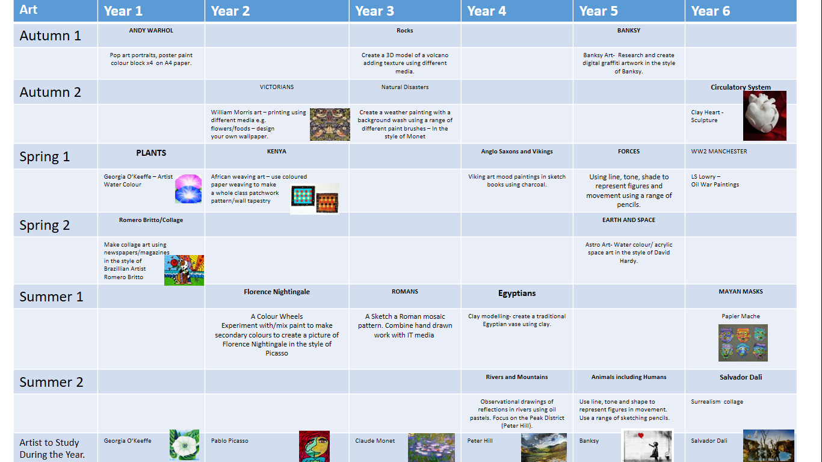

Teaching and Learning

Teaching Art & Design at St Clare’s should be guided by our 5 Main Curriculum Drivers:

“Five main drivers, or key ideas, have informed the design of the curriculum and its implementation at St Clare’s. These are: Faith, Community, Language, Opportunity and Curiosity. The Catholic faith is central to pupils’ development and understanding of the world, including the expectations they must have of themselves and the responsibilities they have to others, particularly those in need. We also want pupils to realise that they are part of a community and to appreciate that this brings challenges, rights and responsibilities. Pupils should grow to serve for a greater good. Many of them enter the school with low levels of spoken language and, without suitable exposure to the wider language of subject domains, this may impede their development and opportunities. We also recognise that in the challenging urban context in which the school is set, opportunities such as access to cultural experiences can be diminished, reducing exposure to inspirational art, music, theatre and much more. So such opportunities are systematically mapped to address this risk of cultural deficit. Finally, we want pupils to be life-long learners and to be intrinsically motivated to utilise their reading skills to take control of their education and personal development. Curiosity about the world and their place within it is central to this.”

Progression

Units are planned to include teaching about key artistic concepts, use of media, methods and techniques, and about great artists, designers and architects in history.

Although links are made between subjects in topics, all subjects are taught discretely. Although connections are made, the skills and knowledge of each subject are developed systematically through careful sequencing of the curriculum. Pupils may make Mayan masks, for example, drawing on an historical stimulus but the series of lessons would focus on the art process, techniques and relevant media, not on the problems of evidence and reconstruction. In short, the integrity of each subject domain is preserved and the understanding of the subject progressively developed through careful sequencing and the oversight of the subject leader.

Roles and responsibilities of the subject leader

- to support and guide the practice of teachers and support staff
- to ensure coverage, continuity and progression in planning
- to monitor and evaluate the effectiveness of art teaching and learning
- to update documentation where necessary
- to produce action plans for the School Development Plan, prepare bids and manage the Art budget effectively
- to liaise and consult with outside agencies where appropriate
- to prepare and lead INSET
- to attend relevant INSET training, or arrange for teachers to attend
- to report to the Senior Leadership Team on developments in the subject

Equal Opportunities and Inclusion

Art plays an important part in the life of our school. Children are able to enjoy and achieve.

- It must be available to every child and all children should take part in creative activities.
- Activities both within and outside the classroom are planned in a way that encourages full and active participation by all children, matched to their knowledge, understanding and previous experience.
- Children should have equal opportunities to develop their understanding and enjoyment of art.
- Pupils should be taught about a diverse range of artists.
- Teachers must ensure that the curriculum is appropriate for the needs of the children.

Assessment and Recording

The teacher of art should note individual pupil’s progress to provide guidance for future teaching and learning and for reporting at the end of the school year. The medium term curriculum plans will form in art an aspect of the record of art taught. Coherence of assessment across the school is supported by discussion and consultation between staff, guided by the Art Subject Leader and Senior Leadership Team. Gathering evidence of pupil attainment is an integral part of assessment, which is built into the schemes of work. Teachers can obtain evidence by direct observation of children at work, questioning pupils or listening to their conversations, and by assessing their sketches and finished pieces.

The Art Subject Leader monitors teaching and progress in Art by:
- informal discussions with teachers, SLT and children
- an annual resource audit
- assessing work and progress
- observing lessons

Resources

Art resources should be kept and well-organised in Key Stage resource rooms. When the resources are in the classroom, pupils are expected to take an increasing level of responsibility for that organizing and respecting the resources. The class teacher is primarily responsible for ensuring the safety of the children during the lesson by instructing them in the safe and appropriate use of any equipment. The class teacher is responsible for the general care of the equipment during the lesson by instructing the children in the correct use of the equipment and by replacing them safely after use. Teachers should report damage to equipment to the Art Subject Leader as soon as possible.

