Week 4 –
attached available cemetery convenience environment foreign hindrance immediately temperature thorough
Week 2 –
ascent assent accountancy discrepancy stationary stationery considerably affordably wrath wreak
Week 5 –
changeable noticeable knowledgeable manageable serviceable forcible illegible legible eligible terrible
Core Homework:
Hand in 1 task each Monday
30 minutes reading every night
Practise weekly spellings
Practise times tables @ ttrockstars

Week 3 –
guessed guest heard herd led lead (noun) morning mourning past passed
Week 6 –
Consolidation of all spellings from this half term.
Spellings
Week 1 –
adorable adorably deceive receive ancient efficient fought sought through thorough
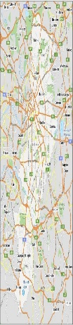
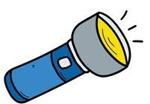
Year 6: Autumn 1
Science – Light Geography -Our Local Area
Flash Back Task: Imagine you are an astronaut aboard the International Space Station watching Earth from above. Write a 2-paragraph logbook entry describing what you observe as Earth spins on its axis and orbits the Sun. (Earth and Space Year 5 Science)

Write a short sales pitch or record a 60-second video promoting a new digital navigation gadget for mountain trekkers. Explain how it helps users navigate safely.
Create a mini tourist brochure featuring 5 key landmarks or physical features of Blackley (e.g., River Irk, local parks, historic buildings).
Choose a view in Blackley that blends both physical features (like the River Irk, tree lines, or rolling park hills in Boggart Hole Clough) and human features (like local brick houses, schools, or historic buildings). Use this to create a skyline silhouette drawing or painting
Interview a relative or research how Blackley has changed over time (e.g., changes to housing, transport, or green spaces). Present your findings as a newspaper report.

Draw a detailed aerial grid map of Boggart Hole Clough or your local street in Blackley. Include a key, 4-figure grid references, and a compass rose showing North.
Take 2 photos or draw 2 sketches of the same location in Blackley at different times of day (e.g., morning vs. late afternoon). Annotate how shadow lengths and light direction change.
Cut out paper puppets and use a torch to perform a 1-minute shadow show. Explain in your script how light traveling in straight lines creates clear shadows when blocked.
Build a working periscope using card and two small mirrors (or silver card). Write 2 sentences explaining how light reflects off the mirrors in straight lines to reach your eyes.
Oracy Task: Stand in front of a window or outdoors in Blackley and record a 60-second video forecast (or present live to your class/family) acting as a TV weather presenter.
Create a 4-panel comic strip following a ray of light from a source (e.g., the Sun or a torch), bouncing off an object, and entering the pupil of an eye.

