Personal, Social & Emotional  - Persevering to reach our goals  - Resolving conflict ourselves  - Taking turns in games and activities without an adult present and offering to share toys  - Tidying up the classroom without the support of an adult  - Independently asking others when we need help | Physical Development  - Learning different types of balances  - Using scissors to cut straight and curved lines  - Using tweezers to pick up objects  - Using a knife and fork correctly  - Holding a pencil using a tripod grip  - Jumping off higher equipment  - Using our core muscles to achieve good posture | Communication and Language  - Retelling short stories  - Creating our own stories using ‘Tales Toolkit’  - Reciting rhymes, poems and songs independently  - Using new vocabulary such as: past, present, future, long ago, year, stegosaurus, triceratops, velociraptor, brachiosaurus, tyrannosaurus-rex, pterodactyl, herbivore, carnivore  - Talking about the similarities and differences between dinosaurs and fossils  - Talking about similarities and differences between toys now and toys from the past
Literacy  - Creating stories using Tales Toolkit  - Repeating words and phrases from familiar stories  - Reading multi-syllabic words  - Recognising the Red Words: I, the, to, no, of, go, my, he, me, for, she, we, was, your, said, you, be, are, like, all, they, her  - Reading simple sentences  - Using language such as “Once upon a time…’, ‘Suddenly…’, ‘First/ Next/ Then…’ to create and tell stories  - Writing sentences using a full stop and a capital letter  - Writing non-fiction texts about dinosaurs/ toys from the past | ST CLARE’S R.C PRIMARY SCHOOL  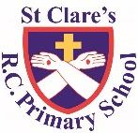  CURRICULUM OVERVIEW  Reception  Summer 1: 2022-23  ‘ Topic: Blast From the Past’  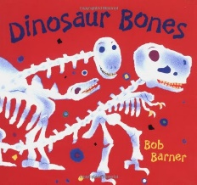  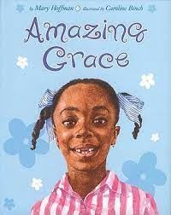  Main texts:  Amazing Grace, Dinosaur Bones  Linked texts: Old Bear, Peepo, The Elves and the Shoemaker, Hassan and Aneesa Celebrate Eid, Dave’s Cave, If I Had a Raptor, The Queen’s Handbag, Little Elizabeth | Maths  - Learning to double numbers using equipment  - Learning double facts off by heart  - Learning number bonds to 5 & 10 off by heart, including subtraction facts e.g. 6+4=10, 4+6=10, 10-6=4, 10-4=6  - Looking for patterns within numbers  - Sharing objects between different numbers and saying if we have any left over  - Sorting numbers into odd and even numbers  - Making maps based on stories
Understanding of the World  - Talking about the past  - Looking at similarities and differences between the past and now  - Looking at timelines  - Discussing seasonal changes  - Learning about the King and celebrating the King’s Coronation  - Learning about Eid | Religious Education  - Learning about baptism and artefacts that are used such as: white gown, Baptismal candle, white shawl  - Visiting St Clare’s Church to see how a Baptism is performed  - Learning about Pentecost and Good News | Expressive Arts and Design  - Learning Nursery Rhymes and the history behind them  - Making paper-mache volcanoes  - Making paints darker and lighter using black and white
Enrichment Opportunities: | - Visit Salford Museum and Art Gallery to take a step back in town (free) | - Visit Manchester Museum to see a dinosaur skeleton

